This lab is worth 10% of your final AI4Games grade.

Due date September 25th 5pm

Lab 2

This lab should build on your work from the previous lab. Implement a simple demo where the player controls a character with the four arrow keys. Up/Down control the speed of the character, and left/right perform a turning motion. The game world should be wrap around.

You will have five alien ships utilising dynamic steering behaviours as follows:
- One alien will use an aimless Wander behaviour.
- One alien will use a Seek behaviour to follow the player around.
- Two aliens will use an Arrive behaviour to follow the player around. They should have different max speeds so they arrive at different times.
- One alien will use a Pursue behaviour to follow the player around.

All NPCs are to implement an object detection mechanism using a cone of vision as described in the notes. Any object in an NPC’s cone of vision should result in some form of object avoidance unless it is the player.

You are to add a text box displayed next to each alien ship indicating what behaviour they are implementing. Allow the user to turn specific AIs on and off by pressing keys 1-5. This helps to clearly see individual NPC behaviours.

Note:
Don’t make the sprites so big that I can’t see the behaviours.

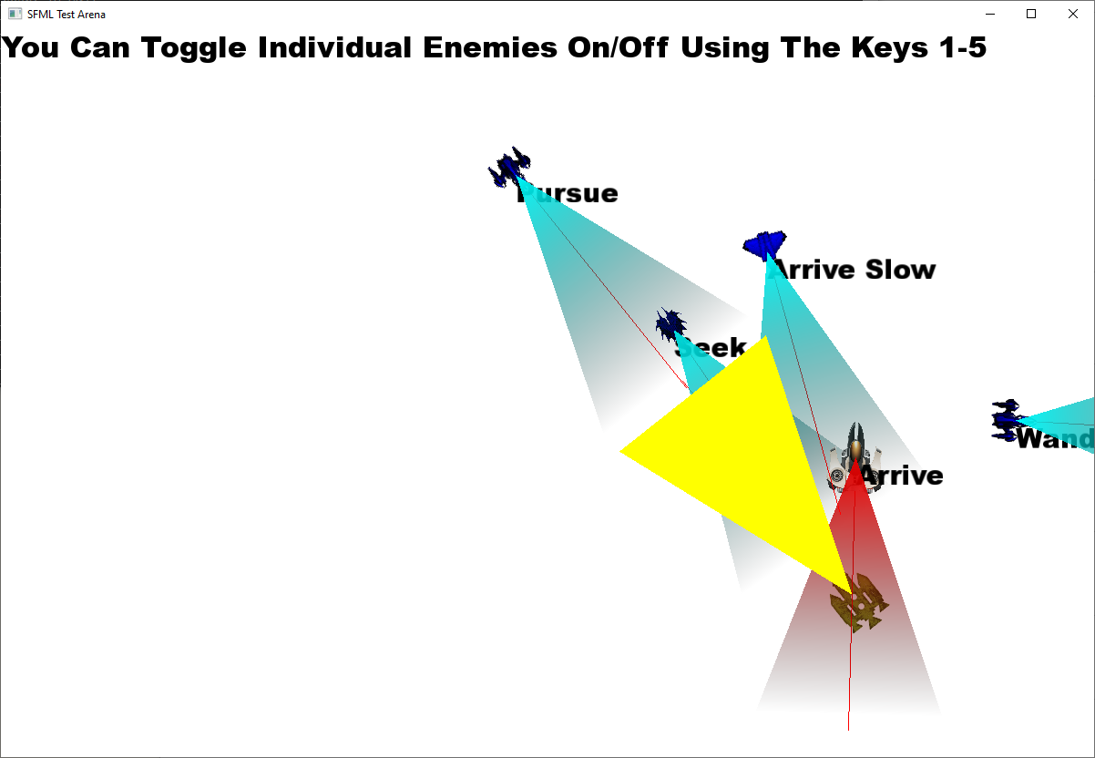

Marking Scheme:

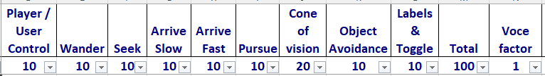

Full marks given for a good implementation, then marks get deducted for non-intelligent looking movement. In person review produces a multiplier between 0 and 1.

