**Normalization**

**Heap**

* Room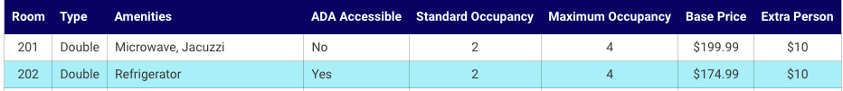
* Guest

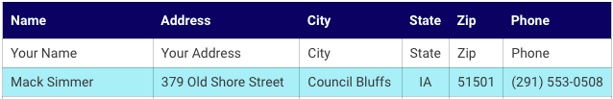

* Reservation

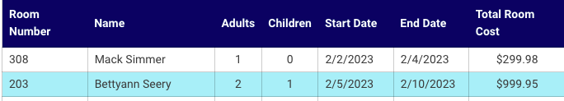

**First Normal Form (1NF)**

To achieve 1NF, the table must satisfy the following conditions:

* There is no top-to-bottom ordering to the rows.
* There is no left-to-right ordering to the columns.
* Every row can be uniquely identified.
* Every row/column intersection (field) contains only one value.
* Room: Amenities (Microwave, Refrigerator) | *Every row/column intersection (field) contains only one value*
* Guest: Primary Key/Surrogate Key | *Every row can be uniquely identified*
* Reservation: Primary Key/Surrogate Key | *Every row can be uniquely identified*

|  |  |  |  |  |  |  |  |
| --- | --- | --- | --- | --- | --- | --- | --- |
| Room | Type | Amenities | ADA Accessible | Standard Occupancy | Maximum Occupancy | Base Price | Extra Person |
| 201 | Double | Microwave | No | 2 | 4 | $199.99 | $10 |
| 201 | Double | Jacuzzi | No | 2 | 4 | $199.99 | $10 |

|  |  |  |  |  |  |  |
| --- | --- | --- | --- | --- | --- | --- |
| GuestID | Name | Address | City | State | Zip | Phone |
| 1 | Mack Simmer | 379 Old Shore Street | Council Bluffs | IA | 51501 | (291) 553-0508 |

|  |  |  |  |  |  |  |  |
| --- | --- | --- | --- | --- | --- | --- | --- |
| ReservationID | Room Number | Name | Adults | Children | Start Date | End Date | Total Room Cost |
| 1 | 308 | Mack Simmer | 1 | 0 | 2/2/2023 | 2/4/2023 | $299.98 |

**Second Normal Form (2NF)**

In academic terms, a table is in 2NF if and only if it is in 1NF and every non-primary-key column is functionally dependent on the entire primary key but not functionally dependent on any proper subset of the primary key.

In plain English, you must already be in 1NF and then all of the columns except the primary key need to be strictly related to each other. Additionally, we should not repeat data across rows.

* **Room**

Room has ***One-to-Many relationship*** with Type, Amenity, Occupancy, BasePrice, and ExtraPersonPrice

|  |  |  |  |  |  |  |
| --- | --- | --- | --- | --- | --- | --- |
| RoomNumber | *TypeID* | *AmenityID* | ADA Accessible | *OccupancyID* | *BasePriceID* | *ExtraPersonPriceID* |
| 201 | 2 | 5 | No | 2 | 3 | 1 |
| 202 | 2 | 3 | Yes | 2 | 2 | 1 |

|  |  |
| --- | --- |
| AmenityID | AmenityName |
| 1 | Microwave |
| 2 | Jacuzzi |
| 3 | Refrigerator |
| 4 | Oven |
| 5 | Microwave, Jacuzzi |
| 6 | Microwave, Refrigerator |
| 7 | Microwave, Jacuzzi, Refrigerator |
| 8 | Microwave, Refrigerator, Oven |

|  |  |
| --- | --- |
| TypeID | Type |
| 1 | Single |
| 2 | Double |
| 3 | Suite |

|  |  |  |
| --- | --- | --- |
| OccupancyID | StandardOccupancy | MaximumOccupancy |
| 1 | 2 | 2 |
| 2 | 2 | 4 |
| 3 | 3 | 8 |

|  |  |
| --- | --- |
| BasePriceID | Price |
| 1 | $149 |
| 2 | $174.99 |
| 3 | $199.99 |
| 4 | $399.99 |

|  |  |
| --- | --- |
| ExtraPersonPriceID | Price |
| 1 | $10 |
| 2 | $20 |

* Guest (I didn't make another table with City, State, and Zip bc there are 41,683 zip codes in USA and I don't think it is worth it to store that big fixed-size table yet, maybe later when there are many traffic - clients)

|  |  |  |  |  |  |  |  |
| --- | --- | --- | --- | --- | --- | --- | --- |
| GuestID | FirstName | LastName | Address | City | State | Zip | Phone |
| 1 | Mack | Simmer | 379 Old Shore Street | Council Bluffs | IA | 51501 | (291) 553-0508 |
| 2 | Bettyann | Seery | 750 Wintergreen Dr. | Wasilla | AK | 99654 | (478) 277-9632 |

* Reservation

Reservation has ***Many-to-Many (One-to-Many?)*** relationship with Guest and Room

|  |  |  |  |  |  |  |  |
| --- | --- | --- | --- | --- | --- | --- | --- |
| ReservationID | *RoomNumber* | *GuestID* | Adults | Children | Start Date | End Date | Total Room Cost |
| 1 | 308 | 1 | 1 | 0 | 2/2/2023 | 2/4/2023 | $299.98 |
| 2 | 203 | 2 | 2 | 1 | 2/5/2023 | 2/10/2023 | $999.95 |

* Bridge Table (Many-to-Many)

- ReservationRoom

- ReservationGuest

Ver.1

* Total **8** tables
* **Room** has 5 tables with *One-to-Many* relationship
* **Reservation** has *One-to-Many* relationship with 2 tables - **Room** and **Guest**
  + Confused what relationship to use between Reservation, Room and Guest

- One-to-Many or Many-to-Many?

* + Confused where to put Foreign Key
  + Confused which table should have three lines branching out (a chicken foot)

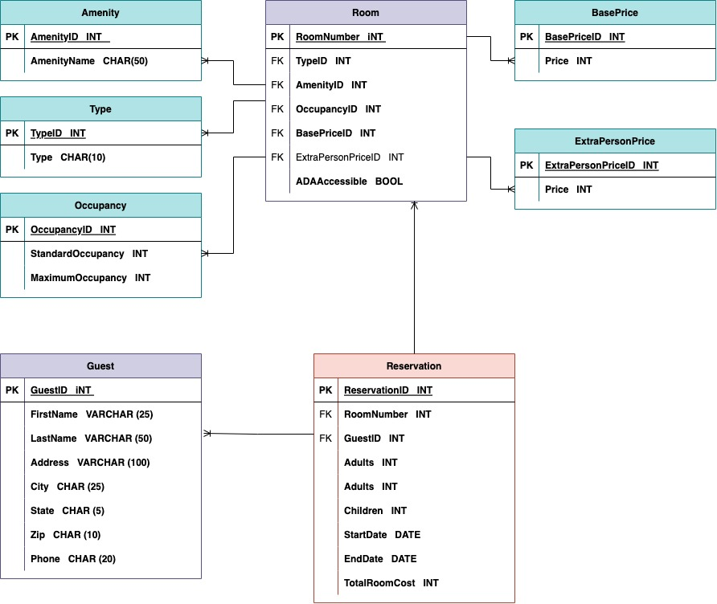

Ver.2

* Total **10** tables (8 tables and 2 bridge tables)
* 3 main tables - Room, Guest, Reservation
* **Room** has *One-to-Many relationship* with 5 tables - Amenity, Type, Occupancy, BasePrice, ExtraPersonPrice
* **Reservation** has *Many-to-Many relationship* with 2 tables - **Room** and **Guest**

