

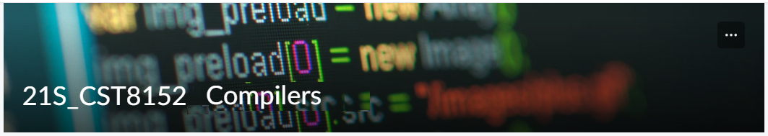

MODEL TASK FOR ASSIGNMENT 2.1 – Bust

Language: [Bust]
Team - [Boyu Li] - Id: [041003345] / [Golden Zhang] - Id: [041051971]

- Note: This task is part of the Assignment 2 from Compilers Course. Any problem, contact your lab professor.

PART 1: RE – Regular Expression (1.5 mark)

Lexeme Classes: Define the classes to be used in your regular expression:

Answer:
L = [A-Za-z] (Letters)
D = [0-9] (Digits)
P =. (Period)
U = _ (Underscore)
C = / (Comment)
NL = \n (Newline)
Q = “(Quote)
OP = ( (Open Parenthesis)
O = [^LDPUCNLQOP]

Define the RE to be used for: variables, literals and keywords:

Answer:

* Comments: CC[^NL]*NL

* Variables: L[L|D|U]*

* Methods: L[L|D|U]*OP

* Literals:
- Numbers
IL = D[D]* (Integer Literal)
FL = D[D]*P[D]* (Float Literal)
- Strings
SL = Q[^Q]*Q (String Literal)
* Keywords:
KEY = {if, else, return, while, fn, true, false, i64, char, f64, String, bool, NULL, let}

PART 2: TD – Transition Diagram (1.5 marks)

Activity: Starting from the previous lexeme classes and obeying the RE, it is possible to define the automata for your language:

Answer (draw / copy image of the automata):

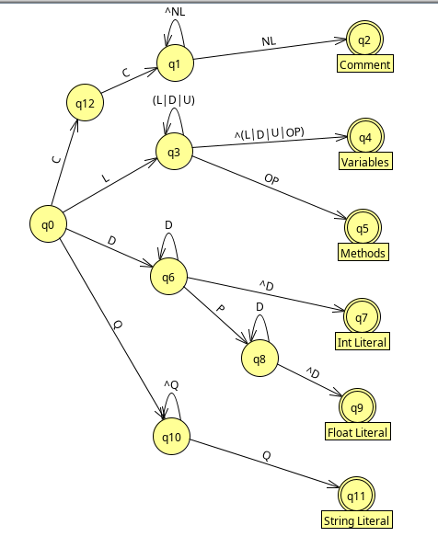

PART 3: TT – Transition Table (2 marks)

Activity: Now, it is possible to define the TT for these lexemes:

Answer (Transition Table):

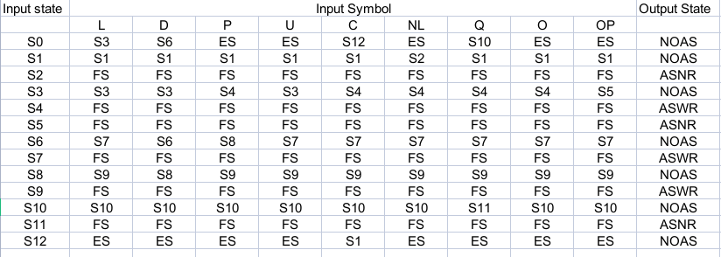

Update: May 30th 2023.

Adapted from resources developed by Prof. Svillen Ranev (Algonquin College, 2019)

