Algonquin College Logo

# SCHOOL OF ADVANCED TECHNOLOGY

### ICT - Applications & Programming

### Computer Engineering Technology – Computing Science



A31

Game C/S Model – Collaboration Diagram

Team:

[Boyu Li] - Id: [041003345] / [Golden Zhang] - Id: [041051971]

Picross Proposal

***This template is suggested (not mandatory) to answer A31 Specification.***

|  |  |
| --- | --- |
| **Part**  **1** | **C/S Architecture** |

* 1. **Server Model (UML Collaboration Diagram)**

*Describe how your server interface should be organized and the main methods to be defined*

* + - ***Example****:*

**Collaboration Diagram** (Server)

[Draw / copy diagram here]

// Define all the actions between classes

// Include message paremeters

// Include return values

* ***Note****: The professor interface continues being a proposal. Focus on your ideas using the best user experience.*

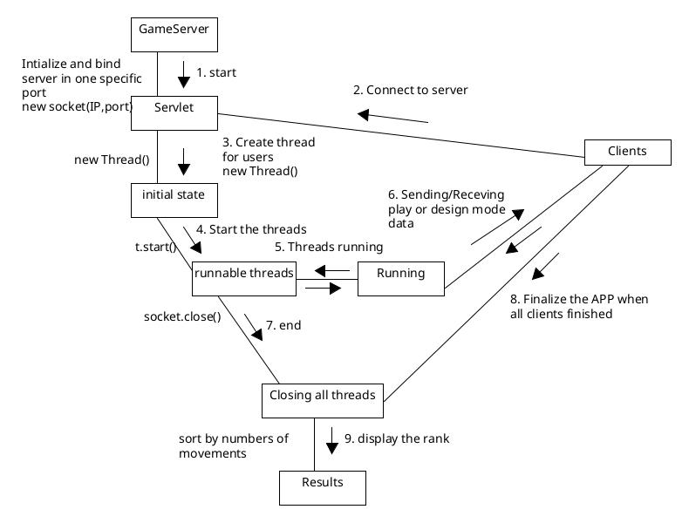

* 1. **Client Model (UML Collaboration Diagram)**

*Describe aspects of your client (interface and methods) considering the proposed idea.*

* + - ***Example****:*

**Collaboration Diagram** (Client)

[Draw / copy diagram here]

// Define all the actions between classes

// Include message paremeters

// Include return values

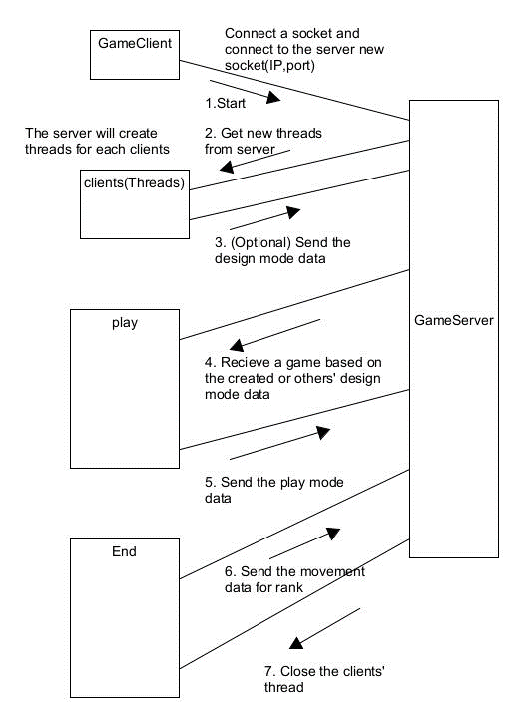

1. **Protocol Proposal**

*Finally, what is your idea to define the protocol to be used.*

**Example** (using the string definition mentioned in the A21 specification)

// Define all protocols to be used.

// Example:

▪ Protocol 0 (P0): When client is connecting with the server;

▪ Protocol 1 (P1): When client is sending a game configuration to server;

▪ Protocol 2 (P2): When server is replying P1.

▪ Protocol 3 (P3): When client is sending game data (user name, points and time) to the server.

Ex: P0 – Starting server, P1 – Starting client,

CONFIGURATION STRING:

® Example: 3,000022033300200010200100001000000000

® In this case:

3 is the dimension;

The remaining string is the game configuration that could be represented by:

000022

033300

200010

200100

001000

000000

PROTOCOL P1:

® protocolSeparator: hashtag (#)

® Format: <clientId><protocolSeparator><data>

® Example: 1#3,000022033300200010200100001000000000

**Our Proposal** (using the string definition mentioned in the A21 specification)

PROTOCOL P0:

® protocolSeparator: hashtag (#)

® Format: <clientId><protocolSeparator><protocol_id>

® Example: 1#0

PROTOCOL P1:

® protocolSeparator: hashtag (#)

® Format: <clientId><protocolSeparator><protocol_id><protocolSeparator><data>

® Example: 1#1#3,000022033300200010200100001000000000

PROTOCOL P2:

® protocolSeparator: hashtag (#)

® Format: <clientId><protocolSeparator><protocol_id><protocolSeparator><data>

® Example: 1#2#3,000022033300200010200100001000000000

PROTOCOL P3:

® protocolSeparator: hashtag (#)

® Format: <clientId><protocolSeparator><protocol_id><protocolSeparator><data>

® Example: 1#3#Player1,50,60,20

1. **Database Integration (Bonus)**
   * *Considering this proposal for 3-tier architecture using Databases, define:*
     + *What to persist.*

Answer: The data I would like to persist are:

Client ID,

User Name,

Design Mode Data,

Play Mode data,

Game time,

Game movements

* + - *What is the DB datatype to be used.*

Answer:

Client ID: INT

User Name: VARCHAR

Design Mode Data: TEXT

Play Mode Data: TEXT

Game Time: SMALLINT

Game Movements: SMALLINT

* + - *How frequently to update.*

Answer:

The data will be updated every second since the timer will keep change (increase) every second. The game data has to update every second to keep the data is real-time.

**References**

*[Include eventual references used here]*

Algonquin College

Summer, 2023