358HW1

Boyu Xu bxp6650

Mingyang Li mlr1159

1.

1. The serial algorithm performs two operations (one multiplication, one addition) every iteration per point on the matrix. Hence, the number of operations executed in the sequential algorithm is:
$$T_{s}=2n*m=2nm$$

2. If the accumulation of the processors using a tree-based combining can be optimally performed in log2(p) steps.

The expression for k is given by $k=n/p$, since p can exactly divide n. The runtime for the parallel algorithm for the parallel computation is:

$$T_{p}= \frac{2mn}{p}+mlog(p)$$

c.

Speed up : $S_{p}= \frac{T_{s}}{T_{p}}= \frac{p}{1+\frac{plog(p)}{2n}}$

$$α\left(n,p\right)= \frac{plog(p)}{\left(p-1\right)*2n}$$

d.

when $n →∞$, Amdahl’s fraction is closed to 0, so it is effective.

2.

b1. serial

1. running the program in serial mode on one processor:

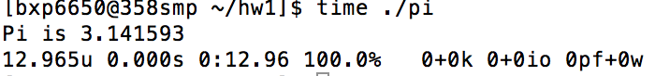

b2. explicit

Running the program in 1 processor:

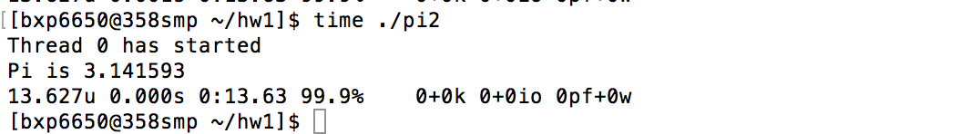

Running the program in 4 processors: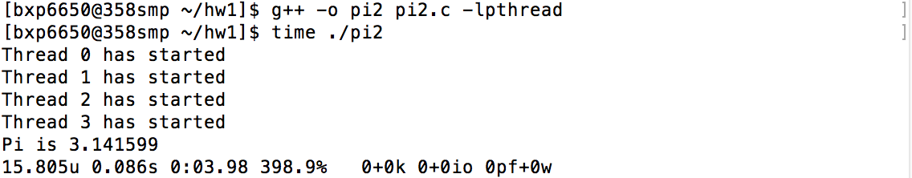

Running the program in 8 processors:

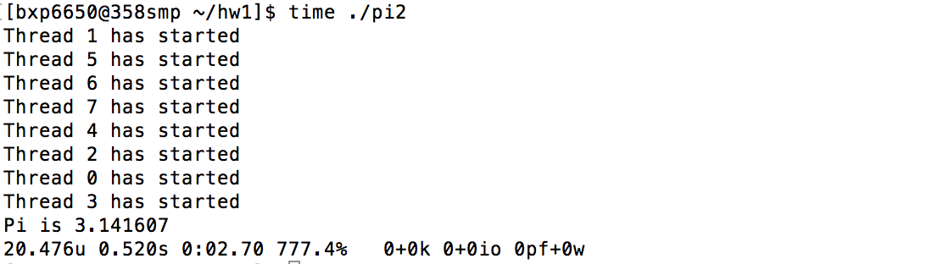

b3. implicit

static scheduling:

Running the program with 1 processor:

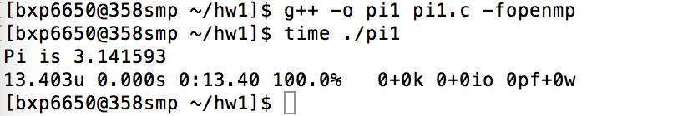

Running the program with 4 processors:

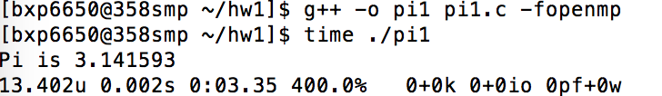

Running the program with 8 processors:

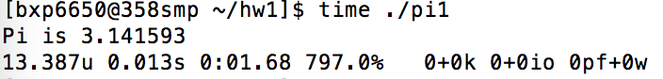

#pragma omp for schedule(static)

Dynamic scheduling:

Running the program with 1 processor:

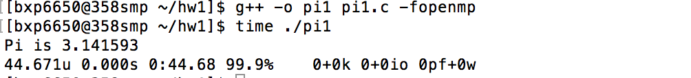

Running the program with 4 processors:



Running the program with 8 processors:

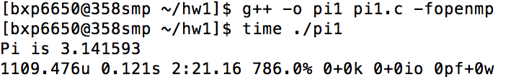

c.

Running the program with 1 processor:

/Users/apple/Library/Containers/com.tencent.qq/Data/Library/Application Support/QQ/Users/258883193/QQ/Temp.db/8C2FCFCF-99D5-4C9E-BAAF-E7BE5384FE57.png

Running the program with 4 processors:



Running the program with 8 processors:

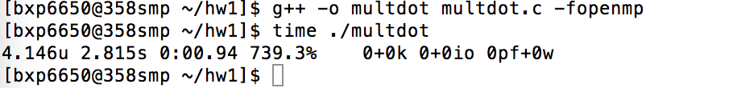

3.

Pthread:

1 processor:

Elapsed time = 481988 ms.

4 processors:

Elapsed time = 122453 ms.

8 processors:

Elapsed time = 115902 ms.

OpenMP:

1 processor:

Elapsed time = 504113 ms.

4 processors:

Elapsed time = 164280ms.

8 processors:

Elapsed time = 120055 ms.