**SuperService Project**

1. Appsettings.json = added the https_port key/value as per <https://learn.microsoft.com/en-us/aspnet/core/security/enforcing-ssl?view=aspnetcore-8.0&tabs=visual-studio%2Clinux-ubuntu#port-configuration>   
   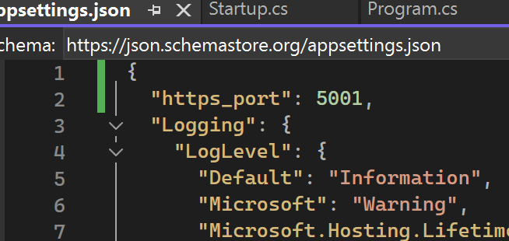
2. launchSettings.json = Added the Staging and Production in the Profiles. This is useful specially in Production wherein we want to handle caching, friendly error pages, diagnostic errors disabled and logging/monitoring enabling. Source - <https://learn.microsoft.com/en-us/aspnet/core/fundamentals/environments?view=aspnetcore-8.0#production>   
   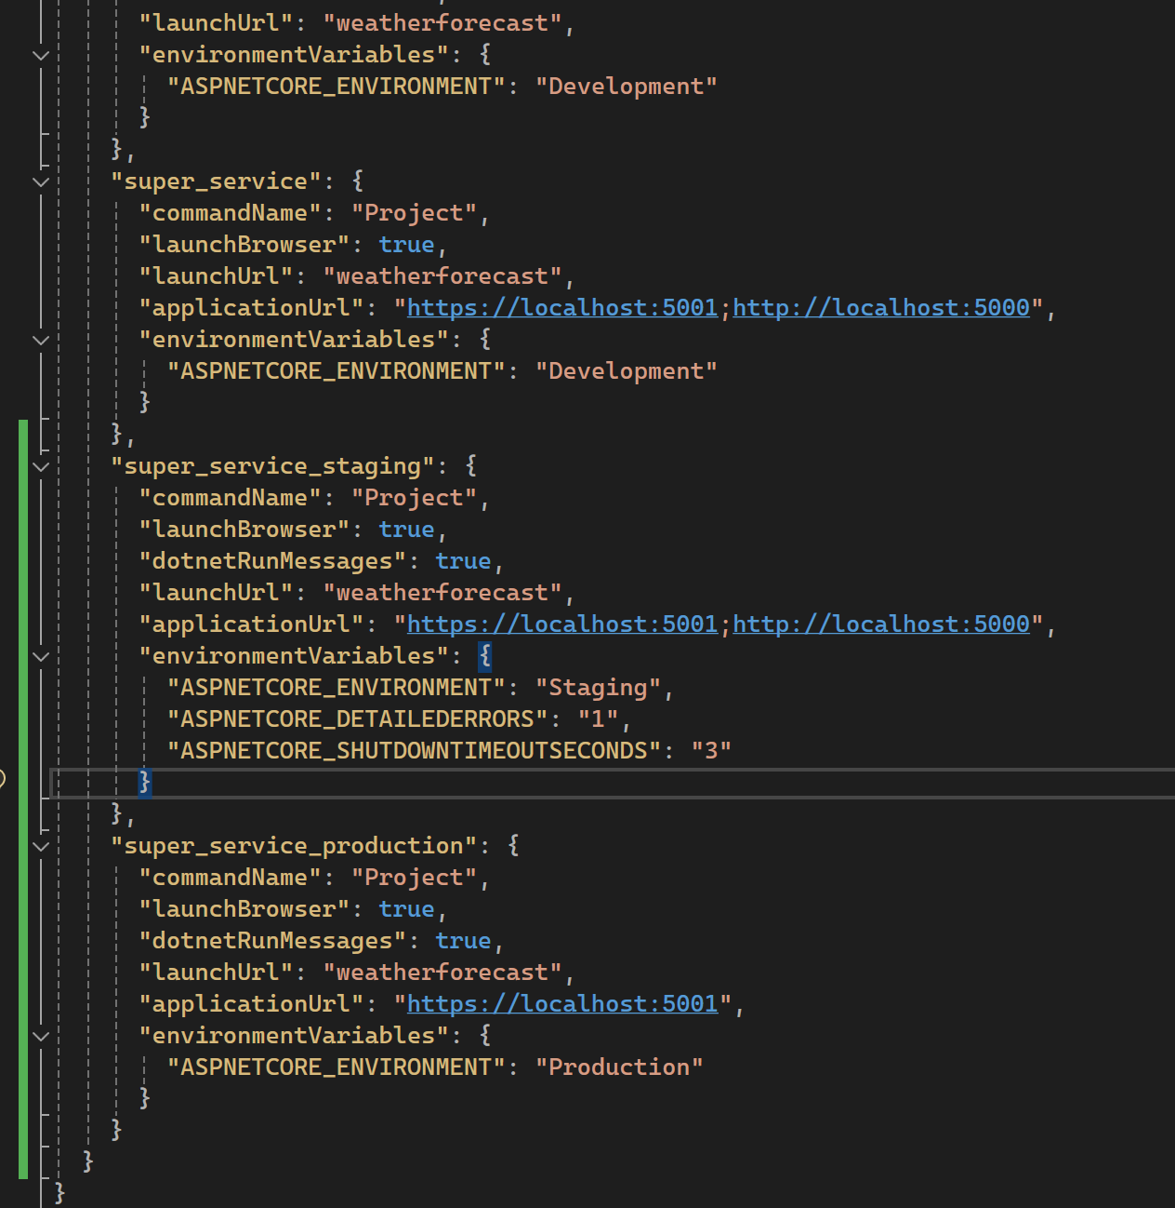  
     
   Then, we can set the ASPNETCORE_ENVIRONMENT variable upon running our containers to any target environment. i.e. in Production  
   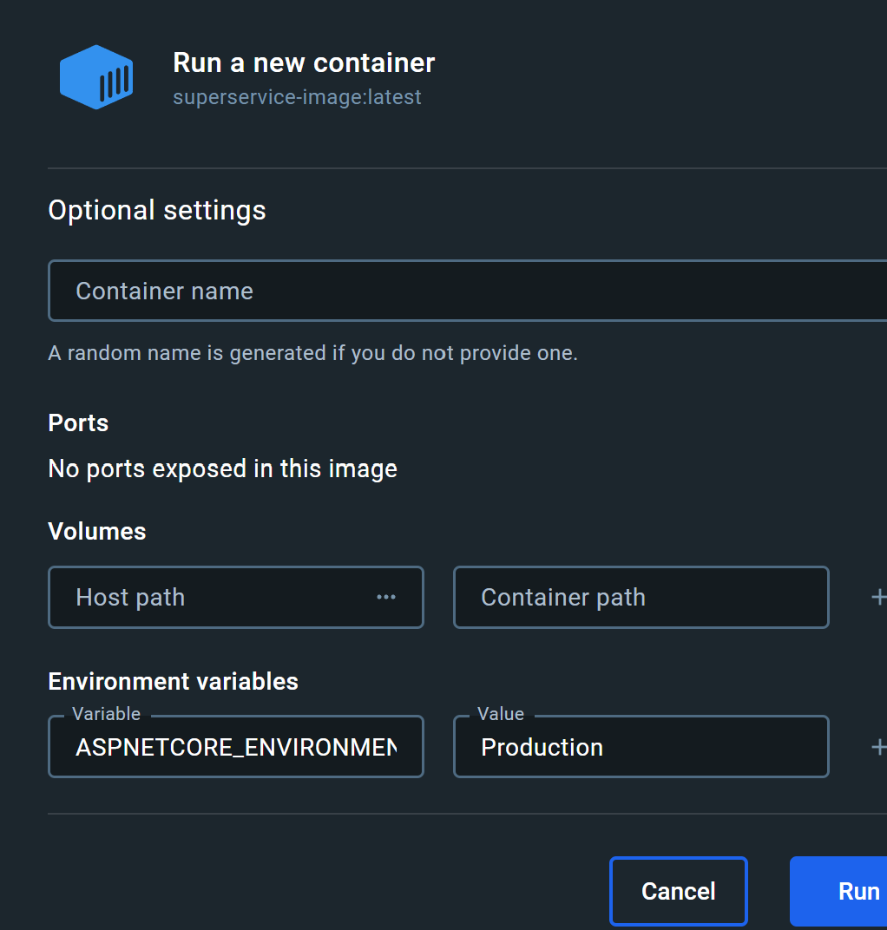

**SuperService.UnitTests Project**

1. Removed the second assert since it will always be false and bound to fail and upon debugging the variables time and now are equal.  
   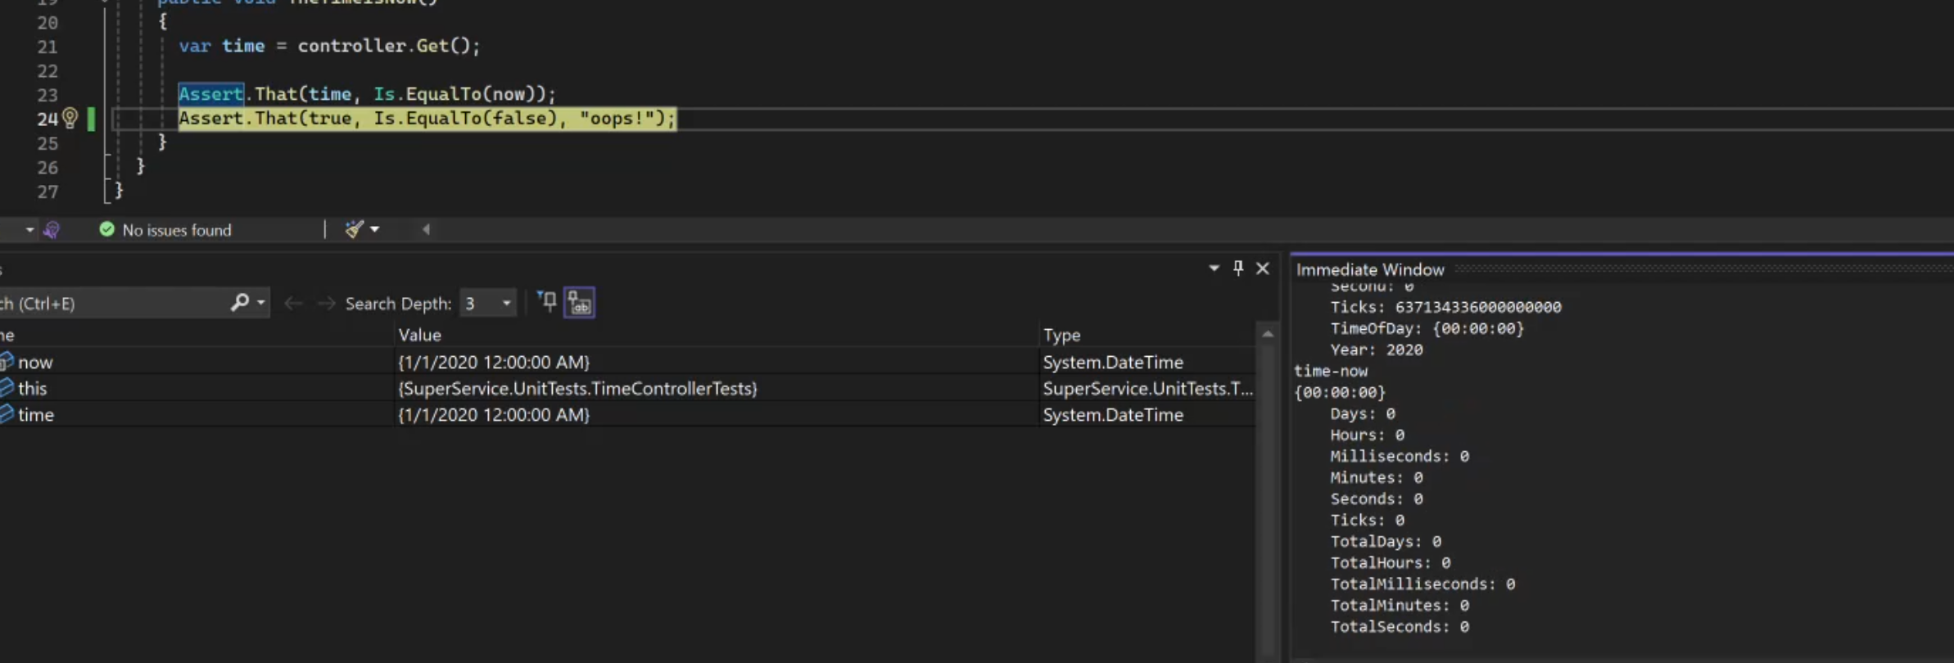

**Docker**

1. I deployed the docker image in my local docker container registry and the sample logs of the Deploy.ps1 can be found in \DevOps_interview_test\BozyFiles\Deploy.log  
   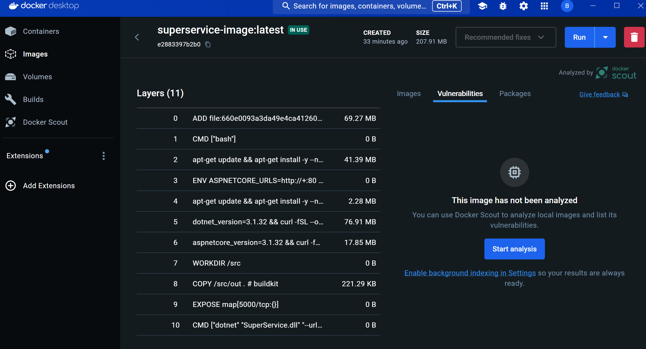

I was able to run a container locally using the newly created image.  
