Company Directory

# Database Structure:

This is a relational database and so you must follow the foreign keys to see the interdependency between the tables. If you examine the getAll.php file you will see that the relationship is retrieved by using LEFT JOIN:

**SELECT p.lastName,**

**p.firstName,**

**p.jobTitle,**

**p.email,**

**d.name as department,**

**l.name as location**

**FROM personnel p**

**LEFT JOIN department d ON (d.id = p.departmentID)**

**LEFT JOIN location l ON (l.id = d.locationID)**

**ORDER BY p.lastName, p.firstName, d.name, l.name**

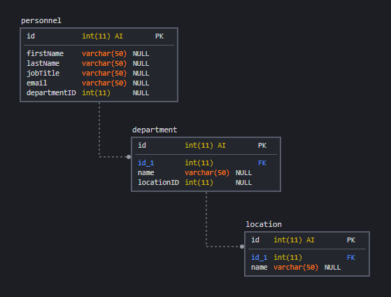

Do not alter the database structure and make sure that your application allows for the addition, update and deletion of entries in all tables.

Before any commit is made the user interface should ask for a confirmation and in cases where there are dependent entries in related tables warn the user that a deletion is not allowed (i.e. where a department has personnel assigned to it or where a location has departments assigned to it).