仓库地址：<https://github.com/Fredxingxing/HotsWeekReporter>

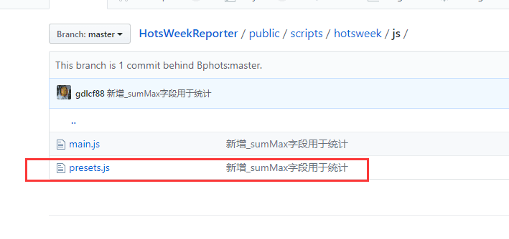

例子：<https://www.bphots.com/week/report/2531/11519>

打开网页输出的是

对应的是

1、周胜场例子：

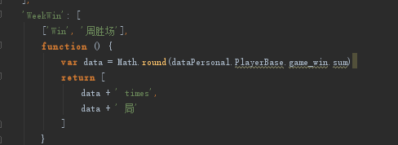

最后打印输出



2、使用最多的英雄例子：

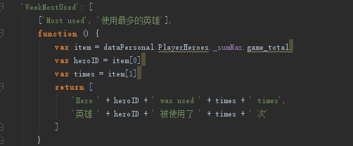

最后打印输出



PlayerBase是按日存的，比如你这周玩了五天，就是存五条数据，sum是五条数据的总和，avg是sum/5，min是五天里面最小的一天的数据，max则是最大。

如果要计算七天里面每一天平均是多少，则用sum/7，手动计算，想知道七天里面玩了多少天，则用任意一个sum/avg。

gameLength的avg是你本周玩的5天里面平均每天快速比赛玩了多久，如果要7天算平均每天玩了多久得自己/7

max和min分别代表本周有记录的5天里，快去比赛玩的最多的一天是多少时间，最少的一天是多少时间

同理sum就是本周内每天的数据加起来，avg就是有数据的5天平均每天的数量，max和min是最大一天和最小一天/嘲讽

**字段含义**

Playerenemies 和Playermates 里面的key值是英雄id号

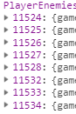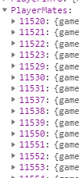

1. 0-0:"game_length":"总时长"
2. 0-1:"game_total":"总局数"
3. 0-2:"game_win":"总胜场"
4. 0-3:"game_length_QuickMatch":"快速匹配游戏时长"
5. 0-4:"game_length_HeroLeague":"英雄联赛游戏时长"
6. 0-5:"game_length_TeamLeague":"团队联赛游戏时长"
7. 0-6:"game_length_UnrankedDraft":"非排名游戏时长"
8. 0-7:"game_total_QuickMatch":"快速匹配总局数"
9. 0-8:"game_total_HeroLeague":"英雄联赛总局数"
10. 0-9:"game_total_TeamLeague":"团队联赛总局数"
11. 0-10:"game_total_UnrankedDraft":"非排名总局数"
12. 0-11:"game_win_QuickMatch":"快速匹配胜场"
13. 0-12:"game_win_HeroLeague":"英雄联赛胜场"
14. 0-13:"game_win_TeamLeague":"团队联赛胜场"
15. 0-14:"game_win_UnrankedDraft":"非排名胜场"
16. 1-0:"party_total":"开黑总次数"
17. 1-1:"party_win":"开黑总胜场"
18. 2-0:"team1_count":"在右手方的游戏次数"
19. 2-1:"Level":"等级分布"
20. 2-2:"Takedowns":"参与击杀数"（solokill+assists）
21. 2-3:"SoloKills":"游戏统计面板中的kill的值" (并非是没有其他人协助杀人的值
22. 2-4:"Assists":"助攻次数"
23. 2-5:"Deaths":"死亡次数"
24. 2-6:"HighestKillStreak":"最高连杀次数"
25. 2-7:"HeroDamage":"英雄伤害"
26. 2-8:"SiegeDamage":"攻城伤害"
27. 2-9:"StructureDamage":"建筑伤害"
28. 2-10:"MinionDamage":"小兵伤害"
29. 2-11:"CreepDamage":""
30. 2-12:"SummonDamage":"对召唤物的伤害"
31. 2-13:"TimeCCdEnemyHeroes":"控制敌方英雄时间"
32. 2-14:"Healing":"治疗量"
33. 2-15:"SelfHealing":"自我治疗量"
34. 2-16:"DamageTaken":"承受伤害"
35. 2-17:"DamageSoaked":""
36. 2-18:"ExperienceContribution":"经验贡献"
37. 2-19:"TownKills":"炮台击杀"
38. 2-20:"TimeSpentDead":"死亡时间"
39. 2-21:"MercCampCaptures":"雇佣兵占领次数"
40. 2-22:"WatchTowerCaptures":"瞭望塔占领次数"
41. 2-23:"MetaExperience":""
42. 2-24:"ProtectionGivenToAllies":""
43. 2-25:"TimeSilencingEnemyHeroes":"沉默敌人的时间"
44. 2-26:"TimeRootingEnemyHeroes":"定身敌人的时间"
45. 2-27:"TimeStunningEnemyHeroes":"眩晕敌人的时间"
46. 2-28:"ClutchHealsPerformed":"关键治疗次数"
47. 2-29:"EscapesPerformed":"死里逃生次数"
48. 2-30:"VengeancesPerformed":"复仇次数"
49. 2-31:"TeamfightEscapesPerformed":"团战逃脱的次数"
50. 2-32:"OutnumberedDeaths":"被gank的击杀次数"
51. 2-33:"TeamfightHealingDone":"团战中治疗量"
52. 2-34:"TeamfightDamageTaken":"团战中承受伤害"
53. 2-35:"TeamfightHeroDamage":"团战中英雄伤害"
54. 2-36:"EndOfMatchAwardGivenToNonwinner":""
55. 2-37:"OnFireTimeOnFire":""
56. 2-38:"TimeOnPoint":""
57. 2-39:"TeamWinsDiablo":"暗黑三英雄团战胜场"
58. 2-40:"TeamWinsFemale":"女性英雄团战胜场"
59. 2-41:"TeamWinsMale":"男性英雄团队胜场"
60. 2-42:"TeamWinsStarCraft":"星际英雄团队胜场"
61. 2-43:"TeamWinsWarcraft":"魔兽英雄团队胜场"
62. 2-44:"WinsWarrior":"前排胜场"
63. 2-45:"WinsAssassin":"刺杀胜场"
64. 2-46:"WinsSupport":"治疗胜场"
65. 2-47:"WinsSpecialist":"专业胜场"
66. 2-48:"WinsStarCraft":"星际英雄胜场"
67. 2-49:"WinsDiablo":"暗黑三英雄胜场"
68. 2-50:"WinsWarcraft":"魔兽英雄胜场"
69. 2-51:"WinsMale":"男性英雄胜场"
70. 2-52:"WinsFemale":"女性英雄胜场"
71. 2-53:"PlaysStarCraft":"星际英雄局数"
72. 2-54:"PlaysDiablo":"暗黑三英雄局数"
73. 2-55:"PlaysOverwatch":"守望先锋英雄局数"
74. 2-56:"PlaysWarCraft":"魔兽英雄局数"
75. 2-57:"PlaysWarrior":"前排局数"
76. 2-58:"PlaysAssassin":"刺杀局数"
77. 2-59:"PlaysSupport":"治疗局数"
78. 2-60:"PlaysSpecialist":"专业局数"
79. 2-61:"PlaysMale":"男性局数"
80. 2-62:"PlaysFemale":"女性局数"
81. 2-63:"DragonNumberOfDragonCaptures":"开启龙骑士次数"
82. 2-64:"DragonShrinesCaptured":"龙骑士祭坛占领次数"
83. 2-65:"GardensSeedsCollected":"花园种子收集"
84. 2-66:"GardensPl**antDamag**e":"恐魔伤害"
85. 2-67:"AltarDamageDone":"天空殿祭坛造成伤害"
86. 2-68:"DamageDoneToImmortal":"对不朽者的伤害"
87. 2-69:"DamageDoneToShrineMinions":"对炼狱祭坛小兵伤害"
88. 2-70:"GemsTurnedIn":"宝石上交"
89. 2-71:"RavenTributesCollected":"乌鸦诅咒收集"
90. 2-72:"CurseDamageDone":"诅咒伤害"
91. 2-73:"MinesSkullsCollected":"鬼灵矿收集"
92. 2-74:"BlackheartDoubloonsCollected":"达布隆币收集"
93. 2-75:"BlackheartDoubloonsTurnedIn":"达布隆币上交"
94. 2-76:"TimeInTemple":"占领祭坛时间"
95. 2-77:"DamageDoneToZerg":"虫群杀手"
96. 2-78:"NukeDamageDone":"核弹头伤害"
97. 2-79:"TimeOnPayload":"花村推车时间"
98. 2-80:"party_total_2":"两人开黑总次数"
99. 2-81:"party_win_2":"两人开黑总胜场"
100. 2-82:"party_total_3":"三人开黑总次数"
101. 2-83:"party_win_3":"三人开黑总胜场"
102. 2-84:"party_total_4":"四人开黑总次数"
103. 2-85:"party_win_4":"四人开黑总胜场"
104. 2-86:"party_total_5":"五人开黑总次数"
105. 2-87:"party_win_5":"五人开黑总胜场"
106. 3-0:"maps_length":"地图总时长"
107. 3-1:"maps_total":"地图总次数"
108. 3-2:"maps_win":"地图获胜"
109. 4-0:"Level_count":"游戏结束时达到相应等级的计数"
110. 4-1:"Takedowns_count":""
111. 4-2:"SoloKills_count":"游戏统计面板中的kill的值" (并非是没有其他人协助杀人的值
112. 4-3:"Assists_count":"助攻次数的计数"
113. 4-4:"Deaths_count":"死亡次数的计数"
114. 4-5:"HighestKillStreak_count":"最高连杀英雄次数"
115. 4-6:"MatchAwards":""
116. 5-0:"last_game_time":"上一局游戏时间节点"

**地图代码对照名称**

https://www.bphots.com/bp_helper/get/maplist/v2

接口中的数据：

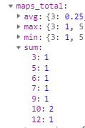

对应的地图名称

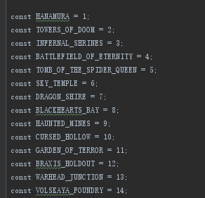

**英雄代码对照名称**

PlayerHeroes的key 对应的英雄名：https://www.bphots.com/bp_helper/get/herolist?lang=zh-CN

