# Key Bindings / Shortcuts Quick Reference

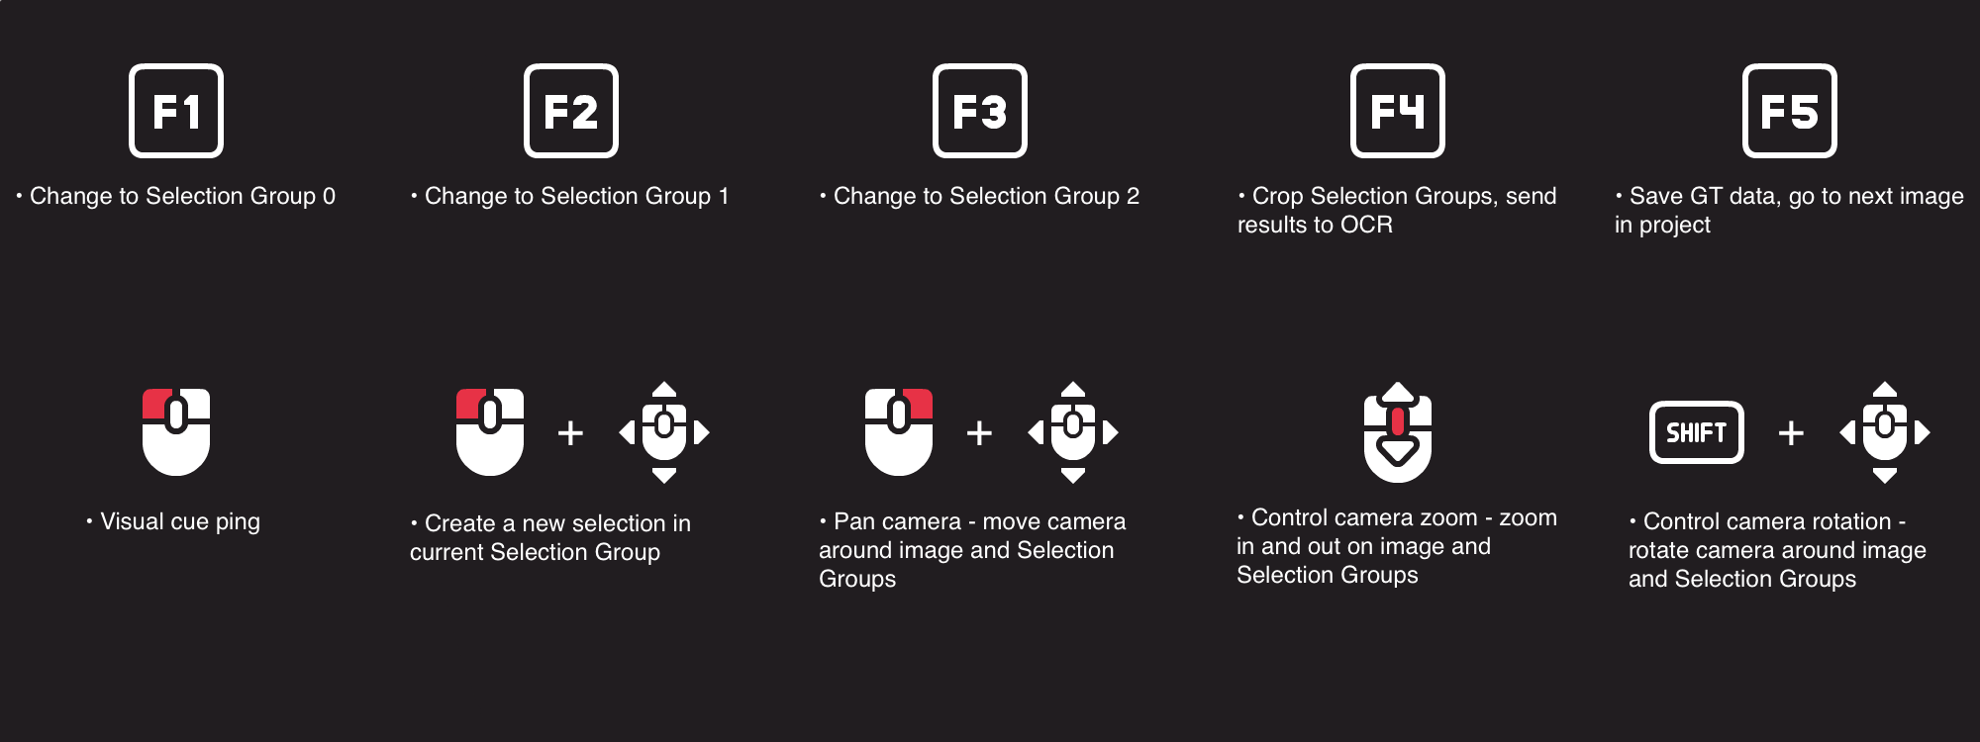

# GroundTruth 2 User Guide

## Introduction

Welcome to the GroundTruth 2 help document!

GroundTruth 2 is a custom WebGL-based application featuring an adaptable editor and time-saving shortcuts that simplify ground-truthing and tagging of image sets for Argosy Post improvements. By shifting from manual data entry to a streamlined review and approval process, it boosts the ground-truthing workflow by more than 70% per piece.

## Getting Started

On Desktop open any web browser and go to <insert final url here>. Window size currently must be greater than 450 x 550 and recommended resolution is 1280 x 720 or greater (720p).

If you need to create an account, please email support@raf.com or billy.miller@raf.com.

## Logging In

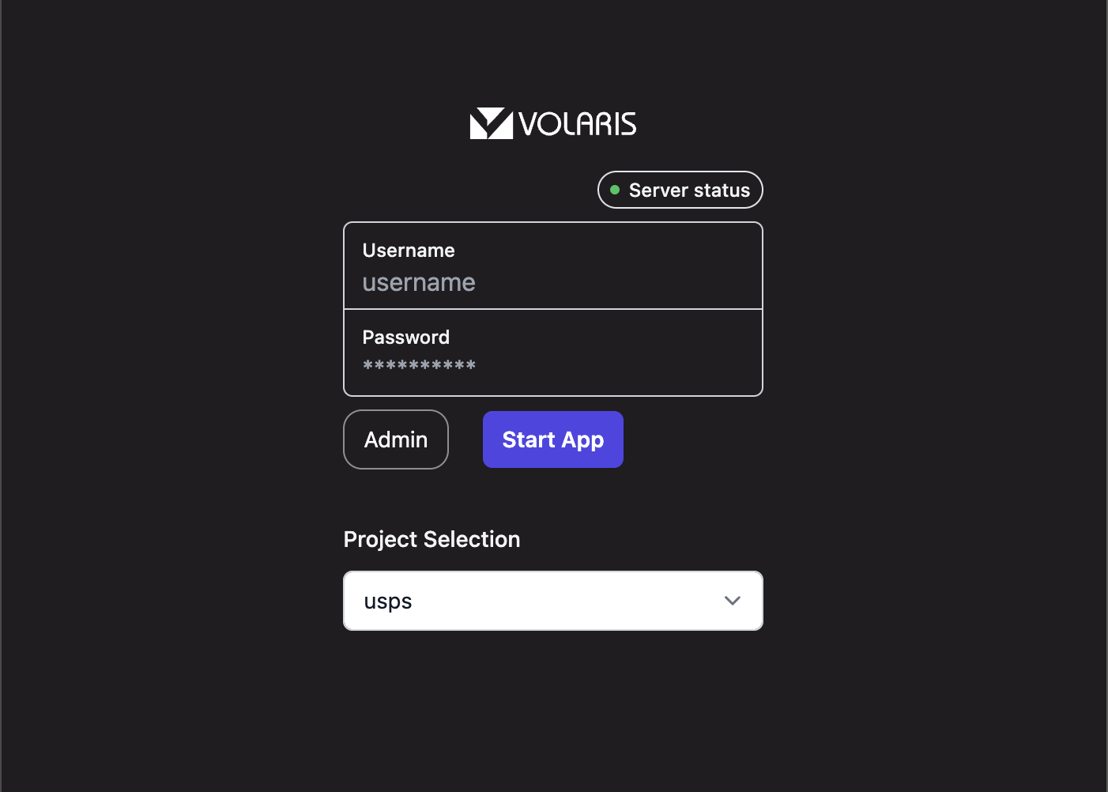

Check the server status in the top-right corner. If the server is unavailable, you won’t be able to start the editor.

If the server is available, enter your credentials, select the project you want to work on, and click Start App.

Note: By default, once you sign in on a browser, all subsequent visits automatically log you into the most recently used account and project. To log out or switch projects, click the Log Out button (exit arrow icon) in the top-left corner of the editor.

## GroundTruthing Instructions

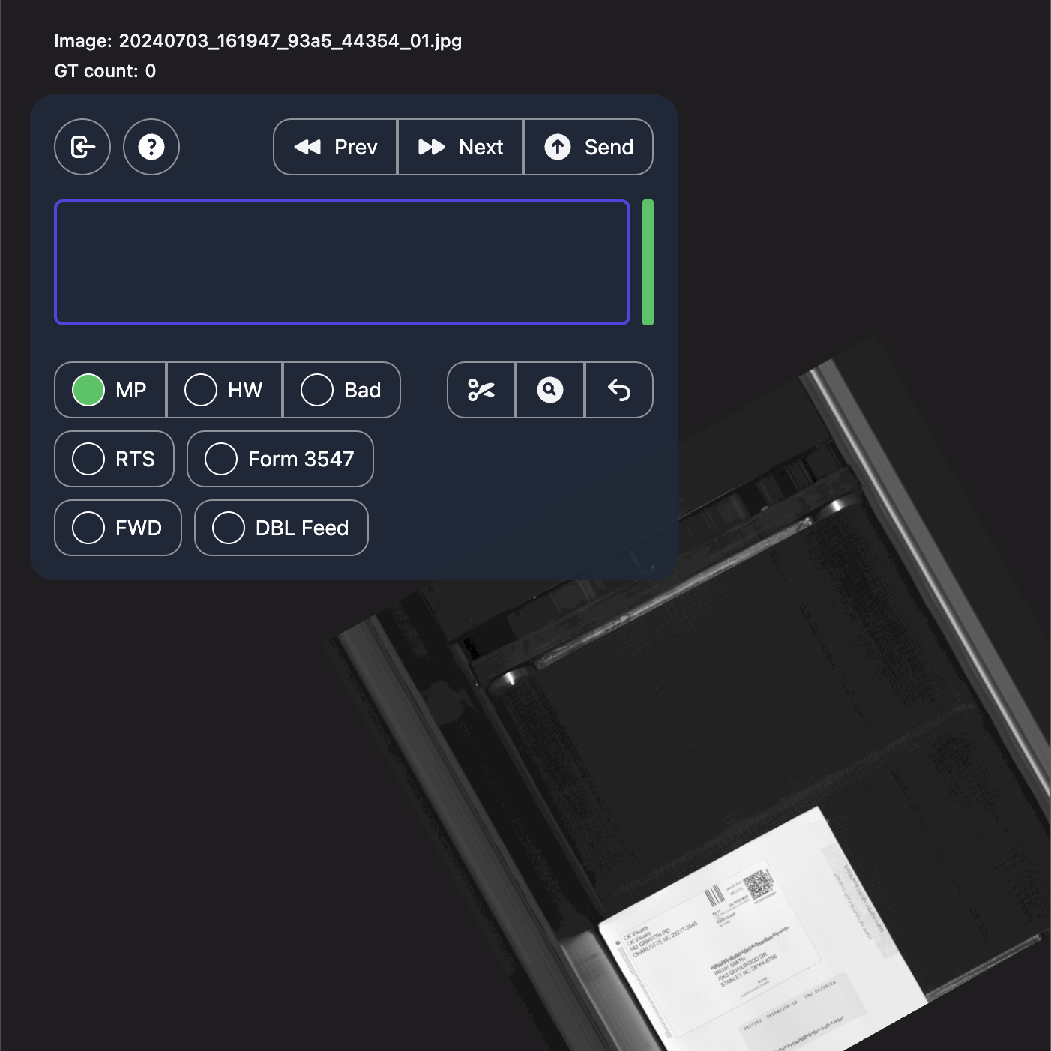

## Recommended Workflow

1. **Position the Image**

Rotate and pan the image until it’s properly aligned.

2. **Create Selection Groups**

• Use the image selection tools to click and drag as many selection groups as needed to capture the data relevant to each group or project.

3. **Process Groups**

• When you’ve defined all necessary groups, click the Process groups button (scissors icon). This action crops and aligns each group for OCR processing.

4. **Review or Reset**

• If you’re satisfied with the selections, move on to the next step.

• If not, click **Reset groups** (return arrow icon) to clear them and start over.

5. **Process Render**

• If you haven’t reset, click **Process render** (magnifying glass icon). The system will capture a screenshot for OCR, validate the recognized text, and automatically place it in the corresponding selection groups.

• You can click **Reset groups** at any time if you want to start over.

6. **Manual Review and Correction**

• Although OCR is automated, it isn’t perfect. Always review the extracted text.

• If the OCR results are incorrect, manually enter the correct data into the relevant selection groups.

7. **Add Metadata (Optional)**

• Select additional metadata tags as needed for the project.

8. **Send and Proceed**

• Click **Send** to upload your ground-truth data to the server and save your work.

• Finally, click **Next** to load the next image in the project deck.

## Traditional Workflow

1. **Manual Review and Correction**

• Manually enter the correct data into the relevant selection groups.

2. **Add Metadata (Optional)**

• Select additional metadata tags as needed for the project.

3. **Send and Proceed**

• Click **Send** to upload your ground-truth data to the server and save your work.

• Finally, click **Next** to load the next image in the project deck.

## Troubleshooting and FAQ

1. I forgot username or password

Solution: email [support@raf.com](mailto:support@raf.com) or [billy.miller@raf.com](mailto:billy.miller@raf.com)

1. Can I use the app offline

Solution: no. The application retrieves new images from the ground-truth project deck and sends GT data back to the server. While the editor can function during brief connection losses, you must be online to submit results or load new images.

1. Is my data secure

All data is fully encrypted on the server, in the database, and when sent from the Server to the Client. Access to information or images from the GroundTruth2 server requires both an authorized account and the corresponding URL and no other resources on the same network are accessible. Only the cropped image snippets within Selection Groups are sent to the OCR engine and they are never stored—either during or after processing. The only data returned is the GT information, which is securely transmitted back to the RAF server.