Java oops
//Task 1 : Getter and Constructor creation of the class "Person"
//==============================================================

package task11;

//Create a class "Person" with attributes "Name and Age"
public class Person {
private String name;
private int age;

// Default constructor
public Person() {

}

// Create a Constructor with attributes Name and Age

public Person(String name, int age) {
this.name = name;
this.age = age;
}

// Create a getter for Name attribute

public String getName() {
return name;
}

// Create a getter for Age attribute
public int getAge() {
return age;
}

//Main Method

public static void main(String[] args) {

// Create an Object for the Class Person
Person objPerson1=new Person("Diviya",30);
Person objPerson2=new Person("Diviya",30);

//Print the Values
System.out.println("First Person \n===============");
System.out.println("Name :"+ objPerson1.name);
System.out.println("Age :"+ objPerson1.age);

//System.out.println("--------------------\n");
System.out.println("\n\nSecond Person\n================");
System.out.println("Name :"+ objPerson2.name);
System.out.println("Age :"+ objPerson2.age);

}

}

Output:
First Person
===============
Name :Diviya
Age :30

Second Person
================
Name :Diviya
Age :30

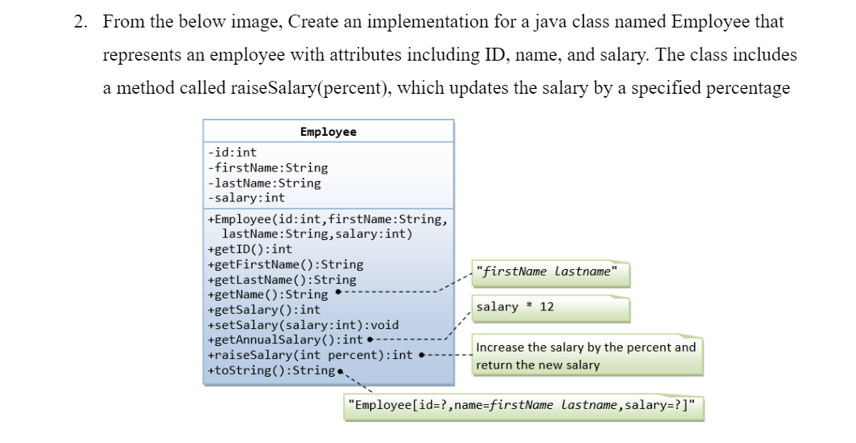

//Task 2: Salary calculation of the employee based on bonus
//=========================================================

package task11;

//Create a class Employee with the attributes - id, First name, Last name, Salary
public class Employee {

private int id;
private String firstName;
private String lastName;
private int salary;

// Constructor
public Employee() {
super();
}

//Create a Constructor with all attributes

public Employee(int id, String firstName, String lastName, int salary) {
this.id = id;
this.firstName = firstName;
this.lastName = lastName;
this.salary = salary;
}

// Create getters for all attributes

public int getId() {
return id;
}

public String getFirstName() {
return firstName;
}

public String getLastName() {
return lastName;
}

public int getSalary() {
return salary;
}

//Method to return full name
public String getName() {
return firstName+lastName;
}

// Set salary
public void setSalary(int salary) {
this.salary = salary;
}

//Method to get Annual salary
public int getAnnualSalary() {
int annualSalary = salary*12;
return annualSalary;
}

//Method to get a new salary after increment
public int getRaiseSalary(int percentage) {
salary=salary+salary*percentage/100;
return salary;
}

//Main method
public static void main(String[] args) {

//Create an object for the class Employee
Employee employee=new Employee(101,"Priya","Bala",10000);

//Print the employee details
System.out.println("Employee Details:\n================");
System.out.println("ID :" + employee.getId());
System.out.println("First Name :"+employee.getFirstName());
System.out.println("Last Name :"+employee.getLastName());
System.out.println("Monthly Salary :"+employee.getSalary());
System.out.print("\nAnnual Salary of the employee "+employee.getName()+" is "+employee.getAnnualSalary());

// Salary calculation based on bonus
int increasedSalary=employee.getRaiseSalary(5);
employee.setSalary(increasedSalary);

//Print the employee details after getting Bonus
System.out.println("\n\nEmployee Details after Bonus:\n===========================");
System.out.println("ID :" + employee.getId());
System.out.println("First Name :"+employee.getFirstName());
System.out.println("Last Name :"+employee.getLastName());
System.out.println("Monthly Salary :"+employee.getSalary());
System.out.print("\n \nAnnual Salary of the employee after getting Bonus "+employee.getName()+" is "+employee.getAnnualSalary());

}

}

Output :
Employee Details:
================
ID :101
First Name :Priya
Last Name :Bala
Monthly Salary :10000

Annual Salary of the employee PriyaBala is 120000

Employee Details after Bonus:
===========================
ID :101
First Name :Priya
Last Name :Bala
Monthly Salary :10500

Annual Salary of the employee after getting Bonus PriyaBala is 126000

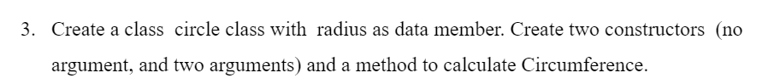
//Task 3: calculate circumference of the circle
//=============================================
package task11;

// Create Class Circle with the attribute radius
public class Circle {

private double radius;
private double pi;

// Create default constructor
public Circle() {

}

// Create constructor with attribute radius

public Circle(double radius, double pi) {
this.radius = radius;
this.pi=pi;
}

// Circumference calculation
public double circleCircumference() {
double cicumference = 2 * pi *radius;
return cicumference;
}

//Getter method
public double getRadius() {
return radius;
}

// Main method
public static void main(String[] args) {

// Create Object
Circle objCircle1 = new Circle(5,Math.PI);
Circle objCircle2 = new Circle(10,Math.PI);

// Print the circumfernce
System.out.println("First Circle \n==============\n");
System.out.print("Radius :"+objCircle1.getRadius());
System.out.printf("\nCircumference of the first circle is %.2f", objCircle1.circleCircumference());

System.out.println("\n\nSecond Circle \n==============\n");
System.out.print("Radius :"+objCircle2.getRadius());
System.out.printf("\nCircumference of the second circle is %.2f", objCircle2.circleCircumference());
}
}

Output:
First Circle
==============

Radius :5.0
Circumference of the first circle is 31.42

Second Circle
==============

Radius :10.0
Circumference of the second circle is 62.83

//Task4: Calculate deposit and withdraw balance of the Account
//============================================================
package task11;

//Create Account class with the attribute balance and name
public class Account {
private String name;
private double balance;

//Main method
public static void main(String[] args) {

// Object creation
Account objAccount = new Account("Priya",10000);

// Print the balance after deposit
System.out.println("Account Deatils \n =====================\n");
System.out.println("Name : "+ objAccount.name);
System.out.println("Current Balance Amount :" + objAccount.balance);
System.out.println("Current Balance Amount after deposit :" +objAccount.depositMoney(1000));

// Print the balance after withdraw
System.out.println("Current Balance Amount after Withdrawal :" +objAccount.withdrawMoney(2000));
}

// Create default constructor

public Account() {

}

// Create constructor with the attributes name and balance

public Account(String name, double balance) {

this.name = name;
this.balance = balance;
}

// Deposit Amount calculation

public double depositMoney(double deposit) {
balance = balance + deposit;
return balance;
}

//Withdraw Amount Calculation
public double withdrawMoney(double withdrawAmount) {
balance = balance - withdrawAmount;
return balance;
}
}

Output:
Account Details
=====================

Name : Priya
Current Balance Amount :10000.0
Current Balance Amount after deposit :11000.0
Current Balance Amount after Withdrawal :9000.0

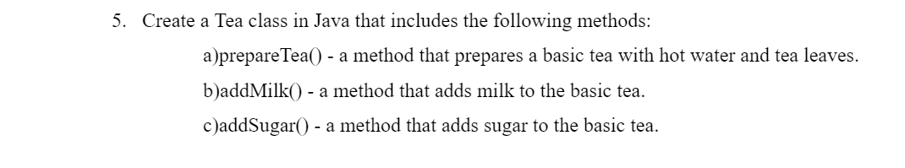
// Task 5: Prepare Normal Tea
package task11;

//Create a Main class with name "Tee" with attributes teaLeaves,hotWater and time.
public class Tee {

private double teaLeaves;
private double hotWater;

//Constructor
public Tee() {

}

public Tee(double teaLeaves, double hotWater) {
this.teaLeaves = teaLeaves;
this.hotWater = hotWater;
}

public Tee( double hotWater) {
this.hotWater = hotWater;
}

// Method to prepare normal tea.
public void prepareTea() {
System.out.println("Milk Tea Preparation : \n======================");
System.out.println("Add hotwater and Tea leaves in brewing time");
addMilk();
addSugar();
}

// Method to add Milk
public void addMilk() {
System.out.println("Add Milk");
}

// Method to add Sugar
public void addSugar() {
System.out.println("Add Sugar");
}
}

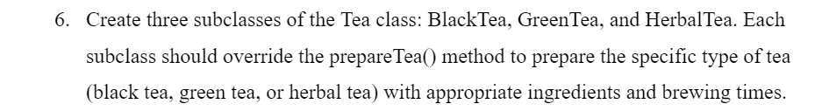
//Prepare Herbal Tea
package task11;

//Create SubClass - HerbalTea of class Tee
public class HerbalTea extends Tee{
private String herbName;
private double brewingTime;

//Constructor
public HerbalTea() {
super();
}

public HerbalTea(double teaLeaves, double hotWater,String herbName, double brewingTime) {
super(teaLeaves, hotWater);
this.herbName = herbName;
this.brewingTime = brewingTime;
}

//Herbal tee Preparation
@Override
public void prepareTea() {
System.out.println("Herbal Tea Preparation : \n======================");
System.out.println("Add hotwater and Herbs in brewing time");
}
}

//Prepare Green Tea
package task11;

//Create SubClass - GreenTea of class Tee
public class GreenTea extends Tee {
private double brewingTime;
private String greenTeaLeaves;

//Constructor

public GreenTea() {
super();
}

public GreenTea(double hotwater,double brewingTime, String greenTeaLeaves) {
super(hotwater);
this.brewingTime = brewingTime;
this.greenTeaLeaves = greenTeaLeaves;
}

//Prepare Green Tea
@Override
public void prepareTea() {
System.out.println("Green Tea Preparation : \n======================");
System.out.println("Add hotwater and greenTeaLeaves in brewing time");
}

}

//Prepare Black Tea
package task11;

//Create SubClass - BlackTea of class Tee
public class BlackTea extends Tee {
private double brewingTime;

//Constructor
public BlackTea() {
super();
}

public BlackTea(double teaLeaves,double hotwater,double brewingTime, String greenTeaLeaves) {
super(teaLeaves,hotwater);
this.brewingTime = brewingTime;
}

//Prepare Black tea
@Override
public void prepareTea() {
System.out.println("Black Tea Preparation : \n======================");
System.out.println("Add hotwater and teaLeaves in brewing time");
}

}

//Creating an array of Tee Objects
package task11;

//Create a class that has Main method
public class MainTee {

//Main Method

public static void main(String [] args) {

//Create an array of Tee objects
Tee[] tee= {new HerbalTea(),new GreenTea(), new BlackTea(),new Tee()};

System.out.println("Different Tea preparation \n==========================");
for(Tee i : tee ) {
System.out.println();
i.prepareTea();
}
}
}

Output:
Different Tea preparation
==========================

Herbal Tea Preparation :
======================
Add hotwater and Herbs in brewing time

Green Tea Preparation :
======================
Add hotwater and greenTeaLeaves in brewing time

Black Tea Preparation :
======================
Add hotwater and TeaLeaves in brewing time

Milk Tea Preparation :
======================
Add hotwater and Tea leaves in brewing time
Add Milk
Add Sugar

