Git & GitHub
- Create a new repository in GitHub.
Created a ZenClassTask repository in Github.
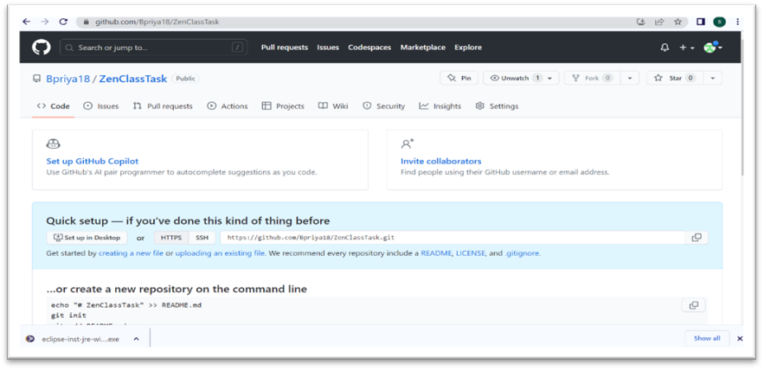

- Use the init command to create a Git repository.
- Observe that there is now .git directory
Created a local git repository by using “git init “ command
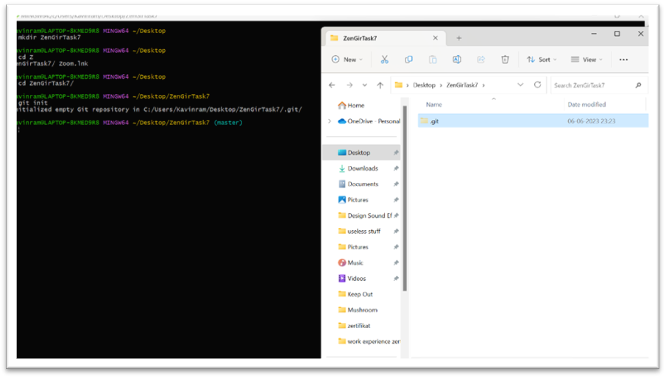

- Create a README.txt file
README text file is created by using touch command.
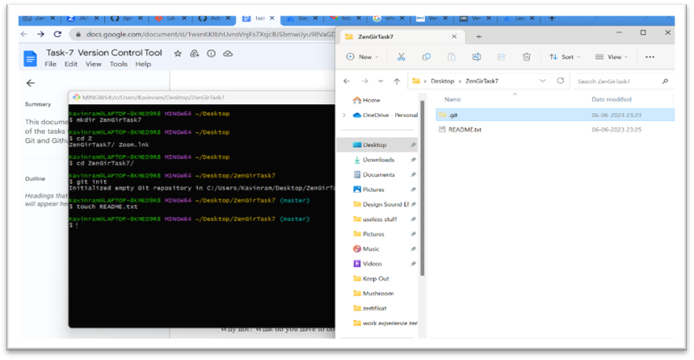
- Look at the output of status command; the README that created should appear as an untracked file.
README.txt file is appear as an untracked file as it is unstaging area.
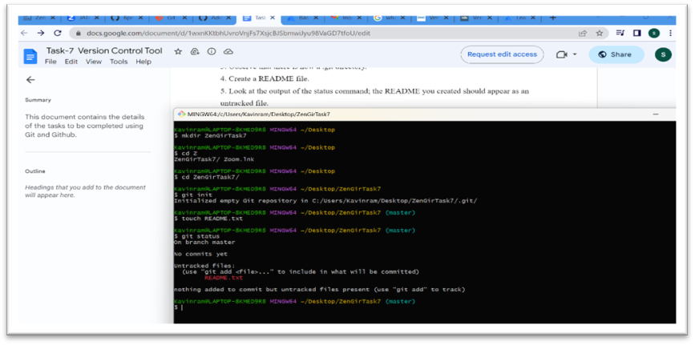
- Use add command to add the new file to the staging area. The output of the Status command.
The git add command adds a change in the working directory to the staging area.

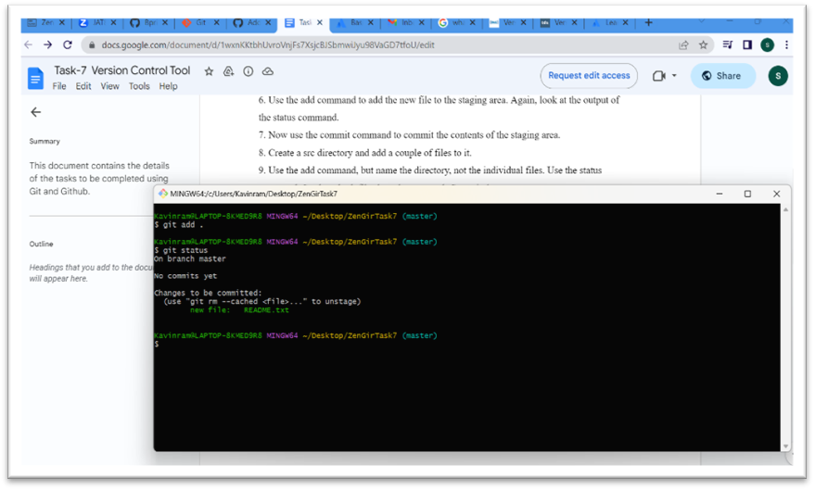

- Now use the commit command to commit the contents of the staging area.
Git assigns each commit a unique ID, called a SHA or hash, that identifies:
- The specific changes
- When the changes were made
- Who created the changes
When you make a commit, -m in the commit message briefly describes the changes.

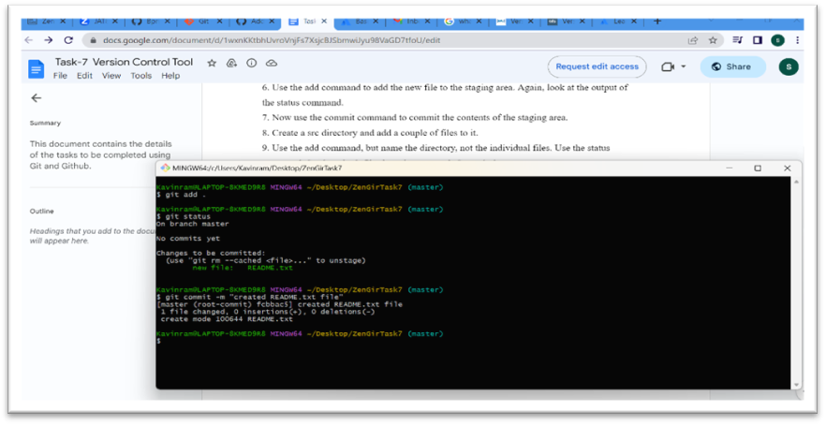

- Create a src directory and add a couple of files to it.
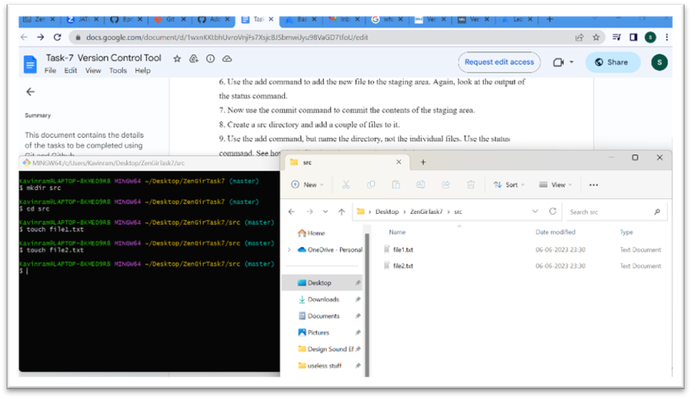

- Use the add command to add the src directory. Use the status command. See how both files have been staged. Commit them.
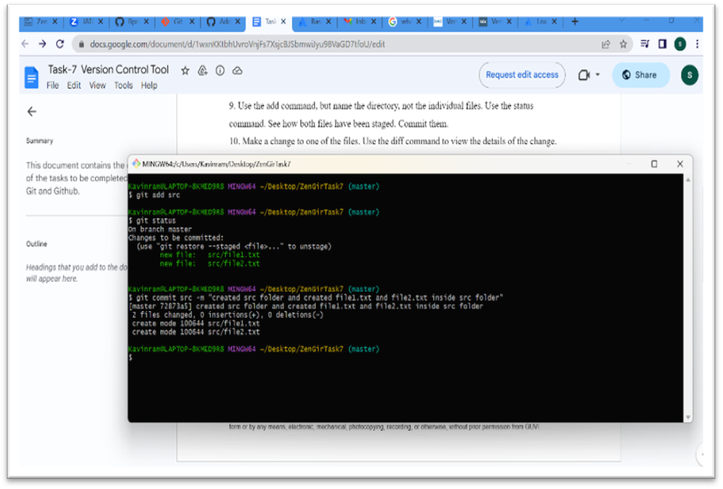

- Make a change to one of the files. Use the diff command to view the details of the change.
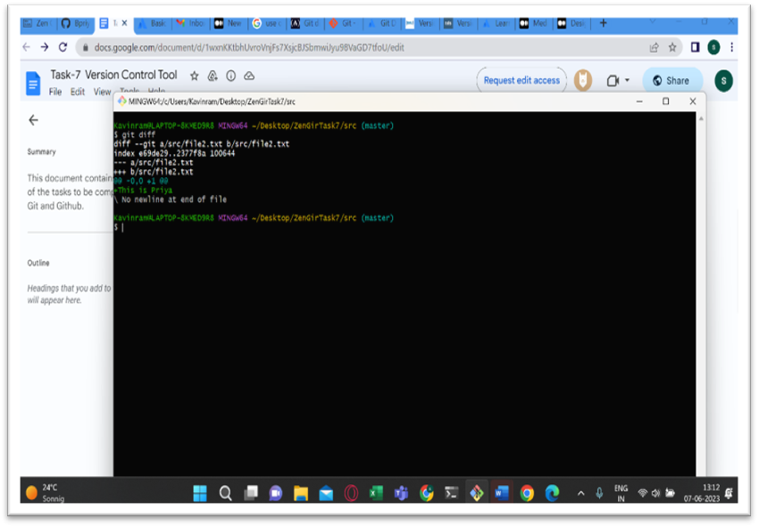
- Next, add the changed file, and notice how it moves to the staging area in the status output. Also observe that the diff command you did before using add now gives no output. Why not? What do you have to do to see a difference in the staging area?
Diff command is used to track the difference between the changes made on a file. Once the file “file2.txt” which had been changed here is moved to the staging area, then the command gives no output.
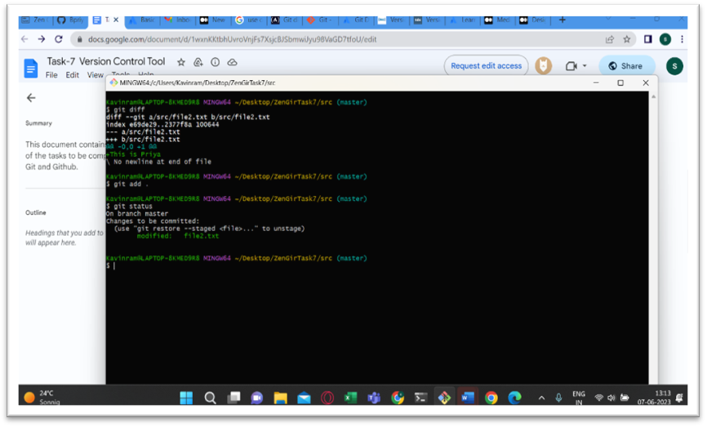
- Without committing make another change to the same file you changed in step 10. Look at the status output and diff output. Notice how you can have both staged and unstaged changes, even when you are talking about the single file. Observe the difference when you use the add command to stage the latest round of changes. Finally, commit them. You should now have started to get a feel for the staging area.
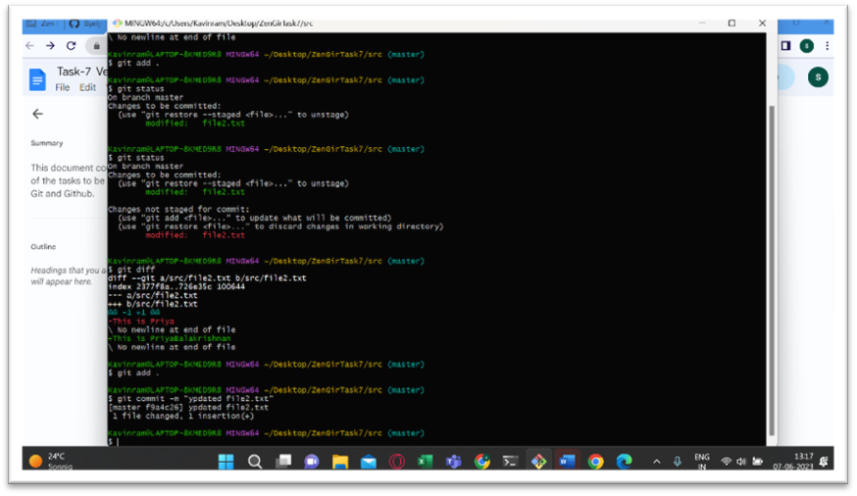
- Use the log command to see all the commits you made so far.
It displays all the commits being made in that repository in multiple lines along with the commit id, author name, date and commit message.
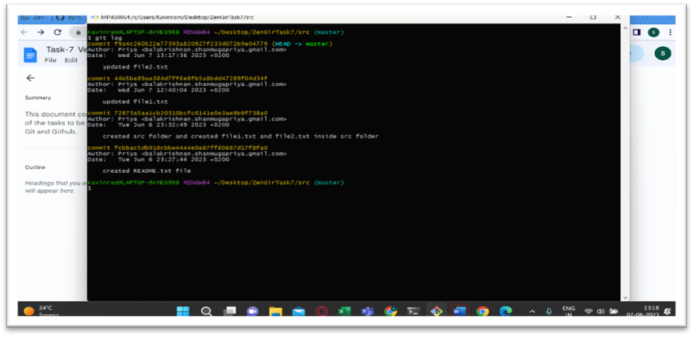
- Use the show command to look at an individual commit. How many characters of the commit identifier can you get away with typing at a minimum?
The git-show is used to see the detailed information of the latest commit, including the commit id and commit message.
A commit in git always has a hash that contains 40 characters. The git client will use varia ble length (default: 7) while GitLab seems to always use 8 characters.

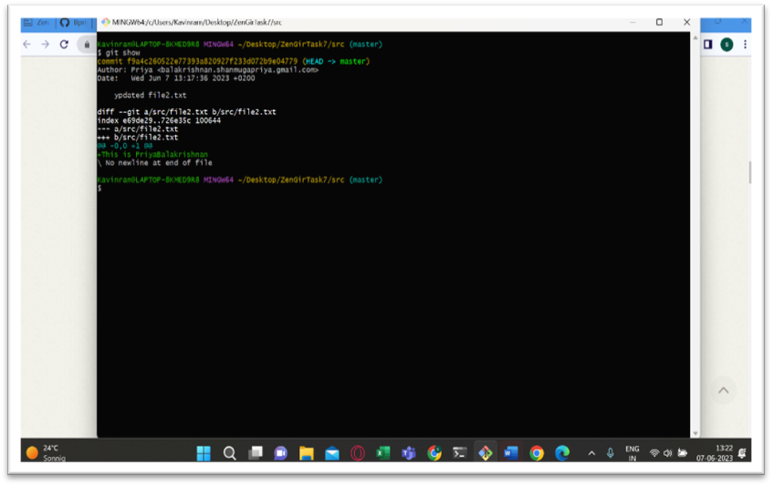
- Make a couple of commits, at least one of which should add an extra file.
