Week 4

## Preprocessing

We already had create a utility class that allowed us to find the top, independent and pendent vertices. We used this class to preprocess a graph. We did this by modifying the graph itself. So we updated our graph to add the functionality to remove and add vertices.

This is how we implement the preprocessing:

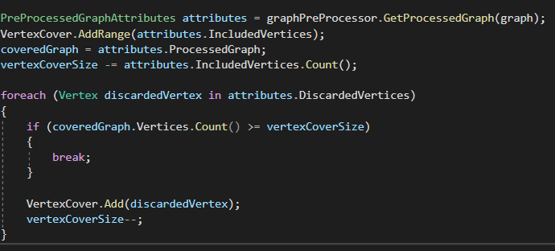

Because we want to have k vertices. We also need to add back certain points otherwise we could never have a full vertex cover. Which has all vertices. We do this by adding vertices until the vertex cover is possible.

We then use the same vertex cover algorithm as before. There is one improvement. We could still look for top vertices each step. This would increase the speed of the algorithm even more.

# Testing



 