Names: Harolt Farinango, Mateo Pilaquinga

DESIGN AND IMPLEMENTATION OF A DATABASE FOR A CAR INSURANCE BUSINESS

Objectives
Understand the complete database design cycle, from conceptualization to implementation, applied to the context of an insurance agency.
Apply theoretical database knowledge in practical scenarios, managing customers, policies, claims, and payments.

Gain practical experience in the design, implementation, and administration of a relational database system for a real insurance business.

Develop critical thinking and problem-solving skills when addressing complex relationships, constraints, and reporting needs inherent in insurance operations.

Description
This project consists of the design and implementation of a relational database for an auto insurance company. The system manages customers, vehicles, policies, coverage, premium payments, claims, and claim payments. The database ensures referential integrity and allows for queries essential to business operations, such as policy status, pending payments, and claims history.

- Requirments

Functional Requirements:

-Management of customers, vehicles, agents, and coverage.
-Creation and modification of policies linked to customers, vehicles, and agents.
-Recording of premium payments and claims.
-Queries on outstanding balances and totals paid per claim or policy.
-Change of policy status (active, expired, canceled, in arrears).

Non-Functional (Quality) Requirements:

-Portability through Docker and MySQL.
-Data integrity and business rules.
-Security, performance, and reliability.
-Maintainability and scalability.

- Conceptual Model (ERD)
The conceptual model represents entities and their relationships without implementation details.
• Customer (CustomerID, FirstName, LastName, Address, Phone, Email)
• Vehicle (VehicleID, Brand, Model, Year, LicensePlate)
• Agent (AgentID, Name, Phone, Email)
• Policy (PolicyID, StartDate, EndDate, Status)
• Coverage (CoverageID, Name, Description)
• PremiumPayment (PaymentID, PaymentDate, Amount)
• Claim (ClaimID, ClaimDate, Description, Status)
• ClaimPayment (ClaimPaymentID, PaymentDate, Amount)
Relationships and Cardinalities:
* Customer – owns –> Vehicle (1:N)
*Agent – manages –> Policy (1:N)
*Vehicle – is covered by –> Policy (1:N)
*Policy – includes –> Coverage (N:M, via PolicyCoverage)
*Policy – generates –> PremiumPayment (1:N)
*Policy – may have –> Claim (1:N)
*Claim – is settled by –> ClaimPayment (1:N)

ERD Diagram
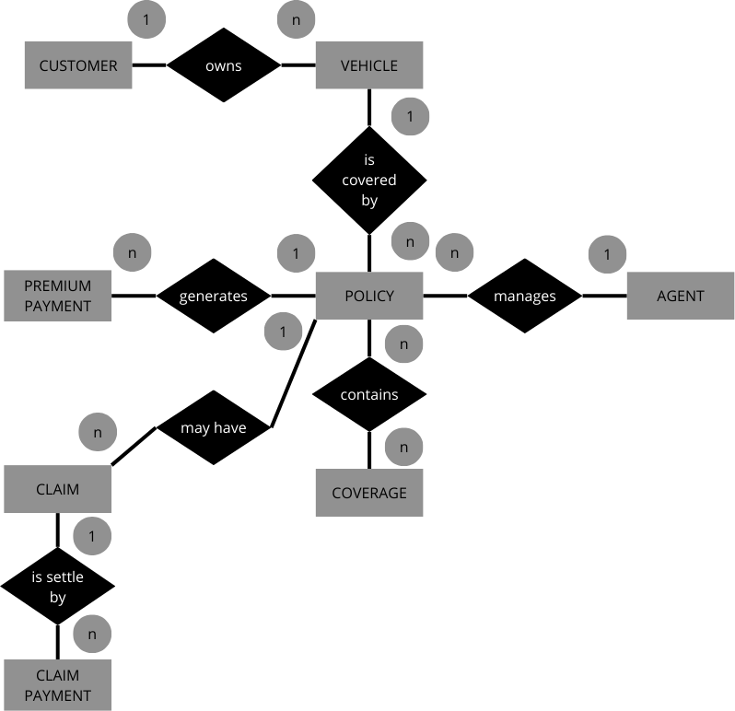
- Logical Model
Customer
(CustomerID PK, FirstName, LastName, Address, Phone, Email UNIQUE)
Vehicle
(VehicleID PK, CustomerID FK, Brand, Model, Year, LicensePlate UNIQUE)
Agent
(AgentID PK, Name, Phone, Email UNIQUE)
Policy
(PolicyID PK, CustomerID FK, VehicleID FK, AgentID FK, StartDate, EndDate, Status)
Coverage
(CoverageID PK, Name, Description)
PolicyCoverage
(PolicyID FK, CoverageID FK, PK = (PolicyID, CoverageID))

PremiumPayment
(PaymentID PK, PolicyID FK, PaymentDate, Amount)
Claim
(ClaimID PK, PolicyID FK, ClaimDate, Description, Status)
ClaimPayment
(ClaimPaymentID PK, ClaimID FK, PaymentDate, Amount)

- Physical Model (SQL Script)

CREATE DATABASE CarInsuranceDB;
USE CarInsuranceDB;

CREATE TABLE Customer (
customer_id INT AUTO_INCREMENT PRIMARY KEY,
first_name VARCHAR(50) NOT NULL,
last_name VARCHAR(50) NOT NULL,
address VARCHAR(100),
phone VARCHAR(20),
email VARCHAR(50) UNIQUE
);

CREATE TABLE Vehicle (
vehicle_id INT AUTO_INCREMENT PRIMARY KEY,
customer_id INT,
brand VARCHAR(50),
model VARCHAR(50),
year INT,
license_plate VARCHAR(20) UNIQUE,
FOREIGN KEY (customer_id) REFERENCES Customer(customer_id)
);

CREATE TABLE Agent (
agent_id INT AUTO_INCREMENT PRIMARY KEY,
name VARCHAR(100) NOT NULL,
phone VARCHAR(20),
email VARCHAR(50) UNIQUE
);

CREATE TABLE Policy (
policy_id INT AUTO_INCREMENT PRIMARY KEY,
customer_id INT,
vehicle_id INT,
agent_id INT,
start_date DATE NOT NULL,
end_date DATE NOT NULL,
status ENUM('active','expired','canceled','arrears'),
FOREIGN KEY (customer_id) REFERENCES Customer(customer_id),
FOREIGN KEY (vehicle_id) REFERENCES Vehicle(vehicle_id),
FOREIGN KEY (agent_id) REFERENCES Agent(agent_id)
);

CREATE TABLE Coverage (
coverage_id INT AUTO_INCREMENT PRIMARY KEY,
name VARCHAR(100) NOT NULL,
description TEXT
);

CREATE TABLE PolicyCoverage (
policy_id INT,
coverage_id INT,
PRIMARY KEY (policy_id, coverage_id),
FOREIGN KEY (policy_id) REFERENCES Policy(policy_id),
FOREIGN KEY (coverage_id) REFERENCES Coverage(coverage_id)
);

CREATE TABLE PremiumPayment (
payment_id INT AUTO_INCREMENT PRIMARY KEY,
policy_id INT,
payment_date DATE NOT NULL,
amount DECIMAL(10,2) NOT NULL,
FOREIGN KEY (policy_id) REFERENCES Policy(policy_id)
);

CREATE TABLE Claim (
claim_id INT AUTO_INCREMENT PRIMARY KEY,
policy_id INT,
claim_date DATE NOT NULL,
description TEXT,
status ENUM('open','closed','in review'),
FOREIGN KEY (policy_id) REFERENCES Policy(policy_id)
);

CREATE TABLE ClaimPayment (
claim_payment_id INT AUTO_INCREMENT PRIMARY KEY,
claim_id INT,
payment_date DATE NOT NULL,
amount DECIMAL(10,2) NOT NULL,
FOREIGN KEY (claim_id) REFERENCES Claim(claim_id)
)

