Meeting minutes: Feb 22, 3 hours

* Sungmo Koo: rough project schedule, teller use cases,
* Breanne Loo: User, ATM
* Daniel Rodriguez: Banker, Owner

We worked on SRS together, most progress was made here, at the end decided to distribute the rest of the workload by modules

Meeting minutes: Feb 28, 3 hours

* Sungmo Koo: Rough project schedule, teller use cases, Sequence Diagram, class diagram
* Breanne Loo: User, ATM, Sequence Diagram, class diagram
* Daniel Rodriguez: Banker, Owner, Sequence Diagram, USe case Diagram, Class Diagram

Created a todo list:

* Use cases x
* Use Case Diagram x
* Collect our UML class diagram x
* Project schedule x
* Minutes x
* Add everything to GitHub x
* Submit x

Template

Use Case ID:

Use Case Name:

Relevant Requirements:

Primary Actor:

Pre-conditions:

Post-conditions:

Basic Flow or Main Scenario:

Extensions or Alternate Flows:

Exceptions:

Related Use Cases:

Meeting minutes: Feb 29, 3 hours

* Sungmo Koo: Create teller use cases, use case diagram, teller sequence diagram, teller class diagram, Rough project schedule.
* Breanne Loo: Created User and ATM use cases, ATM uml use case diagram, user and ATM class, SRS proofreading
* Daniel Rodriguez: Created two new classes, server and account class, to help close some gaps

Meeting minutes: Mar 14th, 1.5 hours

Sungmo Koo: See design doc comments

Breanne Loo: See design doc comments

Daniel Rodriguez: See design doc comments

Dongping Guo: See design doc comments

* Admin to accounts
  + Only one admin
  + Allow admin transfer between users
* Change Pin and add user
  + Only one user can access an account at a time
  + Only one pin
  + Outside conversation for pin change
* Choose an account ATM
  + When on ATM, ATM will display all your accounts the user owns, then the user will select one, enter pin, then do ATM stuff
    - This will work with the “Only one user can access an account at a time” problem on this display
* ATM money display
  + Button to show whether or not text of account balance is always on display
    - Like the view password on other apps
* Name format
  + Issue: when we transfer we want to verify with account owner name
  + When doing a transfer after you put the account # ATM will display the name to verify if you recognize this name
  + When a user is creating an account, the system will ask first, middle, last name.
    - Empty space in the first letter won’t be accepted.
* Interest in saving and Logs?
  + Need time?
  + Bank statement?
  + How does the system log bank information?
    - Going to ask professor, working on other things to do rn
* Teller, what do they do at work?
  + Yes and no option
  + Ask professor

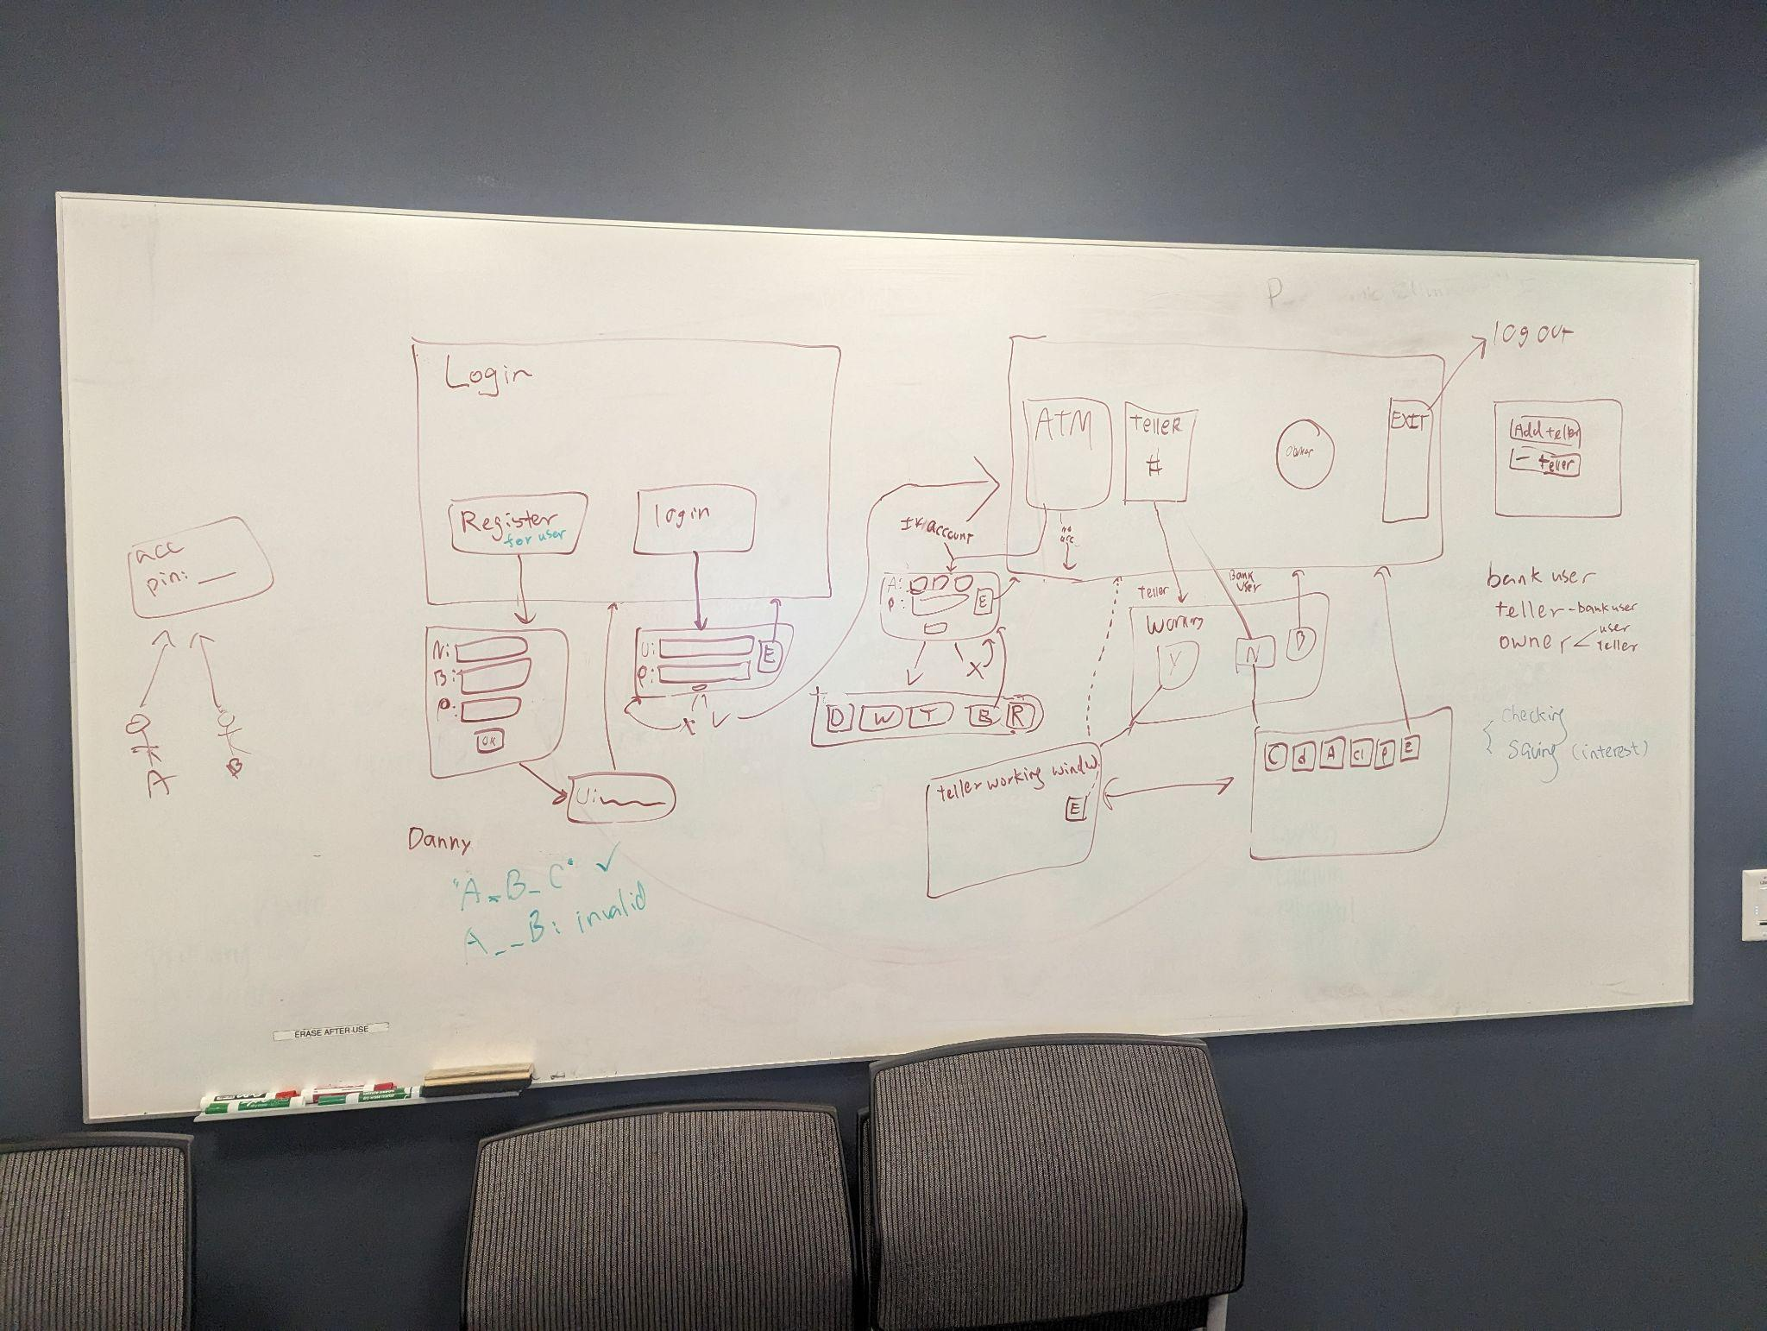

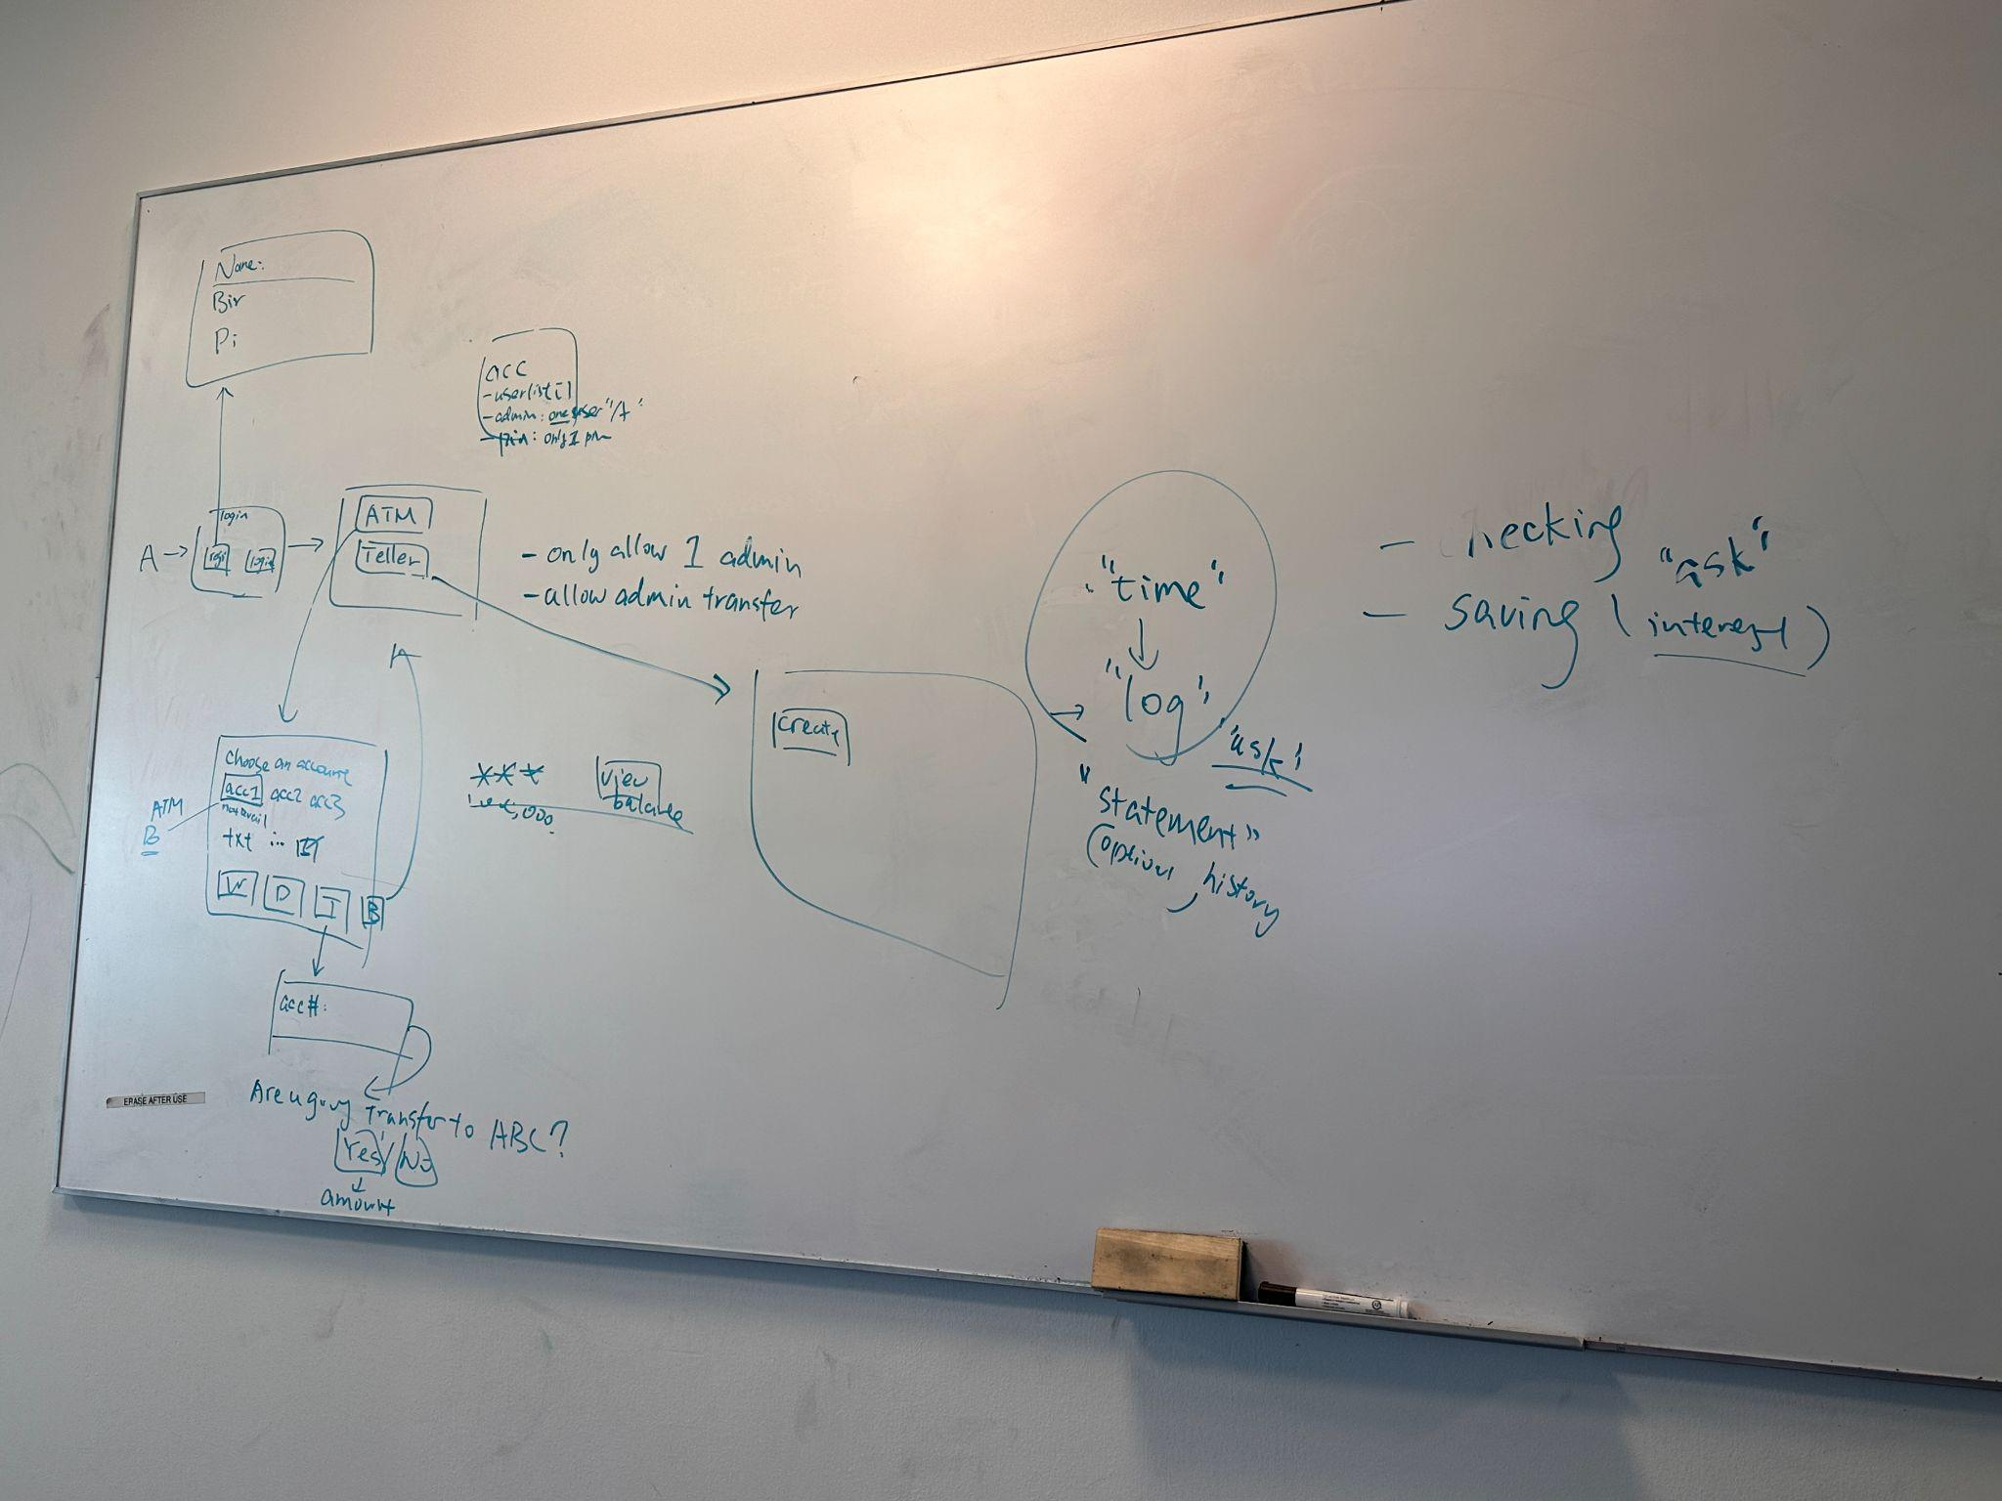

* Note logout sends back to login page and add the exit to the login page

Meeting minutes: Mar 19th, 0.5 hours

Sungmo Koo: See design doc comments

Breanne Loo: See design doc comments

Daniel Rodriguez: See design doc comments

Dongping Guo: See design doc comments

* The teller and atm are separate applications
* We do not need owner class
* Teller Admin
  + Admin teller can add and sub other tellers
* No longer referencing the previous diagrams (Border in red)
* Log transactions on the server and the teller should be able to access them.

Meeting minutes: Mar 21th, 2 hours

Sungmo Koo: See design doc comments

Breanne Loo: See design doc comments

Daniel Rodriguez: See design doc comments

Dongping Guo: See design doc comments

* Delete teller security code
* Delete account, Add user, delete user, Transfer admin, change pin, can only show accounts that the user is admin to
  + Must ask for pin for all the functions listed above (except create account)
* Admin teller has additional function of add teller, delete teller, and print logs
  + Status of teller will be shown on teller main page (the one after login)
* Before Mar 25 finish up the documents

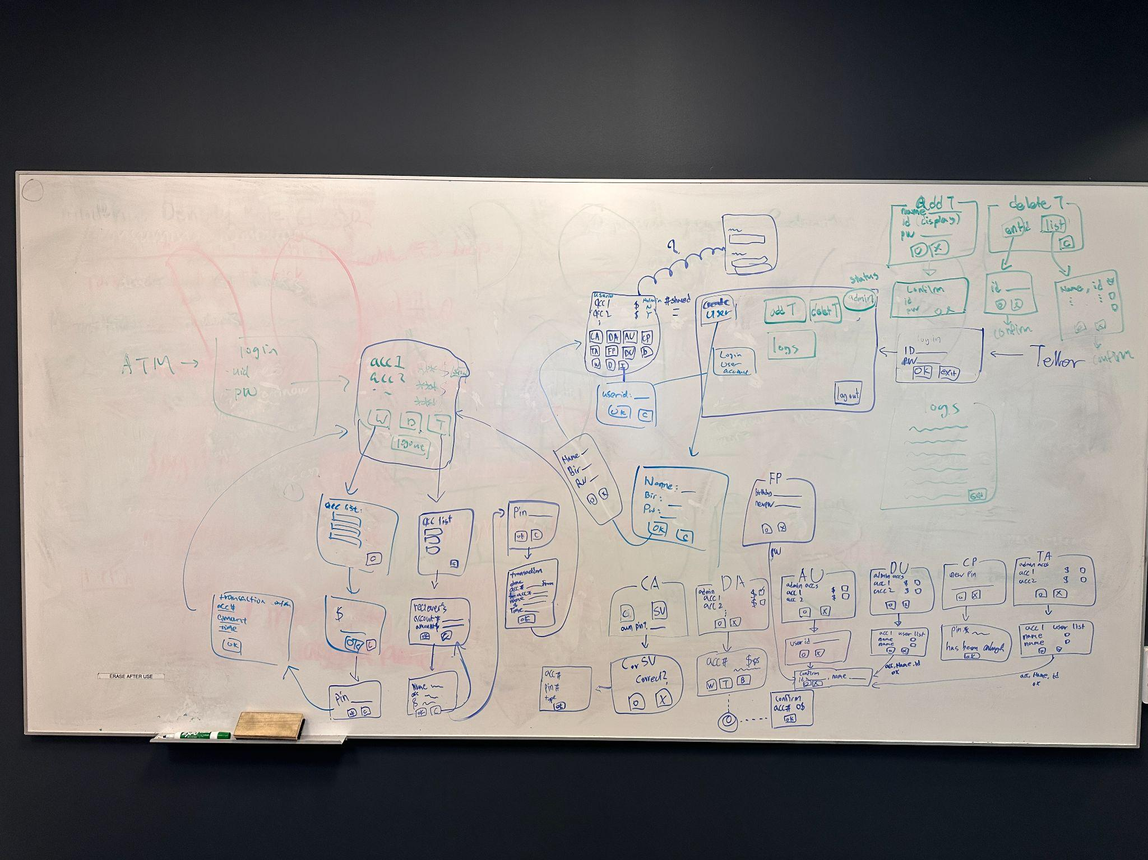

Meeting minutes: Mar 26th, 2 hours

Sungmo Koo: See design doc comments

Breanne Loo: See design doc comments

Daniel Rodriguez: See design doc comments

Dongping Guo: See design doc comments

* Make google sheet of use cases
* Diagrams were discussed
* Presentation overview›
  + System_Overview
  + System UI
  + Class Diagram
    - Maybe sequence

Meeting minutes: Mar 27th, 2 hours

Sungmo Koo: See design doc comments

Breanne Loo: See design doc comments

Daniel Rodriguez: See design doc comments

Dongping Guo: See design doc comments

* Add teller: when add teller, id generated but not entering name. Deleting shows teller name.

Meeting minutes: Mar 28th, 4 hours

Sungmo Koo: See design doc comments

Breanne Loo: See design doc comments

Daniel Rodriguez: See design doc comments

Dongping Guo: See design doc comments

* Completed design document
* Updated SRS with design document
* Updated use cases
* Presentation was presented
* Update design document requirements
* Update github