Capstone project 2 Proposal by Shuangshuang Liu

February 11th, 2020

**Title:** Current and future diversity in global agricultural production and trade networks

**Problem statement**

Food security is becoming a pressing issue especially in some developing countries in tropical areas, due to climate change and a fast-growing population that may affect both crop production and demand. Therefore, it is important to understand how food availability may change through domestic production and international trade under future climate scenarios.

Researchers have modeled the projected agricultural production and net trade in 2050 under climate change (see pictures bellow). However, it is still unclear how production and yield of specific crops (such as maize and rice) as well as their trading network among countries may change. Such information is especially important for susceptible countries (e.g., those in west Africa) to form effective strategies to cope with the challenges and for other countries to offer assistance such as through trade policies.

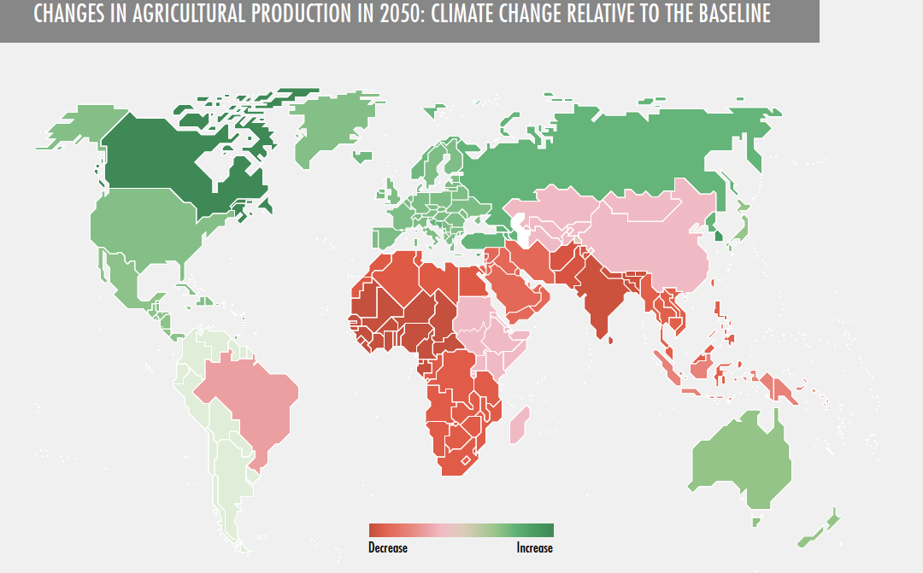

*Source: Figure 2.1 in FAO: The state of agricultural commodity markets 2018.* [*http://www.fao.org/3/I9542EN/i9542en.pdf*](http://www.fao.org/3/I9542EN/i9542en.pdf)

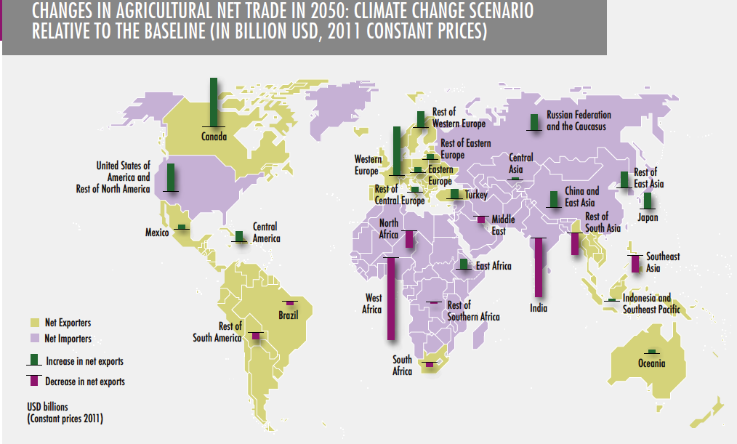

*Source: Figure 2.3 in FAO: The state of agricultural commodity markets 2018.* [*http://www.fao.org/3/I9542EN/i9542en.pdf*](http://www.fao.org/3/I9542EN/i9542en.pdf)

In this project, we will examine the time series data of crop production and yield among countries and predict future trends. Current and future trade network among countries will also be analyzed and modelled. Lastly, climate change scenarios will be incorporated to improve accuracy of the forecasts.

**Potential Clients**

Government officials and policy makers, NGOs and research institutions interested in strategies to improve the economic outlook of countries whose agricultural production and food security may be threatened by future climate conditions.

**Main questions**

(1) What is the diversity in agricultural production and trade networks among countries?

(2) How will such diversity in agricultural commodities produced and trade volume and partners change over time, as the globe gets warmer and crowder?

(3) What can countries susceptible to climate change do to cope with future climate challenges?

**Datasets**

(1) Yearly crop trade data among countries:

<http://www.fao.org/faostat/en/#data/TM>

(2) Yearly crop production and yield dataset by countries:

<https://www.quandl.com/data/UFAO-United-Nations-Food-and-Agriculture/documentation>

(3) World Agricultural Supply and Demand Estimates

<https://www.usda.gov/oce/commodity/wasde/>

(4) Historic and future climate predictions data (data source to be determined—currently have trouble finding a good one)

ISI-MIP model

Inter-Sectoral Impact Model Intercomparison Project

<https://esg.pik-potsdam.de/search/isimip/>

**Analysis flow**

1. Analyze country-level diversity in agricultural production (types of commodities produced such as grains) and in trade network (number of trading partners). Use dataset (1). In addition, analyze what crops share similar time series and which countries share similar time series for specific crops, in terms of amount traded.

2. Analyze changes in annual crop production and yield (dataset (2)) corresponding to climate data (data source TBD) and predict production and/or yield in the future (time series analysis and modeling).

3. Model changes in trade network in response to changes in agricultural production and demand, using selected countries and crops depending on data availability (network analysis).

4. Make recommendations to countries susceptible to climate change regarding how to diversify crop production and trade partner network in response to future climate challenges.

**Deliverables:**

Codes, report, slides, dashboard showing diversity in agricultural production and trade network, as well as projected changes into the future.