UML Diagram

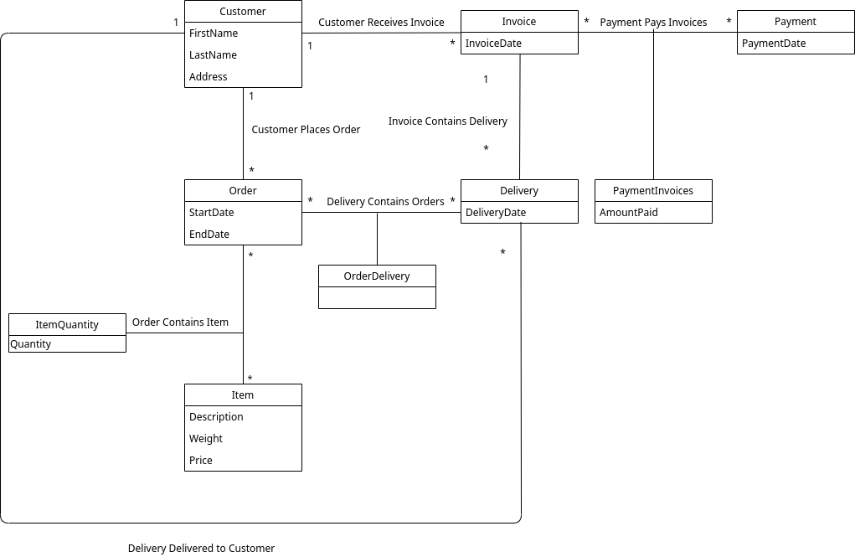

Functional Dependency Diagrams

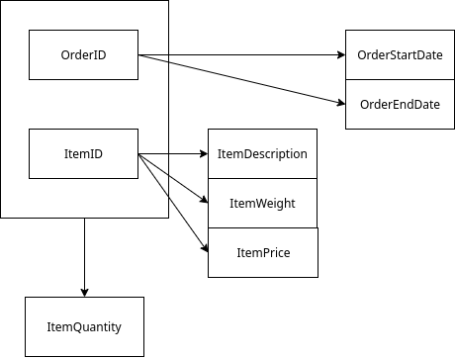

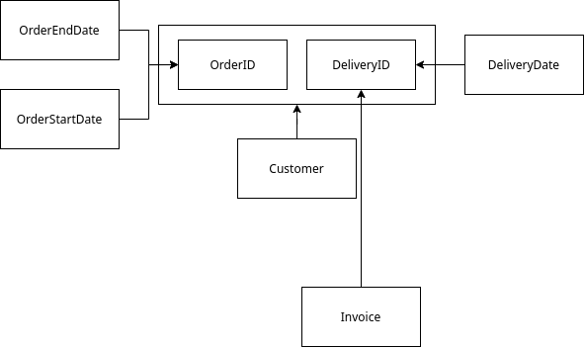

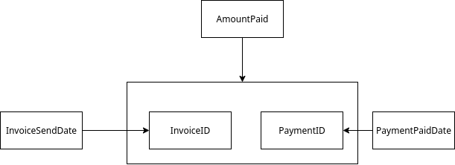

Customer(CustomerID, FirstName, LastName, Address);

Order(OrderID, StartDate, EndDate);

ItemQuantity(ItemID, OrderID, Quantity);

Item(ItemID, Description, Weight, Price);

Delivery(DeliveryID, Date, CustomerID, InvoiceID);

OrderDelivery(DeliveryID,OrderID, CustomerID);

Invoice(InvoiceID, CustomerID, Date);

Payment(PayementID, Date);

PaymentInvoice(PaymentID, InvoiceID, AmountPaid);

Assumptions:

* The customer is only one person. E.g A husband and wife would only put the wife’s name down
* Customers only have 1 address
* In an order the only the quantity value is used to denote the quantity instead of adding in an item twice. So, an invalid order would be **1xApples, 1xApples 2xBananas** instead of **2xApples, 2xBananas.**
* The customer only pays for one invoice at a time