**Creating a Database**

A database can be created using Object Explorer or Transact-SQL language.

1. Creating a Database using Object Explorer

**Click on SQL Server Management Studio at the Start menu**

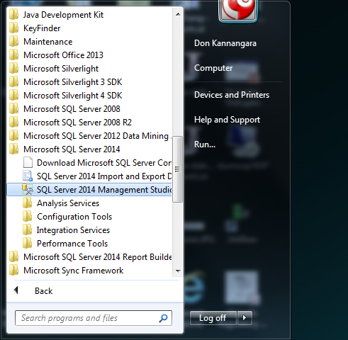

**Use the server name as STU-MSSQL of your PC and Authentication as Windows Authentication and click the Connect button**

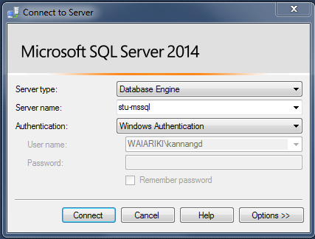

Now right mouse click on Databases folder and Move the cursor to the database folder already created in your name and open it as shown below.

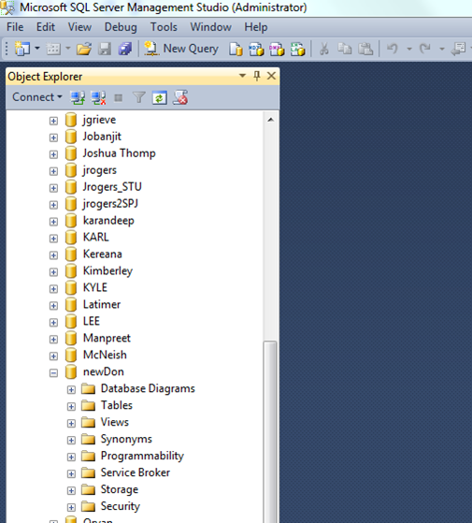

**Creating Tables within your database**

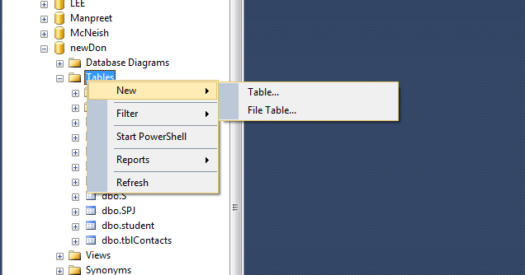

**Create a table called S in your database and set the S# as the primary key. Remember to save the table by clicking the save table option.**

S (s#, sname, status, city)

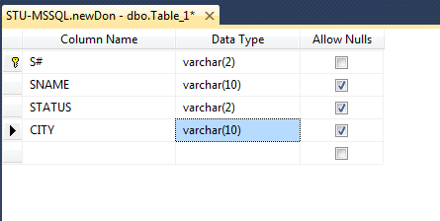

**Read About data types in SQL Server at this link.**

**https://msdn.microsoft.com/en-us/library/ms187752.aspx**

**Enter data into the table S.**

Move the mouse cursor to dbo.S table and press left mouse button. Then select the option “Edit Top 200 Rows” option. Then enter data (See Fig. 5.1) into the S table as shown below.

|  |  |
| --- | --- |
|  |  |

Create following tables in your database:

P (p#, pname, color, weight, city)

J (J#, jname, city)

SPJ (s#, p#, j#, qty)

**Database Diagram (ER Diagram)**

**Right mouse click on database diagram and choose new database diagram option.**

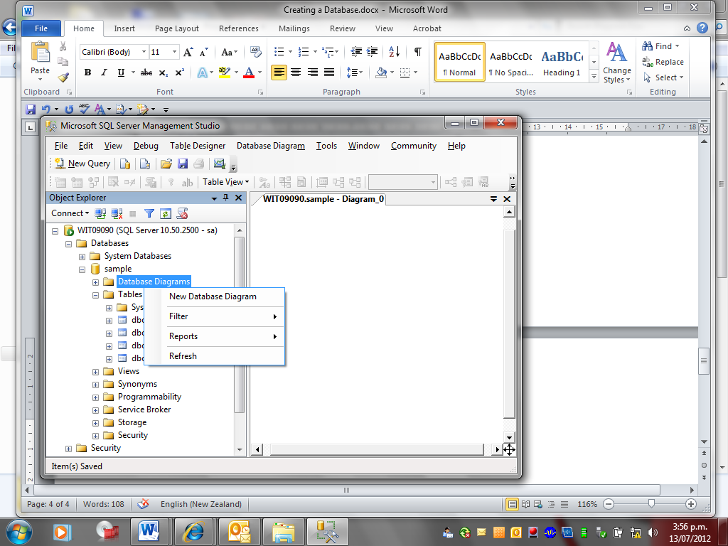

**Add all the tables to the Database Diagram**

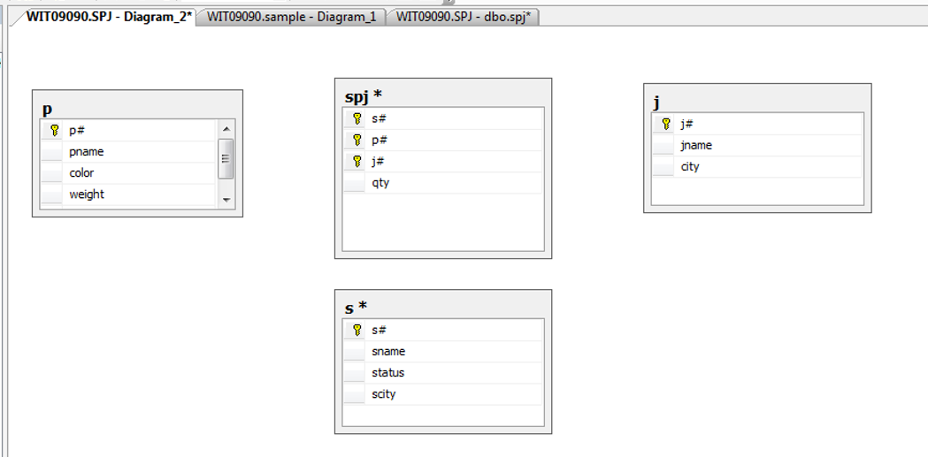

**Establishing relationships between tables**

Right mouse click on a foreign key of the SPJ table and then select **Relationships** option.

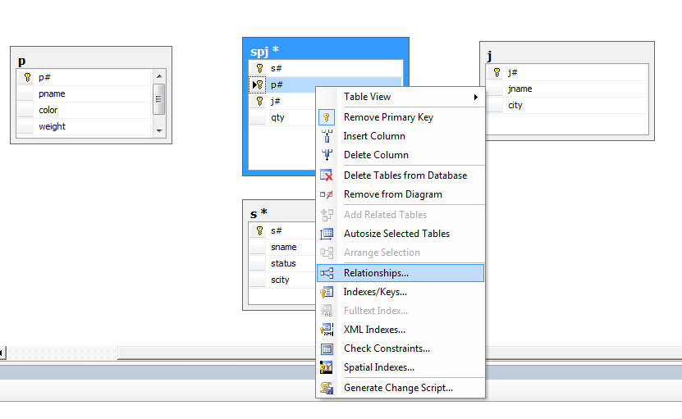

Click Add on the dialog box. Expand the Tables and Columns Specification.

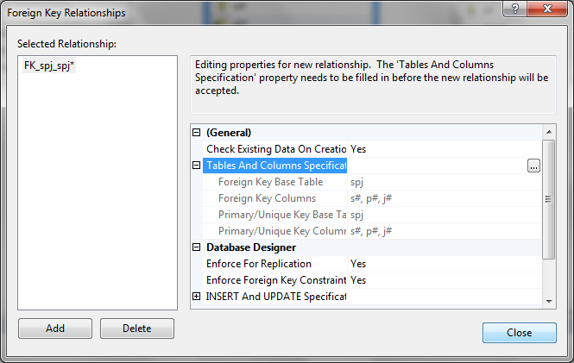

**Database Diagram**

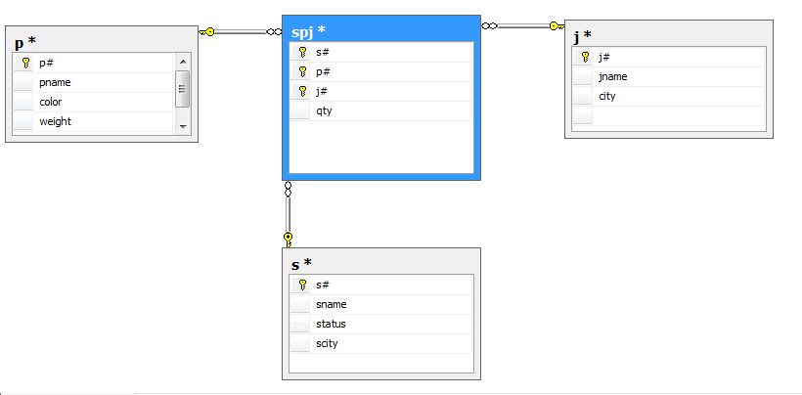

**Now populate your tables with the data of the SPJ database**

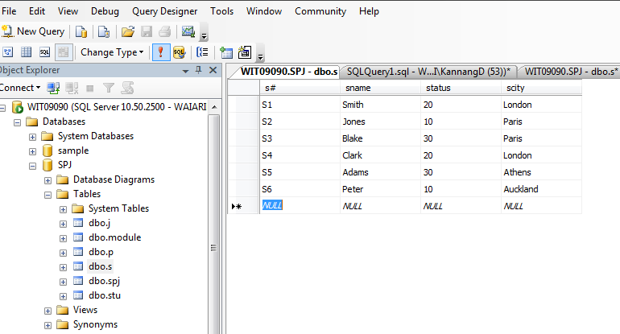

Now Test Your database with a new Query

use spj;

select * from dbo.s;