1. Selecting the patient in the patients table where the patientID = 10001.

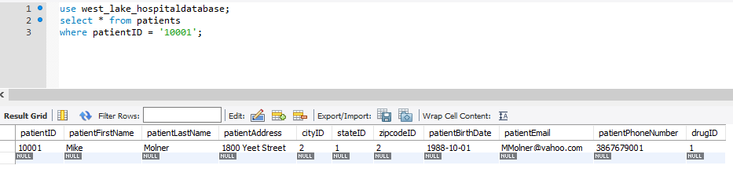

1. Select the doctors first name and doctor’s last name from the researcher who has the id 1.

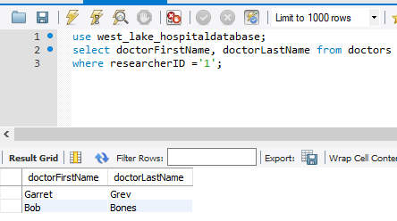

1. Count how many patients we have on the database using the count method from patient database.

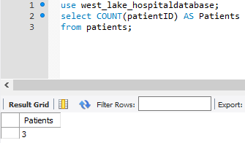

1. Get the count of how many visits we have total from doctorofficevisit table. Using the distinct keyword we can get the exact count incase there are multiple visits by patients on the same day.

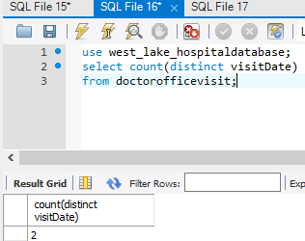

1. List the patients first and last name and the doctor id of the doctor they visit by joining patientID from both patients table and doctorofficevisit.

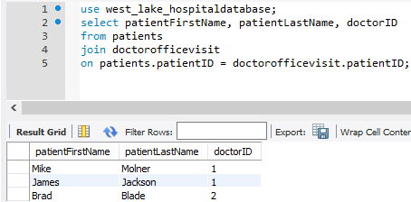

1. Show doctors name and relate them to which patients they are assigned to. Using a join statement, we will join the doctorID from both doctorofficevisit and doctors to show the doctors name with the patientID. It is important to note that if a doctorID field is selected to be shown the query fails saying that doctorID is ambiguous.

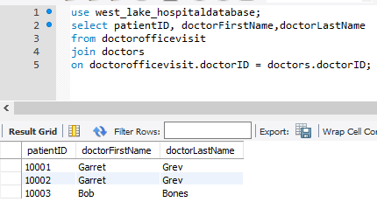

1. One of the patients listed that they have diabetes and they are taking insulin, insert into medications Metformin.



Results:

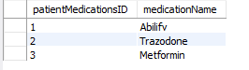

1. A patient says they are visiting from New York, add New York to the states and give it the next available ID number.



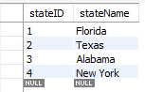

1. A patient has moved and his zipcode has changed, update his zipcode to reflect the new city.

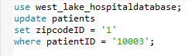

1. The patient taking metformin changed prescriptions delete metformin from the patientmedications table.

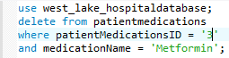

Updated medications table:

