I really like how all the main sections, or ‘zones’ on NEWS.COM are tabbed:

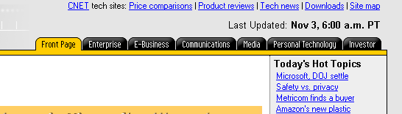

I think I will use this tabbed interface as a generic way to organize zones, though it may get confusing with the tabs for the sites.

I like how simple this adding a note at the bottom of this site is, from http://www.dingwall.bc.ca/history/main.php3?cat=personalities&listing=Marshall_Tito

