Assignment 2 Hybrid Images

# Results

## Image Set 1: High Res Summer & Winter Tree

For the first hybrid images I decided to combine a tree at two different seasonal times, one during Summer and the other during Winter. The original images are of the same tree, but are taken from slightly different angles, resulting in images that do not overlap perfectly. I think if the images were taken from the same spot then this result set would have turned out to be my best results.

### Original Images

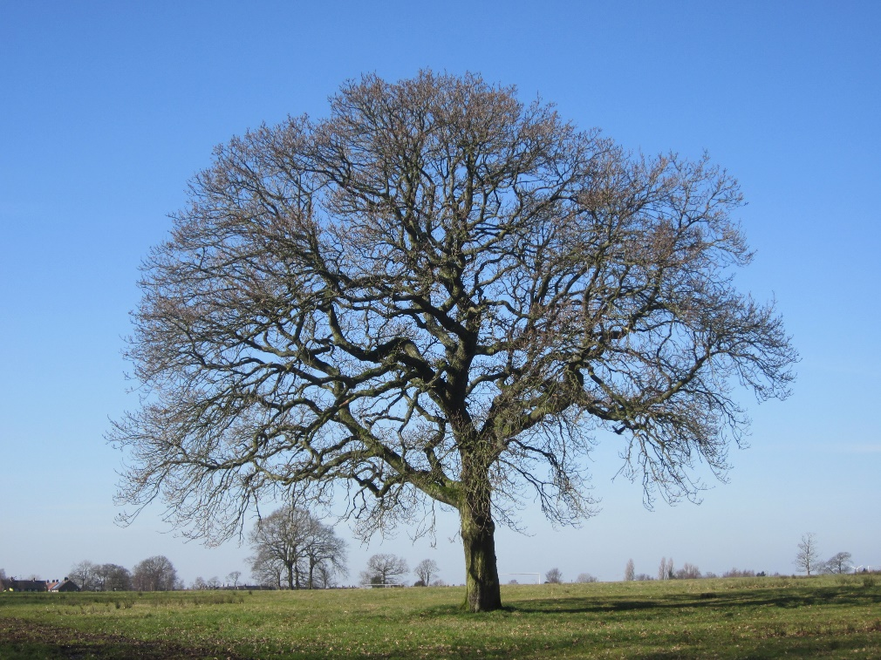

### Gaussian Pyramid: Summer tree

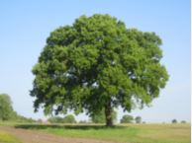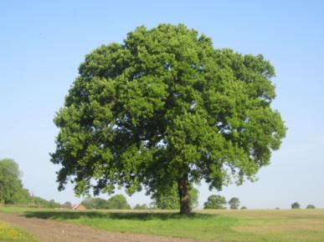

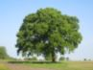

### Laplacian Pyramid: Winter Tree

### Laplacian Pyramid

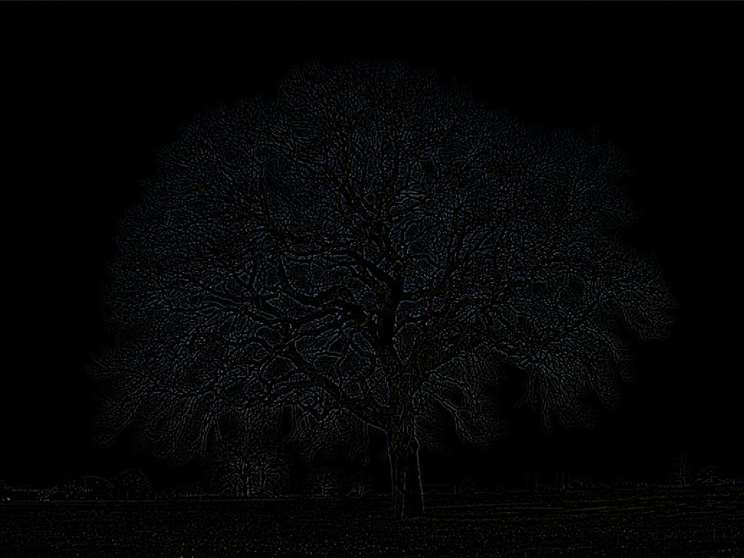

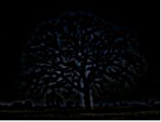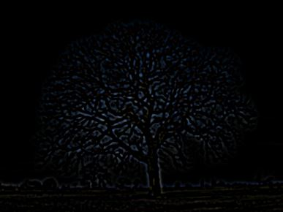

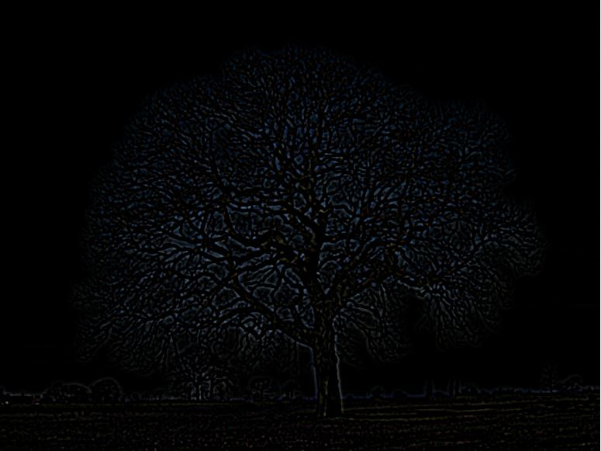





### Hybrid Image

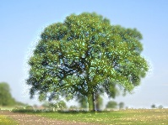

## Result Set 2: Low Res Summer & Winter Tree

### Original Images

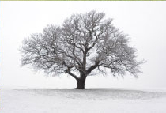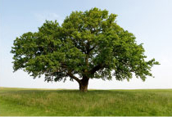

### Gaussian Pyramid: Summer Tree

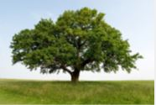



### Laplacian Pyramid: Winter Tree

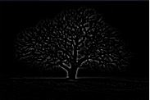

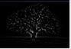

### Hybrid Image

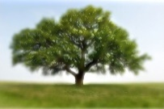

## Result Set 3: Anakin Skywalker & Darth Vader

I wanted to do a foreshadowing example of Anakin Skywalker and Darth Vader. So up close you would see Anakin, and then as you moved far away he would turn into Darth Vader. It was a little difficult because Darth Vader’s image is very black and white – from the reflections. So there is always a little bit of the Darth Vader low frequency image visible in the close up shot.

### Original Images

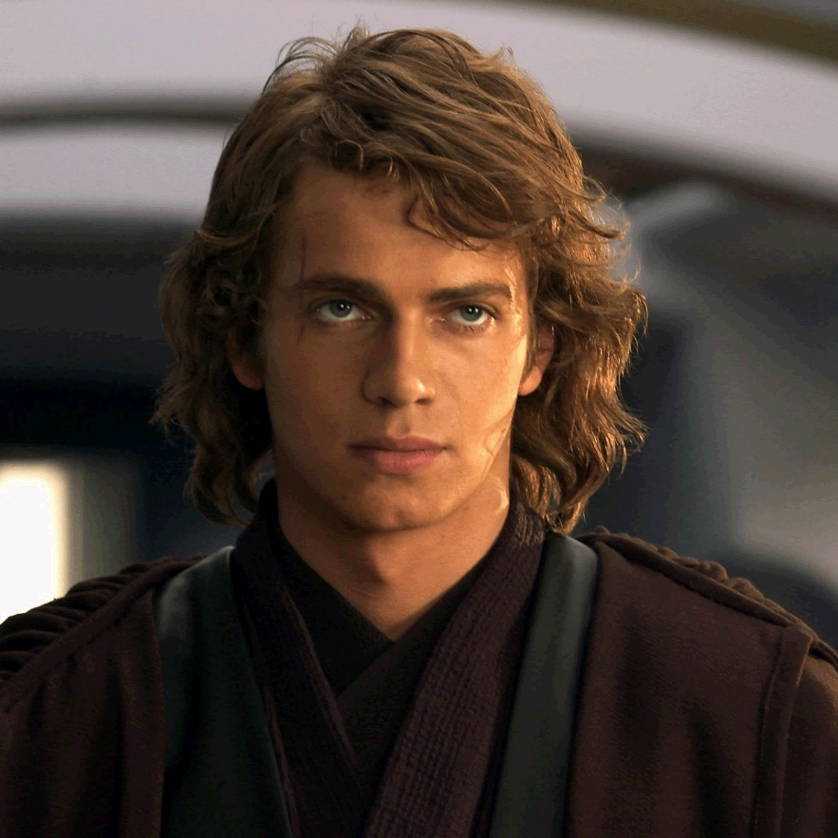

### Gaussian Pyramid: Darth Vader

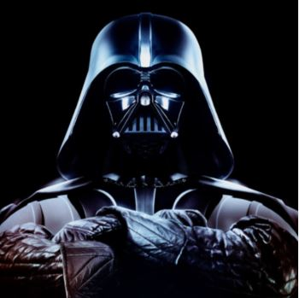

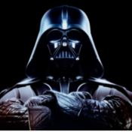

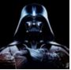



### Laplacian Pyramid: Anakin Skywalker

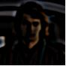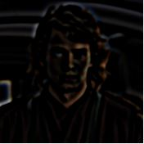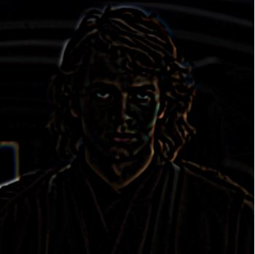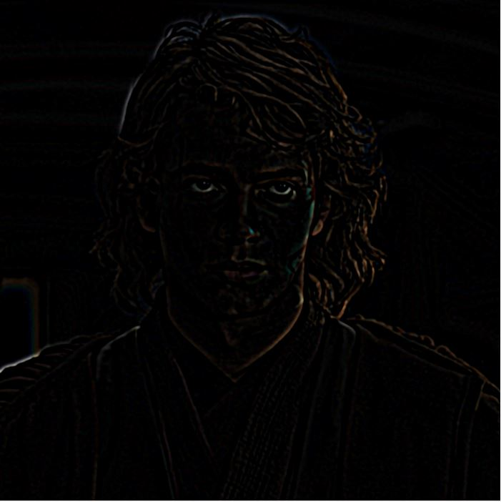

### Hybrid Image

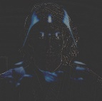

# Algorithm

### Code

There are four code files attached with the assignment. There is a file for each of the three hybrid images, the reasoning is because each image set needed slight variable tweaking in order to get the best results per image – including the low resolution images needing to be scaled, and a file that generates the pyramids for any two images. The pyramids were generated by this code, and in the other three result sets’ respective files there is only the code to make the hybrid images. I felt this resulted in cleaner code and more modular scripts.

The code is basically the same for each set, but has minor differences in variables and setup.

### Gaussian Pyramid

The Gaussian filter is created with a cutoff frequency specified by a variable. The size of the Gaussian filter is the cutoff frequency * 4 + 1. This insures a 4 to 1 ratio between filter size and standard deviation, but insuring the filter size is odd.

The image subsampling is done using matrix vectorized addressing, and is down-sampled twice its length and width. The vectorized subsampling looks like: The Gaussian pyramid is constructed by applying the Gaussian filter against the image, then subsampling the image to a quarter its size – ½ width, ½ height – then the filter is re-applied and the resulting image is subsampled, etc…

### Laplacian Pyramid

The Laplacian pyramid is constructed in a similar fashion as the Gaussian pyramid, with one extra step. The Laplacian image is captured by subtracting a Gaussian filtered image from the original image, resulting in the high frequency parts of the image. Original image, I, Gaussian filtered image of I, IG, equals the Laplacian image, IL: I – IG = IL

The original image is Gaussian filtered, the Laplacian is generated, then the original image – not the Laplacian generated image – is down-sampled and the loop repeats.