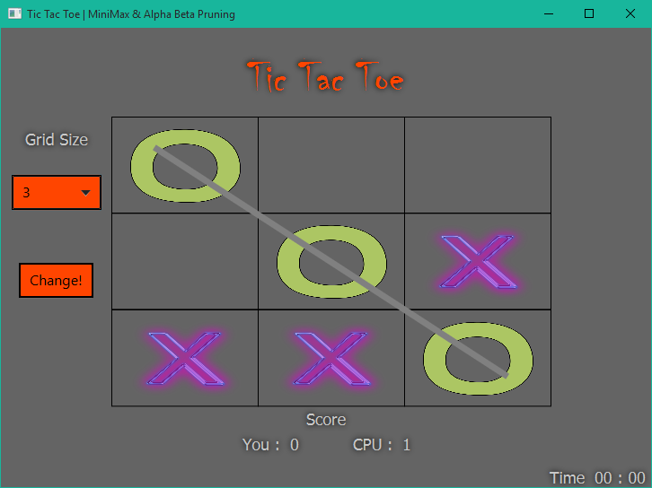
Final Project
Tic-tac-toe | minimax with alpha beta pruning
james Stell
2015

Tic-Tac-Toe

minimax with alpha-beta pruning

Introduction
This project implements a two-person game playing agent for the deterministic, zero-sum, tic-tac-toe game. The algorithm the agent implements is the minimax algorithm with alpha beta pruning, using a utility value on terminal states. I implemented the graphical user interface (GUI) with the Java framework JavaFX. JavaFX allows for the creation of user interfaces using either java code or by using FXML – an XML-based language created by Oracle for building user interfaces. Using JavaFX is very similar to creating an Android app. I used FXML to create most of the user interface that you see, and then java code to generate the actual grid – or tic-tac-toe game board. The coolest feature of a JavaFX application is it allows for the visual styling of GUI components using CSS.
The objective of the game playing agent is to never let the player (the person playing the game) win the game. Therefore, the agent will not try to win itself, but rather prevent the player from winning. It is because of this that the agent will sometimes seem to make unintelligent decisions that prevent it from winning and leading to a draw, but at the same time also prevent the player from winning (which is the goal of the agent).

Algorithm Details
The algorithm I used to implement this agent is the minimax with alpha beta pruning, which is based on the pseudo code found in the class book on page 170. The trick in implementing this algorithm was to follow a true depth first search (DFS) approach to memory management. At first I was generating all the children of the current state and storing them in an ArrayList, even though I was doing a depth first search. While I was doing a DFS in the sense of the tree traversal, I was generating all of the current states children. This caused memory issues and made me go back and re-write my code to follow a true DFS approach, to both time and memory.
I currently start at the root node (the state sent into the minimax algorithm) and then generate its first child, then pass this child to the MinValue function, in which that child state will generate its first child and pass it to the MaxValue function, etc., until a terminal state is reached at which point the recursion backs the utility values up through the parents and to the root node. To handle memory more efficiently I did a few things:
- During the child creation process, if that child is a terminal state (such that x or o wins) I do not create the rest of the children. This would be a waste of memory, and also the algorithm is based on each the agent and the player playing optimal, therefore one would never not choose the winning move, and therefore the other children do not need to be created.
- If the alpha or beta value has been reached (the point at which we trim off the branch) or when returning from a terminal case, I delete all of the current states children from memory. I do this on every level of recursion except for the root node, who needs its children in order to pick the child’s move whose utility value matches that of the value returned from the minimax algorithm.
The graphical game board that the player interacts with is created using JavaFX’s GridPane. Each cell in the grid pane is made up of a custom class I created called GridSquare. The GridSquare class extends JavaFX’s StackPane class (which is just a pane that allows the ‘stacking’ of objects) with a rectangle for the border. In order to extract the GUI information, I have a char instance variable in the GridSquare class called ‘contains’. All cells initially contain an ‘e’ to represent empty. This variable will change to ‘x’ or ‘o’ depending if the player clicks a cell or the agent places an ‘o’ on the cell. Using this variable I can loop through the grid pane and create a 2D char array containing ‘e’, ‘x’, or ‘o’ to represent a particular game state. For example, in Java syntax:
char[ ][ ] board = { {‘e’, ‘x’, ‘e’},
{‘o’, ‘e’, ‘x’},
{‘o’, ‘e’, ‘e’} };
Upon the user clicking the board the GridSquare ‘onMouseClicked function gets executed. I first place an ‘x’ on the screen in the cell the player clicked. I then pass the GridPane into the minimax Start() method. This method loops over the grid pane and creates a 2D char array in the fashion mentioned above.

Classes

Main.java
The Main.java file – the main class and entry point for program execution – basically sets up and loads the user interface specified in the MainView.fxml file. It then sets ‘on click’ listeners for clicking in a tic-tac-toe square, clicking the drop down box to specify game board size, and the button for changing the size. Currently the user always goes first and is always an ‘x’. (This will change in future modifications).
When calling the Minimax.Start() method I do this on a new background thread. This prevents long operations from freezing the UI. After the agent or player wins the game (never the player, my agent is unbeatable) the game will draw a line across the winning ‘o’’s or ‘x’’s and pause for 2 seconds before wiping the game for the next round. The score of the agent and player are kept on the bottom of the screen.

MiniMax.java
The MiniMax.java file contains the algorithm logic. There are four main methods:
- Start the public method called from outside the class
- MiniMax_AlphaBetaPruning the minimax algorithm entry method as described in the books pseudo code.
- MaxValue and MinValue the other methods described in the book, representing max’s and min’s turn in the game tree.
MaxValue and MinValue recurse on each other until a terminal state is reached. A terminal state is described as when either the agent wins, the player wins, or there is a draw. It is at this point that the recursion unwinds passing the utility value back up through the recursion.
The MiniMax_AlphaBetaPruning method returns an Action object which contains information of where the agent should place its next move (i.e. the row and column).

State.java
This class represents a current state in the game. It holds the tic-tac-toe game board represented as a 2D char array, an ArrayList<State> list to hold all children of this state, and various other variables and methods to act on those variables.
A state object is responsible for creating its own children, and knowing which children it has already created and which one it is currently on. This is done with a variable called childCount that denotes which child it needs to create next. The child creation process loops through the 2D array and looks for ‘e’’s, denoting an empty cell. It will generate a child after reaching the childCount’s number of ‘e’’s. For example, if childCount is currently at 2, then 2 children have already been created (0, 1), and we need to create the third child. The algorithm will therefore count to the third ‘e’ and then generate a new State object with the current board, but changing the found ‘e’’s location to either an ‘x’ or an ‘o’ depending on who’s turn it is (max or min).
This brings up another function of a State object. It has a variable called ‘whosTurn’ that contains either ‘Max’ or ‘Min’ that represents who’s turn it is from this state. So if min is placing ‘o’s on the board to generate its children, its child states will set ‘whosTurn’ to Max, because from each of its children states max will make his move.

Winner.java
This is a simple class that represents data sent out of the utility value method. It contains the utility value, if someone one and who won, and other information regarding a terminal states status.

Game.java
This class contains logic to decide if a game is over, who won, and to generate the utility value of a terminal state.

Utility Value
The utility value was a problem area at first. I was using the utility value that the book suggested. Which is a +1 if max wins, -1 if min wins, and 0 for a draw. The issue was all the states in which min should place an ‘o’ had a utility value of -1, visa versa for max. There was no way to distinguish which -1 was the optimal choice for min. So I had to get creative with my utility values. The only thing that changed with each level of recursion is the depth in the game tree. So I started passing the depth around the minimax recursion and eventually into the utility value function. Therefore, if min could place a move that was most optimal (either winning or blocking the player from winning) it would happen sooner in the game tree rather than later, and therefore would have a shallower depth. So on a 3x3 grid I start with a base value of 10. If it is max’s turn I subtract 10 from this and if it is min’s turn I subtract this from the depth. This generates a utility value that is best for each move, rather than just saying a move is good or bad.

Controller.java
This is a JavaFX class that connects to the FXML code. Typically, this file is used extensively for communication between the FXML and the GUI. However, the static components of my GUI are rather simple, and the game board grid is generated dynamically with java code, therefore this file is only used to specify the ComboBox object that lets users change game board size. For some reason one cannot style a ComboBox’s inner workings with CSS (most likely because it is a dynamically allocated object). So the crazy code in this class is just a way to be able to style this GUI element with CSS.

Style.css
The CSS file for styling the GUI.

MyImageView.java
This class extends ImageView – a JavaFX image component – and overrides the minHeigh and minWidth values. This was only necessary to make the x’s and o’s smaller once the application window gets resized smaller.

Explanation of Running Program
Just double click the .jar file and enjoy .

Issues
The algorithm in its current state cannot handle game boards larger than 4x4. The reason for this is the sheer size of the game tree. A 3x3 game tree has 8 factorial (8!) possible states, which is roughly 40,000. Going up to a 4x4 game tree there are 15! possible states, which is roughly 1,307,674,368,000 states. And making the jump just one more cell larger, a 5x5 grid has 24! states, which is roughly 620,448,401,733,239,439,360,000 states! As you can see the size of the game tree grows WAY to fast. It is for this reason that my algorithm in its current state cannot handle grids of this size.
To fix this I would limit the search to a depth of around 22 (this depth can be handled in milliseconds) and apply a function that will score a state based on the current depths amount of information. Basically making an informed guess. Once the game tree is contained within a depth of 22 then the algorithm will pick back up using the utility value and will make optimal moves.

Future Improvements
- I would like to implement the new functionality to handle large game spaces like that mentioned above in the Issues section.
- I want to give the player the ability to choose whether they are an ‘x’ or an ‘o’.
- I want to give the player the ability to choose which ‘x’ and ‘o’ images get used for the game from a list of predefined images.
- I want to add a theme functionality that will allow the player to change themes of the UI with varying colors and fonts.
- I want to add a ‘save’ button that will save the current state of the game (placement of x’s and o’s on the screen as well as the scores of the agent and player) for future play.

