My Very First Markdown 2 PDF Conversion

Brad Wiebe

January 25, 2016

# An image, a citation

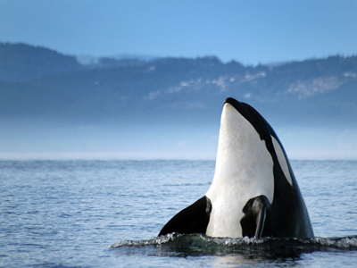 [1]

## #**Groceries**

## *A List by Brad Wiebe*

### Fruits

* Apples
  + Green
  + Red
* Bananas ###Veggies

For a grocer near you, please visit [Facebook](http://facebook.com).

# Bibliography

1. A Free, Free Willy