# How to start Emlin tool.

1. Click this link and download. <https://drive.google.com/drive/folders/1Lz84uWHYzTRyRdnPVQr4MwTWk1px_UIF?usp=sharing>
2. Place zip file in any desired location. Unzip should look like this.

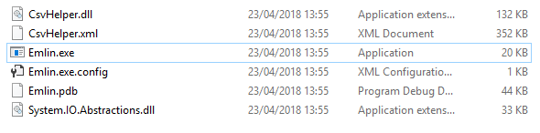

1. Right click “Emlin.exe” and copy.
2. Click windows button, type run and hit enter.
3. Type “shell:startup” and hit enter.
4. Should open a windows file explorer. Right click inside and paste shortcut.
5. Double click “Emlin.exe” and minimize. Icon should disappear and this will appear in the icon tray.

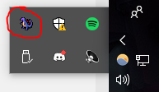

If wanting to exit Emlin at any time, double click the dinosaur and close the window.

Note

Data is saved in the following path:   
“C:\Users\{Computer username}\AppData\Roaming\Emlin\KeyboardData.txt”

The following is an example on how emlin saves data. There is no way to extrapolate information from this data and will, in the future, be encrypted.

