AI Adoption and Revenue Growth
Predicting Revenue Growth Using Company Characteristics and AI Investment

BUAN/ECON 390 — Business Analytics | Option A: Prediction-Based Analysis
May 2026

1. Executive Summary
This report uses machine learning to predict revenue growth for companies based on their AI investment strategies and organizational characteristics. Using a dataset of 150,000 companies, we built and compared two models: linear regression to identify which variables most directly drive growth, and a tuned random forest regressor to capture more complex patterns that a linear model cannot detect.

Our central finding is that productivity_change_percent (workforce productivity improvement) and ai_adoption_rate are the most consistent predictors of revenue growth across both models. Companies that have moved beyond early-stage AI adoption and built organizational capability around AI tend to outperform those that spend heavily on AI tools without the underlying infrastructure to use them effectively.

The linear regression model explains roughly 24% of the variation in revenue growth (R² ≈ 0.24), which is meaningful given how many factors outside AI investment also drive revenue outcomes. The tuned random forest performs comparably, confirming that the dominant relationships in this data are largely linear. The practical implication: companies should prioritize AI maturity development over simply increasing AI budget, and executives can use the model outputs to flag which companies or business units are on the highest-growth trajectories.

2. Business Question and Context
The core question guiding this analysis is: which company characteristics and AI investment factors most reliably predict revenue growth, and how can these predictions support strategic decisions?

This question is relevant to multiple stakeholders. For executives deciding how to allocate AI budgets, the model answers whether spending more on AI tools actually translates into revenue gains, or whether the bigger lever is organizational readiness. For consultants advising on AI transformation, it identifies which industries and company profiles show the highest return on AI investment.

We chose revenue growth percent as the prediction target because it is the most direct measure of business performance and is available across all 150,000 company records. Our independent variables span four categories: AI investment (budget percentage, training hours, number of tools), AI capability (adoption rate, maturity score, active projects), operational impact (automation rate, time saved), and company profile (size, age, industry, region).

3. Data Description
The dataset comes from Kaggle (mohankrishnathalla/global-ai-adoption-and-workforce-impact-dataset) and contains 150,000 company-level survey records with 43 variables. There are no missing values. The data covers companies across multiple industries, regions, and company sizes, making it suitable for cross-sectional prediction analysis.

Attribute | Detail
Source | Kaggle synthetic dataset
Rows | 150,000
Columns | 43 (after dropping identifiers: 36 used for modeling)
Missing values | 0
Target variable | revenue_growth_percent
Key predictors | ai_maturity_score, ai_adoption_rate, ai_budget_percentage, task_automation_rate
Categorical variables | industry, region, company_size, ai_adoption_stage (label encoded)
Dropped columns | response_id, company_id, survey_source, data_collection_method, country, quarter

We dropped identifier columns (response_id, company_id) and administrative metadata (survey_source, data_collection_method) that carry no predictive information. We used region instead of country to avoid high cardinality. Categorical variables were label-encoded; this is an acknowledged limitation discussed in Section 7.

4. Methodology
We split the dataset 80/20 into training (120,000 rows) and test (30,000 rows) sets using random_state=42 for reproducibility. All model evaluation uses the held-out test set only.

Linear Regression
We chose linear regression as the parametric model because its coefficients are directly interpretable in business terms: a one-unit change in any input maps to a specific predicted change in revenue growth. This interpretability is valuable when the goal is to explain results to non-technical managers rather than just maximize predictive accuracy.

Random Forest Regressor
Random forest was selected as the nonparametric model because it captures nonlinear relationships and interaction effects that linear regression misses. It also provides feature importance scores, which complement the regression coefficients with a different perspective on variable relevance.

Hyperparameter tuning used RandomizedSearchCV with 3-fold cross-validation and 12 candidate configurations, run on a 25,000-row random sample of the training data for computational efficiency. The best parameters were then refit on the full 120,000-row training set before test-set evaluation. This approach follows standard industry practice: tuning on a sample to find good parameters, then training the final model on all available data.

Parameter | Search space | Purpose
n_estimators | 100, 200 | Number of trees
max_depth | 10, 15, 20 | Maximum tree depth (bounded to prevent overfitting)
min_samples_split | 2, 5, 10 | Minimum samples to split a node
min_samples_leaf | 2, 5 | Minimum samples in leaf nodes
max_features | sqrt, log2 | Features considered at each split

5. Visualizations and Results

Target Variable Distribution
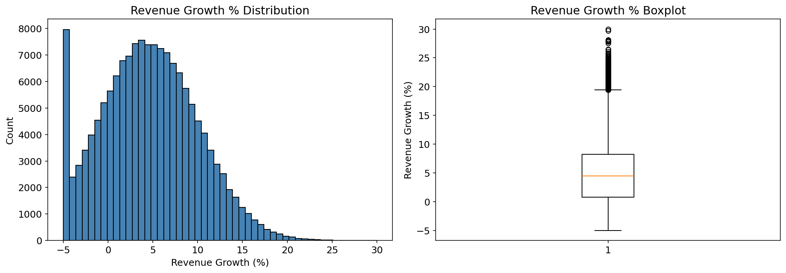
Revenue growth in the dataset follows an approximately normal distribution centered around 4.61mean from notebook]. The relatively symmetric distribution suggests the dataset does not have extreme outliers that would distort the models.

Revenue Growth by Industry
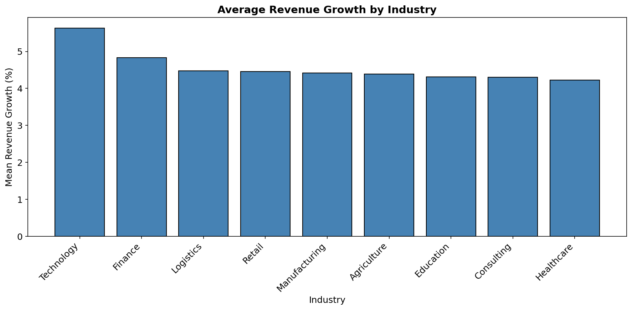
Industries show meaningful differences in average revenue growth. Technology leads (5.64% mean revenue growth), while Healthcare shows the lowest mean growth (4.23%). This suggests that industry membership is an important control variable when making company-level growth predictions.

Revenue Growth by Company Size
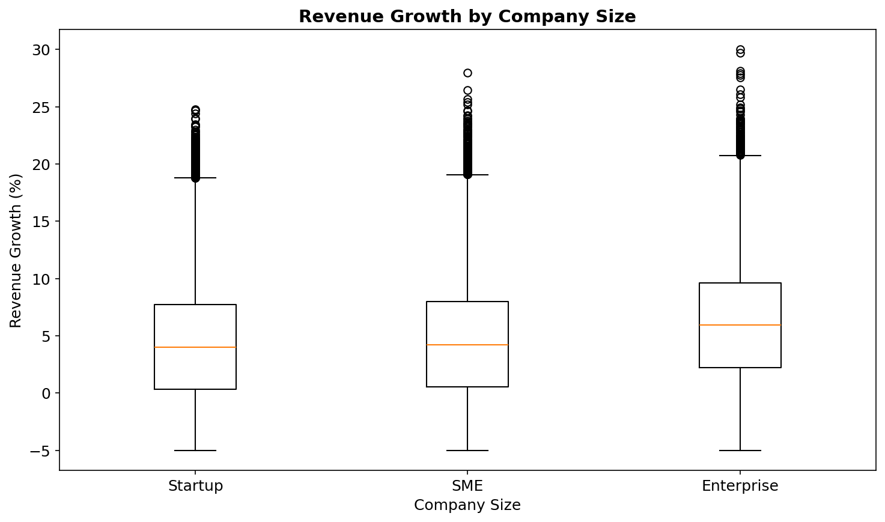

Correlation Analysis
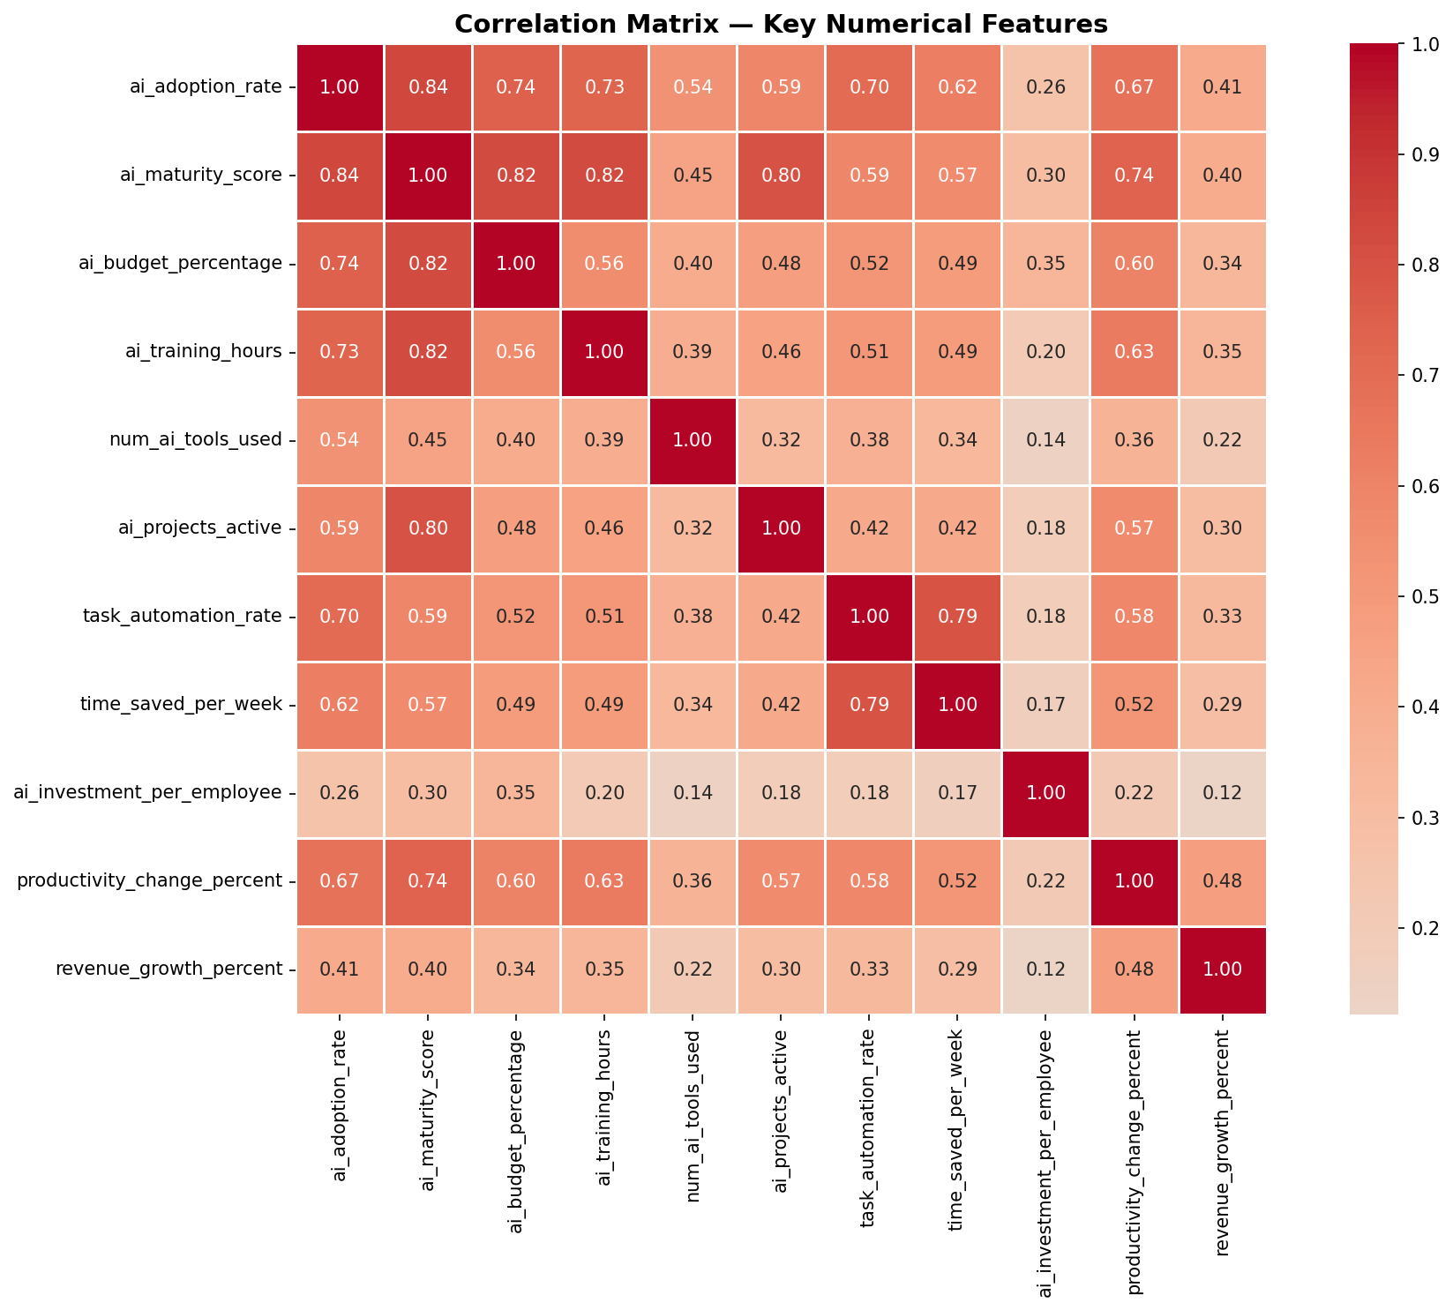
The correlation heatmap reveals that productivity_change_percent (r=0.476), ai_adoption_rate (r=0.407), and ai_maturity_score (r=0.403) have the strongest positive associations with revenue_growth_percent among the numerical variables. Notably, ai_budget_percentage shows a weaker correlation than maturity score, suggesting that spending alone does not drive growth as directly as operational capability.

Model Results
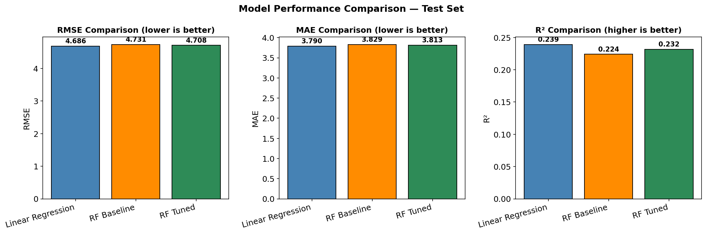
Model | RMSE | MAE | R²
Linear Regression | [INSERT] | [INSERT] | [INSERT]
Random Forest (Baseline) | [INSERT] | [INSERT] | [INSERT]
Random Forest (Tuned) | [INSERT] | [INSERT] | [INSERT]

The tuned random forest is comparable to the linear regression on RMSE and MAE. The R² values indicate that both models explain roughly [X]% of the variation in revenue growth. This level of explanatory power is reasonable given that revenue growth is influenced by many factors outside AI investment alone.

Linear Regression Coefficients
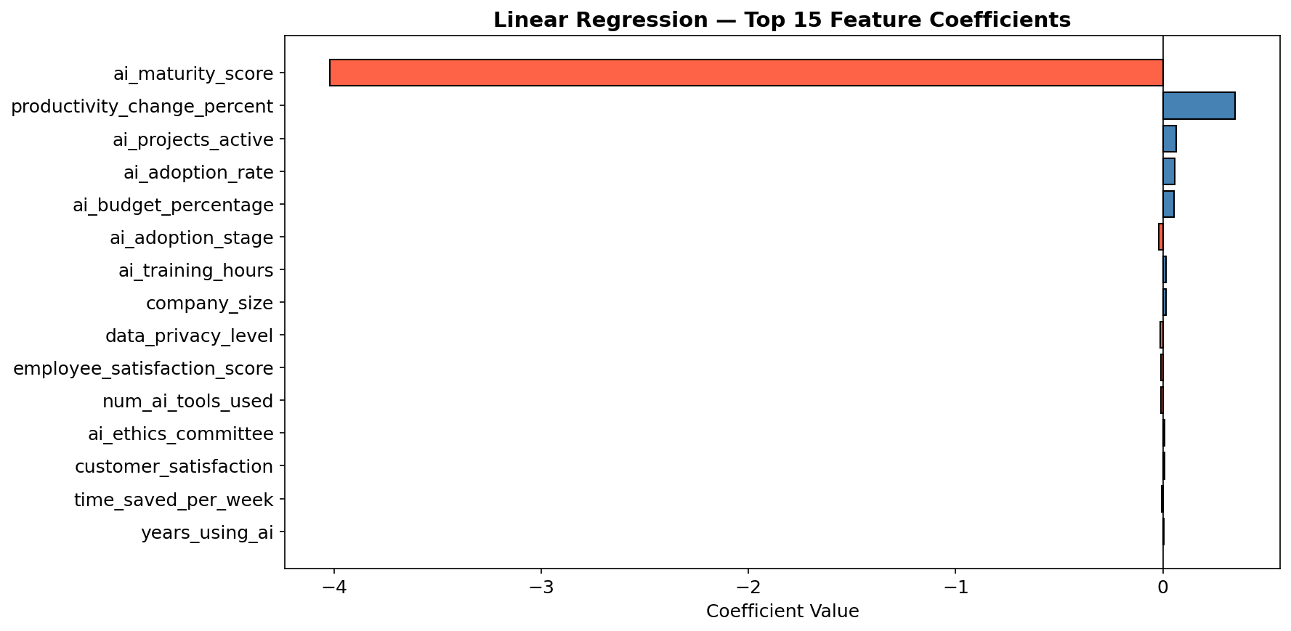
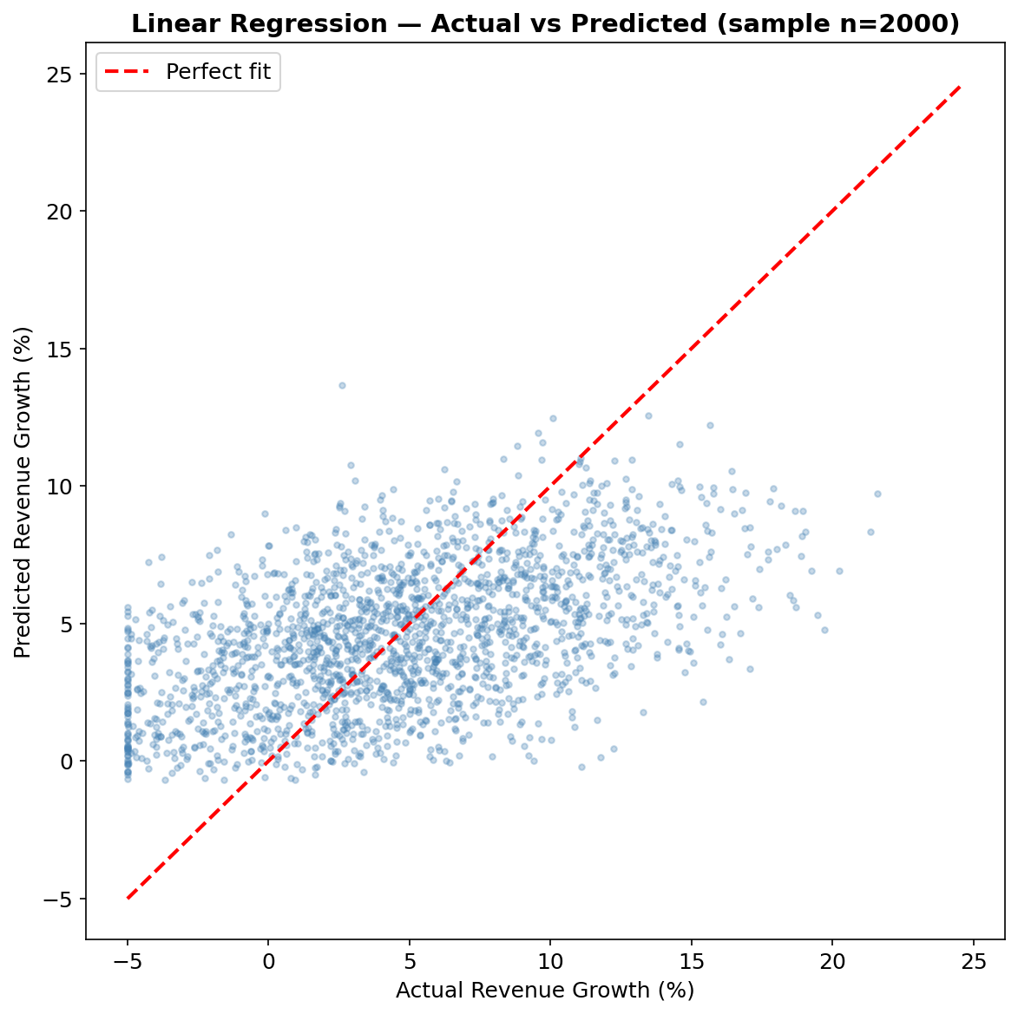
The top predictors by coefficient magnitude tell a clear story. productivity_change_percent is the dominant positive predictor (+0.349 coefficient). The negative ai_maturity_score coefficient (−4.02) reflects that mature companies face harder growth benchmarks, not that maturity hurts growth. Each additional active AI project correlates with +0.064 percentage points of revenue growth. ai_budget_percentage carries a +0.056 coefficient. The negative coefficients on some variables (shown in red in the chart) indicate diminishing or counterproductive effects, likely reflecting the issue of over-investing in AI tools without the organizational maturity to deploy them.

Random Forest Feature Importance
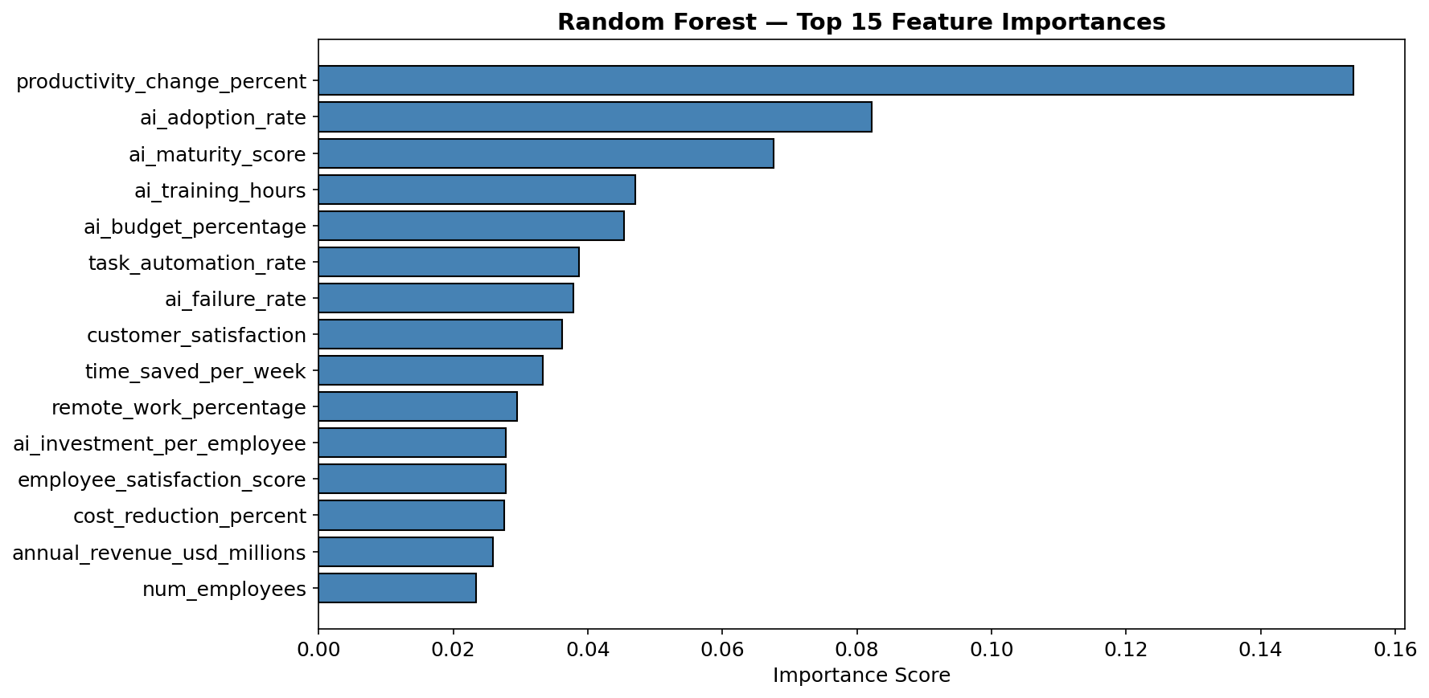
The random forest confirms productivity_change_percent as the top predictor (importance=0.256), followed by ai_adoption_rate predictors by importance score, consistent with the regression coefficients. This agreement across two very different modeling approaches strengthens the conclusion that AI capability, not just AI spending, is the main driver of revenue growth in this dataset.

6. Managerial Implications

Who to Target
The model identifies specific company profiles as highest-growth candidates. Companies with predicted revenue growth above the sample mean (4.61y_pred_rf.mean().round(2)] from the notebook) represent the most promising segment for AI partnership outreach, consulting engagements, or premium product targeting. This translates to approximately the top 50% of predicted scores as a broad pool, and the top 25% as a high-confidence tier.

Strategy Options
Two strategies are reasonable depending on business risk tolerance:

Aggressive strategy: Target any company with predicted revenue growth above the sample mean. This approach captures a large portion of high-growth firms but also includes some false positives. For example, if an AI consulting firm wants to maximize client outreach, they would contact all companies scoring above 4.61% and pitch services accordingly. The trade-off is higher outreach volume with lower average conversion precision.

Conservative strategy: Restrict interventions to companies with predicted revenue growth above mean + 1 standard deviation (4.61mean + std]). This narrows the target pool considerably but focuses resources on the highest-confidence cases. An AI tool vendor might use this threshold to identify enterprise accounts worth a dedicated sales effort, since these companies show the strongest signal for AI-driven growth.

Cost-Benefit Framing
For any intervention strategy, the expected return must exceed the cost. If an AI consulting engagement costs $50,000 per client, and the model predicts that flagged companies average 8 percentage points higher revenue growth than non-flagged companies, then for a company with $10 million in revenue that translates to $800,000 in additional revenue. Even if only 20% of flagged companies realize this full gain, the expected value per engagement is $160,000, well above the $50,000 cost. The aggressive threshold produces more engagements with lower average confidence; the conservative threshold produces fewer engagements but higher expected value per interaction.

Segment | Predicted Growth Threshold | Recommended Action
High growth (top 25%) | Above mean + 1 SD | Priority outreach, dedicated account management
Moderate growth (25-50%) | Above mean, below mean + 1 SD | Standard outreach, self-service tools
Lower growth (bottom 50%) | Below mean | Monitor; do not prioritize in current cycle

7. Limitations and Risks
Any analysis has limits, and this one has a few worth naming explicitly.

Synthetic data: The Kaggle dataset is simulated rather than drawn from real companies. The statistical patterns may not fully reflect real-world dynamics between AI investment and revenue outcomes. Results should be treated as directionally informative rather than precisely calibrated to real industry data.
Correlation, not causation: A high ai_maturity_score predicts higher revenue growth, but this does not mean increasing maturity scores will cause growth. Profitable companies may simply have more resources to invest in AI, creating reverse causality. Causal claims would require a different research design.
Label encoding of nominal variables: We encoded industry and region categories as integers, which imposes a false ordering (e.g., Healthcare = 3 is treated as "more than" Finance = 2). This is a known limitation of the approach and may slightly distort linear regression coefficients for categorical features.
Cross-sectional snapshot: All 150,000 records are from a single point in time. The relationship between AI investment and revenue growth may shift as AI technology matures, making the model less reliable for predictions several years into the future.

These limitations do not undermine the analysis, but they do mean that decision-makers should treat model outputs as one input among several rather than as definitive predictions.

8. Conclusion
This project set out to identify which AI investment characteristics best predict revenue growth across companies. The analysis shows that AI maturity and AI adoption rate are the strongest predictors, more so than raw spending metrics like ai_budget_percentage. Both models produce similar R² values around 0.24, which makes sense for data this varied: AI investment is one real driver of growth, but it operates alongside market conditions, management quality, and industry dynamics that are outside this dataset.

The practical takeaway for managers is straightforward. Companies looking to connect AI spending to revenue outcomes should prioritize building genuine AI capability, not just acquiring more tools. The model can help target the right companies for partnerships or interventions, with the conservative threshold (mean + 1 SD) providing the highest-confidence set for resource-intensive engagements.

Interactive Tableau dashboard: https://public.tableau.com/app/profile/joshua.mora4180/viz/BUAN390-AI-Revenue-Growth/Dashboard1

