Pair Programming 2 Turn In

Name: ___Braden Bell_________ Username: c1020a01 _____

Partner name: _Thomas Snyder________ Partner username: c1020a10_________

_**X**_ I certify that my partner worked with me on this assignment.

SCORE: ____________ (to be filled in by instructor)

2a (5 points)

**Main.c:**

/* File: exampleStart.c

* Author: Cindy Arnold

* Description: read/write names and salaries from/to a file

*/

#include "example.h"

#define MAX_NAME_LENGTH 21

#define ARRAY_LENGTH 5

int main()

{

Employee e[ARRAY_LENGTH];

int i;

int count;

count = readData( e );

printData( e, count );

return( 0 );

}

**Example.h:**

/* File: exampleStart.c

* Author: Cindy Arnold

* Description: read/write names and salaries from/to a file

*/

#ifndef EXAMPLE_H

#define EXAMPLE_H

#define MAX_NAME_LENGTH 21

#define ARRAY_LENGTH 5

typedef struct employee {

char name[MAX_NAME_LENGTH];

double salary;

} Employee;

int readData( Employee[] );

void printData( Employee[], int );

#endif

**Example.c:**

/* File: exampleStart.c

* Author: Cindy Arnold

* Description: read/write names and salaries from/to a file

*/

#include <stdio.h>

#include "example.h"

#define MAX_NAME_LENGTH 21

#define ARRAY_LENGTH 5

/* readData: reads data into array of Employee structures from stdin

* Parameters

* a the array

* Returns: number of elements read in

*/

int readData( Employee e[] ) {

int count = 0;

while( count < ARRAY_LENGTH &&

scanf( "%s%lf", e[count].name, &e[count].salary ) != EOF ) {

count++;

}

return count;

}

/* printData prints array of Employee structures to stdout in a formatted

* table

* Parameters

* e array of Employee structures

* n number of valid elements in array

* Returns nothing

*/

void printData( Employee e[], int n ) {

int i;

// print table heading

printf("Name Salary\n");

printf("---------------------------------\n");

for( i = 0; i < n; i++ ) {

printf("%-20s $%10.2lf\n", e[i].name, e[i].salary );

}

}

**Makefile:**

all: myprogram

myprogram: main.o example.o

gcc main.c example.c -o exampleExe

main: main.c example.h

gcc -c main.c

example: example.c example.h

gcc -c example.c

clean:

rm -rf *.o *.gch

2b (5 points)

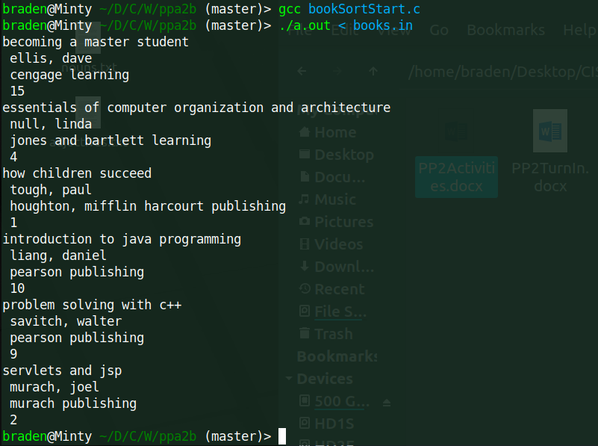

/* File: bookSort.c

* Author: Cindy

* Description: uses array of pointers to an

* array of structures to sort

*/

#include <stdio.h>

#include <string.h>

#define MAX_CHARS 81

#define MAX_BOOKS 10

typedef struct {

char title[MAX_CHARS];

char author[MAX_CHARS];

char publisher[MAX_CHARS];

int edition;

} book_t;

int readBooks( book_t* );

void initSortingArray( book_t*, book_t**, int );

void printBooks( book_t**, int );

void sortBooks( book_t**, int );

void swap( book_t**, book_t** );

int main() {

book_t books[MAX_BOOKS];

book_t* titlePtrs[MAX_BOOKS];

int numBooks;

numBooks = readBooks( books );

initSortingArray( books, titlePtrs, numBooks );

sortBooks( titlePtrs, numBooks );

printBooks( titlePtrs, numBooks );

return 0;

}

/* readBooks: fills book_t array with at most MAX_BOOKS

* book info from file books.in

* Parameters: a array of book structure

* Returns: number of books

*/

int readBooks( book_t* a ) {

FILE* in;

int i = 0;

char junk;

in = fopen( "books.in", "r" );

if ( in != NULL ) {

while ( i < MAX_BOOKS &&

fgets( a[i].title, MAX_CHARS, in ) != NULL ) {

fgets( a[i].author, MAX_CHARS, in );

fgets( a[i].publisher, MAX_CHARS, in );

fscanf(in, "%d", &a[i].edition );

fscanf(in, "%c", &junk );

i++;

}

}

return i;

}

/* initSortingArray: sets all pointers in array to point to

* books array

* Parameters:

* a books array

* t pointers to elements in books array

* n number of books in array a

* Postcondition: t contains n valid pointers to n elements in a

* Returns: nothing

*/

// ADD CODE HERE for the initSortingArray that initializes the array of pointers

void initSortingArray(book_t* a, book_t** t, int n ) {

for (int i = 0; i < n; i++) {

t[i] = &a[i];

}

}

/* printBooks: prints book info to stdout

* Parameters:

* aPtr: array of pointers to book_t structures

* n: number of valid element in n

* Returns: nothing

*/

void printBooks( book_t** aPtr, int n ) {

int i;

for( i = 0; i < n; i++ ) {

printf("%s %s %s %d\n", aPtr[i]->title, aPtr[i]->author,

aPtr[i]->publisher, aPtr[i]->edition );

}

}

/* sortBooks: uses a selection sort to sort book info

* Parameters:

* aPtr: array of pointers to book_t structures

* n: number of valid elements in aPtr

* Returns: nothing

*/

// ADD CODE HERE for the sort function that sorts/swaps the array of pointers

// NOT the array of books by book title

// MAKE SURE TO CALL THE swap FUNCTION!

void sortBooks(book_t** bookPtrs, int n) {

int i = 0;

int minI = 0;

int top = 0;

for (top = 0; top < (n - 1); top++) {

minI = top;

for (int i = (top + 1); i < n; i++) {

if(strcmp(bookPtrs[i]->title, bookPtrs[minI]->title) < 0) {

minI = i;

}

}

swap(&bookPtrs[minI], &bookPtrs[top]);

}

}

/* swap: swaps pointers to book_t array elements

* Parameters:

* b1, b2: references to pointers to book_t elements

* Postcondition: actual parameter pointer values swapped

* Returns: nothing

*/

// ADD CODE HERE TO swap the pointers to books in the array of pointers

void swap(book_t** b1 , book_t** b2) {

book_t* temp = *b1;

*b1 = *b2;

*b2 = temp;

}