Pair Programming 5 Turn In

Name: _____Braden Bell_____________________ Username: ___c1020a01________

Partner name: _____Thomas Snyder__________ Partner username: _____c1020a10_______

_X__ I certify that my partner worked with me on this assignment.

SCORE: ____________ (to be filled in by instructor)

5a (5 points)

**[PASTE THE SCREEN SHOT OF THE TESTS WITH A WHITE BACKGROUND FOR PAIR PROGRAMMIG 5A HERE]**

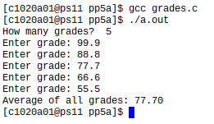

**[PASTE CODE FOR PAIR PROGRAMMING 5A HERE – NOT A SCREEN SHOT. DOWNLOAD THE UPDATED gradesStart.c. OPEN IT WITH A TEXT EDITOR LIKE NOTEPAD++ OR WORDPAD, COPY THE CODE, PASTE IT HERE. MAKE SURE IT IS SINGLE SPACED AND USE A COURIER NEW FONT]**

/* File: grades.c

* Author: Cindy Arnold

* Description: demonstrates dynamically allocates array

*/

#include <stdio.h>

#include <stdlib.h>

int main() {

int count, i;

// ADD CODE HERE TO declare pointer to grades (doubles)

double *grades;

double sum = 0, average = 0;

// as user how many grades

printf( "How many grades? " );

scanf( "%d", &count );

// ADD CODE HEE TO dynamically allocate count grades

grades = (double*) malloc(sizeof(double)*count);

// ADD CODE HERE TO get the grades

i = 0;

while (i < count) { //User populates grades array until it is full

printf("Enter grade: ");

scanf( "%lf", &grades[i]);

i++;

}

// ADD CODE HERE TO compute and print the sum and average

for (i = 0; i < count; i++) { //Calculate sum

sum += grades[i];

}

average = (sum /(double)count); //Calculate average

//printf("Sum of all grades: %0.2lf\n", sum);

printf("Average of all grades: %0.2lf\n", average); //Print average

free(grades); //Deallocate dynamic memory to prevent memory leaks

return 0;

}

5b (5 points)

**[PASTE THE SCREEN SHOT OF THE TESTS WITH A WHITE BACKGROUND FOR PAIR PROGRAMMIG 5B HERE]**

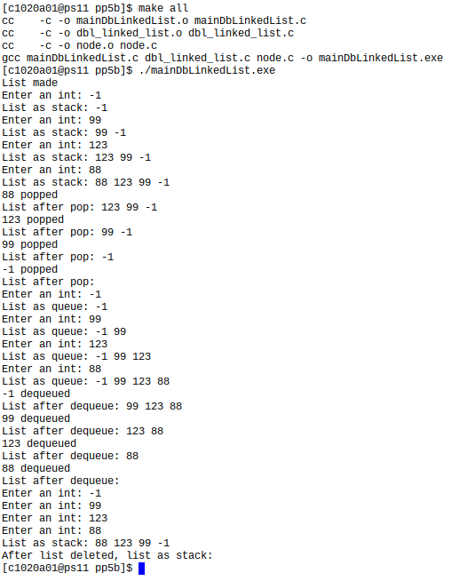

**[PASTE CODE FOR PAIR PROGRAMMING 5B HERE – NOT A SCREEN SHOT. DOWNLOAD node.h, node.c, dbl_linked_list.h, AND dbl_linked_list.c. OPEN THEM WITH A TEXT EDITOR LIKE NOTEPAD++ OR WORDPAD, COPY THE CODE, PASTE IT HERE. MAKE SURE IT IS SINGLE SPACED AND USE A COURIER NEW FONT]**

**node.h:**

#ifndef NODE_H

#define NODE_H

typedef struct node_t {

int i;

struct node_t* nextPtr;

struct node_t* prevPtr;

} node_t;

node_t* initNode(int);

#endif

**node.c:**

#include <stdio.h>

#include <stdlib.h>

#include "node.h"

/* initNode: initializes a node set up for a doubly linked list

* Parameters:

* i = the data to be stored in the node

* Returns: a pointer to the node

*/

node_t* initNode(int data) {

node_t* nodePtr;

nodePtr = malloc(sizeof(node_t));

nodePtr -> i = data;

nodePtr -> nextPtr = NULL;

nodePtr -> prevPtr = NULL;

return nodePtr;

}

**dbl_linked_list.h:**

#ifndef DBL_LINKED_LIST_H

#define DBL_LINKED_LIST_H

#include "node.h"

typedef struct {

node_t* headPtr;

node_t* tailPtr;

int count;

} dbl_linked_list_t;

void createList(dbl_linked_list_t*);

void insertNode(dbl_linked_list_t*, node_t*);

node_t* popNode(dbl_linked_list_t*);

node_t* dequeueNode(dbl_linked_list_t*);

void deleteList(dbl_linked_list_t*);

void traverseStack(const dbl_linked_list_t*);

void traverseQueue(const dbl_linked_list_t*);

#endif

**dbl_linked_list.c:**

#include <stdio.h>

#include <stdlib.h>

#include "dbl_linked_list.h"

/* createList: initializes the doubly linked list

* Parameters:

* listPtr - pointer to the list

* Returns: nothing

*/

void createList(dbl_linked_list_t* listPtr) {

if (listPtr != NULL) {

listPtr -> count = 0;

listPtr -> headPtr = NULL;

listPtr -> tailPtr = NULL;

}

}

/* insertNode: Inserts a new node in the first slot of the doubly linked list

* Parameters:

* listPtr - pointer to the list

* nPtr - points to the node

* Returns: nothing

*/

void insertNode(dbl_linked_list_t* listPtr, node_t* nPtr) {

if (listPtr != NULL) {//Make sure the list has been created by createList

listPtr -> count++;

if(listPtr -> headPtr == NULL ) { //If listPtr's list is empty

//printf("headPtr was NULL\n");

listPtr -> headPtr = nPtr;

listPtr -> tailPtr = nPtr;

}

else { //If listPtr's list is not empty

//printf("headPtr was not NULL\n");

nPtr -> nextPtr = listPtr -> headPtr;

listPtr -> headPtr -> prevPtr = nPtr;

listPtr -> headPtr = nPtr;

}

}

}

/* popNode: pops the first node out of the doubly linked list

* Parameters:

* listPtr - pointer to the list

* Returns: a pointer to the node that was popped

*/

node_t* popNode(dbl_linked_list_t* listPtr) {

if(listPtr != NULL && listPtr -> headPtr != NULL) { //If the list is not empty and it was initialized

listPtr -> count--; //A. Decriment count

node_t* nodePtr = listPtr -> headPtr; //B. nodePtr = the node at the end of the list

listPtr -> headPtr = listPtr -> headPtr -> nextPtr; //C. Set headPtr to point to next in the list

if (listPtr -> headPtr != NULL) { //If the list is still not empty

listPtr -> headPtr -> prevPtr = NULL; //Set headPtr's previous pouinter to NULL

}

else { //If the list is empty:

listPtr -> tailPtr = NULL; //set tailPtr to NULL

}

nodePtr -> prevPtr = NULL; //Set nodeptr's prev and next ptrs to NULL since the node's not in the list anymore

nodePtr -> nextPtr = NULL;

return nodePtr; //Return nodePtr

}

else

return NULL; //Return NULL

}

/* createList: Prints the data in the doublely linked list as if it were a list

* Parameters:

* listPtr - pointer to the list

* Returns: nothing

*/

void traverseStack(const dbl_linked_list_t* listPtr) {

if (listPtr != NULL) { //If list has been initialized

node_t* curPtr = listPtr -> headPtr; //curPtr = list's headPtr

while(curPtr != NULL) { //While curPtr isn't NULL

printf("%d ", curPtr -> i); //Print curPtr's data

curPtr = curPtr -> nextPtr; //Update curPtr to point to the next node

}

}

}

/* dequeueNode: initializes the list

* Parameters:

* listPtr - pointer to the list

* Returns: a pointer to the item dequeued

*/

node_t* dequeueNode(dbl_linked_list_t* listPtr) {

if(listPtr != NULL && listPtr -> headPtr != NULL) { //If the list is not empty and it was initialized

listPtr -> count--; //A. Decriment count

node_t* nodePtr = listPtr -> tailPtr; //B. nodePtr = the node at the end of the list

listPtr -> tailPtr = listPtr -> tailPtr -> prevPtr; //C. Set headPtr to point to next in the list

if (listPtr -> tailPtr != NULL) { //If the list is still not empty

listPtr -> tailPtr -> nextPtr = NULL; //Set headPtr's previous pouinter to NULL

}

else { //If the list is empty:

listPtr -> headPtr = NULL; //set tailPtr to NULL

}

nodePtr -> prevPtr = NULL; //Set nodeptr's prev and next ptrs to NULL since the node's not in the list anymore

nodePtr -> nextPtr = NULL;

return nodePtr; //Return nodePtr

}

else

return NULL; //Return NULL

}

/* traverseQueue: prints items in the dynamically linked list as if it were a queue

* Parameters:

* listPtr - pointer to the list

* Returns: nothing

*/

void traverseQueue(const dbl_linked_list_t* listPtr) {

if (listPtr != NULL) { //If list has been initialized

node_t* curPtr = listPtr -> tailPtr; //curPtr = list's tailPtr

while(curPtr != NULL) { //While curPtr isn't NULL

printf("%d ", curPtr -> i); //Print curPtr's data

curPtr = curPtr -> prevPtr; //Update curPtr to point to the next node

}

}

}

/* deleteList: Deletes the doubly linked list

* Parameters:

* listPtr - pointer to the list

* Returns: nothing

*/

void deleteList(dbl_linked_list_t* listPtr) {

if (listPtr != NULL && listPtr -> headPtr != NULL) { //If the list exists and is not empty

node_t* curPtr = listPtr -> headPtr; //curPtr = the list's headPtr

while(curPtr != NULL) { //While curPtr isn't null:

listPtr -> headPtr = curPtr -> nextPtr; //headPtr = curPtr's nextPtr

free(curPtr); //Deallocate curPtr's memory

curPtr = listPtr -> headPtr; //Update curPtr

}

listPtr -> tailPtr = NULL; //Set list's tail pointer to NULL

listPtr -> count = 0; //Set list's count to 0

}

}