Assignment1_Template
- For the variable ‘Height’ in the ‘trees’ data set, complete the following tasks.

- Calculate the mean, variance, and standard deviation. (20 pts)
Mean 76
Variance 40.6
Standard deviation 6.37

- Make a frequency distribution table. Make sure it includes the frequency, relative frequency, cumulative frequency and cumulative percentage. Do not exlude values which have a frequency of 0 (zero). Make sure your table is presented in APA style. Do not group the data into intervals. (60 points)

Table 1

Frequency Distribution Table for the Heights of Trees in the ‘trees’ Dataset

Height | f | Relative f | Cumulative f | Cumulative %
63 | 1 | 0.03 | 1 | 3
64 | 1 | 0.03 | 2 | 6
65 | 1 | 0.03 | 3 | 10
66 | 1 | 0.03 | 4 | 13
67 | 0 | 0 | 4 | 13
68 | 0 | 0 | 4 | 13
69 | 1 | 0.03 | 5 | 16
70 | 1 | 0.03 | 6 | 19
71 | 1 | 0.03 | 7 | 23
72 | 2 | 0.06 | 9 | 29
73 | 0 | 0 | 9 | 29
74 | 2 | 0.06 | 11 | 35
75 | 3 | 0.1 | 14 | 45
76 | 2 | 0.06 | 16 | 52
77 | 1 | 0.03 | 17 | 55
78 | 1 | 0.03 | 18 | 58
79 | 1 | 0.03 | 19 | 61
80 | 5 | 0.16 | 24 | 77
81 | 2 | 0.06 | 26 | 84
82 | 1 | 0.03 | 27 | 87
83 | 1 | 0.03 | 28 | 90
84 | 0 | 0 | 28 | 90
85 | 1 | 0.03 | 29 | 94
86 | 1 | 0.03 | 30 | 97
87 | 1 | 0.03 | 31 | 100
Total | 31

Note. These trees are tall.

- Make a frequency distribution graph with the normal curve superimposed on it. Plot the scores on the x axis and the frequency on the y axis. Make sure your graph is presented in APA style. Do not group the data into intervals. (30 points)
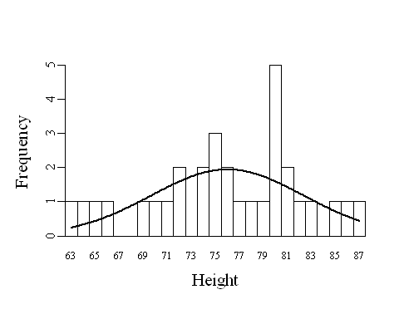

- Make a histogram of the frequency data. Looking at the histogram, describe the distribution as you have been instructed in class (not as ‘pretty,’ ‘fun,’ ‘strange,’ etc.). (15 points)
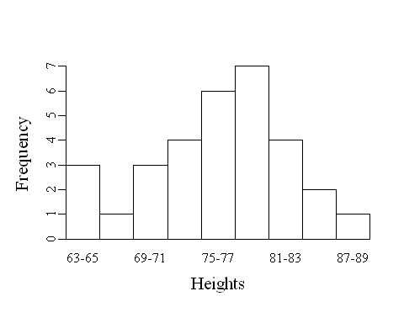
- Make a boxplot. (10 points)
