Weight
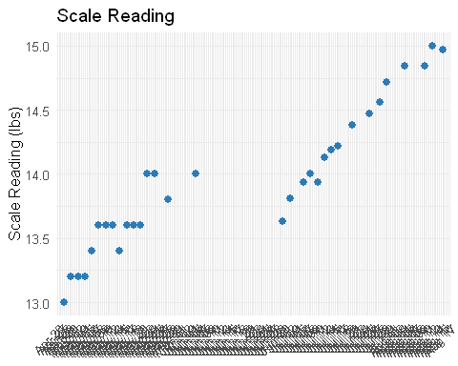
Date | Lbs | Oz | Scale.reading
2026-04-28 | 13 | 1.0 | 13.00
2026-04-30 | 13 | 2.0 | 13.20
2026-05-02 | 13 | 2.0 | 13.20
2026-05-04 | 13 | 2.0 | 13.20
2026-05-06 | 13 | 5.0 | 13.40
2026-05-08 | 13 | 8.0 | 13.60
2026-05-10 | 13 | 8.0 | 13.60
2026-05-12 | 13 | 8.0 | 13.60
2026-05-14 | 13 | 5.0 | 13.40
2026-05-16 | 13 | 8.0 | 13.60
2026-05-18 | 13 | 8.0 | 13.60
2026-05-20 | 13 | 8.0 | 13.60
2026-05-22 | 13 | 15.0 | 14.00
2026-05-24 | 13 | 15.0 | 14.00
2026-05-28 | 13 | 12.0 | 13.80
2026-06-05 | 14 | 0.0 | 14.00
2026-06-29 | NA | NA | NA
2026-06-30 | 13 | 10.0 | 13.63
2026-07-02 | 13 | 13.0 | 13.81
2026-07-06 | 13 | 15.0 | 13.94
2026-07-08 | 14 | 0.0 | 14.00
2026-07-10 | 13 | 15.0 | 13.94
2026-07-12 | 14 | 2.0 | 14.13
2026-07-14 | 14 | 3.0 | 14.19
2026-07-16 | 14 | 3.5 | 14.22
2026-07-20 | 14 | 6.0 | 14.38
2026-07-25 | 14 | 7.5 | 14.47
2026-07-28 | 14 | 9.0 | 14.56
2026-07-30 | 14 | 11.5 | 14.72
2026-08-04 | 14 | 13.5 | 14.84
2026-08-10 | 14 | 13.5 | 14.84
2026-08-12 | 15 | 0.0 | 15.00
2026-08-15 | 14 | 15.5 | 14.97

