**Generative Deep Learning**

**Tasks to do Lab 6 – Lines and curves Generation**

בראדלי פייצוויג 311183073

דייויד נשאש 321522302

**1.Generation of lines with negative slope**

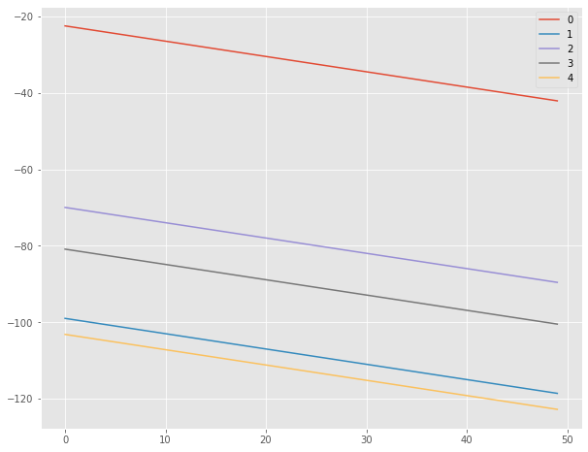

**Real:**

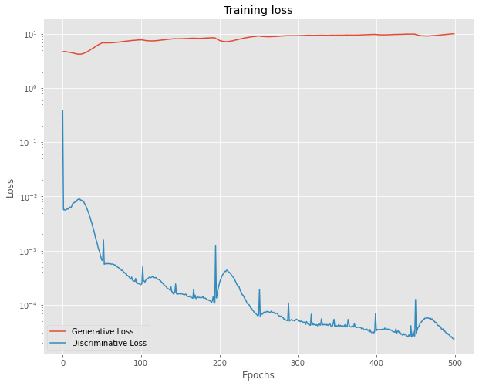

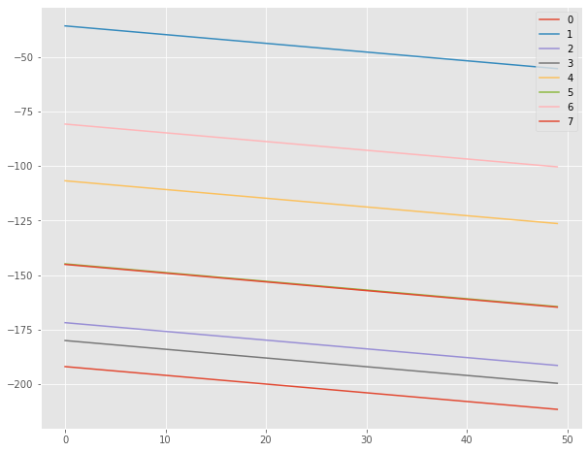

**Generated:**

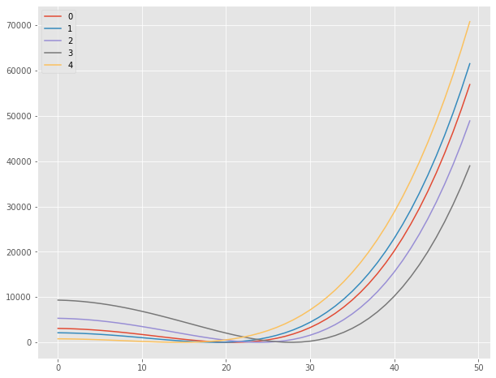**1.Generation of second curve**

**Real:**

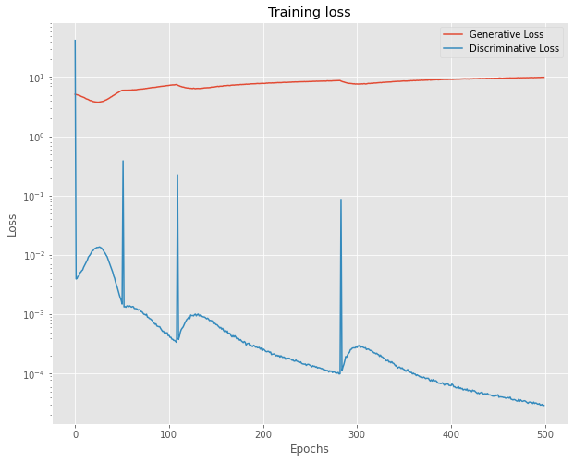

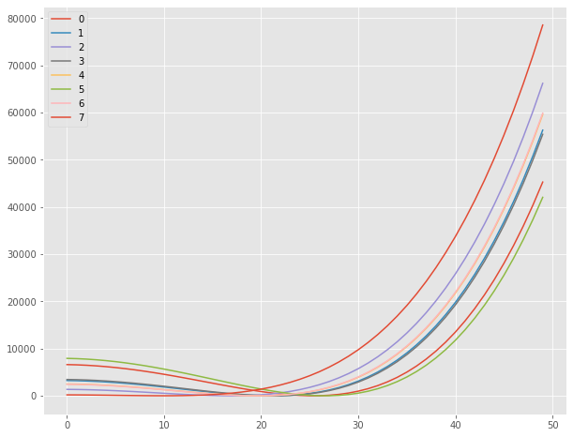

**Generated:**