Avenza for GSAR Basic Guide
Avenza is a free app available on iOS and Android devices that can display maps generated in CalTopo on your phone or tablet. More than just showing an image, Avenza uses “GeoReferenced” PDFs, so Avenza knows where you are on your map, and can provide you coordinates, azimuth / bearing, or distance to other locations on that map. Think of it as a very fancy and smart paper map.

Installing

Search for ‘Avenza’ on your devices store, or use the following link
https://store.avenza.com/pages/app-features

Importing a Map
- You will need an internet connection (WiFi, Mobile Data, etc)
- Open the Avenza app
- Next, either read the getting started information, or select ‘Skip’ in the top right corner. An account is not needed, but you’re welcome to create one.
- tap  for Android users, or for iOS users, followed by "Download or import a map"
- Scan the QR Code on the CalTopo map. Avenza Maps features a built-in QR code reader.
  - Tap the QR Code icon in the top right corner. 
  - If this is the first time you are using the app, you will need to allow the app access to the device camera.
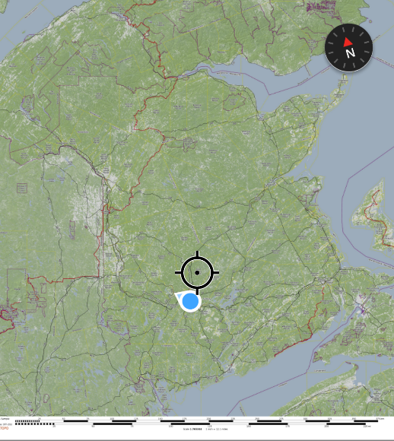
  - Scan the QR code, The map will be download and ready for offline use
- Click the map name / code in your map list to access it
- You will be prompted to allow avenza to access your location, you should allow precise access while using the app
- Your location will now be shown on the map
- Tap the coordinate at the bottom of the screen to change from the default degree to MGRS / USNG for SAR use.
- You now have access to detailed georeferences offline maps!
- With the free version you can only have 3 maps at a time, and will have to delete older maps to use more.
If you’re in Canada (south of the Archipelago) and have followed the steps above, you should see your location on the Overview map below
Note: Because the map is created at a fixes scale, zooming in, especially from a provincial overview, will not show additional details. For a more detailed map try out the below link to Fundy National Park in NB
All of Canada Overview |  | Fundy National Park (Coastal) | 
https://caltopo.com/p/P619D |  | https://caltopo.com/p/U21AR

