Unable to get authentication with a registry:2 to work by following the docker instructions, under Restricting access; Native basic auth; https://docs.docker.com/registry/deploying/. Documentation is miss the line;
-e “REGISTRY_AUTH=htpasswd” \
in the box starting with docker run -d -p 5000:5000 ...

Was able to get authentication with registry:2 to work when a web search found http://github.com/docker/distribution/blob/master/docs/deploying.md
which had the missing line.
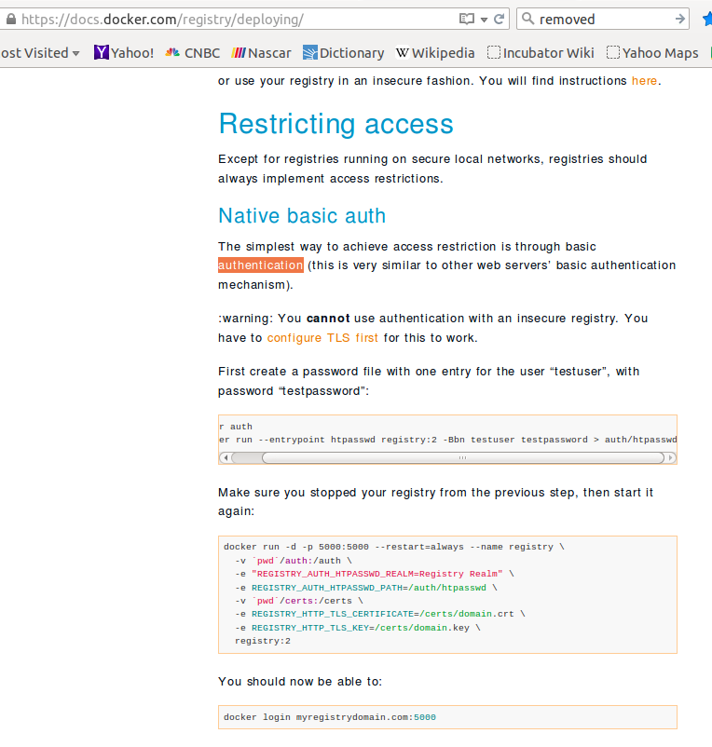

Another incident with getting authentication with a registry:2 to work on same page; Restricting access; Managing with Compose https://docs.docker.com/registry/deploying/. Documentation has the wrong the line;
REGISTRY_STORAGE_FILESYSTEM_ROOTDIRECTORY: /var/lib/registry
in the box starting with registry: ...

The http://github.com/docker/distribution/blob/master/docs/deploying.md
which has the correct line for authentication with a registry:2 and not the REGISTRY_STORAGE.. line. Was not able to test this with compose at this time.
REGISTRY_AUTH: htpasswd

