Project Concept

# Description

My project will be the game tic-tac-toe, where a human player goes against an AI. The AI will be where most of the complexity lies as it will use information from previous matches as a way to determine what it thinks the best list of moves to make is.

# Libraries

The Project currently does not rely on any third-party libraries other than the .Net library.

# Testing

The project makes use of unit tests and asserts to ensure that each tested class is behaving correctly, and creates a barrier for regressions.

To run the tests, open the solution in Visual Studio and use the shortcut [CTRL+R A], or use the ‘Test’ menu at the top of the screen:

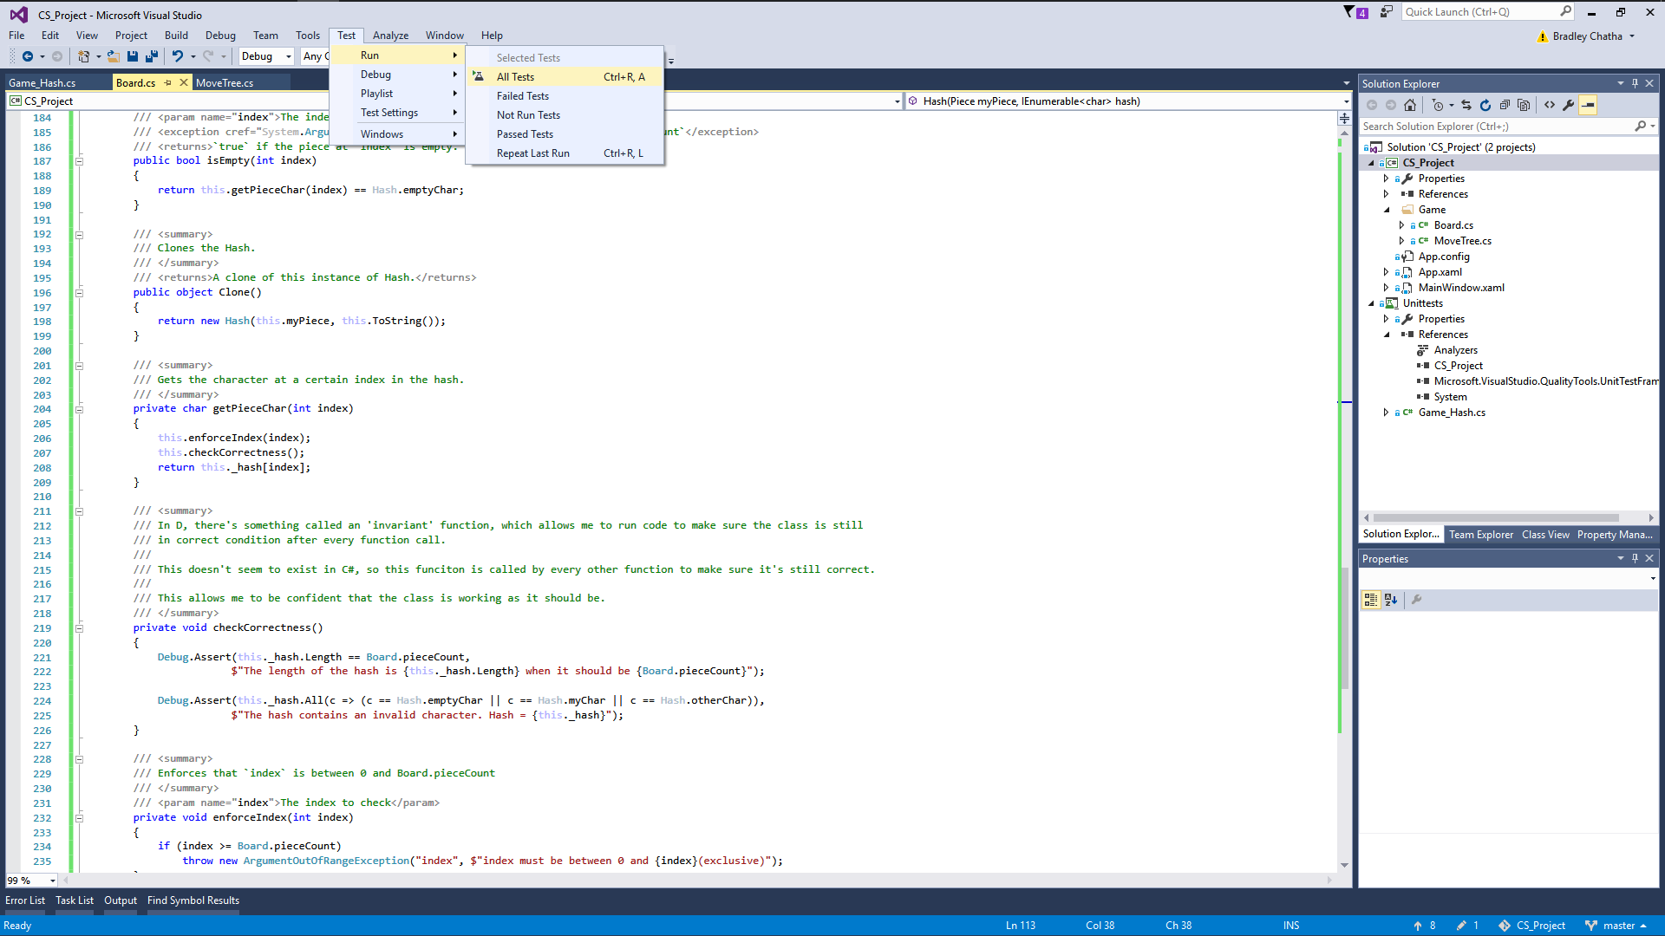

# Tooling

* Visual Studio 2015
* Git