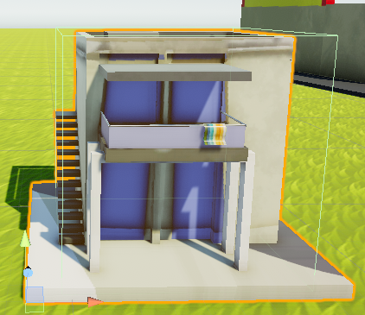Prefab Layout:



This particular prefab was initially sized at 5m (hence the 5m mesh). Prefabs should have a root object that contains the functionality/scripts. Meshes should be contained in a separate child object.

Required Properties for **Structures**:

* **Tag**: MUST be set as appropriate or most effects (eg damage) will not apply correctly.
* **Colliders**: Can be set as appropriate on the root object, but at least one is required.
* **Transform**:The entity’s mesh should never pass into negative XZ space. In other words, all geometry should be to the fore and right of the entity’s origin (as pictured top-right).
* 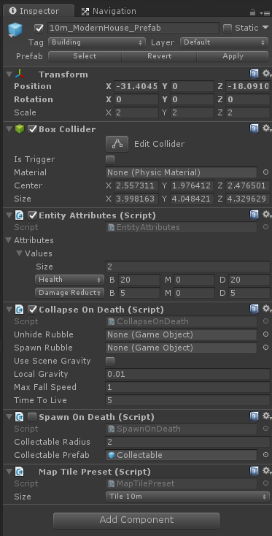**Entity Attributes (script)**: Contains all of the major gameplay attributes. Initialise with:
  + **Damage Reduction**:
    - Structure 5m: 5
    - Structure 10m: 10
    - Structure 20m: 20
    - Structure 30m: 30
    - Structure 40m: 40
    - Structure 80m: 80
  + **Health**:
    - Structure 5m: 10
    - Structure 10m: 20
    - Structure 20m: 30
    - Structure 30m: 40
    - Structure 40m: 50
    - Structure 80m: 80
* **Collapse On Death (Script)**:
  + Rubble: If the prefab contains a rubble child object, attach it under **Unhide Rubble**. Otherwise, if there is a global rubble prefab attach it under **Spawn Rubble**.
* **Spawn On Death (Script)**:
  + Only required if the structure will spawn a ‘collectable’
* **Map Preset (Script)**:
  + Size: Size of structure along one side.