## Scripted Objects live here:

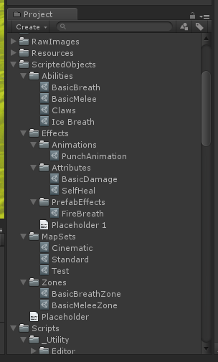

## Create New Ability:

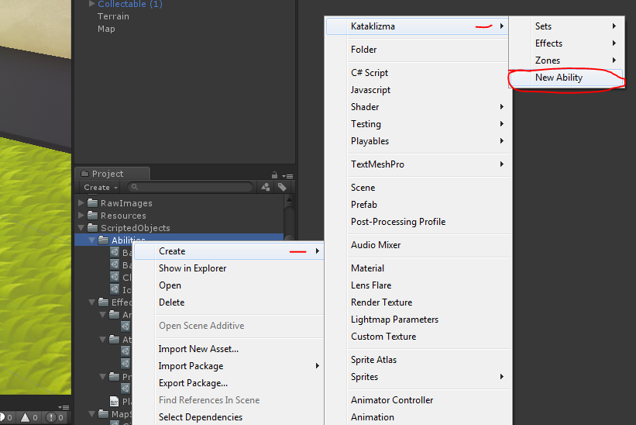

## Ability Properties:

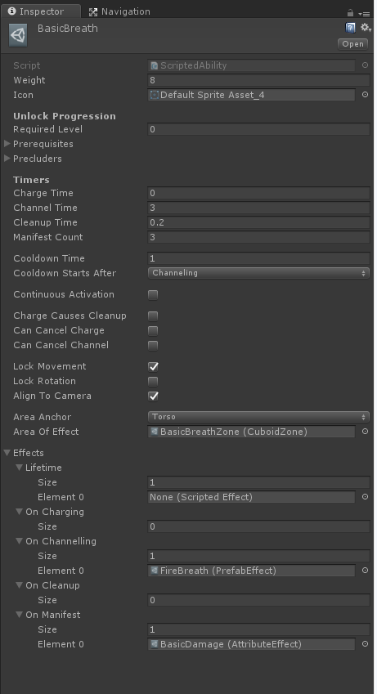

**Charge Time:** Time between activation request and channeling begins

**Channel Time:** Time during which ability “manifests” its effects (ie, “proc”-ing)

**Cleanup Time:** Time AFTER channeling (or charging, if opted in) before the ability is completed.

**Manifest Count:** Number of procs per channeling (Minimum 1)

**Cooldown Time:** Time before ability can be reactivated

**Cooldown Starts After:** When cooldown applies

**Continuous Activation:** Is ability continuously system-activated

**Charge Causes Cleanup:** Cleanup timer required even if Channeling never occurs

**Can Cancel Charge:** Can Charge time be skipped

**Can Cancel Channel:** Can Channel time be skipped

**Lock Movement:** Stop Character from moving (translating) while ability is active

**Lock Rotation:** Stop Character from rotating while ability is active

**Align To Camera:** Lock Character in “chase cam” when ability is active

**Area Anchor:** Body location that AoE is anchored to

**Area of Effect:** ScriptedZone to determine AoE. Null indicates self-only ability.

**Effects/Lifetime:** Apply/Activate all effects when this ability is added/bound to the character

**Effects/OnCharging:** Apply/Activate all effects when ability starts “charging”

**Effects/OnChannelling:** Apply/Activate all effects when ability starts “channeling”

**Effects/OnCleanup:** Apply/Activate all effects when ability starts “cleanup”

**Effects/OnManifest:** Apply/Activate all effects when ability triggers a “manifest” (Max(1, Manifest Count) per full channel)

## Create Zone:

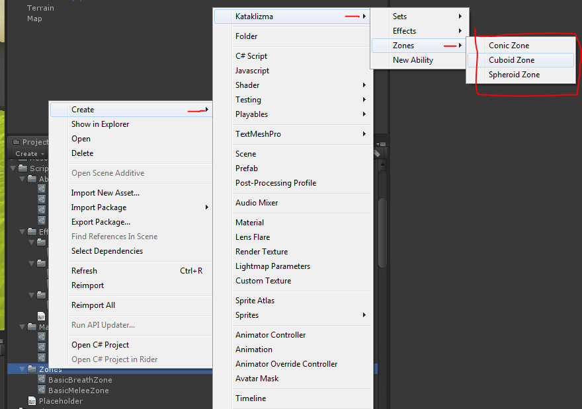

## Zone Properties (Cuboid Zone):

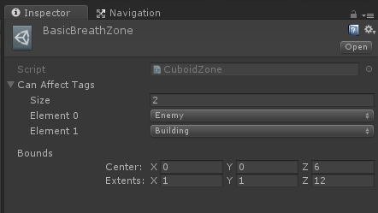

## Create Effects:

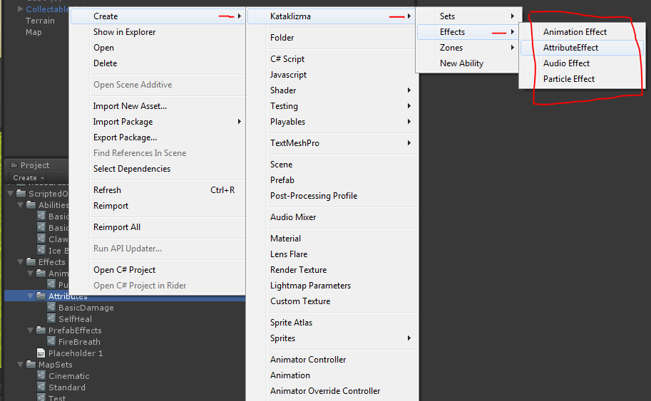

## Effect Properties (Attribute Effect):

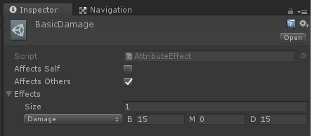

## Effect Properties (Prefab Effect):

