**Continuous BCI Paradigm**

Contents

Experimental Outline 2

1: Baseline 3

1.1: Collecting Motor Imagery Baseline Data 3

1.2: Preparing Matlab for BCI 3

1.2a: SYSTEM 3

1.2b: Sensor BCI 4

1.4: Collecting Discrete Baseline BCI Data 8

2: Training 9

2a: Collecting Motor Imagery Training Data 9

**2.1 Collecting Continuous Training BCI Data** 9

**2.2 Collecting Discrete Training BCI Data** 9

2b: Collecting Motor Imagery Training Data 10

**3: Evaluation** 10

3.1: Collecting Motor Imagery Evaluation Data 10

3.2: Collecting Continuous BCI Evaulation Data 10

3.3: Collecting Discrete BCI Evaluation Data 11

**4: Source vs. Sensor (Continuous)** 11

**4.1: Collecting Motor Imagery Data** 11

4.2: Preparing Matlab 11

4.2a: Preparing Matlab: SYSTEM 11

4.2b: Preparing Matlab: SOURCE IMAGING 13

4.2c: Preparing Matlab: ESI BCI 15

4.3: Continuous Control 16

# Experimental Outline

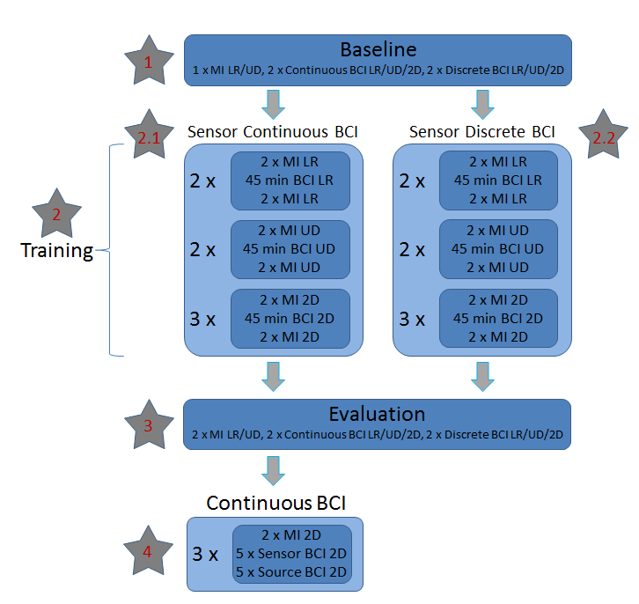

# 1: Baseline

## 1.1: Collecting Motor Imagery Baseline Data

1. Open windows explorer and navigate to “D:\Brad\bci_Continuous\BCI2000\batch and double click on the “MI_cc_EEG.bat” batch file where “cc” represents the LR/UD/2D dimension of interest.
2. Under Storage Tab:
   1. Enter subject initials after last backslash
   2. Replace “xx” with subject initials, “mm” with month, “dd” with the day, and “cc” with the dimension abbreviation in the subject name:

“xx_MI_cc_BASELINE _2016mmdd”

1. Click on “Set Config” and “Start” in BCI2000
2. Repeat 1 x for LR and UD, Close BCI2000

## 1.2: Preparing Matlab for BCI

### 1.2a: SYSTEM

1. Open Matlab 2015b (if already open, close and re-open)
2. Type “bci_ESI_Continuous” into command window and press enter
   1. The bci_ESI_Continuous GUI should pop up
3. Click on “Load Param”
   1. Navigate to “D:\Brad\bci_Continuous\bci_fESI_Continuous

\from_Brad\bci_fESI_PARAM” folder and open “SYSTEM_Default.mat”

* 1. If default param file is not there, copy figure to the right. When selecting sensors, select the “motor parietal” montage option.

1. Enter Subject Info
   1. Initials
   2. Session
   3. Run
2. Click on “Set System Parameters”

### 1.2b: Sensor BCI

1. In the “Training Data” panel (top right), click on “Add” and navigate to “D:\Brad\bci_Continuous\BCI2000\data\” and load the two training runs (.dat files) for LR and UD previously collected. Load the LR file first and the UD file second.

1. Select “Sensor” from the spatial domain drop down menu in the “System Parameters” panel (top left)
2. Click on “Perform Regression” button in “Training Data” panel
3. Inspect regression results
   1. Inspect “Sensor Task 1 vs 2” results for horizontal dimension and “Sensor Task 3 vs 4” for vertical dimension (try to identify a single frequency with the largest R-squared values and try this one first in step 5)

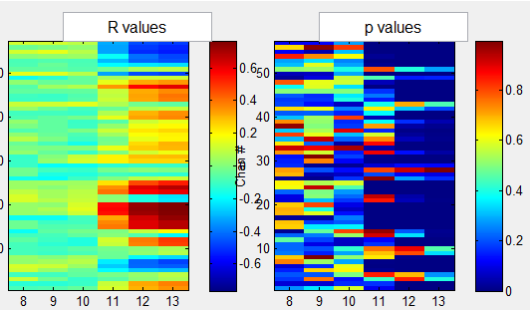

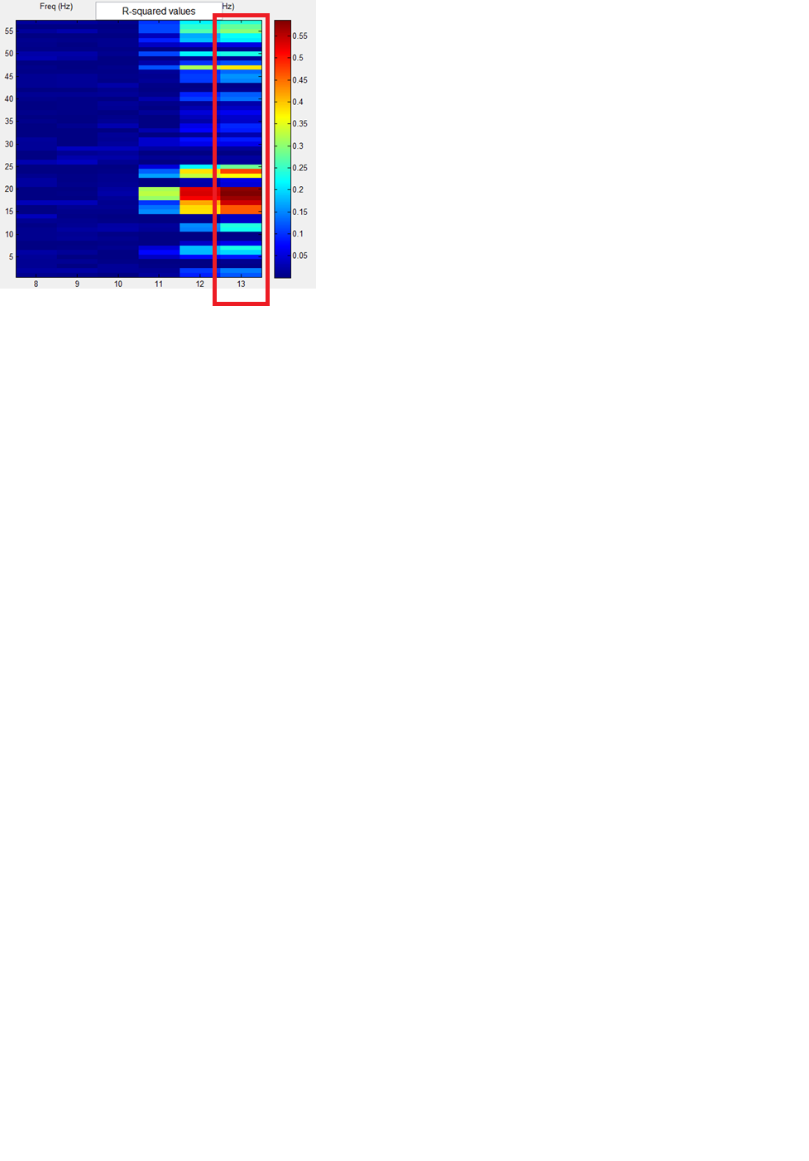

1. Type in 250 for the “Analysis Window” and 100 for the “Update Window”
2. In “BCI Parameters” panel , for each dimension used:
   1. Select the movement type in the “Dimension” drop down menu (i.e.. horizontal, vertical)
   2. Select the task pairing in the “Tasks” drop down menu (i.e. 1 vs 2, 3 vs 4)
   3. Select a frequency based on your inspection of the regression results in the “Frequency” drop down menu
   4. Click on the “Loc #” button to select channels and weights
      1. At least 1 channel should be automatically added to the data list; if no channels survive the statistical tests, select a different frequency and repeat
      2. If no channels survive for any of the frequencies (8-13), select 11 Hz as the frequency. Scroll down to the numbers corresponding to C3 and C4 and add them to the list. A +/-1weight should automatically be added to the right column based on the regression results.

Note: the numbers of C3 and C4 will vary based on which electrode montage is used. You can click on the “Current Electrodes Montage” button at the bottom of the GUI and click on C3 – D19 and C4 – B22 to determine which number they are.

* + 1. Click on the “Save and Close” button.
  1. Once a frequency and channels have been selected, set the scale for that particular dimension
  2. Set “Cycle Length” to 30 and “Buffer Length” to 5
  3. Set “Display Control Sig” to the checked state.
  4. Press “Check BCI” and then “Set BCI”

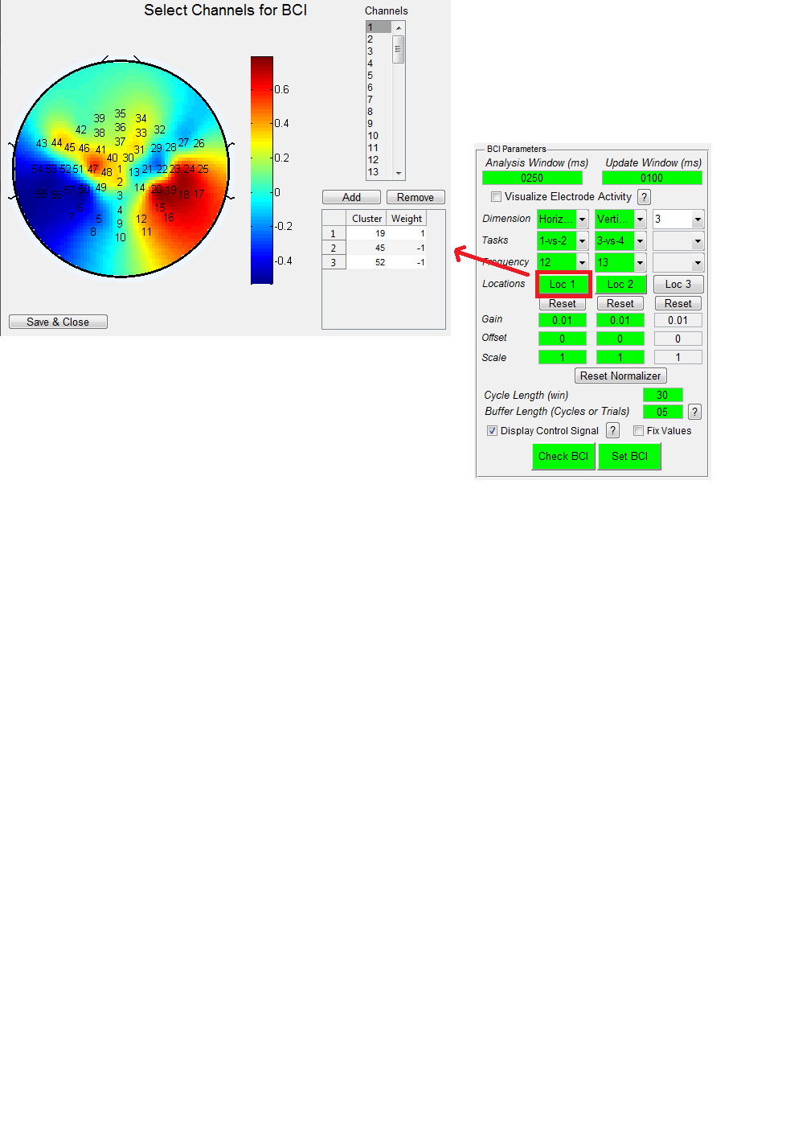

**1.3: Collecting Continuous Baseline BCI Data**

1. In the Matlab GUI, select “Continuous BCI” in the “Task Type” drop-down menu and make sure that “Sensor” is selected in the “Analysis Domain” drop-down menu.
2. Open windows explorer and navigate to “D:\Brad\bci_Continuous\BCI2000\batch and double click on the “CP_cc_FT_EEG.bat” batch file where “cc” represents the LR/UD/2D dimension of interest.
3. Under Storage Tab:
   1. Enter subject initials after last backslash
   2. Replace “xx” with subject initials, “mm” with month, “dd” with the day, and “cc” with the dimension abbreviation in the subject name:
   3. “xx_CP_cc_BASELINE _2016mmdd”
4. Under “**Filtering**” tab:
   1. Click on “Edit Matrix” to the right of “FTInitialOutput” – make sure that the matrix is one column and **two rows** (both 0)

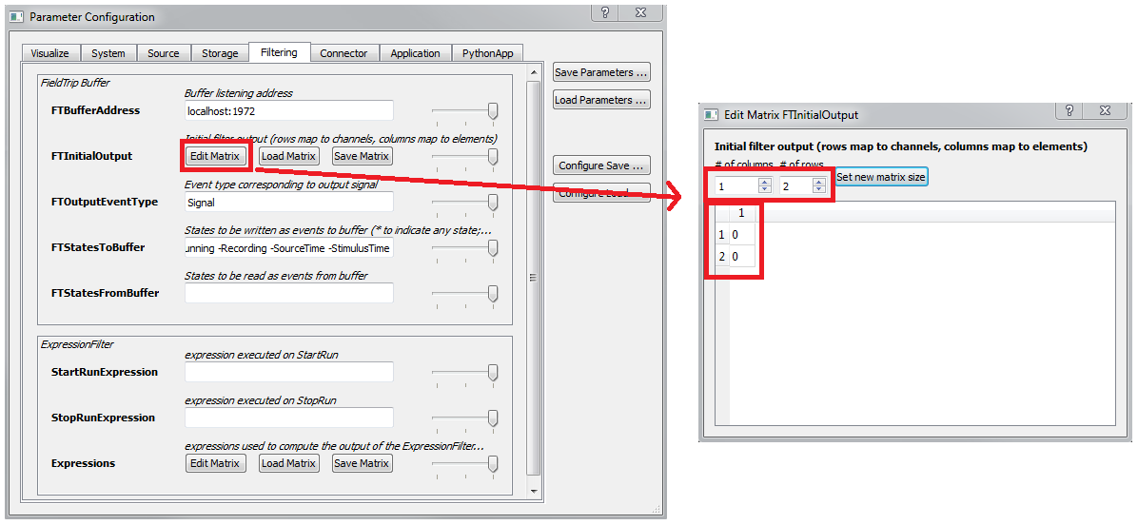

1. 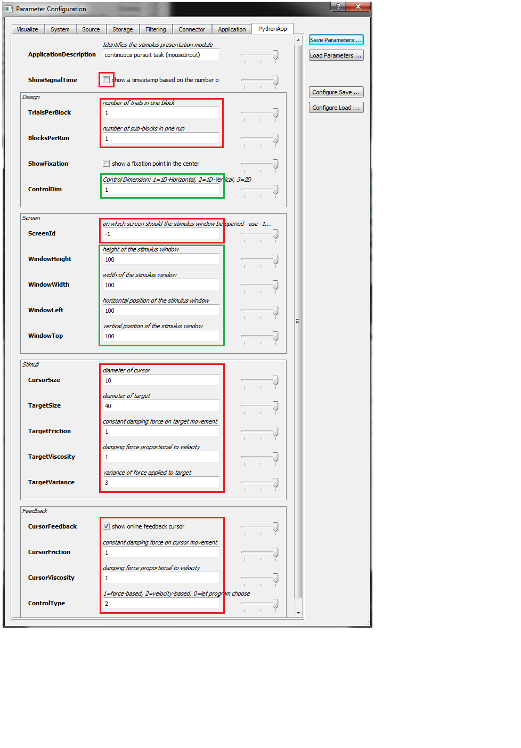Under “**PythonApp**” tab:

(Red – Don’t change)

(Green – Change as needed)

* 1. “ShowSignalTime” – Off
  2. “TrialsPerBlock – 1
  3. “BlocksPerRun – 2
  4. “ShowFixation – Off
  5. “ControlDim” – Change
  6. “ScreenId” – -1
  7. “WindowHeight” – Change
  8. “WindowWidth” – Change
  9. “WindowLeft” – Change
  10. “WindowTop” – Change
  11. “CursorSize” – 10
  12. “TargetSize” – 40
  13. “TargetFriction” – 1
  14. “TargetViscosity” – 1
  15. “TargetVariance” – 3
  16. “CursorFeedback” – On
  17. “CursorFriction” – 1
  18. “CursorViscosity” – 1
  19. “ControlType” – 2

1. Close out of configuration window
2. Click on “Set Config” in BCI2000
3. Press “Start” in BCI2000 and as soon as possible, click “StartBCI” in the Matlab GUI
4. Click on “Set Config” and “Start” in BCI2000
5. Repeat 2 x for LR, UD, and 2D, Close Matlab & BCI2000

## 1.4: Collecting Discrete Baseline BCI Data

1. In the Matlab GUI, select “Traditional BCI” in the “Task Type” drop-down menu and make sure that “Sensor” is selected in the “Analysis Domain” drop-down menu.
2. Open windows explorer and navigate to “D:\Brad\bci_Continuous\BCI2000\batch and double click on the “DT_cc_FT_EEG.bat” batch file where “cc” represents the LR/UD/2D dimension of interest.
3. Under Storage Tab:
   1. Enter subject initials after last backslash
   2. Replace “xx” with subject initials, “mm” with month, “dd” with the day, and “cc” with the dimension abbreviation in the subject name:

“xx_DT_cc _BASELINE _2016mmdd”

1. Under “**Filtering**” tab:
   1. Click on “Edit Matrix” to the right of “FTInitialOutput” – make sure that the matrix is one column and **three rows** (all 0)
2. Click on “Set Config” and “Start” in BCI2000, and as soon as possible click on “Start BCI” in the Matlab GUI
3. Repeat 2 x for LR, UD, and 2D, Close Matlab & BCI2000

# 2: Training

## 2a: Collecting Motor Imagery Training Data

1. Open windows explorer and navigate to “D:\Brad\bci_Continuous\BCI2000\batch and double click on the “MI_cc_EEG.bat” batch file where “cc” represents the LR/UD/2D dimension of interest.
2. Under Storage Tab:
   1. Enter subject initials after last backslash
   2. Replace “xx” with subject initials, “mm” with month, “dd” with the day, and “cc” with the dimension abbreviation in the subject name:

“xx_MI_cc_TRAIN _2016mmdd”

1. Click on “Set Config” and “Start” in BCI2000
2. Repeat 2 x for dimension of interest, close BCI2000

**2.1 Collecting Continuous Training BCI Data**

1. See 1.2 & 1.3
2. Open windows explorer and navigate to “D:\Brad\bci_Continuous\BCI2000\batch and double click on the “CP_cc_FT_EEG.bat” batch file where “cc” represents the LR/UD/2D dimension of interest.
3. Under Storage Tab:
   1. Enter subject initials after last backslash
   2. Replace “xx” with subject initials, “mm” with month, “dd” with the day, and “cc” with the dimension abbreviation in the subject name:

“xx_CP_cc _EVAL _2016mmdd”

1. Click on “Set Config” and “Start” in BCI2000
2. Repeat 20 x for dimension of interest, close Matlab & BCI2000

**2.2 Collecting Discrete Training BCI Data**

1. See 1.2 & 1.4
2. Open windows explorer and navigate to “D:\Brad\bci_Continuous\BCI2000\batch and double click on the “DT_cc_FT_EEG.bat” batch file where “cc” represents the LR/UD/2D dimension of interest.
3. Under Storage Tab:
   1. Enter subject initials after last backslash
   2. Replace “xx” with subject initials, “mm” with month, “dd” with the day, and “cc” with the dimension abbreviation in the subject name:

“xx_DT_cc _TRAIN _2016mmdd”

1. Click on “Set Config” and “Start” in BCI2000
2. Repeat 10 x for LR, UD, and 2D, Close Matlab & BCI2000

## 2b: Collecting Motor Imagery Training Data

1. Open windows explorer and navigate to “D:\Brad\bci_Continuous\BCI2000\batch and double click on the “MI_cc_EEG.bat” batch file where “cc” represents the LR/UD/2D dimension of interest.
2. Under Storage Tab:
   1. Enter subject initials after last backslash
   2. Replace “xx” with subject initials, “mm” with month, “dd” with the day, and “cc” with the dimension abbreviation in the subject name:

“xx_MI_cc_TRAIN _2016mmdd”

1. Click on “Set Config” and “Start” in BCI2000
2. Repeat 2 x for dimension of interest, close BCI2000

**3: Evaluation**

(Identical to Baseline)

## 3.1: Collecting Motor Imagery Evaluation Data

1. Open windows explorer and navigate to “D:\Brad\bci_Continuous\BCI2000\batch and double click on the “MI_2D_EEG.bat” batch file where “cc” represents the LR/UD/2D dimension of interest.
2. Under Storage Tab:
   1. Enter subject initials after last backslash
   2. Replace “xx” with subject initials, “mm” with month, “dd” with the day, and “cc” with the dimension abbreviation in the subject name:

“xx_MI_cc_EVAL _2016mmdd”

1. Click on “Set Config” and “Start” in BCI2000
2. Repeat 2 x for LR, UD, and 2D, Close Matlab & BCI2000

## 3.2: Collecting Continuous BCI Evaulation Data

1. See 1.2 & 1.3
2. Open windows explorer and navigate to “D:\Brad\bci_Continuous\BCI2000\batch and double click on the “CP_cc_FT_EEG.bat” batch file where “cc” represents the LR/UD/2D dimension of interest.
3. Under Storage Tab:
   1. Enter subject initials after last backslash
   2. Replace “xx” with subject initials, “mm” with month, “dd” with the day, and “cc” with the dimension abbreviation in the subject name:

“xx_CP_cc _EVAL _2016mmdd”

1. Click on “Set Config” and “Start” in BCI2000
2. Repeat 4 x for LR, UD, and 2D, Close Matlab & BCI2000

## 3.3: Collecting Discrete BCI Evaluation Data

1. See 1.2 & 1.4
2. Open windows explorer and navigate to “D:\Brad\bci_Continuous\BCI2000\batch and double click on the “DT_cc_FT_EEG.bat” batch file where “cc” represents the LR/UD/2D dimension of interest.
3. Under Storage Tab:
   1. Enter subject initials after last backslash
   2. Replace “xx” with subject initials, “mm” with month, “dd” with the day, and “cc” with the dimension abbreviation in the subject name:

“xx_DT_cc _EVAL _2016mmdd”

1. Click on “Set Config” and “Start” in BCI2000
2. Repeat 2 x for LR, UD, and 2D, Close Matlab & BCI2000

**4: Source vs. Sensor (Continuous)**

**4.1: Collecting Motor Imagery Data**

1. Open windows explorer and navigate to “D:\Brad\bci_Continuous\BCI2000\batch and double click on the “MI_2D_EEG.bat” batch file
2. Under Storage Tab:
   1. Enter subject initials after last backslash
   2. Replace “xx” with subject initials, “mm” with month and “dd” with day in the subject name:

“xx_MI_2D_EVAL _2016mmdd”

1. Click on “Set Config” and “Start” in BCI2000
2. Repeat 1 x for LR and UD
3. Close BCI2000

## 4.2: Preparing Matlab

### 4.2a: Preparing Matlab: SYSTEM

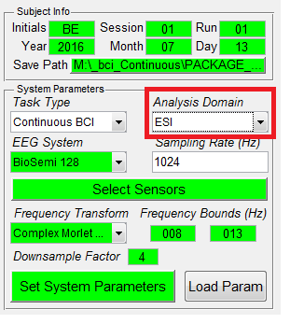

1. Open Matlab (if already open, close and re-open)
2. Type “bci_ESI_Continuous” into command window and press enter
   1. The bci_ESI_Continuous GUI should pop up
3. Click on “Load Param”
   1. Navigate to “D:\Brad\bci_Continuous\bci_fESI_Continuous

\from_Brad\bci_fESI_PARAM” folder and open “Default_System.mat”

1. Enter Subject Info
   1. Initials
   2. Session
   3. Run
2. Click on “Set System Parameters”

### 4.2b: Preparing Matlab: SOURCE IMAGING

1. If subject-specific “brain files” are available, load them into the “Cortex File”, “Head Model”, and “Brain Region File” fields. Otherwise, click on the “Default Anatomy” check box – the necessary files should automatically load.
2. 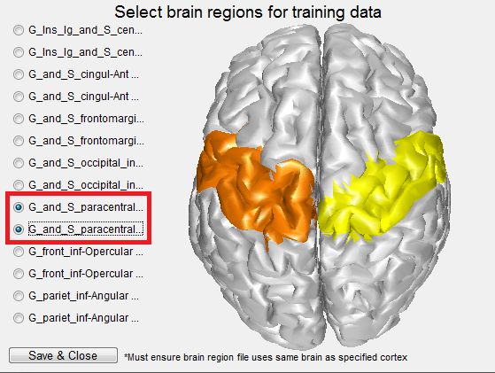Click on the “Select Brain Regions” button and select the bilateral paracentral regions. Click on the “Save & Close” button
3. Select “MSP” under the “Parcellation Method” drop-down menu
4. Click on the “Add” button under the “Prelocalization Data” text box and navigate to “D:\Brad\bci_Continuous\BCI2000\data\” and load the two training runs (.dat files) previously collected.
5. Select “No Noise Estimation” in the “Noise Estimation” drop-down menu
6. Click on “CheckESI” and “SetESI” and wait for both buttons to turn green (this will take ~60 seconds)

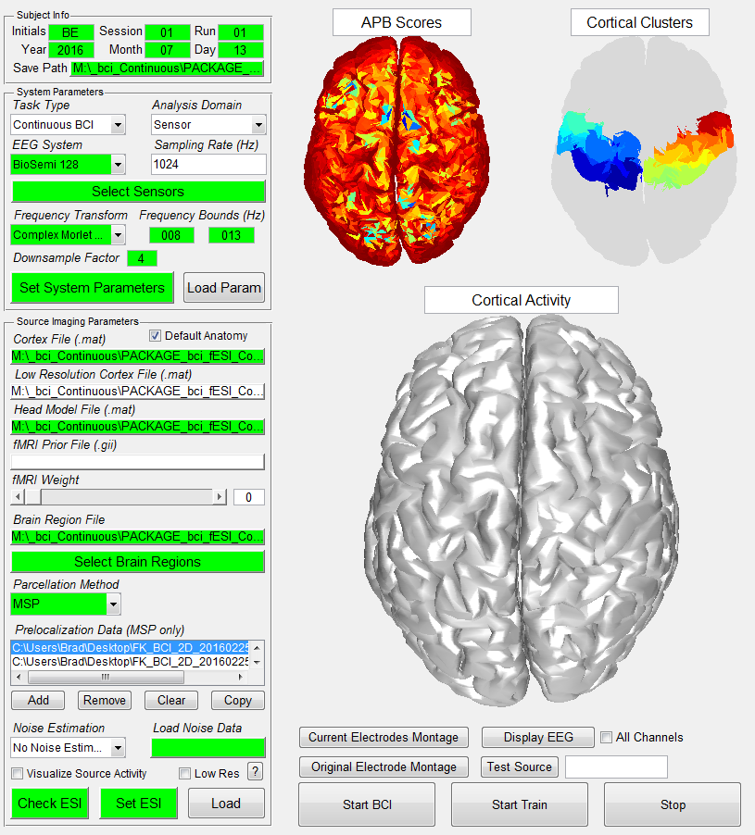

### 4.2c: Preparing Matlab: ESI BCI

1. Click on the “Copy” button under the “Load Training Data” text box. The files from the “Prelocalization Data” text should automatically be copied over.
2. Double check that the “Analysis Domain” is set to “ESI” in the “System Parameters” panel.
3. Click on the “Perform Regression” button and wait. A waitbar should pop up indicating progress.
4. Inspect regression results
   1. Inspect “Source Cluster Task 1 vs 2” results for horizontal dimension and “Source Cluster Task 3 vs 4” for vertical dimension (try to identify a single frequency with the largest R-squared values and try this one first in step 5)
5. Type in 250 for the “Analysis Window” and 100 for the “Update Window”
6. 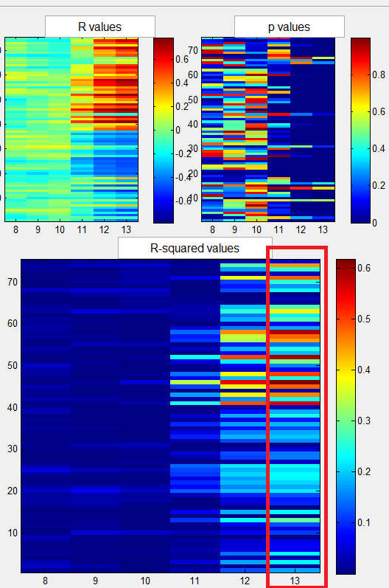In “BCI Parameters” panel , for each dimension used:
   1. Select the movement type in the “Dimension” drop down menu (i.e.. horizontal, vertical)
   2. Select the task pairing in the “Tasks” drop down menu (i.e. 1 vs 2, 3 vs 4)
   3. Select a frequency based on your inspection of the regression results in the “Frequency” drop down menu
   4. Click on the “Loc #” button to select brain parcels and weights
      1. At least 1 parcel should be automatically added to the data list; if no channels survive the statistical tests, select a different frequency and repeat
   5. Once a frequency and parcels have been selected, set the scale for that particular dimension
   6. Set “Cycle Length” to 30 and “Buffer Length” to 5
   7. Set “Display Control Sig” to the checked state.
   8. Press “Check BCI” and then “Set BCI”

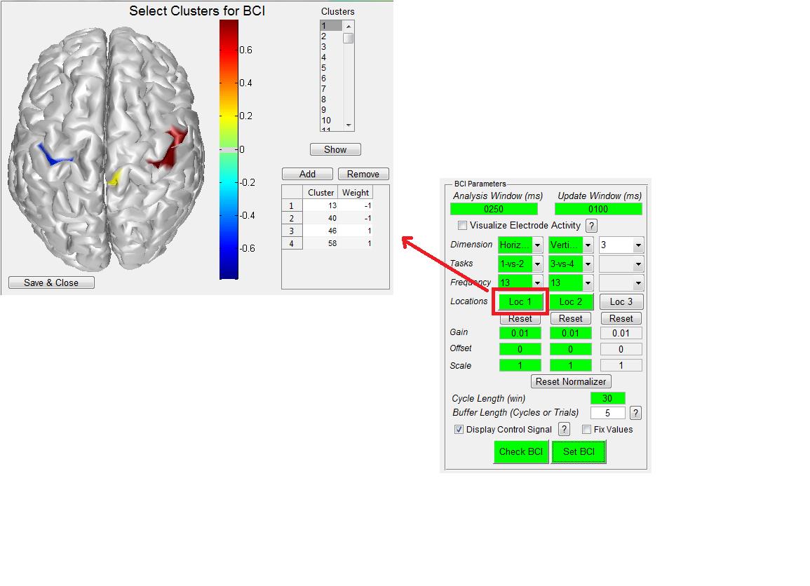

## 4.3: Continuous Control

1. See 1.2 & 1.3

**MOUSE CONTROL**

1. Open windows explorer and navigate to “D:\Brad\bci_Continuous\BCI2000\batch and double click on the “CP_MOUSE_2D.bat” batch file