Killarney Mosaic Project

We are pleased to report the successful completion of our community-sponsored mosaic project, which has transformed ordinary road curb signs into vibrant works of art throughout the neighborhood.

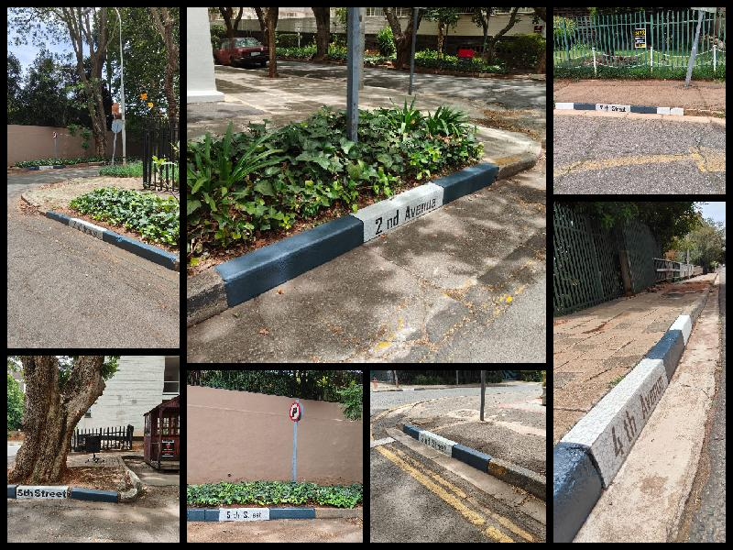

The project, executed by Eternity Mosaic under the skilled guidance of owner Hannes, has received overwhelming positive response from residents who express how these artistic additions have enhanced our community's visual appeal and fostered a sense of local pride. The mosaics have been spilled over into our neighboring Norwood.

Your Community Needs You



Building on this success, we propose launching another round of the project, this time inviting participation from the wider community. This expansion would allow more residents to contribute their creativity, strengthen community bonds, and extend these beautiful mosaics to additional areas within Killarney.

We will be accepting requests until the end of April, once full payment for your curb has been made the work shall commence. You can expect the price per road sign to be around R1250.

To make your request please fill out the Mosaic form.

If anyone is interested in engaging with Eternity Mosaics for other projects please reach out to Hannes.

Hannes Eternity Mosaic
tel: +27 83 230 5971
email: info@mosaiceternity.co.za
website: https://mosaiceternity.co.za/

