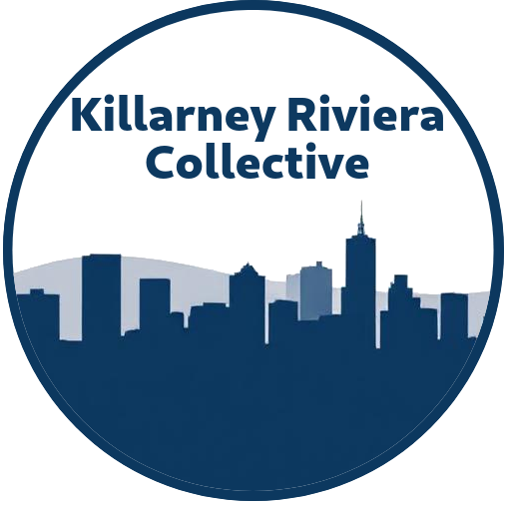

SECTION 18A TAX CERTIFICATE PROCESS
A Guide for Donors Supporting the Killarney and Riviera Community Improvement Collective

WHAT IS A SECTION 18A TAX CERTIFICATE?

A SECTION 18A TAX CERTIFICATE IS AN OFFICIAL DOCUMENT THAT
- Serves as proof of your donation to an approved public benefit organization
- Allows you to claim a tax deduction from your taxable income
- Is issued by organizations approved by SARS under Section 18A of the Income Tax Act
- Helps reduce your overall tax liability while supporting worthy causes

THE BENEFITS OF SECTION 18A

For Individual Donors
- Reduce your taxable income
- Support meaningful community projects with tax efficiency
- Receive official documentation for tax submission purposes

For Business Donors
- Enhance your corporate social responsibility profile
- Reduce company tax liability
- Support local community development initiatives

OUR PARTNERSHIP STRUCTURE

The Killarney and Riviera Community Improvement Collective (KRC) partners with Champions of the Environment Foundation to provide Section 18A benefits to donors
- KRC identifies and implements community improvement projects
- Champions of the Environment Foundation serves as the SARS-approved financial administrator
- All projects align with making the community safer, cleaner, and more beautiful

THE DONATION PROCESS

1. PROJECT CONSULTATION
- Liaise with KRC representatives to discuss community projects
- Identify which project(s) align with your donation goals
- Agree on donation amount for specific project implementation



2. FORMAL INVOICE
- Champions of the Environment Foundation issues an official invoice
- Invoice details the agreed donation amount and project allocation
- Administrative fee is transparently disclosed (negotiated based on donation size)



3. DONATION PAYMENT
- Transfer funds as per invoice instructions
- Champions of the Environment Foundation processes the donation
- Funds are earmarked for the specified KRC project



4. SECTION 18A ISSUANCE
- Champions of the Environment Foundation issues your Section 18A tax certificate
- Certificate contains all information required by SARS
- You receive documentation for your records



5. TAX SUBMISSION
- Submit your Section 18A certificate to SARS with your annual tax return
- Claim the deduction from your taxable income
- Potentially reduce your tax liability



IMPORTANT NOTES

KRC VOLUNTEERS
The Killarney and Riviera Community Improvement Collective does not receive remuneration, they are community volunteers

ADMINISTRATIVE FEES
Champions of the Environment Foundation charges a nominal fee for Section 18A administration based on donation size

FEE DISCLOSURE
All fees are negotiated and presented upfront before donation processing

PROJECT UPDATES
Donors receive updates on project implementation and impact

CONTACT INFORMATION

Killarney and Riviera Community Improvement Collective
Project Coordinator | Bradley Stuart Kirton
Email | bradleykirton@gmail.com

Champions of the Environment Foundation
Executive Director | Stella Victoria Helwick
Registration | 2008/007274/08
Email | stella.connect@gmail.com

This document serves as an informational guide only. Tax circumstances vary, and donors are advised to consult with their tax professionals regarding their specific situation.

