Project – (250 Points Total)

1. VLANs, VTP, and IEEE 802.1q (NOTE: Make sure you accomplish this ***without*** going into VLAN Database mode and show the syntax for both 2960 and 3560 switches!)

VLANs or Virtual Local Area Networks are a group of devices that communicate as if they were on the same wire through a Local Access Network. VLANs use VTP (VLAN Trunking Protocol) that propagates a VLAN on the whole Local Area Network. IEEE 802.1q is a standard used to encapsulate packets passed to/from VLANs. It is used on 3560 switches.

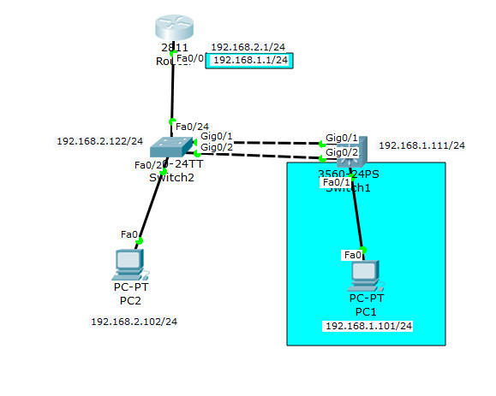

|  |  |
| --- | --- |
| Router> | This prompt specifies the router is in USER mode |
| Router>enable | this command is entered to go from USER mode to PRIVILEGE mode |
| Router# | You are now in PRIVILEGE mode |
| Router#configure terminal | used to enter GLOBAL CONFIGURATION mode from PRIVILEGE mode. This is needed to configure all parameters within the router |
| Router(config)# | You are now in GLOBAL CONFIGURATION mode |
| Router(config)#interface FastEthernet0/0 | This is entered to go into INTERFACE CONFIGURATION mode to configure the fastethernet0/0 interface within the router |
| Router(config-if)#no shutdown | Used to enable the specified instance |
| Router(config)#interface fastEthernet0/0.1 | This is entered to go into SUBINTERFACE CONFIGURATION mode to configure the fastethernet0/0.1 subinterface within the router |
| Router(config-subif)# | You are now in SUBINTERFACE CONFIGURATION mode |
| Router(config-subif)# encapsulation dot1Q 1 | Sets 802.1q encapsulation on vlan 1 |
| Router(config-subif)# ip address 192.168.1.1 255.255.255.0 | This sets the IP Address to 192.168.1.1 with a subnet mask of 255.255.255.0 which is the default subnet mask for a Class C IP Address |
| Router(config-subif)#interface FastEthernet0/0.2 | This is entered to go into SUBINTERFACE CONFIGURATION mode to configure the fastethernet0/0.2 subinterface within the router |
| Router(config-subif)# encapsulation dot1Q 2 | Sets 802.1q encapsulation on vlan 2 |
| Router(config-subif)# ip address 192.168.2.1 255.255.255.0 | This sets the IP Address to 192.168.2.1 with a subnet mask of 255.255.255.0 which is the default subnet mask for a Class C IP Address |

|  |  |
| --- | --- |
| Switch1> | This prompt specifies the router is in USER mode |
| Switch1>enable | this command is entered to go from USER mode to PRIVILEGE mode |
| Switch1# | You are now in PRIVILEGE mode |
| Switch1#configure terminal | used to enter GLOBAL CONFIGURATION mode from PRIVILEGE mode. This is needed to configure all parameters within the router |
| Switch1(config)# | You are now in GLOBAL CONFIGURATION mode |
| Switch1(config)#vtp mode client | sets the switch to be the client |
| Switch1(config)#interface fastEthernet0/1 | This is entered to go into INTERFACE CONFIGURATION mode to configure the fastethernet0/2 interface within the router |
| Switch1(config-if)# | You are now in INTERFACE CONFIGURATION mode |
| Switch1(config-if)#switchport mode access | sets the port as an access port |
| Switch1(config-if)#interface GigabitEthernet0/1 | This is entered to go into INTERFACE CONFIGURATION mode to configure the Gigabitethernet0/1 interface within the router |
| Switch(config-if)# switchport trunk encapsulation dot1q | Sets the 3560 router to use 802.1q trunking encapsulation |
| Switch1(config-if)#switchport mode trunk | Sets the switchport mode to trunk |
| Switch1(config-if)#interface GigabitEthernet0/2 | This is entered to go into INTERFACE CONFIGURATION mode to configure the Gigabitethernet0/2 interface within the router |
| Switch(config-if)# switchport trunk encapsulation dot1q | Sets the 3560 router to use 802.1q trunking encapsulation |
| Switch1(config-if)#switchport mode trunk | Sets the switchport mode to trunk |
| Switch1(config-if)#interface Vlan1 | This is entered to go into INTERFACE CONFIGURATION mode to configure the Vlan1 interface within the router |
| Switch1(config-if)#ip address 192.168.1.111 255.255.255.0 | This sets the IP Address to 192.168.1.111 with a subnet mask of 255.255.255.0 which is the default subnet mask for a Class C IP Address |
| Switch1(config-if)#interface Vlan2 | This is entered to go into INTERFACE CONFIGURATION mode to configure the Vlan2 interface within the router |
| Switch1(config-if)#ip address 192.168.2.122 255.255.255.0 | This sets the IP Address to 192.168.2.122 with a subnet mask of 255.255.255.0 which is the default subnet mask for a Class C IP Address |

|  |  |
| --- | --- |
| Switch2> | This prompt specifies the router is in USER mode |
| Switch2>enable | this command is entered to go from USER mode to PRIVILEGE mode |
| Switch2# | You are now in PRIVILEGE mode |
| Switch2#configure terminal | used to enter GLOBAL CONFIGURATION mode from PRIVILEGE mode. This is needed to configure all parameters within the router |
| Switch2(config)# | You are now in GLOBAL CONFIGURATION mode |
| Switch2(config)#interface fastEthernet0/2 | This is entered to go into INTERFACE CONFIGURATION mode to configure the fastethernet0/2 interface within the router |
| Switch2(config-if)# | You are now in INTERFACE CONFIGURATION mode |
| Switch2(config-if)#switchport access vlan 2 | enables the interface to join vlan 2 |
| Switch2(config-if)#switchport mode access | sets the port as an access port |
| Switch2(config-if)#interface fastEthernet/24 | This is entered to go into INTERFACE CONFIGURATION mode to configure the fastethernet0/24 interface within the router |
| Switch2(config-if)#switchport mode trunk | Sets the switchport mode to trunk |
| Switch2(config-if)#interface GigabitEthernet0/1 | This is entered to go into INTERFACE CONFIGURATION mode to configure the Gigabitethernet0/1 interface within the router |
| Switch2(config-if)#switchport mode trunk | Sets the switchport mode to trunk |
| Switch2(config-if)#interface GigabitEthernet0/2 | This is entered to go into INTERFACE CONFIGURATION mode to configure the Gigabitethernet0/2 interface within the router |
| Switch2(config-if)#switchport mode trunk | Sets the switchport mode to trunk |
| Switch2(config-if)#interface Vlan1 | This is entered to go into INTERFACE CONFIGURATION mode to configure the Vlan1 interface within the router |
| Switch2(config-if)#ip address 192.168.1.111 255.255.255.0 | This sets the IP Address to 192.168.1.111 with a subnet mask of 255.255.255.0 which is the default subnet mask for a Class C IP Address |
| Switch2(config-if)#interface Vlan2 | This is entered to go into INTERFACE CONFIGURATION mode to configure the Vlan2 interface within the router |
| Switch2(config-if)#ip address 192.168.2.122 255.255.255.0 | This sets the IP Address to 192.168.2.112 with a subnet mask of 255.255.255.0 which is the default subnet mask for a Class C IP Address |

Show Command:

show vtp status - used to display VLAN trunking protocol status information.

you are looking for the VTP Operating Mode to correspond to what you want the switch to be, a client or server.

show vlan - used to show VLAN information.

You are looking for your interfaces to be under their specified vlan.

show interface trunk - used to show all interfaces that have trunking enabled.

Troubleshooting Commands

show vtp status - If the vtp operating mode is not the one youre looking for, then issue either a vtp mode server or vtp mode client command depending on what you want.

show vlan - If the vlans you made arent showing up you may want to repeat vlan setup using int vlan *x* command. If the interfaces aren’t under the correct vlan, try entering the interface and specify the vlan youd like to use by using the switchport access *x* command.

show interface trunk - If the interface mode says off try entering the interface and entering a no shutdown command in global configuration mode. If the interface isnt in the first table, reestablish the trunking protocol on it.

Sources used:

<http://www.cisco.com/c/en/us/td/docs/switches/lan/catalyst4500/12-2/25ew/configuration/guide/conf/vlans.html>

<http://www.cisco.com/c/en/us/support/docs/lan-switching/vtp/10558-21.html>

1. InterVLAN Routing with a Router-on-a-stick and SVIs

A router on a stick is basically a router connected to a LAN using 1 physical interface connection. The interface is sometimes divided into subinterfaces. An SVI (Switch Virtual Interface) is a virtualization made by a single interface being split into sub interfaces. for example: FastEthernet 0/0 can be split into f0/0.1, f0/0.2, f/0.3, f0/0.4... .



|  |  |
| --- | --- |
| Router> | This prompt specifies the router is in USER mode |
| Router>enable | this command is entered to go from USER mode to PRIVILEGE mode |
| Router# | You are now in PRIVILEGE mode |
| Router#configure terminal | used to enter GLOBAL CONFIGURATION mode from PRIVILEGE mode. This is needed to configure all parameters within the router |
| Router(config)# | You are now in GLOBAL CONFIGURATION mode |
| Router(config)#interface FastEthernet0/0 | This is entered to go into INTERFACE CONFIGURATION mode to configure the fastethernet0/0 interface within the router |
| Router(config-if)#no shutdown | Used to enable the specified instance |
| Router(config)#interface fastEthernet0/0.1 | This is entered to go into SUBINTERFACE CONFIGURATION mode to configure the fastethernet0/0.1 subinterface within the router |
| Router(config-subif)# | You are now in SUBINTERFACE CONFIGURATION mode |
| Router(config-subif)# encapsulation dot1Q 1 | Sets 802.1q encapsulation on vlan 1 |
| Router(config-subif)# ip address 192.168.1.1 255.255.255.0 | This sets the IP Address to 192.168.1.1 with a subnet mask of 255.255.255.0 which is the default subnet mask for a Class C IP Address |
| Router(config-subif)#interface FastEthernet0/0.2 | This is entered to go into SUBINTERFACE CONFIGURATION mode to configure the fastethernet0/0.2 subinterface within the router |
| Router(config-subif)# encapsulation dot1Q 2 | Sets 802.1q encapsulation on vlan 2 |
| Router(config-subif)# ip address 192.168.2.1 255.255.255.0 | This sets the IP Address to 192.168.2.1 with a subnet mask of 255.255.255.0 which is the default subnet mask for a Class C IP Address |

|  |  |
| --- | --- |
| Switch1> | This prompt specifies the router is in USER mode |
| Switch1>enable | this command is entered to go from USER mode to PRIVILEGE mode |
| Switch1# | You are now in PRIVILEGE mode |
| Switch1#configure terminal | used to enter GLOBAL CONFIGURATION mode from PRIVILEGE mode. This is needed to configure all parameters within the router |
| Switch1(config)# | You are now in GLOBAL CONFIGURATION mode |
| Switch1(config)#interface fastEthernet0/1 | This is entered to go into INTERFACE CONFIGURATION mode to configure the fastethernet0/2 interface within the router |
| Switch1(config-if)# | You are now in INTERFACE CONFIGURATION mode |
| Switch1(config-if)#switchport mode access | sets the port as an access port |
| Switch1(config-if)#interface GigabitEthernet0/1 | This is entered to go into INTERFACE CONFIGURATION mode to configure the Gigabitethernet0/1 interface within the router |
| Switch(config-if)# switchport trunk encapsulation dot1q | Sets the 3560 router to use 802.1q trunking encapsulation |
| Switch1(config-if)#switchport mode trunk | Sets the switchport mode to trunk |
| Switch1(config-if)#interface GigabitEthernet0/2 | This is entered to go into INTERFACE CONFIGURATION mode to configure the Gigabitethernet0/2 interface within the router |
| Switch(config-if)# switchport trunk encapsulation dot1q | Sets the 3560 router to use 802.1q trunking encapsulation |
| Switch1(config-if)#switchport mode trunk | Sets the switchport mode to trunk |
| Switch1(config-if)#interface Vlan1 | This is entered to go into INTERFACE CONFIGURATION mode to configure the Vlan1 interface within the router |
| Switch1(config-if)#ip address 192.168.1.111 255.255.255.0 | This sets the IP Address to 192.168.1.111 with a subnet mask of 255.255.255.0 which is the default subnet mask for a Class C IP Address |
| Switch1(config-if)#interface Vlan2 | This is entered to go into INTERFACE CONFIGURATION mode to configure the Vlan2 interface within the router |
| Switch1(config-if)#ip address 192.168.2.122 255.255.255.0 | This sets the IP Address to 192.168.2.122 with a subnet mask of 255.255.255.0 which is the default subnet mask for a Class C IP Address |

|  |  |
| --- | --- |
| Switch2> | This prompt specifies the router is in USER mode |
| Switch2>enable | this command is entered to go from USER mode to PRIVILEGE mode |
| Switch2# | You are now in PRIVILEGE mode |
| Switch2#configure terminal | used to enter GLOBAL CONFIGURATION mode from PRIVILEGE mode. This is needed to configure all parameters within the router |
| Switch2(config)# | You are now in GLOBAL CONFIGURATION mode |
| Switch2(config)#interface fastEthernet0/2 | This is entered to go into INTERFACE CONFIGURATION mode to configure the fastethernet0/2 interface within the router |
| Switch2(config-if)# | You are now in INTERFACE CONFIGURATION mode |
| Switch2(config-if)#switchport access vlan 2 | enables the interface to join vlan 2 |
| Switch2(config-if)#switchport mode access | sets the port as an access port |
| Switch2(config-if)#interface fastEthernet/24 | This is entered to go into INTERFACE CONFIGURATION mode to configure the fastethernet0/24 interface within the router |
| Switch2(config-if)#switchport mode trunk | Sets the switchport mode to trunk |
| Switch2(config-if)#interface GigabitEthernet0/1 | This is entered to go into INTERFACE CONFIGURATION mode to configure the Gigabitethernet0/1 interface within the router |
| Switch2(config-if)#switchport mode trunk | Sets the switchport mode to trunk |
| Switch2(config-if)#interface GigabitEthernet0/2 | This is entered to go into INTERFACE CONFIGURATION mode to configure the Gigabitethernet0/2 interface within the router |
| Switch2(config-if)#switchport mode trunk | Sets the switchport mode to trunk |
| Switch2(config-if)#interface Vlan1 | This is entered to go into INTERFACE CONFIGURATION mode to configure the Vlan1 interface within the router |
| Switch2(config-if)#ip address 192.168.1.111 255.255.255.0 | This sets the IP Address to 192.168.1.111 with a subnet mask of 255.255.255.0 which is the default subnet mask for a Class C IP Address |
| Switch2(config-if)#interface Vlan2 | This is entered to go into INTERFACE CONFIGURATION mode to configure the Vlan2 interface within the router |
| Switch2(config-if)#ip address 192.168.2.122 255.255.255.0 | This sets the IP Address to 192.168.2.122 with a subnet mask of 255.255.255.0 which is the default subnet mask for a Class C IP Address |

Show Commands:

show ip route - Shows all routes in the routing table. You are looking for all the ip addresses for the 2 networks in this topology.

ping *ip address* (Windows CMD) - Pings the ip address given. You are looking for a reply from the ip address.

TroubleShooting Commands:

show ip route - If the routes don't populate, try making sure all ports are connected correctly.

ping *ip address* (Windows CMD) - If routes still don't populate verify that you can connect to the router by pinging it from each computer.

Sources used:

<http://www.cisco.com/c/en/us/td/docs/switches/lan/catalyst4500/12-2/25ew/configuration/guide/conf/vlans.html>

<http://www.cisco.com/c/en/us/support/docs/lan-switching/vtp/10558-21.html>

<https://learningnetwork.cisco.com/thread/62241>

1. First Hop Redundancy Protocol with HSRP using Link Aggregation between two 3560 multilayer switches. Demonstrate your knowledge of LACP and PAgP.

First Hop Redundancy Protocol (FHRP) is a family of protocols that are used so that the host can take advantage of redundant routers in a subnet. Having redundant routers can benefit a system in supporting a LAN, but FHRP needs to also be used when these redundant routers exist. One of these FHRP protocols is the Hot Standby Router Protocol (HSRP). HSRP uses an active/standby model means that while one routers is working, there is always another router standing by and waiting to take over if the active HSRP has a problem.

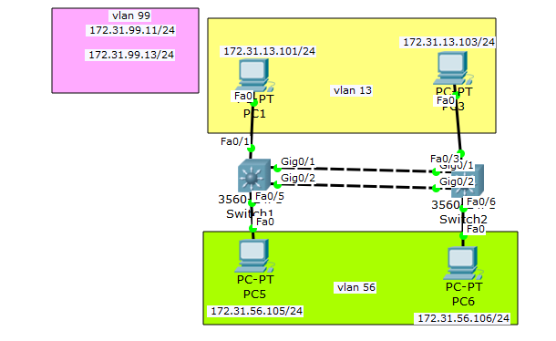

|  |  |
| --- | --- |
| Switch1> | This prompt specifies the router is in USER mode |
| Switch1>enable | this command is entered to go from USER mode to PRIVILEGE mode |
| Switch1# | You are now in PRIVILEGE mode |
| Switch1#configure terminal | used to enter GLOBAL CONFIGURATION mode from PRIVILEGE mode. This is needed to configure all parameters within the router |
| Switch1(config)# | You are now in GLOBAL CONFIGURATION mode |
| Switch1(config)#ip routing | Enables the Switch to work as a layer 3 device with routing capabilities |
| Switch1(config)#spanning-tree mode pvst | maintains a spanning-tree instance for each vlan configured |
| Switch1(config)#spanning-tree vlan 13,56,99 priority 24576 | sets the priority of the vlans 13,56,and 99 using spanning tree protocol |
| Switch1(config)#interface Port-channel 1 | This is entered to go into INTERFACE CONFIGURATION mode to configure the port-channel 1 interface within the router |
| Switch1(config-if)# switchport trunk native vlan 99 | sets the native vlan for the interface |
| Switch1(config-if)# switchport trunk encapsulation dot1q | Sets the interface to use trunk encapsulation 802.1q |
| Switch1(config-if)# switchport mode trunk | Sets the switchport mode to trunk |
| Switch1(config)#interface fastEthernet0/1 | This is entered to go into INTERFACE CONFIGURATION mode to configure the fastethernet0/1 interface within the router |
| Switch1(config-if)# | You are now in INTERFACE CONFIGURATION mode |
| Switch1(config-if)# switchport access vlan 13 | to set the access port to carry traffic for a different VLAN 13 |
| Switch1(config-if)# switchport mode access | sets the port as an access port |
| Switch1(config-if)# spanning-tree portfast | forces the ports to supercede the listening, learning, and forwarding states |
| Switch1(config-if)#interface FastEthernet0/5 | This is entered to go into INTERFACE CONFIGURATION mode to configure the fastethernet0/5 interface within the switch |
| Switch1(config-if)# switchport access vlan 56 | to set the access port to carry traffic for a different VLAN 56 |
| Switch1(config-if)# switchport mode access | sets the port as an access port |
| Switch1(config-if)# spanning-tree portfast | forces the ports to supercede the listening, learning, and forwarding states |
| Switch1(config-if)#interface GigabitEthernet0/1 | This is entered to go into INTERFACE CONFIGURATION mode to configure the GigabitEthernet0/1 interface within the router |
| Switch1(config-if)# switchport trunk native vlan 99 | Sets the native VLAN for the 802.1Q trunk. |
| Switch1(config-if)# switchport trunk encapsulation dot1q | Sets the interface to use trunk encapsulation 802.1q |
| Switch1(config-if)# switchport mode trunk | Sets the switchport mode to trunk |
| Switch1(config-if)#channel-protocol pagp | sets the ether-channel mode to be pagp |
| Switch1(config-if)# channel-group 1 mode desirable | try and negotiate with the other side, and if he agrees, then enable the channel. |
| Switch1(config-if)#interface GigabitEthernet0/2 | This is entered to go into INTERFACE CONFIGURATION mode to configure the GigabiEthernet0/2 interface within the switch |
| Switch1(config-if)# switchport trunk native vlan 99 | Sets the native VLAN for the 802.1Q trunk. |
| Switch1(config-if)# switchport trunk encapsulation dot1q | Sets the interface to use trunk encapsulation 802.1q |
| Switch1(config-if)# switchport mode trunk | Sets the switchport mode to trunk |
| Switch1(config-if)#channel-protocol pagp | sets the ether-channel mode to be pagp |
| Switch1(config-if)# channel-group 1 mode desirable | try and negotiate with the other side, and if he agrees, then enable the channel. |
| Switch1(config-if)#interface Vlan1 | This is entered to go into INTERFACE CONFIGURATION mode to configure the vlan1 interface within the switch |
| Switch1(config-if)# no ip address | disables ip address |
| Switch1(config-if)# shutdown | disables interface |
| Switch1(config-if)#interface Vlan13 | This is entered to go into INTERFACE CONFIGURATION mode to configure the vlan13 interface within the switch |
| Switch1(config-if)# standby 13 ip 172.31.13.1 | activate the Hot Standby Router Protocol |
| Switch1(config-if)# standby 13 priority 115 | sets the router’s priority level |
| Switch1(config-if)# standby 13 preempt | allow the once active device to take over for the stanby once it comes back online |
| Switch1(config-if)#interface Vlan56 | This is entered to go into INTERFACE CONFIGURATION mode to configure the vlan56 interface within the switch |
| Switch1(config-if)# ip address 172.31.56.2 255.255.255.0 | This sets the IP Address to 172.31.56.2 with a subnet mask of 255.255.255.0 which is the default subnet mask for a Class C IP Address |
| Switch1(config-if)# standby 56 ip 172.31.56.1 | activate the Hot Standby Router Protocol |
| Switch1(config-if)# standby 56 priority 105 | sets the router’s priority level |
| Switch1(config-if)# standby 56 preempt | allow the once active device to take over for the stanby once it comes back online |
| Switch1(config-if)#interface Vlan99 | This is entered to go into INTERFACE CONFIGURATION mode to configure the vlan99 interface within the switch |
| Switch1(config-if)# ip address 172.31.99.11 255.255.255.0 | This sets the IP Address to 172.31.99.11 with a subnet mask of 255.255.255.0 which is the default subnet mask for a Class C IP Address |
| Switch1(config-if)# standby 99 ip 172.31.99.1 | activate the Hot Standby Router Protocol |
| Switch1(config-if)# standby 99 priority 115 | sets the router’s priority level |
| Switch1(config-if)# standby 99 preempt | allow the once active device to take over for the stanby once it comes back online |

|  |  |
| --- | --- |
| Switch2> | This prompt specifies the router is in USER mode |
| Switch2>enable | this command is entered to go from USER mode to PRIVILEGE mode |
| Switch2# | You are now in PRIVILEGE mode |
| Switch2#configure terminal | used to enter GLOBAL CONFIGURATION mode from PRIVILEGE mode. This is needed to configure all parameters within the router |
| Switch2(config)# | You are now in GLOBAL CONFIGURATION mode |
| Switch2(config)#ip routing | Enables the Switch to work as a layer 3 device with routing capabilities |
| Switch2(config)#spanning-tree mode pvst | maintains a spanning-tree instance for each vlan configured |
| Switch2(config)#spanning-tree vlan 13,56,99 priority 24576 | sets the priority of the vlans 13,56,and 99 using spanning tree protocol |
| Switch2(config)#interface Port-channel 1 | This is entered to go into INTERFACE CONFIGURATION mode to configure the port-channel 1 interface within the router |
| Switch2(config-if)# switchport trunk native vlan 99 | sets the native vlan for the interface |
| Switch2(config-if)# switchport trunk encapsulation dot1q | Sets the interface to use trunk encapsulation 802.1q |
| Switch2(config-if)# switchport mode trunk | Sets the switchport mode to trunk |
| Switch2(config)#interface fastEthernet0/3 | This is entered to go into INTERFACE CONFIGURATION mode to configure the fastethernet0/3 interface within the router |
| Switch2(config-if)# | You are now in INTERFACE CONFIGURATION mode |
| Switch2(config-if)# switchport access vlan 13 | to set the access port to carry traffic for VLAN 13 |
| Switch2(config-if)# switchport mode access | sets the port as an access port |
| Switch2(config-if)# spanning-tree portfast | forces the ports to supercede the listening, learning, and forwarding states |
| Switch2(config-if)#interface FastEthernet0/6 | This is entered to go into INTERFACE CONFIGURATION mode to configure the fastethernet0/6 interface within the switch |
| Switch2(config-if)# switchport access vlan 56 | to set the access port to carry traffic for a different VLAN 56 |
| Switch2(config-if)# switchport mode access | sets the port as an access port |
| Switch2(config-if)# spanning-tree portfast | forces the ports to supercede the listening, learning, and forwarding states |
| Switch2(config-if)#interface GigabitEthernet0/1 | This is entered to go into INTERFACE CONFIGURATION mode to configure the ethernet0/1 interface within the switch |
| Switch2(config-if)# switchport trunk native vlan 99 | Sets the native VLAN for the 802.1Q trunk. |
| Switch2(config-if)# switchport trunk encapsulation dot1q | Sets the interface to use trunk encapsulation 802.1q |
| Switch2(config-if)# switchport mode trunk | Sets the switchport mode to trunk |
| Switch2(config-if)#channel-protocol pagp | sets the ether-channel mode to be pagp |
| Switch2(config-if)# channel-group 1 mode desirable | try and negotiate with the other side, and if he agrees, then enable the channel. |

|  |  |
| --- | --- |
| Switch2(config-if)#interface GigabitEthernet0/2 | This is entered to go into INTERFACE CONFIGURATION mode to configure the gigabitethernet0/2 interface within the switch |
| Switch2(config-if)# switchport trunk native vlan 99 | Sets the native VLAN for the 802.1Q trunk. |
| Switch2(config-if)# switchport trunk encapsulation dot1q | Sets the interface to use trunk encapsulation 802.1q |
| Switch2(config-if)# switchport mode trunk | Sets the switchport mode to trunk |
| Switch2(config-if)#channel-protocol pagp | sets the ether-channel mode to be pagp |
| Switch2(config-if)# channel-group 1 mode desirable | try and negotiate with the other side, and if he agrees, then enable the channel. |
| Switch2(config-if)#interface Vlan1 | This is entered to go into INTERFACE CONFIGURATION mode to configure the vlan1 interface within the switch |
| Switch2(config-if)# no ip address | disables ip address |
| Switch2(config-if)# shutdown | disables interface |
| Switch2(config-if)#interface Vlan13 | This is entered to go into INTERFACE CONFIGURATION mode to configure the vlan13 interface within the switch |
| Switch2(config-if)# ip address 172.31.13.3 255.255.255.0 | This sets the IP Address to 172.31.13.3 with a subnet mask of 255.255.255.0 which is the default subnet mask for a Class C IP Address |
| Switch2(config-if)# standby 13 ip 172.31.13.1 | activate the Hot Standby Router Protocol |
| Switch2(config-if)# standby 13 priority 105 | sets the router’s priority level |
| Switch2(config-if)# standby 13 preempt | allow the once active device to take over for the stanby once it comes back online |
| Switch2(config-if)#interface Vlan56 | This is entered to go into INTERFACE CONFIGURATION mode to configure the vlan56 interface within the switch |
| Switch2(config-if)# ip address 172.31.56.3 255.255.255.0 | This sets the IP Address to 172.31.56.3 with a subnet mask of 255.255.255.0 which is the default subnet mask for a Class C IP Address |
| Switch2(config-if)# standby 56 ip 172.31.56.1 | activate the Hot Standby Router Protocol |
| Switch2(config-if)# standby 56 priority 115 | sets the router’s priority level |
| Switch2(config-if)# standby 56 preempt | allow the once active device to take over for the stanby once it comes back online |
| Switch2(config-if)#interface Vlan99 | This is entered to go into INTERFACE CONFIGURATION mode to configure the vlan99 interface within the switch |
| Switch2(config-if)# ip address 172.31.99.13 255.255.255.0 | This sets the IP Address to 172.31.99.13 with a subnet mask of 255.255.255.0 which is the default subnet mask for a Class C IP Address |
| Switch2(config-if)# standby 99 ip 172.31.99.1 | activate the Hot Standby Router Protocol |
| Switch2(config-if)# standby 99 priority 105 | sets the router’s priority level |
| Switch2(config-if)# standby 99 preempt | allow the once active device to take over for the stanby once it comes back online |

Show Commands:

TroubleShooting Commands:

1. IPv4 and IPv6 Static routing (NOTE: With AND Without the use of a default static route.)

IPv4 is the fourth version of the Internet Protocol (IP). IP is connectionless. IPv4 addresses have 32 bits in them, giving us **4,294,967,296 addresses.**  However, as the demand for cellphones and the Internet of Things, Ipv4 addresses have been exhausted, leaving us to create the next revision. IPv6 is the newest implementation of IP. IPv6 uses 128 bits to create addresses, and has 340,282,366,920,938,463,463,374,607,431,768,211,456 or 2^128 possible addresses, so we shouldnt run out any time soon.

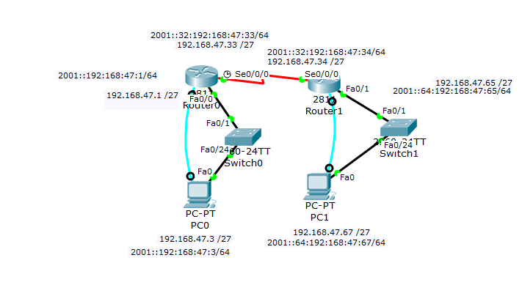

|  |  |
| --- | --- |
| Router0> | This prompt specifies the router is in USER mode |
| Router0>enable | this command is entered to go from USER mode to PRIVILEGE mode |
| Router0# | You are now in PRIVILEGE mode |
| Router0#configure terminal | used to enter GLOBAL CONFIGURATION mode from PRIVILEGE mode. This is needed to configure all parameters within the router |
| Router0(config)# | You are now in GLOBAL CONFIGURATION mode |
| Router0(config)#ipv6 unicast-routing | Enables the forwarding of IPv6 unicast datagrams. |
| Router0(config)#interface FastEthernet0/0 | This is entered to go into INTERFACE CONFIGURATION mode to configure the fastethernet0/0 interface within the router |
| Router0(config-if)# | You are now in INTERFACE CONFIGURATION mode |
| Router0(config-if)# ip address 192.168.47.1 255.255.255.224 | This sets the IP Address to 192.168.47.1 with a subnet mask of 255.255.255.224 |
| Router0(config-if)# ipv6 address | This sets the IPv6 Address to 2001::192:168:47:1/64 |
| Router0(config-if)#interface Serial0/0/0 | This is entered to go into INTERFACE CONFIGURATION mode to configure the serial0/0/0 interface within the router |
| Router0(config-if)# ip address 192.168.47.33 255.255.255.224 | This sets the IP Address to 192.168.47.33 with a subnet mask of 255.255.255.224 |
| Router0(config-if)# ipv6 address | This sets the IPv6 Address to 2001::32:192:168:47:33/64 |
| Router0(config-if)# clock rate 2000000 | this sets the clock rate to 2000KB per second |
| Router0(config-if)#exit | exit interface configuration mode |
| Router0(config)# | now in Global configuration Mode |
| Router0(config)#ip route 192.168.47.64 255.255.255.224 192.168.47.34 | Creates an ip route in the format of *networkAddress SubnetMask ClosestGateway* |
| Router0(config)#ip route 0.0.0.0 0.0.0.0 192.168.47.34 | Creates an ip route in the format of *networkAddress SubnetMask ClosestGateway* |
| Router0(config)#ipv6 route 2001:0:0:64::/64 Serial0/0/0 | creates an ipv6 route in the format of *ipv6address/subnetmask interfaceGateway* |
| Router0(config)#ipv6 route ::/0 Serial0/0/0 | creates an ipv6 route in the format of *ipv6address/subnetmask interfaceGateway* |

|  |  |
| --- | --- |
| Router1> | This prompt specifies the router is in USER mode |
| Router1>enable | this command is entered to go from USER mode to PRIVILEGE mode |
| Router1# | You are now in PRIVILEGE mode |
| Router1#configure terminal | used to enter GLOBAL CONFIGURATION mode from PRIVILEGE mode. This is needed to configure all parameters within the router |
| Router1(config)# | You are now in GLOBAL CONFIGURATION mode |
| Router1(config)#ipv6 unicast-routing | Enables the forwarding of IPv6 unicast datagrams. |
| Router1(config)#interface FastEthernet0/1 | This is entered to go into INTERFACE CONFIGURATION mode to configure the fastethernet0/1 interface within the router |
| Router1(config-if)# | You are now in INTERFACE CONFIGURATION mode |
| Router1(config-if)# ip address 192.168.47.65 255.255.255.224 | This sets the IP Address to 192.168.47.65 with a subnet mask of 255.255.255.224 |
| Router1(config-if)# ipv6 address | This sets the IPv6 Address to 2001::64:192:168:47:65/64 |
| Router1(config-if)#interface Serial0/0/0 | This is entered to go into INTERFACE CONFIGURATION mode to configure the serial0/0/0 interface within the router |
| Router1(config-if)# ip address 192.168.47.34 255.255.255.224 | This sets the IP Address to 192.168.47.34 with a subnet mask of 255.255.255.224 |
| Router1(config-if)# ipv6 address | This sets the IPv6 Address to 2001::32:192:168:47:34/64 |
| Router1(config)#ip route 192.168.47.0 255.255.255.224 192.168.47.33 | Creates an ip route in the format of *networkAddress SubnetMask ClosestGateway* |
| Router1(config)#ip route 0.0.0.0 0.0.0.0 192.168.47.33 | Creates an ip route in the format of *networkAddress SubnetMask ClosestGateway* |
| Router1(config)#ipv6 route 2001::/64 Serial0/0/0 | creates an ipv6 route in the format of *ipv6address/subnetmask interfaceGateway* |
| Router1(config)#ipv6 route ::/0 Serial0/0/0 | creates an ipv6 route in the format of *ipv6address/subnetmask interfaceGateway* |

Show Commands:

Show ip static-route - Shows all static routes in the routers routing table. We are looking for 1 address to show up.(the network address of the opposite network)

Show ipv6 static - Shows all static routes in the router’s ipv6 routing table. We are looking for 1 ipv6 address to show up.(the network address of the opposite network)

Show ip route - Shows the router’s routing table. We are looking for all possible networks to be available.

Show ipv6 route - Shows the router’s routing table. We are looking for all possible ipv6 networks to be available.

ipconfig (CMD prompt) shows the current running ip configuration

ipv6config (CMD prompt) shows current running ipv6 configuration

Troubleshooting commands:

Use Command Prompt to ping the other computer. If it doesnt work, then first make sure your computers are configured with ip and ipv6 addresses.

ipconfig (CMD prompt) shows the current running ip configuration

ipv6config (CMD prompt) shows current running ipv6 configuration

If either of these are missing or incorrect, try to go into the computers ip configuration and change it.

If any of the links between devices are red, make sure you have all interfaces enabled. You can do this using the show int command. Whatever interface is down, that you expect to be up, use a no shutdown command.

5.

EIGRP and EIGRP for IPv6 (NOTE: Make sure you utilize VLSM in your topology and configuration without the use of automatic summarization.)

Enhanced Interior Gateway Routing Protocol, or EIGRP, is a routing protocol that uses distance and next hop to determine its path. EIGRP sorts neighbors by distance and selects the path of least resistance out of these neighbors. With this protocol there is no need to advertise all the interfaces.

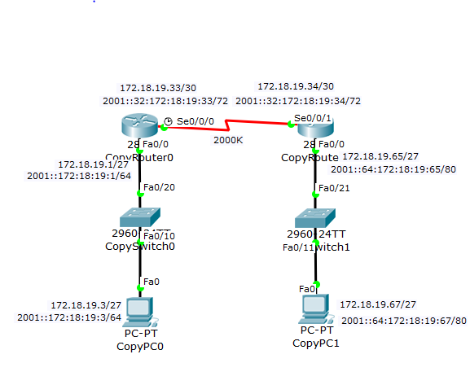

|  |  |
| --- | --- |
| Router0> | This prompt specifies the router is in USER mode |
| Router0>enable | this command is entered to go from USER mode to PRIVILEGE mode |
| Router0# | You are now in PRIVILEGE mode |
| Router0#configure terminal | used to enter GLOBAL CONFIGURATION mode from PRIVILEGE mode. This is needed to configure all parameters within the router |
| Router0(config)# | You are now in GLOBAL CONFIGURATION mode |
| Router0(config)#ipv6 unicast-routing | Enables the forwarding of IPv6 unicast datagrams. |
| Router0(config)#interface FastEthernet0/0 | This is entered to go into INTERFACE CONFIGURATION mode to configure the fastethernet0/0 interface within the router |
| Router0(config-if)# | You are now in INTERFACE CONFIGURATION mode |
| Router0(config-if)# ip address 172.18.19.1 255.255.255.224 | This sets the IP Address to 172.18.19.1 with a subnet mask of 255.255.255.224 |
| Router0(config-if)# ipv6 address | This sets the IPv6 Address to 2001::172:18:19:1/64 |
| Router0(config-if)# ipv6 eigrp 307 | Sets the interface to use eigrp configured for ipv6 using autonomous system number 307 |
| Router0(config-if)# no shutdown | Used to enable the specified instance |
| Router0(config-if)#interface Serial0/0/0 | This is entered to go into INTERFACE CONFIGURATION mode to configure the serial0/0/0 interface within the router |
| Router0(config-if)# ipv6 address 2001::32:172:18:19:33/72 | This sets the IPv6 Address to 2001::32:172:18:19:33/72 |
| Router0(config-if)# ipv6 eigrp 307 | Sets the interface to use eigrp configured for ipv6 using autonomous system number 307 |
| Router0(config-if)# clock rate 2000000 | this sets the clock rate to 2000KB per second |
| Router0(config-if)# no shutdown | Used to enable the specified instance |
| Router0(config-if)#ipv6 router eigrp 307 | Sets the router to use eigrp with autonomous system number 307 |
| Router0(config-rtr)# no shutdown | Used to enable the specified instance |

|  |  |
| --- | --- |
| Router1> | This prompt specifies the router is in USER mode |
| Router1>enable | this command is entered to go from USER mode to PRIVILEGE mode |
| Router1# | You are now in PRIVILEGE mode |
| Router1#configure terminal | used to enter GLOBAL CONFIGURATION mode from PRIVILEGE mode. This is needed to configure all parameters within the router |
| Router1(config)# | You are now in GLOBAL CONFIGURATION mode |
| Router1(config)#ipv6 unicast-routing | Enables the forwarding of IPv6 unicast datagrams. |
| Router1(config)#interface FastEthernet0/0 | This is entered to go into INTERFACE CONFIGURATION mode to configure the fastethernet0/0 interface within the router |
| Router1(config-if)# | You are now in INTERFACE CONFIGURATION mode |
| Router1(config-if)# ipv6 address  2001::64:172:18:19:65/80 | This sets the IPv6 Address to 2001::64:172:18:19:65/80 |
| Router1(config-if)# ipv6 eigrp 307 | Sets the interface to use eigrp configured for ipv6 using autonomous system number 307 |
| Router1(config-if)# no shutdown | Used to enable the specified instance |
| Router1(config-if)#interface Serial0/0/1 | This is entered to go into INTERFACE CONFIGURATION mode to configure the serial0/0/1 interface within the router |
| Router1(config-if)# ipv6 address 2001::32:172:18:19:34/72 | This sets the IPv6 Address to 2001::32:172:18:19:34/72 |
| Router1(config-if)# ipv6 eigrp 307 | Sets the interface to use eigrp configured for ipv6 using autonomous system number 307 |
| Router1(config-if)# no shutdown | Used to enable the specified instance |
| Router1(config-if)#ipv6 router eigrp 307 | Sets the router to use eigrp with autonomous system number 307 |
| Router1(config-rtr)# no shutdown | enables the interface |

Show Commands:

Show ip route - Shows the router’s routing table. We are looking for all possible networks to be available.

Show ipv6 route - Shows the router’s routing table. We are looking for all possible ipv6 networks to be available.

ipconfig (CMD prompt) shows the current running ip configuration

ipv6config (CMD prompt) shows current running ipv6 configuration

show ip protocol- Shows the protocols running on the router and what interfaces they are attached to.

TroubleShooting Commands:

Use Command Prompt to ping the other computer using both ipv4 and ipv6. If it doesnt work, then first make sure your computers are configured with ip and ipv6 addresses.

ipconfig (CMD prompt) shows the current running ip configuration

ipv6config (CMD prompt) shows current running ipv6 configuration

If either of these are missing or incorrect, try to go into the computers ip configuration and change it.

If that doesnt do it, make sure you have ipv6 unicast-routing enabled. you can find out by using the command: show running-config. This will show your current configuration.

If any of the links between devices are red, make sure you have all interfaces enabled. You can do this using the show int command. Whatever interface is down, that you expect to be up, use a no shutdown command.

If your eigrp routes arent showing up, make sure you have enabled eigrp on each interface, and on the router itself.

Resources used:

http://www.cisco.com/c/en/us/support/docs/ip/enhanced-interior-gateway-routing-protocol-eigrp/16406-eigrp-toc.html

6. OSPFv2 and OSPFv3 (NOTE: Make sure you utilize loopback interfaces within your topology and configuration…and make sure you specify why you are utilizing them.)

OSPF or open shortest path first is a routing protocol which uses dijkstra’s algorithm to determine what path it should take. It does this by making a tree and seeing how it can traverse the tree to get to the destination, while using as little distance as possible. We use an area number to broadcast necessary networks across a common area. Loopbacks are basically local hosts on a LAN. But OSPF treats them like a regular network. So we need loopbacks in order to use them as a router-id. Since they are a virtual interface, they should never go down.

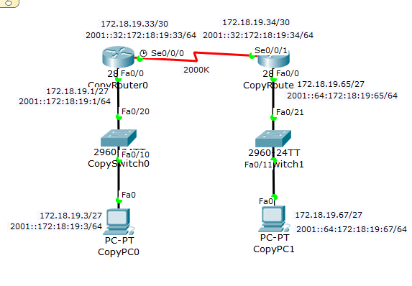

|  |  |
| --- | --- |
| Router0> | This prompt specifies the router is in USER mode |
| Router0>enable | this command is entered to go from USER mode to PRIVILEGE mode |
| Router0# | You are now in PRIVILEGE mode |
| Router0#configure terminal | used to enter GLOBAL CONFIGURATION mode from PRIVILEGE mode. This is needed to configure all parameters within the router |
| Router0(config)# | You are now in GLOBAL CONFIGURATION mode |
| Router0(config)#ipv6 unicast-routing | Enables the forwarding of IPv6 unicast datagrams. |
| Router0(config)# interface Loopback1 | This is entered to go into INTERFACE CONFIGURATION mode to configure the loopback interface within the router |
| Router0(config-if)# ip address 172.18.19.200 255.255.255.255 | This sets the IP Address to 172.18.19.200 with a subnet mask of 255.255.255.255 |
| Router0(config-if)# ipv6 address | This sets the IPv6 Address to 2001::200:172:18:19:200/128 |
| Router0(config)#interface FastEthernet0/0 | This is entered to go into INTERFACE CONFIGURATION mode to configure the fastethernet0/0 interface within the router |
| Router0(config-if)# | You are now in INTERFACE CONFIGURATION mode |
| Router0(config-if)# ip address 172.18.19.1 255.255.255.224 | This sets the IP Address to 17.18.19.1 with a subnet mask of 255.255.255.224 |
| Router0(config-if)# ipv6 address | This sets the IPv6 Address to 2001::172:18:19:1/64 |
| Router0(config-if)# ipv6 ospf 1 area 0 | Sets the interface to use ospf area 0 |
| Router0(config-if)# no shutdown | Used to enable the specified instance |
| Router0(config-if)#interface Serial0/0/0 | This is entered to go into INTERFACE CONFIGURATION mode to configure the serial0/0/0 interface within the router |
| Router0(config-if)#ip address 172.18.19.33 255.255.255.252 | This sets the IP Address to 172.18.19.33 with a subnet mask of 255.255.255.252 |
| Router0(config-if)# ipv6 address | This sets the IPv6 Address to 2001::32:172:18:19:33/64 |
| Router0(config-if)# ipv6 ospf 1 area 0 | Sets the interface to use ospf area 0 |
| Router0(config-if)# clock rate 2000000 | this sets the clock rate to 2000KB per second |
| Router0(config-if)# no shutdown | enables the interface |
| Router0(config-if)#ipv6 router ospf1 | Sets the router to use ospf |
| Router0(config-rtr)#router-id 172.18.19.200 | sets the Router ID associated with the virtual link neighbor. |
| Router0(config)#router ospf 1 | enter router configuration mode for ospf |
| Router0(config-router)# router-id 172.18.19.200 | sets the Router ID associated with the virtual link neighbor. |
| Router0(config-router)# log-adjacency-changes | Make it so that whenever ospf detects a new adjacency it lets the user know. |
| Router0(config-router)# network 172.18.19.0 0.0.0.31 area 0 | broadcasts the specified network with the specified wildcard subnet mask over the specified area number. |
| Router0(config-router)# network 172.18.19.32 0.0.0.3 area 0 | broadcasts the specified network with the specified wildcard subnet mask over the specified area number. |
| Router0(config-router)# network 172.18.19.200 0.0.0.0 area 0 | broadcasts the specified network with the specified wildcard subnet mask over the specified area number. |

|  |  |
| --- | --- |
| Router1> | This prompt specifies the router is in USER mode |
| Router1>enable | this command is entered to go from USER mode to PRIVILEGE mode |
| Router1# | You are now in PRIVILEGE mode |
| Router1#configure terminal | used to enter GLOBAL CONFIGURATION mode from PRIVILEGE mode. This is needed to configure all parameters within the router |
| Router1(config)# | You are now in GLOBAL CONFIGURATION mode |
| Router1(config)#ipv6 unicast-routing | Enables the forwarding of IPv6 unicast datagrams. |
| Router1(config)# interface Loopback1 | This is entered to go into INTERFACE CONFIGURATION mode to configure the loopback interface within the router |
| Router1(config-if)# ip address 172.18.19.201 255.255.255.255 | This sets the IP Address to 172.18.19.201 with a subnet mask of 255.255.255.255 |
| Router1(config-if)# ipv6 address | This sets the IPv6 Address to 2001::201:172:18:19:201/128 |
| Router1(config)#interface FastEthernet0/0 | This is entered to go into INTERFACE CONFIGURATION mode to configure the fastethernet0/0 interface within the router |
| Router1(config-if)# | You are now in INTERFACE CONFIGURATION mode |
| Router1(config-if)# ipv6 address | This sets the IPv6 Address to 2001::64:172:18:19:65/64 |
| Router1(config-if)# ipv6 ospf 1 area 0 | Sets the interface to use ospf area 0 |
| Router1(config-if)# no shutdown | Used to enable the specified instance |
| Router1(config-if)#interface Serial0/0/1 | This is entered to go into INTERFACE CONFIGURATION mode to configure the serial0/0/1 interface within the router |
| Router1(config-if)# ip address 172.18.19.34 255.255.255.252 | This sets the IP Address to 172.18.19.34 with a subnet mask of 255.255.255.252 |
| Router1(config-if)# ipv6 address | This sets the IPv6 Address to 2001::32:172:18:19:34/72 |
| Router1(config-if)# ipv6 ospf 1 area 0 | Sets the interface to use ospf area 0 |
| Router1(config-if)# no shutdown | Used to enable the specified instance |
| Router1(config-if)#ipv6 router eigrp 307 | Sets the router to use eigrp with autonomous system number 307 |
| Router1(config-rtr)# no shutdown | Used to enable the specified instance |
| Router1(config-if)#ipv6 router ospf1 | Sets the router to use ospf |
| Router1(config-rtr)#router-id 172.18.19.201 | sets the Router ID associated with the virtual link neighbor. |
| Router1(config)#router ospf 1 | enter router configuration mode for ospf |
| Router1(config-router)# router-id 172.18.19.201 | sets the Router ID associated with the virtual link neighbor. |
| Router1(config-router)# log-adjacency-changes | Make it so that whenever ospf detects a new adjacency it lets the user know. |
| Router1(config-router)# network 172.18.19.64 0.0.0.31 area 0 | broadcasts the specified network with the specified wildcard subnet mask over the specified area number. |
| Router1(config-router)# network 172.18.19.32 0.0.0.3 area 0 | broadcasts the specified network with the specified wildcard subnet mask over the specified area number. |
| Router1(config-router)# network 172.18.19.201 0.0.0.0 area 0 | broadcasts the specified network with the specified wildcard subnet mask over the specified area number. |

Show Commands:

Show ip route - Shows the router’s routing table. We are looking for all possible networks to be available.

Show ipv6 route - Shows the router’s routing table. We are looking for all possible ipv6 networks to be available.

ipconfig (CMD prompt) shows the current running ip configuration

ipv6config (CMD prompt) shows current running ipv6 configuration

show ip protocol- Shows the protocols running on the router and what interfaces they are attached to.

TroubleShooting Commands:

Use Command Prompt to ping the other computer using both ipv4 and ipv6. If it doesnt work, then first make sure your computers are configured with ip and ipv6 addresses.

ipconfig (CMD prompt) shows the current running ip configuration

ipv6config (CMD prompt) shows current running ipv6 configuration

If either of these are missing or incorrect, try to go into the computers ip configuration and change it.

If that doesnt do it, make sure you have ipv6 unicast-routing enabled. you can find out by using the command: show running-config. This will show your current configuration.

If any of the links between devices are red, make sure you have all interfaces enabled. You can do this using the show int command. Whatever interface is down, that you expect to be up, use a no shutdown command.

If your ospf routes arent showing up, make sure you have enabled ospf on each interface, and on the router itself. You also may need to make sure you advertise the networks on a common area.

Resources used: http://www.cisco.com/c/en/us/products/ios-nx-os-software/open-shortest-path-first-ospf/index.html

7. Extended ACLs and Extended Named ACLs for IPv4 and IPv6 (NOTE: how, where and why you applying these…)

ACLs are Access control Lists. These control lists can monitor traffic and only allow you through if you are on the list. ACLs almost act like a bouncer at a party, only letting you through if the list says so, otherwise, you get dropped. In this case we are applying it outwardly on Router 5 below to router 6.

The goal of this ACL is to block icmp traffic and pings from going to Router 6. So the PC4 shouldnt be able to ping pc6. We are using an extended ACL because we want to specify where not to go specifically.

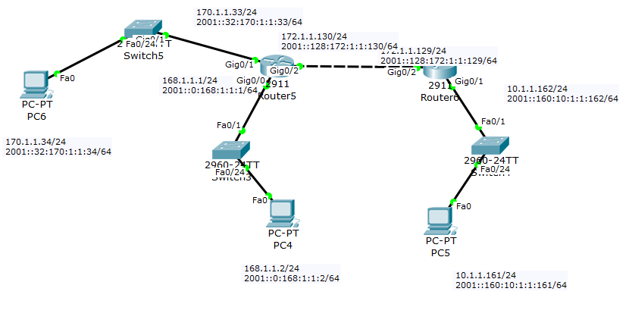

|  |  |
| --- | --- |
| Router(config)#ipv6 unicast-routing | Enables the forwarding of IPv6 unicast datagrams. |
| Router(config)#interface GigabitEthernet0/0 | This is entered to go into INTERFACE CONFIGURATION mode to configure the gigabitEthernet0/0 interface within the router |
| Router(config-if)# ip address 168.1.1.1 255.255.255.0 | This sets the IP Address to 168.1.1.1 with a subnet mask of 255.255.255.0 which is the default subnet mask for a Class C IP Address |
| Router(config-if)# ipv6 address | This sets the IPv6 Address to 2001::168:1:1:1/64 |
| Router(config-if)#interface GigabitEthernet0/1 | This is entered to go into INTERFACE CONFIGURATION mode to configure the gigabitEthernet0/1 interface within the router |
| Router(config-if)# ip address 170.1.1.33 255.255.255.0 | This sets the IP Address to 170.1.1.33 with a subnet mask of 255.255.255.0 which is the default subnet mask for a Class C IP Address |
| Router(config-if)# ipv6 address  2001::32:170:1:1:33/64 | This sets the IPv6 Address to 2001::32:170:1:1:33/64 |
| Router(config-if)#interface GigabitEthernet0/2 | This is entered to go into INTERFACE CONFIGURATION mode to configure the gigabitEthernet0/2 interface within the router |
| Router(config-if)# ip address 172.1.1.130 255.255.255.0 | This sets the IP Address to 172.1.1.130 with a subnet mask of 255.255.255.0 which is the default subnet mask for a Class C IP Address |
| Router(config-if)# ip access-group BLOCKPING out | applies the access-group BLOCKPING facing outward on the specified interface |
| Router(config-if)# ipv6 address 2001::128:172:1:1:130/64 | This sets the IPv6 Address to 2001::128:172:1:1:130/64 |
| Router(config-if)#ip route 10.1.1.0 255.255.255.0 172.1.1.129 | Creates an ip route in the format of *networkAddress SubnetMask ClosestGateway* |
| Router(config)#ipv6 route 2001:0:0:160::/64 2001::128:172:1:1:129 | creates an ipv6 route in the format of *ipv6address/subnetmask interfaceGateway* |
| Router(config)#ip access-list extended BLOCKPING | Creates the extended ACL named BLOCKPING |
| Router(config-ext-nacl)# deny icmp 168.1.1.0 0.0.0.255 172.1.1.0 0.0.0.255 echo | deny icmp traffic moving from 168.1.1.0 with a wildcard mask of 0.0.0.255 to 17.1.1.0 with a wildcard mask of 0.0.0.255, of echo type |
| Router(config-ext-nacl)# permit icmp 172.1.1.0 0.0.0.255 168.1.1.0 0.0.0.255 echo-reply | deny icmp traffic moving from 17.1.1.0 with a wildcard mask of 0.0.0.255 to 168.1.1.0 with a wildcard mask of 0.0.0.255, of echo-reply type |
| Router(config-ext-nacl)#ipv6 access-list BLOCKPINGIPv6 | Creates the extended ipv6 ACL named BLOCKPINGIPv6 |
| Router(config-ipv6-acl)# deny icmp 2001::/64 2001:0:0:128::/64 echo-request | deny icmp traffic moving from 2001::/64 to 2001:0:0:128::/64 , of echo-request type |
| Router(config-ipv6-acl)# permit icmp 2001:0:0:128::/64 2001::/64 echo-reply | deny icmp traffic moving from 2001:0:0:128::/64 to 2001::/64 , of echo-reply type |

|  |  |
| --- | --- |
| Router1(config)#ipv6 unicast-routing | Enables the forwarding of IPv6 unicast datagrams. |
| Router1(config-if)#interface GigabitEthernet0/1 | This is entered to go into INTERFACE CONFIGURATION mode to configure the gigabitEthernet0/1 interface within the router |
| Router1(config-if)# ip address 10.1.1.162 255.255.255.0 | This sets the IP Address to 10.1.1.162 with a subnet mask of 255.255.255.0 which is the default subnet mask for a Class C IP Address |
| Router1(config-if)# ipv6 address  2001::160:10:1:1:161/64 | This sets the IPv6 Address to 2001::160:10:1:1:161/64 |
| Router1(config-if)#interface GigabitEthernet0/2 | This is entered to go into INTERFACE CONFIGURATION mode to configure the gigabitEthernet0/2 interface within the router |
| Router1(config-if)# ip address 172.1.1.129 255.255.255.0 | This sets the IP Address to 172.1.1.129 with a subnet mask of 255.255.255.0 which is the default subnet mask for a Class C IP Address |
| Router1(config-if)# ipv6 address 2001::128:172:1:1:129/64 | This sets the IPv6 Address to 2001::128:172:1:1:129/64 |
| Router1(config-if)#ip route 168.1.1.0 255.255.255.0 172.1.1.130 | Creates an ip route in the format of *networkAddress SubnetMask ClosestGateway* |
| Router1(config)#ip route 170.1.1.0 255.255.255.0 172.1.1.130 | Creates an ip route in the format of *networkAddress SubnetMask ClosestGateway* |
| Router1(config)#ipv6 route 2001::/64 GigabitEthernet0/2 | creates an ipv6 route in the format of *ipv6address/subnetmask interfaceGateway* |
| Router1(config)#ipv6 route 2001:0:0:32::/64 GigabitEthernet0/1 | creates an ipv6 route in the format of *ipv6address/subnetmask interfaceGateway* |

Show Commands:

Show ip route - Shows the router’s routing table. We are looking for all possible networks to be available.

ipconfig (CMD prompt) shows the current running ip configuration

show ip protocol- Shows the protocols running on the router and what interfaces they are attached to.

showaccess-list- Shows the access control list entries

TroubleShooting Commands:

Use Command Prompt to ping the other computer using both ipv4 and ipv6. If it doesn't work, then first make sure your computers are configured with ip and ipv6 addresses.

ipconfig (CMD prompt) shows the current running ip configuration

If either of these are missing or incorrect, try to go into the computer's ip configuration and change it.

If that doesn't do it, make sure you have ipv6 unicast-routing enabled. you can find out by using the command: show running-config. This will show your current configuration.

If any of the links between devices are red, make sure you have all interfaces enabled. You can do this using the show int command. Whatever interface is down, that you expect to be up, use a no shutdown command.

If the traffic you want blocked is still going out, you may have put the ACL on the wrong interface or going the wrong direction.

Resources used:

http://www.cisco.com/c/en/us/td/docs/security/asa/asa92/configuration/general/asa-general-cli/acl-extended.pdf

1. Static NAT and Dynamic NAT/PAT for IPv4 (NOTE: Make sure you show a configuration with static NAT for a web server in the DMZ, then PAT using a pool of multiple addresses for internal hosts connecting to the Internet. You should also demonstrate your knowledge of using just the interface IP Address when this is the only available address presented to you.)

NAT or Network Address Translation provides a one to one translation of IP addresses. The only parts that it changes in the packets it translates is the IP address parts. Nats can be used to connect two incompatible networks. PAT or Port address Translation allows specific private IP address to hide behind a single ip address that is made public.

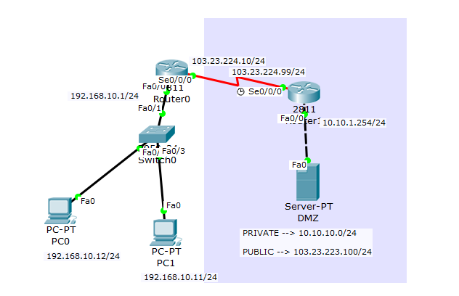

|  |  |
| --- | --- |
| Router0> | This prompt specifies the router is in USER mode |
| Router0>enable | this command is entered to go from USER mode to PRIVILEGE mode |
| Router0# | You are now in PRIVILEGE mode |
| Router0#configure terminal | used to enter GLOBAL CONFIGURATION mode from PRIVILEGE mode. This is needed to configure all parameters within the router |
| Router0(config)# | You are now in GLOBAL CONFIGURATION mode |
| Router0(config)#ip dhcp excluded-address 192.168.10.1 192.168.10.10 | Sets aside addresses within the range given |
| Router0(config)#ip dhcp pool pool1 | creates and enters the pool named pool1 |
| Router0(dhcp-config)# network 192.168.10.0 255.255.255.0 | sets the network to apply to the pool |
| Router0(dhcp-config)# default-router 192.168.10.1 | sets the default router |
| Router0(dhcp-config)# dns-server 192.168.1.1 | sets the dns server |
| Router0(dhcp-config)#interface FastEthernet0/0 | This is entered to go into INTERFACE CONFIGURATION mode to configure the fastEthernet0/0 interface within the router |
| Router0(config-if)# description gateway nat-overload | Sets the nat to use one public ip address for all private hosts. |
| Router0(config-if)# ip address 192.168.10.1 255.255.255.0 | This sets the IP Address to 192.168.10.1 with a subnet mask of 255.255.255.0 which is the default subnet mask for a Class C IP Address |
| Router0(config-if)# ip nat inside | Connects the interface to the inside network |
| Router0(config-if)# no shutdown | Used to enable the specified instance |
| Router0(config-if)#interface Serial0/0/0 | This is entered to go into INTERFACE CONFIGURATION mode to configure the Serial0/0/0 interface within the router |
| Router0(config-if)# ip address 103.23.224.10 255.255.255.0 | This sets the IP Address to 103.23.224.10 with a subnet mask of 255.255.255.0 which is the default subnet mask for a Class C IP Address |
| Router0(config-if)# ip nat outside | Connects the interface to the outside network |
| Router0(config-if)# no shutdown | Used to enable the specified instance |
| Router0(config-if)#ip nat inside source list 1 interface Serial0/0/0 overload | Establishes static translation between an inside local address and an inside global address. |
| Router0(config)#ip route 0.0.0.0 0.0.0.0 Serial0/0/0 | Creates an ip route in the format of *networkAddress SubnetMask InterfaceGateway* |
| Router0(config)#access-list 1 permit 192.168.10.0 0.0.0.255 | permit the given ip through |

|  |  |
| --- | --- |
| Router1> | This prompt specifies the router is in USER mode |
| Router1>enable | this command is entered to go from USER mode to PRIVILEGE mode |
| Router1# | You are now in PRIVILEGE mode |
| Router1#configure terminal | used to enter GLOBAL CONFIGURATION mode from PRIVILEGE mode. This is needed to configure all parameters within the router |
| Router1(config)# | You are now in GLOBAL CONFIGURATION mode |
| Router1(config)#interface FastEthernet0/0 | This is entered to go into INTERFACE CONFIGURATION mode to configure the fastEthernet0/0 interface within the router |
| Router1(config-if)# ip address 10.10.10.254 255.255.255.0 | This sets the IP Address to 10.10.10.254 with a subnet mask of 255.255.255.0 which is the default subnet mask for a Class C IP Address |
| Router1(config-if)# ip nat inside | Connects the interface to the inside network |
| Router1(config-if)# no shutdown | Used to enable the specified instance |
| Router1(config-if)#interface Serial0/0/0 | This is entered to go into INTERFACE CONFIGURATION mode to configure the Serial0/0/0 interface within the router |
| Router1(config-if)# ip address 103.23.224.99 255.255.255.0 | This sets the IP Address to 103.23.224.99 with a subnet mask of 255.255.255.0 which is the default subnet mask for a Class C IP Address |
| Router1(config-if)# ip nat outside | Connects the interface to the inside network |
| Router1(config-if)# clock rate 2000000 | this sets the clock rate to 2000KB per second |
| Router1(config-if)# no shutdown | Used to enable the specified instance |
| Router1(config-if)#ip nat inside source static 10.10.10.10 103.23.224.100 | Establishes static translation between an inside local address and an inside global address. |
| Router1(config)#ip route 0.0.0.0 0.0.0.0 Serial0/0/0 | Creates an ip route in the format of *networkAddress SubnetMask InterfaceGateway* |

New Show Commands:

show ip nat translation - this shows nats translation entries

TroubleShooting Commands:

If the nat translation isnt matching what youd expect, make sure you have all interfaces enabled, and that you configured nat on the correct side of the interface.

Resources used:

http://www.ciscozine.com/nat-and-pat-a-complete-explanation/

9. DHCP Server on the Router and a local DHCP client and a remote DHCP client (ie: using DHCP Relay.)

Dynamic Host Configuration Protocol is used to dynamically assign ip addresses to computers and devices. This helps especially on large networks where it would be tedious to individually assign IP addresses.

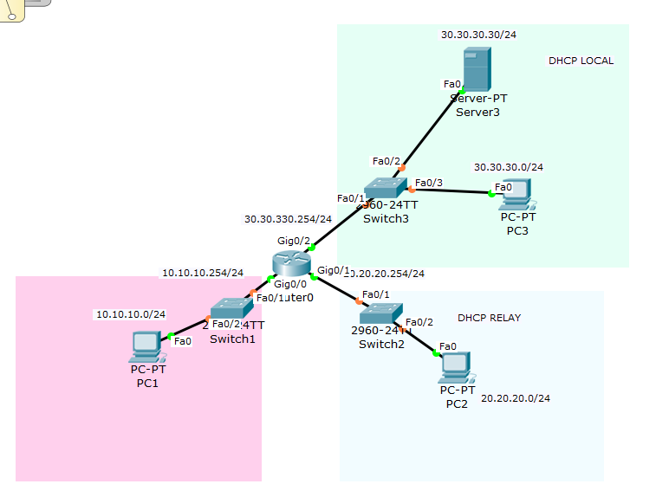

|  |  |
| --- | --- |
| Router0> | This prompt specifies the router is in USER mode |
| Router0>enable | this command is entered to go from USER mode to PRIVILEGE mode |
| Router0# | You are now in PRIVILEGE mode |
| Router0#configure terminal | used to enter GLOBAL CONFIGURATION mode from PRIVILEGE mode. This is needed to configure all parameters within the router |
| Router0(config)# | You are now in GLOBAL CONFIGURATION mode |
| Router0(config)#ip dhcp pool pool1 | creates and enters the pool named pool1 |
| Router0(dhcp-config)# network 10.10.10.0 255.255.255.0 | adds the given network to the pool |
| Router0(dhcp-config)# default-router 10.10.10.254 | Sets the default router |
| Router0(dhcp-config)# dns-server 10.10.10.254 | sets the dns server |
| Router0(dhcp-config)#interface GigabitEthernet0/0 | This is entered to go into INTERFACE CONFIGURATION mode to configure the gigabitEthernet0/0 interface within the router |
| Router0(config-if)# ip address 10.10.10.254 255.255.255.0 | This sets the IP Address to 10.10.10.254 with a subnet mask of 255.255.255.0 which is the default subnet mask for a Class C IP Address |
| Router0(config-if)# no shut | enables the interface |
| Router0(config-if)#interface GigabitEthernet0/1 | This is entered to go into INTERFACE CONFIGURATION mode to configure the gigabitEthernet0/1 interface within the router |
| Router0(config-if)# ip address 20.20.20.254 255.255.255.0 | This sets the IP Address to 20.20.20.254 with a subnet mask of 255.255.255.0 which is the default subnet mask for a Class C IP Address |
| Router0(config-if)# ip helper-address 30.30.30.30 | used To forward a client broadcast request when the client and server are on separate networks |
| Router0(config-if)# no shut | enables the interface |
| Router0(config-if)#interface GigabitEthernet0/2 | This is entered to go into INTERFACE CONFIGURATION mode to configure the gigabitEthernet0/2 interface within the router |
| Router0(config-if)# ip address 30.30.30.254 255.255.255.0 | This sets the IP Address to 30.30.30.254 with a subnet mask of 255.255.255.0 which is the default subnet mask for a Class C IP Address |
| Router0(config-if)# no shut | enables the interface |

Show Commands:

show ip dhcp pool - shows the current pools and information about leased addresses.

show ip dhcp binding - shows currently bound ip addresses and their lease expiration

troubleshooting Commands:

If youve successfully configured the pool and you see what youd exppect from show ip dhcp pool and show ip dhcp binding, but your computer or device cant seem to get a dynamic ip address from the DNS. If this happens you can open the computers command prompt and type ipconfig /release and then ipconfig /renew. This will drop the static ip and replace it with a new one if everything is set up right.

If that doesnt work try backtracking and making sure you defined the pool well enough.

resources used:

<https://technet.microsoft.com/en-us/library/dd145320(v=ws.10).aspx>

10. PPP using PPP CHAP

PPP, or Point to Point Protocol, provides a standard way to transport data over point to point links. It has it’s own encapsulation style and a protocol to configure and test data-link connections.

PPP CHAP is the Point to Point Protocol Challenge Handshake Authentication Protocol. PPP CHAP authenticates it’s partner by doing a three way handshake on passwords and usernames. One host then sends an encrypted message to the other and if the 2nd host successfully decrypts it and responds the 1st host will accept the authentication.

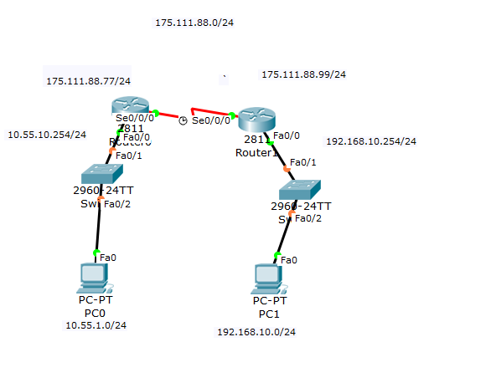

|  |  |
| --- | --- |
| Router0> | This prompt specifies the router is in USER mode |
| Router0>enable | this command is entered to go from USER mode to PRIVILEGE mode |
| Router0# | You are now in PRIVILEGE mode |
| Router0#configure terminal | used to enter GLOBAL CONFIGURATION mode from PRIVILEGE mode. This is needed to configure all parameters within the router |
| Router0(config)# | You are now in GLOBAL CONFIGURATION mode |
| Router0(config)#ip dhcp excluded-address 10.55.1.254 | Sets aside addresses within the range given |
| Router0(config)#ip dhcp pool pool1 | creates and enters the pool named pool1 |
| Router0(dhcp-config)# network 10.55.1.0 255.255.255.0 | adds the specified network to the pool |
| Router0(dhcp-config)# default-router 10.55.1.254 | add the default router |
| Router0(dhcp-config)# dns-server 8.8.8.8 | add the dns server |
| Router0(dhcp-config)#username Router1 password 0 cisco | Sets the username and password used in chap |
| Router0(config)#interface FastEthernet0/0 | This is entered to go into INTERFACE CONFIGURATION mode to configure the fastEthernet0/0 interface within the router |
| Router0(config-if)# ip address 10.55.1.254 255.255.255.0 | This sets the IP Address to 10.55.1.254 with a subnet mask of 255.255.255.0 which is the default subnet mask for a Class C IP Address |
| Router0(config-if)#no shutdown | Used to enable the specified instance |
| Router0(config-if)#interface Serial0/0/0 | This is entered to go into INTERFACE CONFIGURATION mode to configure the SerialEthernet0/0/0 interface within the router |
| Router0(config-if)# ip address 175.111.88.77 255.255.255.0 | This sets the IP Address to 175.111.88.77 with a subnet mask of 255.255.255.0 which is the default subnet mask for a Class C IP Address |
| Router0(config-if)# encapsulation ppp | applies port to port protocol on the interface |
| Router0(config-if)# ppp authentication chap | sets the interface to use chap authentication |
| Router0(config-if)#no shutdown | Used to enable the specified instance |
| Router0(config-if)#ip route 0.0.0.0 0.0.0.0 Serial0/0/0 | Creates an ip route in the format of *networkAddress SubnetMask InterfaceGateway* |

|  |  |
| --- | --- |
| Router1> | This prompt specifies the router is in USER mode |
| Router1>enable | this command is entered to go from USER mode to PRIVILEGE mode |
| Router1# | You are now in PRIVILEGE mode |
| Router1#configure terminal | used to enter GLOBAL CONFIGURATION mode from PRIVILEGE mode. This is needed to configure all parameters within the router |
| Router1(config)# | You are now in GLOBAL CONFIGURATION mode |
| Router1(config)#ip dhcp pool pool1 | creates and enters the pool named pool1 |
| Router1(dhcp-config)# network 192.168.10.0 255.255.255.0 | adds the specified network to the pool |
| Router1(dhcp-config)# default-router 192.168.10.254 | adds the default router |
| Router1(dhcp-config)# dns-server 8.8.8.8 | adds the dns server |
| Router1(dhcp-config)#username Router0 password 0 cisco | Sets the username and password used in chap |
| Router1(config)#interface FastEthernet0/0 | This is entered to go into INTERFACE CONFIGURATION mode to configure the fastEthernet0/0 interface within the router |
| Router1(config-if)# ip address 192.168.10.254 255.255.255.0 | This sets the IP Address to 192.168.10.254 with a subnet mask of 255.255.255.0 which is the default subnet mask for a Class C IP Address |
| Router1(config-if)#no shutdown | enables the interface |
| Router1(config-if)#interface Serial0/0/0 | This is entered to go into INTERFACE CONFIGURATION mode to configure the Serial0/0/0 interface within the router |
| Router1(config-if)# ip address 175.111.88.99 255.255.255.0 | This sets the IP Address to 175.111.88.99 with a subnet mask of 255.255.255.0 which is the default subnet mask for a Class C IP Address |
| Router1(config-if)# encapsulation ppp | applies port to port protocol on the interface |
| Router1(config-if)# ppp authentication chap | sets the interface to use chap authentication |
| Router1(config-if)# clock rate 2000000 | this sets the clock rate to 2000KB per second |
| Router1(config-if)#no shutdown | Used to enable the specified instance |
| Router1(config-if)#ip route 0.0.0.0 0.0.0.0 Serial0/0/0 | Creates an ip route in the format of *networkAddress SubnetMask InterfaceGateway* |

Show Commands:

No new commands needed.

TroubleShooting Commands:

debug ppp negotiation & debug ppp authentication - Allows the user to see PPP negotiations. but unfortunately, sometimes it can be hard to find what you need if you don't know what you're looking for. There is a helpful link below used for troubleshooting.

Resources:

<http://www.cisco.com/c/en/us/support/docs/wan/point-to-point-protocol-ppp/25647-understanding-ppp-chap.html>

Helpful Link- <http://www.cisco.com/c/en/us/support/docs/wan/point-to-point-protocol-ppp/25440-debug-ppp-negotiation.html>