Lab 2

**Date Assigned: 9/14/2015**

**Lab Report Due: Midnight 9/21/2015 on iLearn**

**You may want to bring your textbook to labs to look up syntax and examples.**

**Have a question? Ask your instructor for help, or look at the book or past lecture slides.**

**We encourage you to talk to your classmates; it's okay to discuss ideas (but NOT copy code) during lab.**

**You probably won't finish all of the exercises. Do as much as you can in the allotted time. You NEED to finish the rest after you leave the lab.**

**Before you leave, SHOW your work to your instructor to get credit for your work in lab.**

**Complete all sections and turn in a report to iLearn before the deadline. See turn-in check list (at the end of this document) for more details.**

**For each lab, lab attendance and your work during lab 40%, lab report 60%.**

**Section 1: More HTML Tags**

**Tables**

To insert a table, use a <table> tag. A table element is divided into rows with the <tr> tag, and each row is divided into data cells, where each data cell is a <td> tag, which stands for “table data”. You can place any other content tag within a <td> tag, even tables within tables.

Example:

<!DOCTYPE html>

<html>

<head>

<meta charset="utf-8" />

<title>Try Tables</title>

</head>

<body>

<table>

<tr>

<td>Jill</td>

<td>Smith</td>

<td>50</td>

</tr>

<tr>

<td>Eve</td>

<td>Jackson</td>

<td>94</td>

</tr>

<tr>

<td>John</td>

<td>Doe</td>

<td>80</td>

</tr>

</table>

</body>

</html>

Log into your lab computer. Create a new folder on the desktop and name it **lab2**. In **lab2**, create a page **tabletest.html** that includes code in the example above. View your page in a web browser.

Change the start tag of <table> to <table border="1" style="width:100%">. Refresh your page. What does the table look like now?

Create a table like the one below, and insert it into **tabletest.html.** Save changes, refresh the page, and view the page in a web browser.

|  |  |  |  |
| --- | --- | --- | --- |
| Id | First Name | Last Name | GPA |
| 1 | Eve | Jackson | 94 |
| 2 | John | Doe | 80 |
| 3 | Adam | Johnson | 67 |
| 4 | Jill | Smith | 50 |

**More about link tag <a>**

Once, it was very popular on the web to have links like this:

<!DOCTYPE html>

<html>

<head>

<meta charset="utf-8" />

<title>Try Tables</title>

</head>

<body>

<ul>

<li>Click <a href=”http://www.tasteofhome.com/recipes/apple-pie”> here </a> for apple pie recipes</li>

<li>Click <a href=”http://www.tasteofhome.com/recipes/peach-pie”> here </a> for peach pie recipes</li>

<li>Click <a href=”http://www.tasteofhome.com/recipes/purple-plum-pie”> here </a> for prune pie recipes</li>

</ul>

</body>

</html>

In **lab2**, create a page **linktest.html** that includes code in the example above. View your page in a web browser.

It seemed so clever and intuitive, making the clickable text be the word "here." There are two big problems with this, though:

Accessibility: Screen-reading software for the blind often will read the text of the links on a page so that the user can easily navigate to other pages. Links like those above read as "here," "here," "here" — useless.

Indexing: Search engines pay special attention to the click text on a page, since those are often an important clue about the content of the destination page. The links above don't show what the important words are.

So what do you do instead? Just wrap the link tags around important words:

Modify **linktest.html** to make “apple pie recipes”, “[peach pie recipes](http://google.com/search?as_q=peach+pie+recipes)”, “[prune pie recipes](http://google.com/search?as_q=prune+pie+recipes)” clickable instead of “here”. Save changes, and refresh the page in a web browser.

**Video**

Here is an example of embedding video directly on your page:

<div>

<video width="300" controls autoplay>  
 <source src="http://clips.vorwaerts-gmbh.de/big_buck_bunny.mp4">

</video>

</div>

The attributes controls and autoplay are called boolean attributes. A tag either has or not has them.

Add the above video to **linktest.html**. View it in a web browser.

Remove “autoplay”. Refresh the page. Any difference?

Make width 200. Refresh the page.

**Audio**

<div>

<audio controls>

<source src="http://www.jingle.org/britsungmont.mp3" type="audio/mpeg">

Your browser does not support the audio element.

</audio>

</div>

Add the above audio to **linktest.html**. View it in a web browser.

Add “autoplay” (Where to add?). Refresh the page. Any difference?

**Image**

If the image is being served on the same domain as your HTML file, you can also use the relative URL. If you had, for example, an image “banner.jpg” in the folder of lab2, you could link to this image by <img src="banner.jpg" alt="Banner">. Read <https://kb.iu.edu/d/abwp> for more about relative URL. (We will discuss relative URL this afternoon as well)

Download an image (for example, search “President Obama” in <https://images.google.com/>) from the internet, save it into the lab2 folder, and add it into **linktest.html**. (Don’t use the internet URL, use the relative URL instead)

Download another image from the internet, save it to the desktop, and add it into **linktest.html**. (Don’t use the internet URL, use the relative URL. )

**The <figure> and <figcaption> tags**

<figure>, <figcaption> are often used together with <img>. Here is how to use these two tags:

<figure>

<img src="http://static1.wikia.nocookie.net/__cb20120724095441/spiritedaway/images/a/a7/Chihiro.png">

<figcaption>Chihiro from the movie Spirited Away. </figcaption>

</figure>

Add the above figure to **linktest.html**. View it in a web browser.

**Text/Font Style**

These are tags that you place around a block of text to change their appearances.

<strong> is used to denote text with strong importance in its content, and <em> is used to indicate that a block of text has a stress emphasis. <strong> is usually rendered as bold, and <em> rendered as italic, but it is important not to equate <strong> with bold and <em> with italic.

Modify **linktest.html** to make “apple pie recipes”, “[peach pie recipes](http://google.com/search?as_q=peach+pie+recipes)”, “[prune pie recipes](http://google.com/search?as_q=prune+pie+recipes)” bold. Save changes, and refresh the page in a web browser.

CSS, which we will learn later, is the preferred way of modifying the appearance of HTML elements. With CSS, any block of text can be made bold or italic, and the <strong> and <em> elements can also be restyled to do something different from the default bold and italic.

There are also some tags that can help you specify the font size, font face and color of text. Try the following code in **linktest.html**.

<p>

<font face="Arial">Welcome to Greasy Joe's.</font>

You will <b>never</b>, <i>ever</i>, <u>EVER</u> beat

<font size="+4" color="red">OUR</font> prices!

</p>

However, the <font> tag is not supported in new HTML pages. People use CSS instead.

**Section 2: “About Me” Page**

Create a page **aboutme.html** that describes you. Include information such as:

Your name

A description of you in <= 2 sentences.

A list of classes you are taking right now at Marist.

Your 3 favorite movies, books, or TV shows, in order. Make at least one link to an interesting site about that TV show/movie/book, such as its IMDB page.

Two images that represent you when you're happy and sad. (consider <https://images.google.com/>)

Something about one of your neighbors (people sitting next to you)

Don’t forget to validate your web page at <http://validator.w3.org/>.

Finally, save your web page. We are going to continue to work on it in lab 3.

Example (Your page doesn’t need to be exactly the same, and feel free to add more):

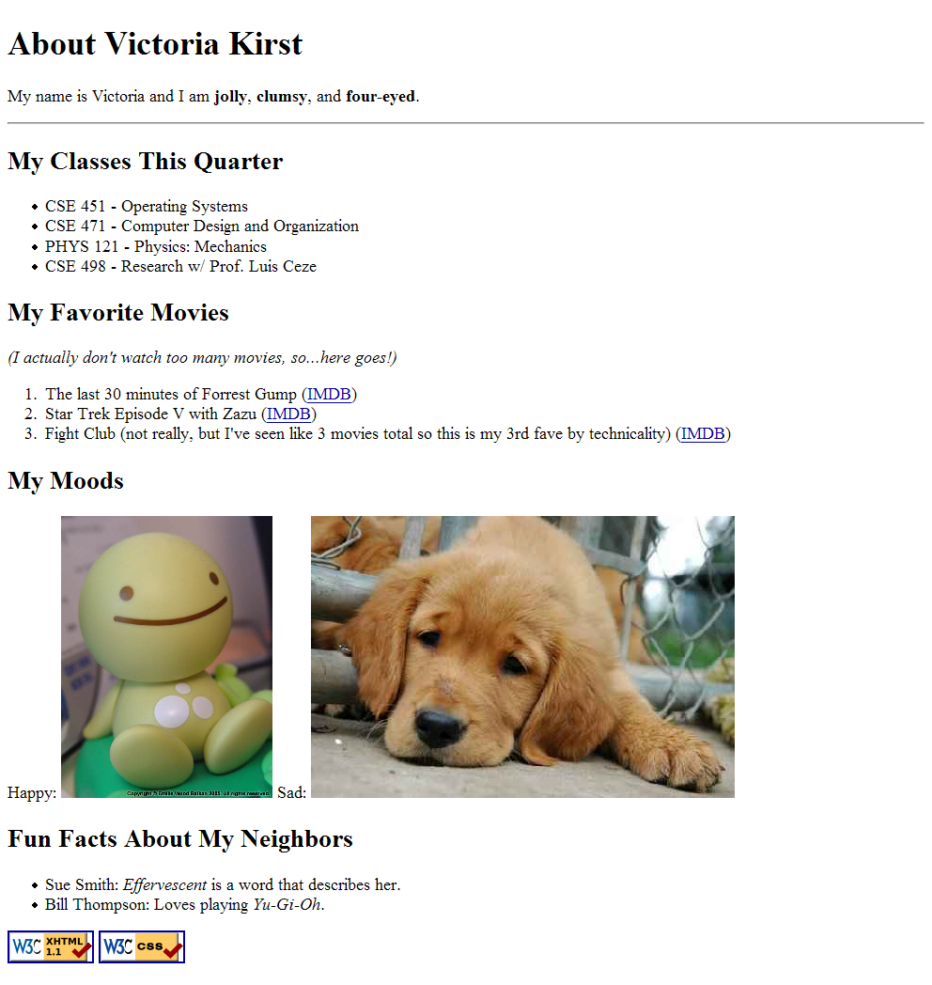

**TURN-IN CHECKLIST:**

**Source Code (.html/.css/.js files) created in this assignment. Remember to include your name, the date, and the lab number in comments near the beginning of your code.**

**Pictures used in this assignment.**

**Create a folder and name it 'FirstName_LastName_lab_2'. In the newly created folder copy and paste your source code (.html/.css/.js files) and pictures. Then compress the folder, and upload it to iLearn.**