Lab 8
Date Assigned: 10/26/2015
Lab Report Due: Midnight 11/02/2015 on iLearn

- You may want to bring your textbook to labs to look up syntax and examples.
- Have a question? Ask your instructor for help, or look at the book or past lecture slides.
- We encourage you to talk to your classmates; it's okay to discuss ideas (but NOT copy code) during lab.
- You probably won't finish all of the exercises. Do as much as you can in the allotted time. You NEED to finish the rest after you leave the lab.
- Before you leave, SHOW your work to your instructor to get credit for your work in lab.
- Complete all sections and turn in a report to iLearn before the deadline. See turn-in check list (at the end of this document) for more details.
- For each lab, lab attendance and your work during lab 40%, lab report 60%.

Section 1: A Survey Form
<form id="surveyform">

<p>Please enter your first name: </p>
<input id = "fname">
<br>

<p>Please enter your last name: </p>
<input id = "lname">
<br>

<p>Please enter your major: </p>
<input id = "major">
<br>

<p>Please enter your email address: </p>
<input id = "email">
<br>

<p>Please enter your phone number: </p>
<input id = "phone">
<br>

</form>

- Create a folder lab8 on the desktop. Create a page section1.html that includes code in the above example, and save it in lab8. View the page in Chrome.
- Let’s make a drop down list with multiple options:
<p> Where do you come from? </p>
<select id = "states" >
<option value="NA">Not Applicable</option>
<option value="AL">Alabama</option>
<option value="AK">Alaska</option>
<option value="AZ">Arizona</option>
<option value="AR">Arkansas</option>
<option value="CA">California</option>
<option value="CO">Colorado</option>
<option value="CT">Connecticut</option>
<option value="DE">Delaware</option>
<option value="DC">District Of Columbia</option>
<option value="FL">Florida</option>
<option value="GA">Georgia</option>
<option value="HI">Hawaii</option>
<option value="ID">Idaho</option>
<option value="IL">Illinois</option>
<option value="IN">Indiana</option>
<option value="IA">Iowa</option>
<option value="KS">Kansas</option>
<option value="KY">Kentucky</option>
<option value="LA">Louisiana</option>
<option value="ME">Maine</option>
<option value="MD">Maryland</option>
<option value="MA">Massachusetts</option>
<option value="MI">Michigan</option>
<option value="MN">Minnesota</option>
<option value="MS">Mississippi</option>
<option value="MO">Missouri</option>
<option value="MT">Montana</option>
<option value="NE">Nebraska</option>
<option value="NV">Nevada</option>
<option value="NH">New Hampshire</option>
<option value="NJ">New Jersey</option>
<option value="NM">New Mexico</option>
<option value="NY">New York</option>
<option value="NC">North Carolina</option>
<option value="ND">North Dakota</option>
<option value="OH">Ohio</option>
<option value="OK">Oklahoma</option>
<option value="OR">Oregon</option>
<option value="PA">Pennsylvania</option>
<option value="RI">Rhode Island</option>
<option value="SC">South Carolina</option>
<option value="SD">South Dakota</option>
<option value="TN">Tennessee</option>
<option value="TX">Texas</option>
<option value="UT">Utah</option>
<option value="VT">Vermont</option>
<option value="VA">Virginia</option>
<option value="WA">Washington</option>
<option value="WV">West Virginia</option>
<option value="WI">Wisconsin</option>
<option value="WY">Wyoming</option>
</select>
<br>

Add the above code into the form (id “surveyform”) container in section1.html. View the page in Chrome.
- Add a question with radio buttons into the form (id “surveyform”) container in section1.html.
<p>How did you hear about us? </p>
<input type="radio"> Google/Yahoo/Bing
<input type="radio"> Friends
<input type="radio"> Media
<input type="radio"> Others
<br>

Are we done? Is there anything missing?
Recap from lab 7:
Important: Radio buttons should be grouped by name attribute (radio buttons should have the same name), so that only one can be selected at a time. Without the same name, radio buttons will not be mutually exclusive.

- Add a name attribute to radio buttons we just created. Let name be “source”.
- Add the following code into the form (id “surveyform”) container in section1.html.
<p> Please rate our services out of a scale of 5: </p>
<input type="number" min="1" max="5" id = "rating">
<br>

Section 2: Javascript and HTML Form
We will handle form events with an external Javascript file.

- Create an empty Javascript file, name it “section1.js”, and attach it to section1.html (Make sure you add reference to section1.js right before the closing tag of body).

- Add the following code to the form (id “surveyform”) container in section1.html.
<button type="button" onclick = "clicksubmit();" >Submit Your Answers </button> <br>
Where “clicksubmit()” is a Javascript function we are going to define in section1.js later.

- View the page in Chrome. Click the “submit your answers” button. Does it work?
Open the web console, you should be able to see an error message “Uncaught ReferenceError: clicksubmit is not defined”. This is because the function “clicksubmit()” is not defined in our Javascript file yet.

- Now let’s define our own function “clicksubmit()” in the external Javascript file section1.js.
function clicksubmit() {
// read value from input boxes by their id, and save them in variables
var firstname = document.getElementById('fname').value;
var lastname = document.getElementById('lname').value;
var major = document.getElementById('major').value;
var email = document.getElementById('email').value;
var cell = document.getElementById('phone').value;
var score = document.getElementById('rating').value;
// reading values from a drop-down list or from radio type input boxes is very complicated.
// we will discuss how to read values from drop-down lists and radio type input boxes later, after we learn if-else and for loops
// display the value of input box using alert
alert(firstname + " "+ lastname + " is majoring in " + major + ". "+ firstname + " can be reached at "+cell + ". "+ firstname + "'s rating of our website is "+ score);
alert("Hi, " + firstname + "! Thanks for your participation in the survey! "+ " A copy of this survey has been sent to your email address at " + email );
}
Note: How to read values from regular input boxes (not including radio types)
Recap from lab 7:
We use document.getElementById("idvalue") in Javascript to refer to a specific element in HTML. In this case, document.getElementById("idvalue") refers to the element in section1.html with id “idvalue” (“idvalue” can be replaced by the value of the id attribute, such as “fname”, “lname”), and document.getElementById("idvalue").value refers to what user has typed in the input box of “idvalue”. We save the value in a variable home, and use it in the alert() function.
Note: Reading values from a drop-down list or from radio type input boxes is very complicated. We will discuss how to read values from drop-down lists and radio type input boxes later, after we learn if-else and for loops.
View section1.html in Chrome.

Section 3: A Pizza Order Form
- Create a page section3.html, and save it in lab8. View the page in Chrome.
- Let’s create a new form. In section3.html, add the following code:
<form id="pizza">

</form>

- Add code into the form (id “pizza”) container in section3.html, so that your section3.html looks like (See lab7.doc if you don’t remember how to add boxes/buttons):
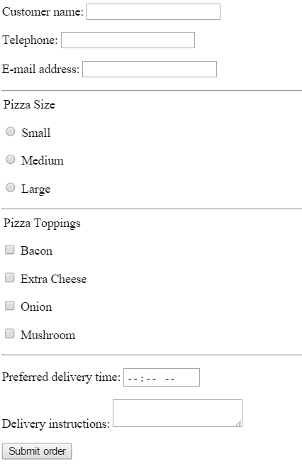

- Create an empty Javascript file, name it “section3.js”, and attach it to section3.html (Make sure you add reference to section1.js right before the closing tag of body).
- In section3.html, add an “onclick” attribute to the button “Submit order”. Let the value of “onclick” be “clicksubmit2();”, where “clicksubmit2()” is name of a Javascript function which we will define in the external Javascript file.
- In section3.js, add the definition of “clicksubmit2()” following the format of
function clicksubmit2() {
// add code here
// You need statements to read value from input boxes (Customer name, telephone, email address, delivery time, delivery instructions), and save them each in a variable
// You don’t need to read values of Pizza size and Pizza toppings -- We will work on them in the future labs

// You need statements to display the value of input boxes using alert

}
to display what user has typed about his/her major in an alert box.
View section3.html in Chrome.

TURN-IN CHECKLIST:

- Source Code (.html/.css/.js files) created in this assignment. Remember to include your name, the date, and the lab number in comments near the beginning of your code.

Create a folder and name it 'FirstName_LastName_lab_8'. In the newly created folder copy and paste your source code (.html/.css/.js files). Then compress the folder, and upload it to iLearn.

