Bradley Lamitie

CWID#: 20070503

Homework 0

Due 1/27/2019

MSCS 630 - Dr. Pablo Rivas

**Java Version:**

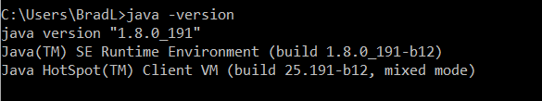

**Java Compiler Version:**



**Github Account:** 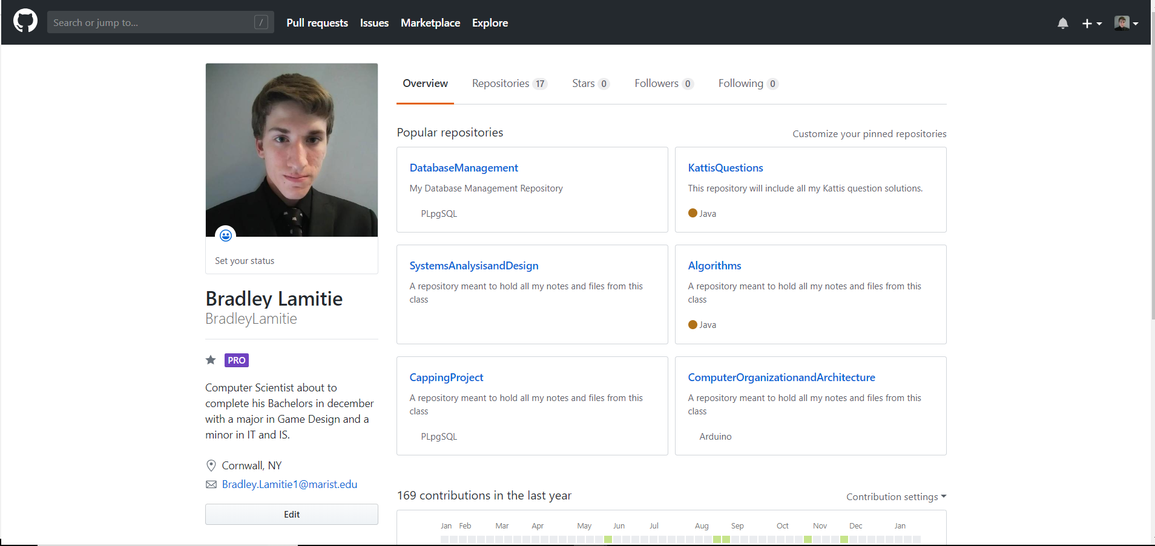

**Github Class Repository:** 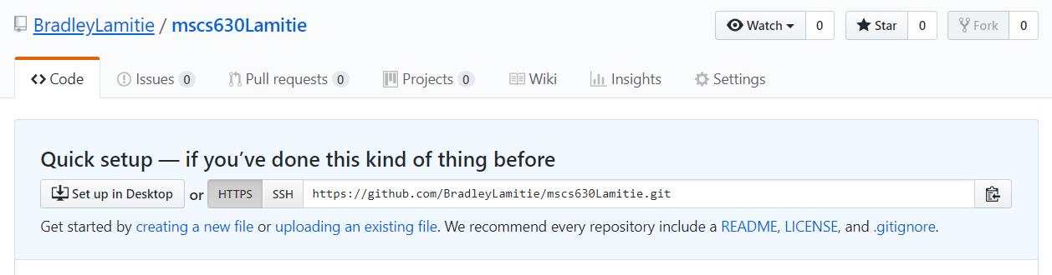

**GitHub class repository HTTPS link:**

https://github.com/BradleyLamitie/mscs630Lamitie.git