1. Open task scheduler

1. At the top left click action then click create Task

1. Write ‘scrape_insta_url’ for the name and click the following:
   1. ‘Run whether user is logged on or not’
   2. ‘Do not store password. Task will only have access to local computer resources’
   3. ‘Run with highest privileges’

1. Go to the ‘triggers’ tab and click ‘new’

1. Change the start date and time to what you want. Change to the following variables below
   1. Repeat task every 1 hour
   2. For a duration of 1 day
   3. Stop all running task at end of repetition duration

Click ok

1. Go to the ‘actions’ tab and click ‘new’

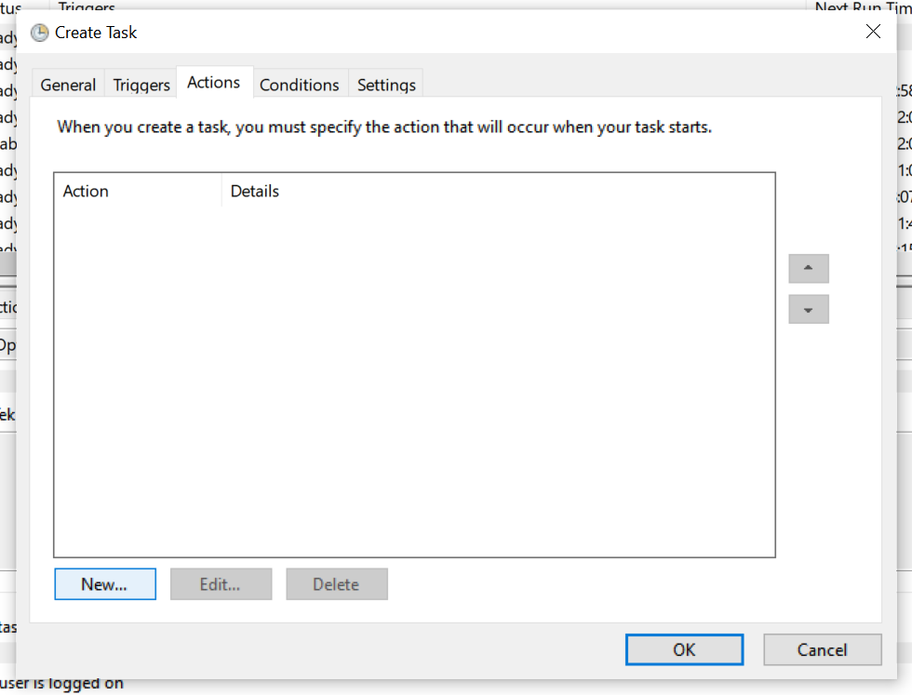

1. Click on ‘browse’ and choose ‘scrape_url.py’. write ‘scrape_url.py’ for ‘Add arguments (optional)’. Write your directory where ‘scrape_url.py’ reside in for ‘Start in (optional)’. If there are empty spaces in your directory, you need add quotation marks around it. After you are done, click ok.

1. Go to the ‘Conditions’ tab and check uncheck the ‘start the task only if the computer is on AC power’. After that, click ok.

