Allen Bradley Roberts
Com S 352 – Operating Systems
February 8, 2019

Assignment 3

Question 1:
Why are two modes (user and kernel) needed? What is the difference between an interrupt and a trap?

Answer:
Two modes are needed because

Question 2:

Answer:

Question 3:
Explain what the following options will do when used with ps:
- ps -e
- ps -l

Answer:
ps -e is used to see every process running on the system
ps -l is used for “Long Format” which shows more information about the process.

Question 4:
Combine ps with grep to get the PID of a process (e.g. FireFox). Then, use the kill command to send a SIGTERM signal to that process.

Answer:
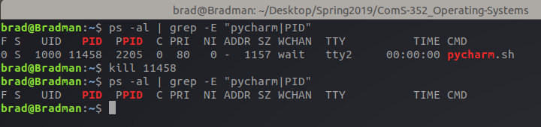

Question 5:
How many times message “Both parent and child reach here” will be printed?

Answer:
“Both parent and child reach here” is printed a total of 2 times, once for the child process and once for the parent.

Question 6:
Explain what the command pstree does.

Answer:
pstree displays a tree of the running processes on the system. This is useful in showing what processes are parents and children.

