Company C
GLO-BUS weekly report · Year 7 results · StratOS
Feedback, not recommendations: this report names the position your inputs reveal and general things to watch. Every decision is your team's. Rival figures come only from the class-wide reports.
1. Your scorecard
Rank 2 of 8, overall score 84 (rank 3 last year). Leader: Company D at 86.
Scored measure | You | Investor expectation
EPS | $2.10 | $2.15 | Below
ROE | 15.5% | 15.5% | Met
Stock price | $26.10 | $27.00 | Below
Credit rating | BB- | BB | Below
Image rating | 71 | 72 | Below
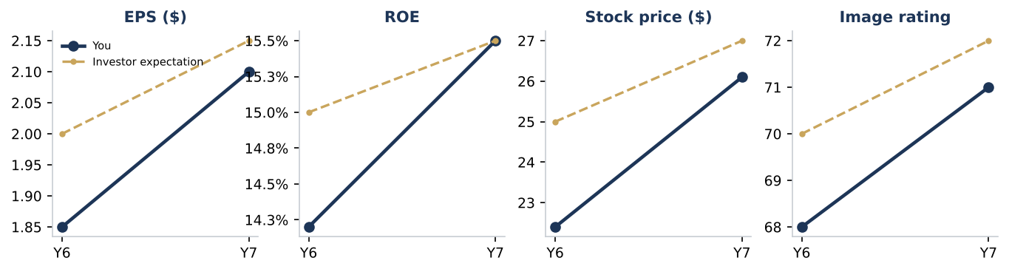
2. The position you've taken
Cameras: your inputs look like a best-cost provider position (mixed). Price -4.4% vs the industry, P/Q +0.1 stars, cost per unit -4.3%. On the competitor report you sit in the value leader group. That matches the strategy you chose. Best-cost providers offer above-average quality at an average or slightly lower price, so costs must stay tightly controlled to fund both.
Drones: your inputs look like a best-cost provider position (mixed). Price +3.5% vs the industry, P/Q +0.2 stars, cost per unit +0.6%. On the competitor report you sit in the premium differentiator group. You chose differentiation. Best-cost providers offer above-average quality at an average or slightly lower price, so costs must stay tightly controlled to fund both.
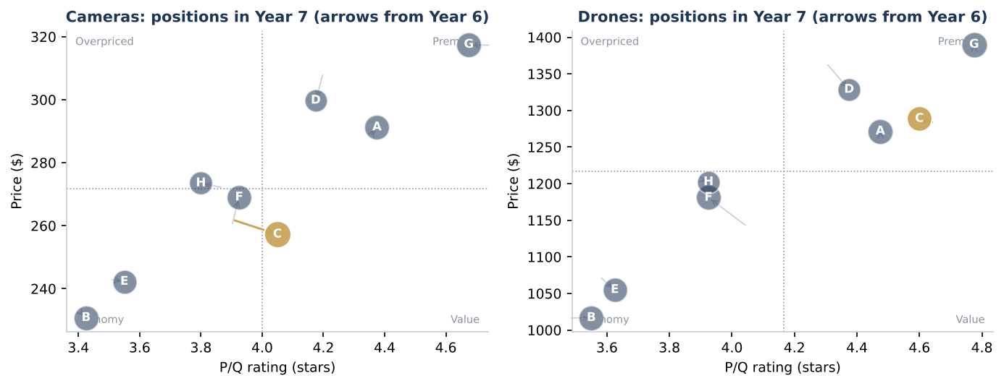
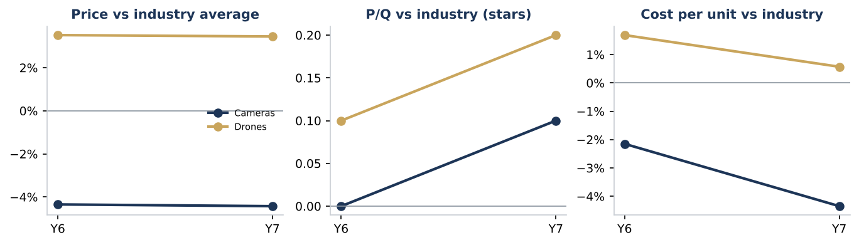
3. Progress
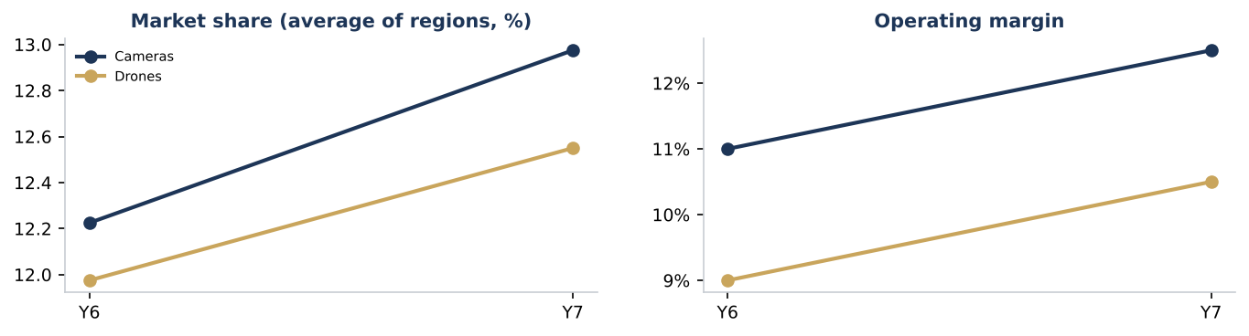
4. Where you stand in the contest
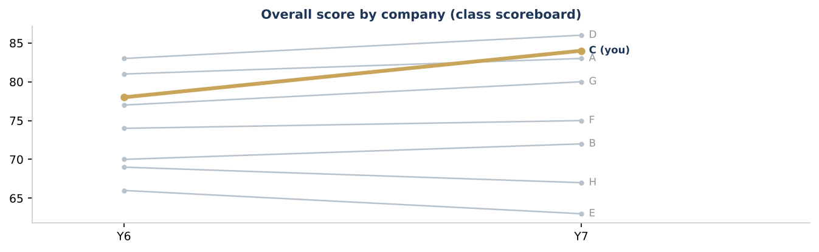
What rivals changed since last year (from the competitor report):
- Company F (drones): price +3.5%, P/Q -0.1 stars, share +0.3 points; now in the low-cost / economy group.
- Company D (drones): price -2.7%, P/Q +0.1 stars, share +1.3 points; now in the premium differentiator group.
- Company F (cameras): price +3.6%, P/Q +0.0 stars, share +0.4 points; now in the low-cost / economy group.
- Company D (cameras): price -2.9%, P/Q -0.0 stars, share +0.3 points; now in the premium differentiator group.
- Company E (drones): price -1.7%, P/Q +0.0 stars, share -0.9 points; now in the low-cost / economy group.
5. What to look out for next round
- Drones: the position your inputs show differs from the strategy you chose. You chose differentiation; price +3.5% vs the industry and P/Q +0.2 stars put you closer to best-cost provider. Teams that drift between positions usually pay for both and get credit for neither. Decide whether the drift is deliberate.
- EPS below investor expectations. EPS: $2.10 against an expectation of $2.15. EPS is scored directly; it reflects price, cost and volume together, so look for which of the three moved against you.
- Credit rating below investor expectations. Credit rating: BB- against an expectation of BB. Credit rating follows debt, interest coverage and cash; it also affects borrowing costs.
- Image rating below investor expectations. Image rating: 71 against an expectation of 72. Image rating builds slowly from P/Q, models, warranty, advertising and CSR; it is hard to recover quickly once it falls behind.
6. Questions for your team
- Is the drones position your inputs now show the one you meant to build?
- Which input did you change most this year, and did the result move the way the projections said?

