GLO-BUS Weekly Review — Company C (Year 7 results)
StratOS GLO-BUS Coach output. Feedback, not recommendations: it names the position your inputs reveal and what to watch; every decision is your team's. Rival figures come only from the class-wide reports (scoreboard, Competitive Intelligence Report).
In one line: Rank 2 of 8 with a best-cost provider position in both products; drones have drifted from the strategy you chose.
Section | What it shows
W1. Scorecard | 1 of 5 scored measures met investor expectations in Year 7; EPS fell short ($2.10 vs $2.15)
W2. Position | Cameras read as best-cost provider (as chosen); drones have drifted toward best-cost provider
W3. Progress | Cost per unit vs the industry: cameras -4.3%, drones +0.6% — the number that decides whether the position pays
W4. Contest | Rank 2 of 8, 2 points behind Company D; Company F moved most in drones
W5. Management brief | 3 of 3 goals from your management interview missed this round
W6. Watch list | 4 things to watch before the Year 8 decisions
W7. Questions | Questions for the team before Year 8
W1. Scorecard
1 of 5 scored measures met investor expectations in Year 7; EPS fell short ($2.10 vs $2.15).
Rank 2 of 8, overall score 84 (rank 3 last year). Leader: Company D at 86.
Scored measure | You | Investor expectation | Result
EPS | $2.10 | $2.15 | Below
ROE | 15.5% | 15.5% | Met
Stock price | $26.10 | $27.00 | Below
Credit rating | BB- | BB | Below
Image rating | 71 | 72 | Below
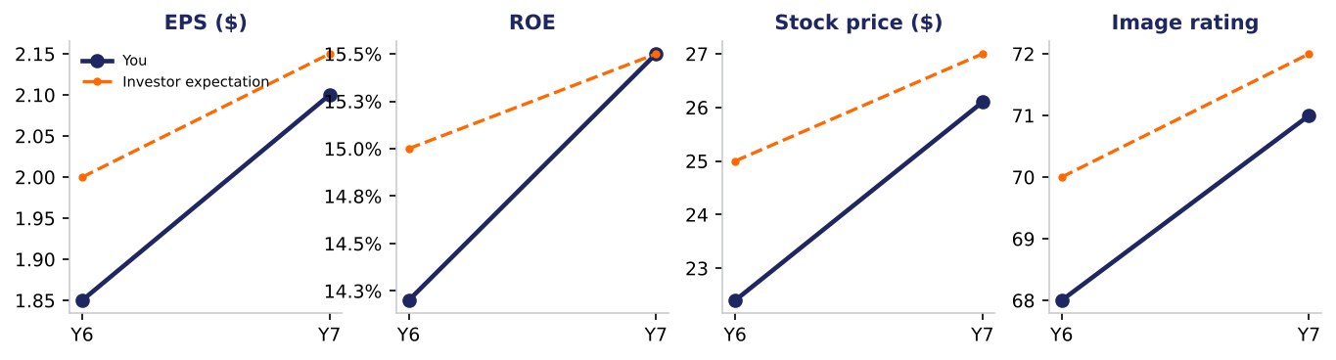
Impact Summary — the team writes this:
[In two or three sentences: what this tells you about your position, and what you will discuss before entering next year's decisions.]
W2. The position you've taken
Cameras read as best-cost provider (as chosen); drones have drifted toward best-cost provider.
Product | Apparent position | Chosen strategy | Price vs industry | P/Q vs industry | Cost vs industry | Group (CIR)
Cameras | Best-cost provider (mixed) | Best-cost provider | -4.4% | +0.1 stars | -4.3% | Value leader
Drones | Best-cost provider (mixed) | Differentiation | +3.5% | +0.2 stars | +0.6% | Premium differentiator
Cameras: your inputs look like a best-cost provider position (mixed). Price -4.4% vs the industry, P/Q +0.1 stars, cost per unit -4.3%. On the competitor report you sit in the value leader group. That matches the strategy you chose. Best-cost providers offer above-average quality at an average or slightly lower price, so costs must stay tightly controlled to fund both.
Drones: your inputs look like a best-cost provider position (mixed). Price +3.5% vs the industry, P/Q +0.2 stars, cost per unit +0.6%. On the competitor report you sit in the premium differentiator group. You chose differentiation. Best-cost providers offer above-average quality at an average or slightly lower price, so costs must stay tightly controlled to fund both.
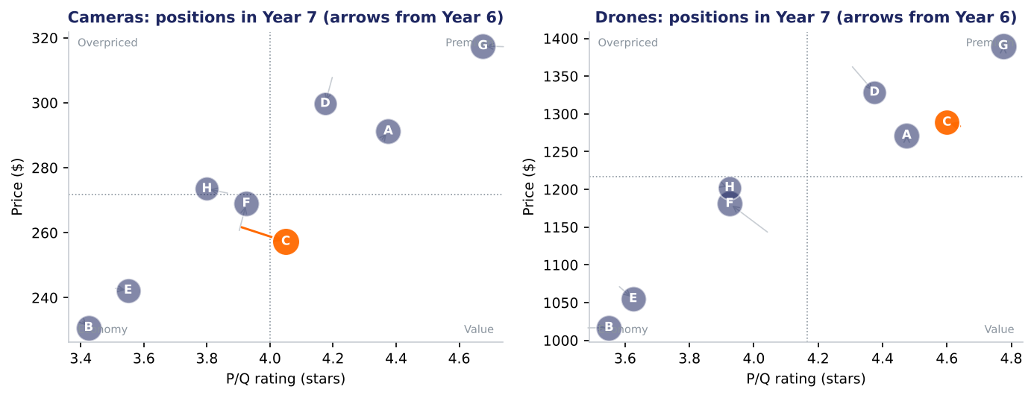
Impact Summary — the team writes this:
[In two or three sentences: what this tells you about your position, and what you will discuss before entering next year's decisions.]
W3. Progress
Cost per unit vs the industry: cameras -4.3%, drones +0.6% — the number that decides whether the position pays.
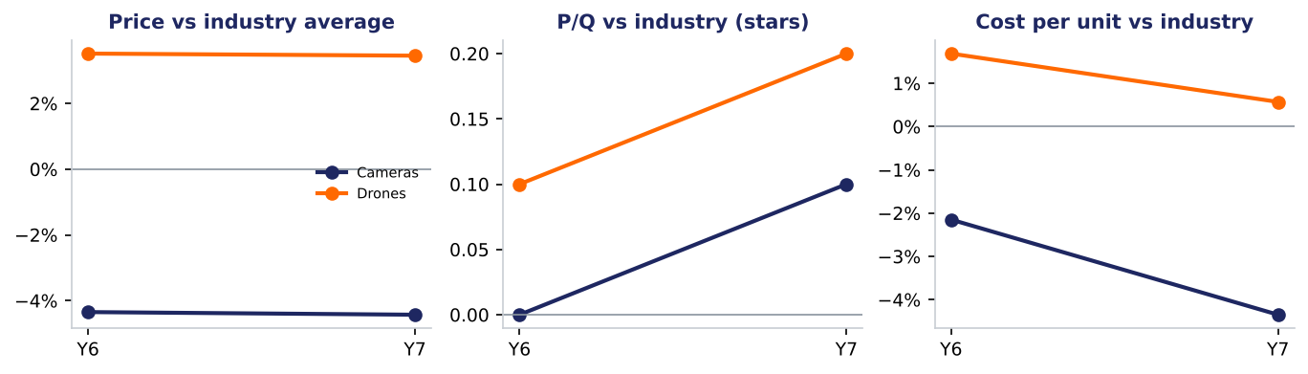
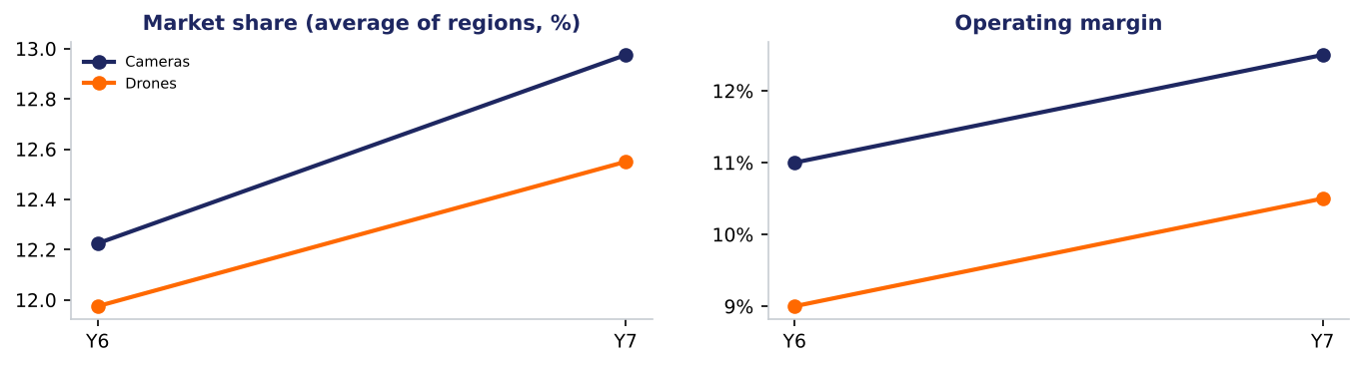
Impact Summary — the team writes this:
[In two or three sentences: what this tells you about your position, and what you will discuss before entering next year's decisions.]
W4. Where you stand in the contest
Rank 2 of 8, 2 points behind Company D; Company F moved most in drones.
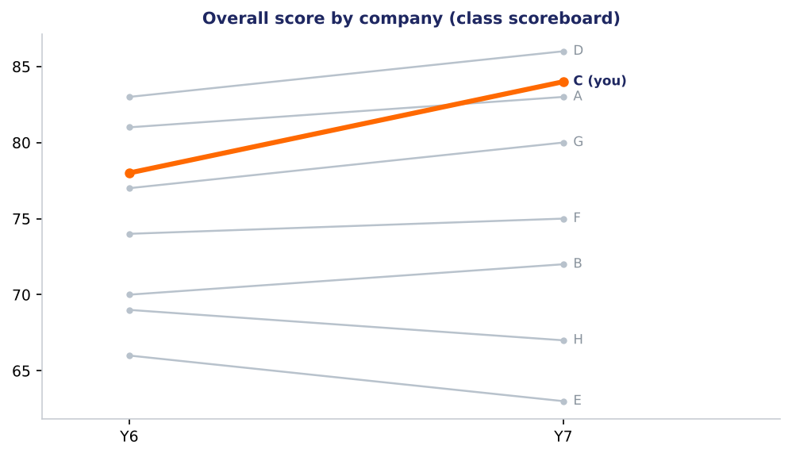
What rivals changed since last year (Competitive Intelligence Report):
- Company F (drones): price +3.5%, P/Q -0.1 stars, share +0.3 points; now in the low-cost / economy group.
- Company D (drones): price -2.7%, P/Q +0.1 stars, share +1.3 points; now in the premium differentiator group.
- Company F (cameras): price +3.6%, P/Q +0.0 stars, share +0.4 points; now in the low-cost / economy group.
- Company D (cameras): price -2.9%, P/Q -0.0 stars, share +0.3 points; now in the premium differentiator group.
- Company E (drones): price -1.7%, P/Q +0.0 stars, share -0.9 points; now in the low-cost / economy group.
Impact Summary — the team writes this:
[In two or three sentences: what this tells you about your position, and what you will discuss before entering next year's decisions.]
W5. Against your management brief
3 of 3 goals from your management interview missed this round.
Goal | Measure | This round | Target | Status
B1. Beat investor expectations for EPS | EPS | 2.1 | investor expectation 2.15 | missed
B2. Hold a credit rating of BB or better | Credit rating | BB- | BB | missed
B3. Keep the image rating at or above expectations | Image rating | 71 | investor expectation 72 | missed
- Protect the credit rating: no growth that needs new debt (check: Credit rating each round)
- Cameras compete on value, drones on quality (check: Position in the weekly report)
W6. What to look out for next round
4 things to watch before the Year 8 decisions.
Watch item | Evidence | General lesson
Drones: the position your inputs show differs from the strategy you chose | You chose differentiation; price +3.5% vs the industry and P/Q +0.2 stars put you closer to best-cost provider. | Teams that drift between positions usually pay for both and get credit for neither. Decide whether the drift is deliberate.
Management goal B1 missed: Beat investor expectations for EPS | EPS: 2.1 against investor expectation 2.15. This goal came from your management interview. | EPS reflects price, cost and volume together; look for which of the three moved against you.
Management goal B2 missed: Hold a credit rating of BB or better | Credit rating: BB- against BB. This goal came from your management interview. | Credit rating follows debt, interest coverage and cash; it also sets borrowing costs.
Management goal B3 missed: Keep the image rating at or above expectations | Image rating: 71 against investor expectation 72. This goal came from your management interview. | Image rating builds slowly from P/Q, models, warranty, advertising and CSR.
W7. Questions for the team
- Is the drones position your inputs now show the one you meant to build?
- Which input did you change most this year, and did the result move the way the projections said?
Sources
Source: GLO-BUS captures, Years 6–7 (company reports, class scoreboard, Competitive Intelligence Report); StratOS weekly_report.py

