Principles of Measurement & Instrumentation I

Laboratory

PHYS417

Preliminary Work

Nuray BAŞARAN

2140689

Experiment 2- Arduino-Based Measurement Devices

Experiment Date: 16.10.2019

Submission Date: 16.10.2019

**Question 1: Explain the difference between microprocessor, microcomputer and microcontroller.**

Microcomputer is a small and cheap computer. It has microprocessor, memory and a circuit with its inputs and outputs.

Microprocessor is an important part in microcomputer like a CPU in a computer. It has Control Unit (CU) and Arithmetic Logic Unit (ALU) of a microcomputer.

Microcontroller does specific work as a small computer in a bigger system. RAM, ROM and CPU are the most common examples.

Shortly, microcomputer is a small computer to do some works in cheaper way. Microprocessor is an important part of a microcomputer like CPU which is a microcontroller in a computer.

**Question 2: Explain the difference between an analog signal and a digital signal.**

Signals provide us to carry information from one side to other side. If amplitude of the signal changes continuously in a time period, it is “analog signal”. We examine it with amplitude, period, frequency and phase. If the signal is changing in discrete amplitude, it is “digital signal”. We examine it with binary numbers. We represent analog signals with sinusoidal waves and digital signals with square waves. For example, human voice is an analog signal but recorded voice on CD or MP is a digital signal. We use this kind of changes sometimes because analog signals have infinite resolution so they produce too much noise and they are much more difficult to analyze. Therefore changing signals to each other is necessary for different situations.

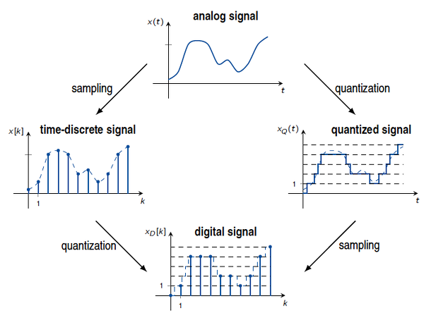

**Question 3: Explain the basic principle of the PWM. (Pulse Width Modulation)**

We know that from question 2; analog signal has infinite resolution in magnitude and time therefore we can control things directly in analog circuits. In this method, we can control analog signals by using digital sources. Basically, we change the duty cycle which is a repeating series of on and off pulses. When the supply is switched off, it is off time and when it applies DC, it is on time. If a signal is on at %20 of the period and off at %80, It uses %20 of the all voltage.

For example;

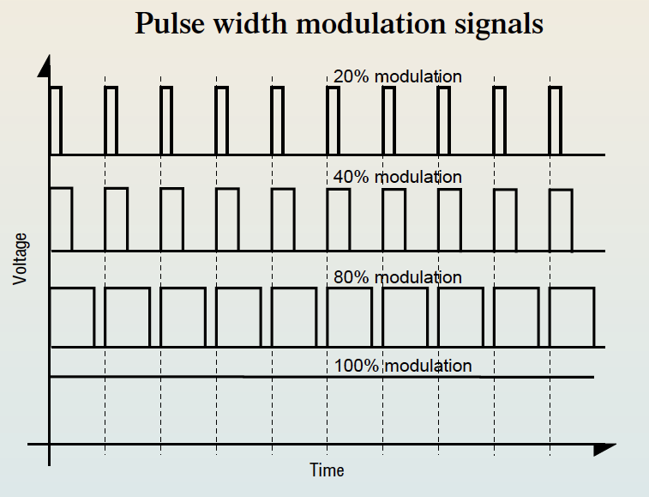

If we apply 20 voltage; we get %20*20 = 4V in the first one, %40*20=8V in the second one, %80*20=16V in the third one and finally %100*20=20V for the last one.

If our duty cycle is 10 second and the signal is on for 5 second and off for 5 second, It is %50 pulse width modulation. If our duty cycle is 4 second and the signal is on for 2 second and off for 2 second, it is still %50 pulse width modulation. When we change frequency, we change only the time of duty cycle.

**Question 4: Describe the purpose of the following functions in Arduino.**

digitalRead()- We use this to read the pin number by writing the pin number in the ().

analogRead()- the purpose is same with digitalRead() but we read it on the scale from 0 to 1024.

digitalWrite()- This function sends 5V or 0V to the pin. It has only two settings which are 1 and 0, true and false, HIGH and LOW respectively.

analogWrite()- It send value 0 to 255. 255 means, pin takes all power %100 of the time and 128 means pin takes all power %50 of the time.

pinMode()- Basically, we choose output. It provides flowing of power to the pin.

Serial.begin()- It corresponds to the data rate in bits per second for data transmission.

delay()- It pauses the program for the number of milliseconds.

millis()- We can determine the certain time when things happen.

Serial.print()- It sends strings somethings to the serial monitor.

Serial.println()- It is similar to serial.print. It prevents from printing many results in a straight line without spaces.

map()- Setting a range of values to another new range.

random()- It provides to adjust a number when we don’t know the number.

**Question 5: What does Clock Speed mean for a microcontroller? How is it related to the time response of the microcontroller?**

Clock speed is the rate that the executed instructions per second for a CPU. In other words, it is the number of pulses per second. It is measured most commonly in MHz and GHz. 1MHz equals to one million cycles per second.

Microcontrollers perform the specific tasks. Their executed instructions per second give us clock speed and they are usually preferred according to their clock speed.

**Question 6: Explain INTERRUPT on Arduino with an analogy.**

Interrupt interrupts the processor quickly when there is an important thing.

For example, when we go to an exam, we get questions on papers and a pencil to solve these questions. We get information about exam from teacher or assistants such as time. Now think that pencil and papers are our materials. Question and information is our inputs. The exam is started and we start to think and do the questions. If we think ourselves as a processor, when we are interrupted by teachers for correction on a question, we detect the teacher’s new information and then we continue to exam with this information.

**Question 7: What is the resolution of Analog-to-Digital Converter in Arduino UNO?**

It has 10 bit resolution which means values from 0 to 1023 (there are 2^10=1024 values from 0 to 1023). Therefore, we can map our values into values between 0 and 1023.

**REFERENCES**

<https://www.elprocus.com/differences-between-analog-signal-and-digital-signal/>

<https://www.tutorialspoint.com/differences-in-microcomputer-microprocessor-and-microcontroller>

<https://www.javatpoint.com/difference-between-analog-signals-and-digital-signals>

<https://www.embedded.com/introduction-to-pulse-width-modulation/>

<https://www.youtube.com/watch?v=GQLED3gmONg&t=234s>

[https://www.letsstartcoding.com/functions](https://www.letsstartcoding.com/functions#pinMode)

<https://www.computerhope.com/jargon/c/clockspe.htm>