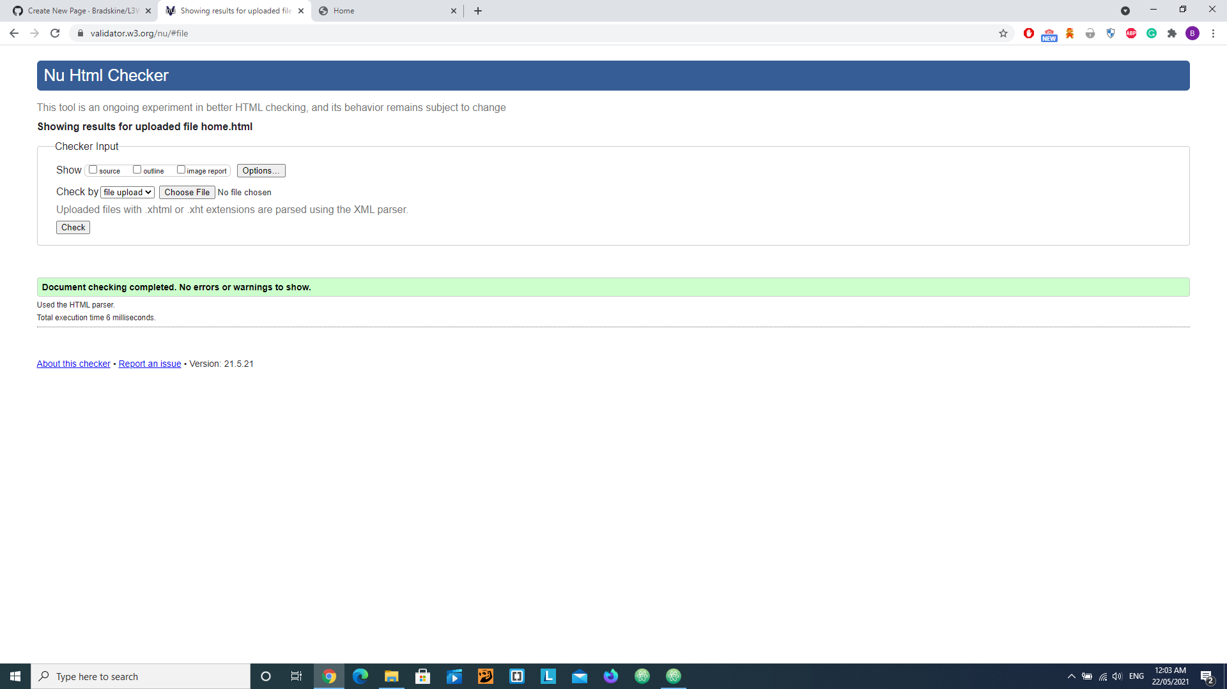

Home

Media

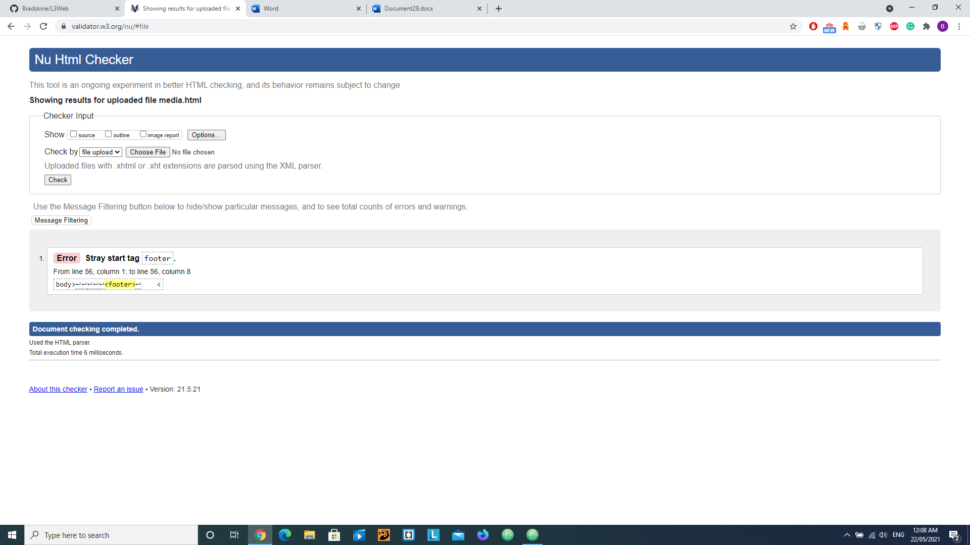

Css

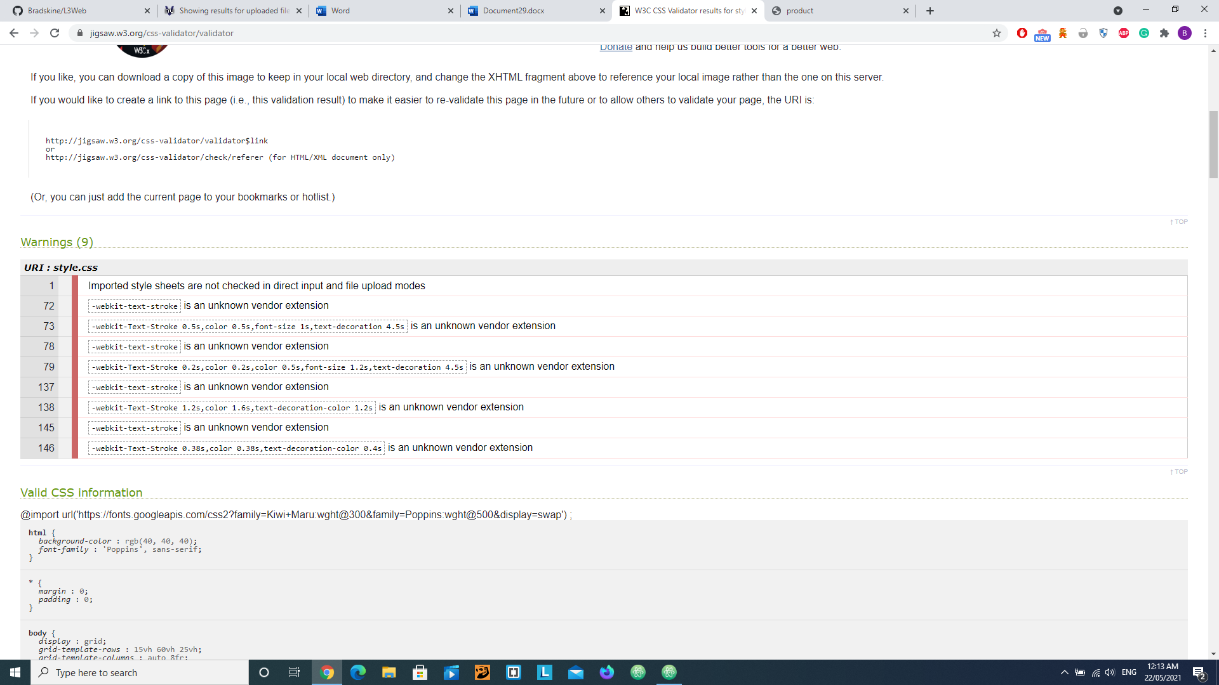

Pruducts

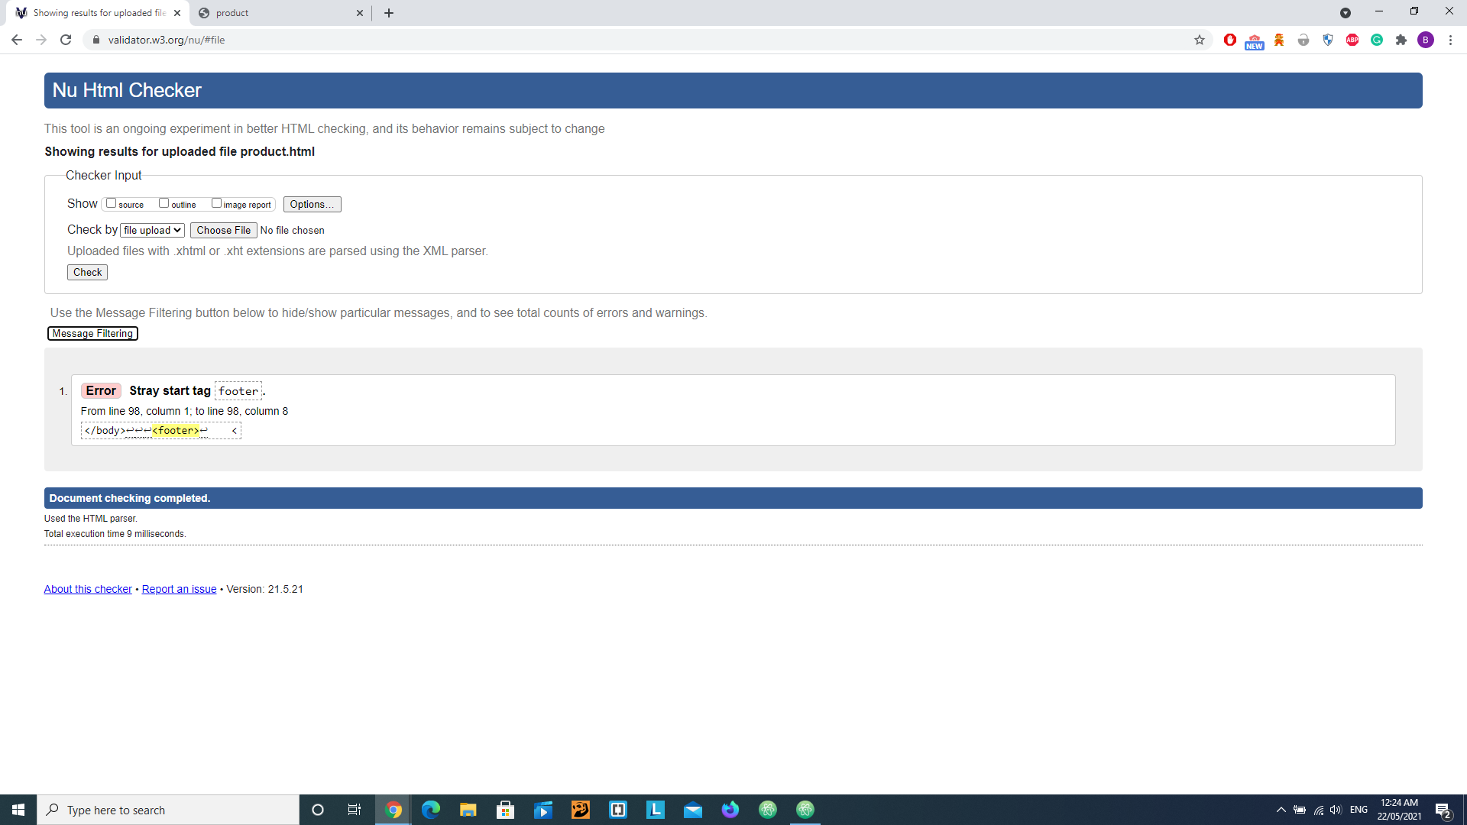

## **Relevant implications**

User friendly = using a traditional layout to ensure users find it easy to navigate the content on your website Contrast = the difference between colors and light and dark to standout from text and background colours for example.