LAB REPORT TEMPLATE

MREN 103 – Mechatronics and Robotics Design I
Mechatronics and Robotics Engineering Program
Queen’s University, Kingston

Group #24
Laboratory #42 - Introduction to the Universe and Everything

Remove all text in red for your report. You can use the text in black. Check the lab report style guide.
Student Names: John Smith and Jane Doe
Instructor Name: Prof. Surgenor
Date Report Submitted: September 13, 2007

Summary:
A prewired breadboard was used as an introduction to the hardware and software for the ItsyBitsy microcontroller. Activities included: a) using a digital multimeter (DMM) for voltage measurements, b) editing a supplied program to change its sequence of operations and c) debugging of wiring errors. Objective of the lab and brief summary of the activities.

Hardware:
The setup for the breadboard used in the lab is pictured in Fig. 1. Components on the breadboard include: ItsyBitsy microcontroller, resistors, LEDs, pushbutton and assorted jumper wires. Photo of the apparatus with supporting text.

Software:
A listing of the program Group24Lab1IntroSwitch used in the lab is given in Appendix A. Add text that explains the sequence of operations. In the listing itself, don’t forget to highlight all changes from the supplied program.

Results:
The pin assignments and measure voltages are reported in Table 1. The diagnostic table developed in response to the wiring errors introduced by the instructor is given as Table 2. Concise answers to the questions. Reproduce the numbering format in the lab handout
Q1. The answer is … Source: https://library.queensu.ca/
Q2. Don’t know the answer.
Q3. No, and the reason is …
All figures and tables need to be numbered and cited in the text.

Conclusions:
What did you learn in the lab, that you didn’t already know. If you didn’t learn anything, say so, but comment on where you originally learned the material.

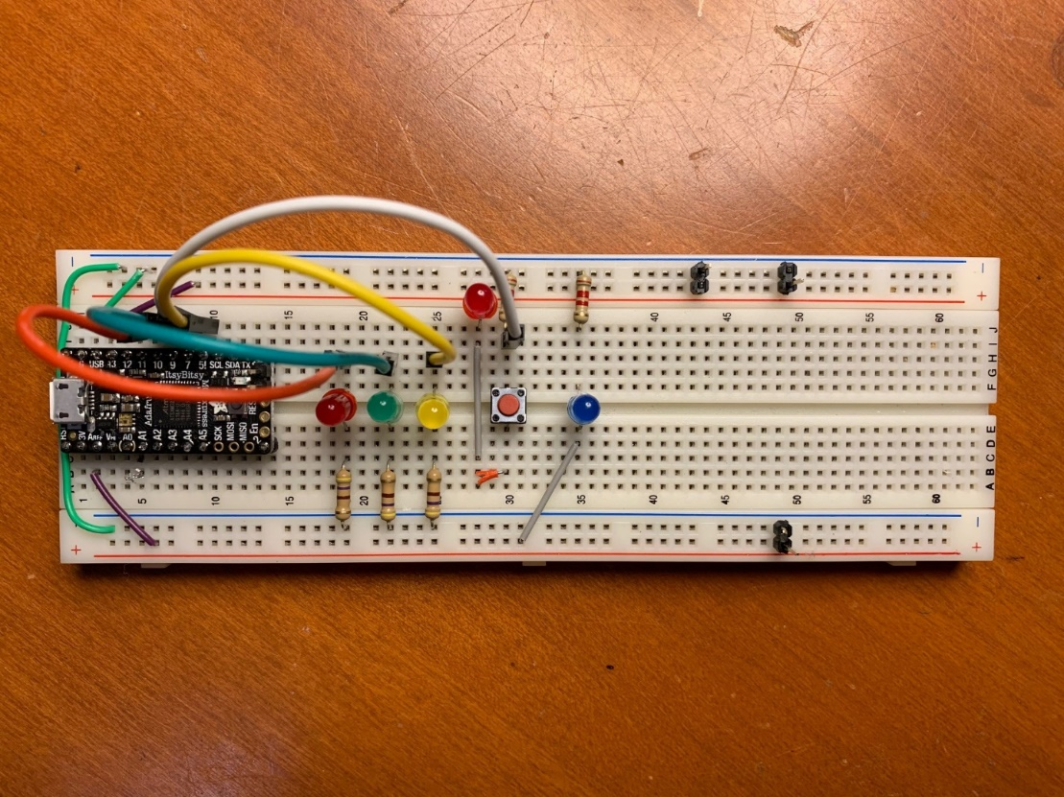
Fig. 1. Breadboard setup for Lab #1 with microcontroller, LEDs and resistors shown.
Table 1. Pin assignments and measured voltages in Lab #1.
Item | Pin# on ItsyBitsy that it connects to |  | Item | Voltage (record to within 0.01 V)
Red LED |  |  | 5V rail to ground
Green LED |  |  | 3V rail to ground
Yellow LED |  |  | Across power LED
Red button |  |  | Across yellow LED
 |  |  | Across green LED
Across red LED
(not the button LED)

Table 2. Diagnostic table for wiring errors in Lab #1
Number | Symptom | Source of Problem | Fix
1 | Orange LED fails to turn on | Broken leg on LED | Replaced orange LED
2
3
4

(Appendix should start on a new page, not as shown here)

Appendix A - Program Listing: (8 point font, 2 column, single spaced, changes highlighted)

/*******************************************************
MREN103Lab2BadServo (v1.2)

Original by B. Surgenor, 11/12/2021
Revised by H. Fernanco, 03/03/2022
- adapted from Stack for ItsyBitsy
- this has bugs that prevents it from working properly

*******************************************************/

// Pin Assignments
int RED = 10; //red LED Pin
int GRN = 9; //yellow LED Pin

int servoPin = 12; //servo connected to digital pin 12
int pulseWidth; //servoPulse function variable

// Set-up Routine
void setup() {

Serial.begin(9600);

// set stat of pins
pinMode(YLW, OUTPUT);
pinMode(RED, OUTPUT);

Serial.println("Press button to start.");
do{
digitalWrite(GRN, HIGH);
delay(125);
digitalWrite(GRN, LOW);
delay(125);
}while(digitalRead(BUTTON) == LOW);
}
// Main Routine
void loop(){

delay(1000);
Serial.println("Servo sweeping.");
turnOnLED(YLW); // yellow indicates running

// first sweep, starts at 90 deg and rotates to 180 deg
for (myAngle=90; myAngle<=180; myAngle++)
{
servoPulse(servoPin, myAngle);
delay(20);
Serial.println(myAngle);
}

// second sweep, starts at 180 deg and rotates to 0 deg
for (myAngle=180; myAngle>=0; myAngle++)
{
servoPulse(servoPin, myAngle);
delay(20);
Serial.println(myAngle);
}

// third sweep, starts at 0 deg and rotates to 90 deg
for (myAngle=0; myAngle<=90; myAngle++)
{
servoPulse(servoPin, myAngle);
delay(20);
Serial.println(myAngle);
}
turnOnLED(RED); // red indicates end of a cycle
delay(1000); // pause before repeating cycle
digitalWrite(RED,LOW);
Serial.println(" "); // generate a line feed
}
});

