# Initial Trials

## Trial 1 (Labmates)

Participants stood in a hallway and observed a cube. In the real condition, the cube was observed through a narrow door window and movement was allowed; in the virtual condition, the cube was observed through a wider virtual window (that did not have any other room environment information), movement was allowed, and the screen itself could be relocated. After the cube was removed from their view, participants then advanced forward, a meter at a time, pointed at where they thought the cube was and squeezed the trigger.  
-The location of the cube was determined semi-randomly, on the floor about a meter from the door and such that it could also be seen from the door.

-In both cases, the HMD was worn and the controller was used to gather data.

-A calibration round was used, for both conditions, to ensure that a user's way of holding the controller did not interfere with results.

-The virtual condition did not have a ground plain reference.

-The real condition had a narrower window.

### Results (s000, Farzana):

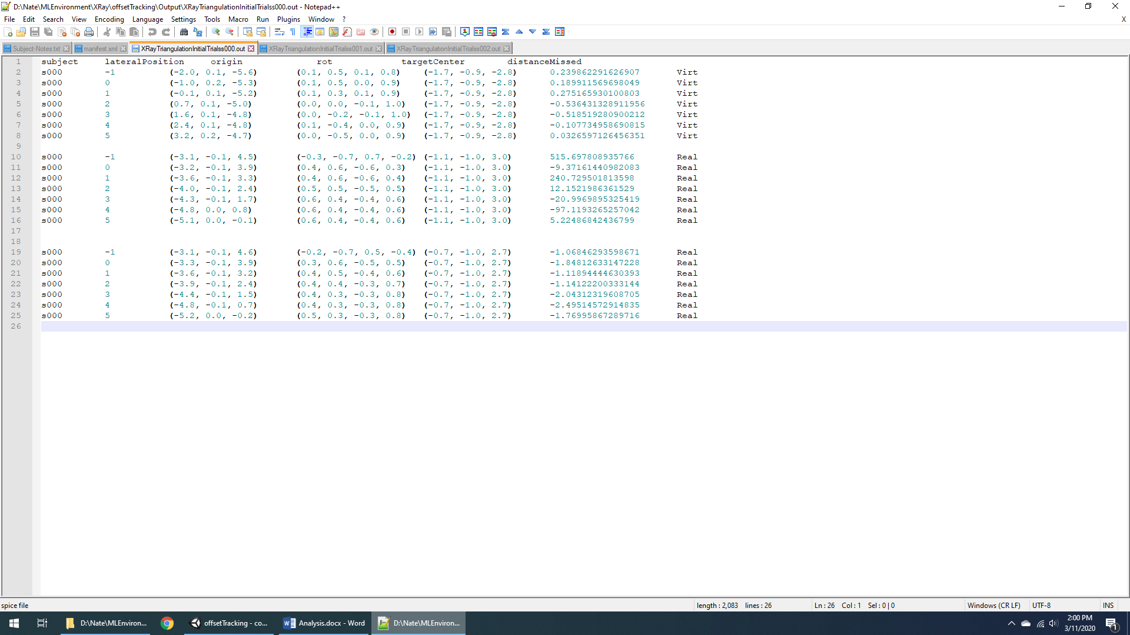

-First real distance trial was discarded; there was, perhaps, some sort of tracking or calibration error.

-Accuracy results were better in the virtual condition.

### Results (s001, Arefin):

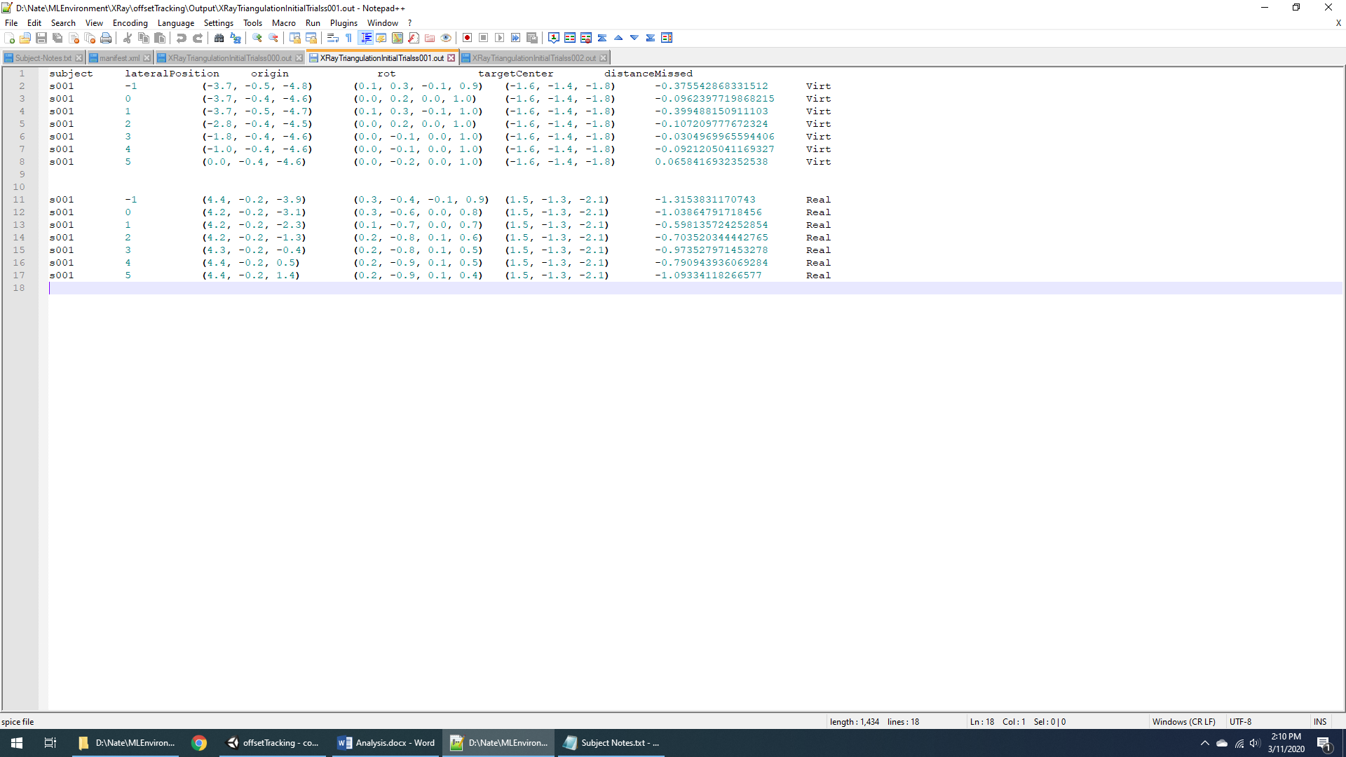

-Results again show stronger accuracy in the virtual condition.

### Results (s002, Nate):

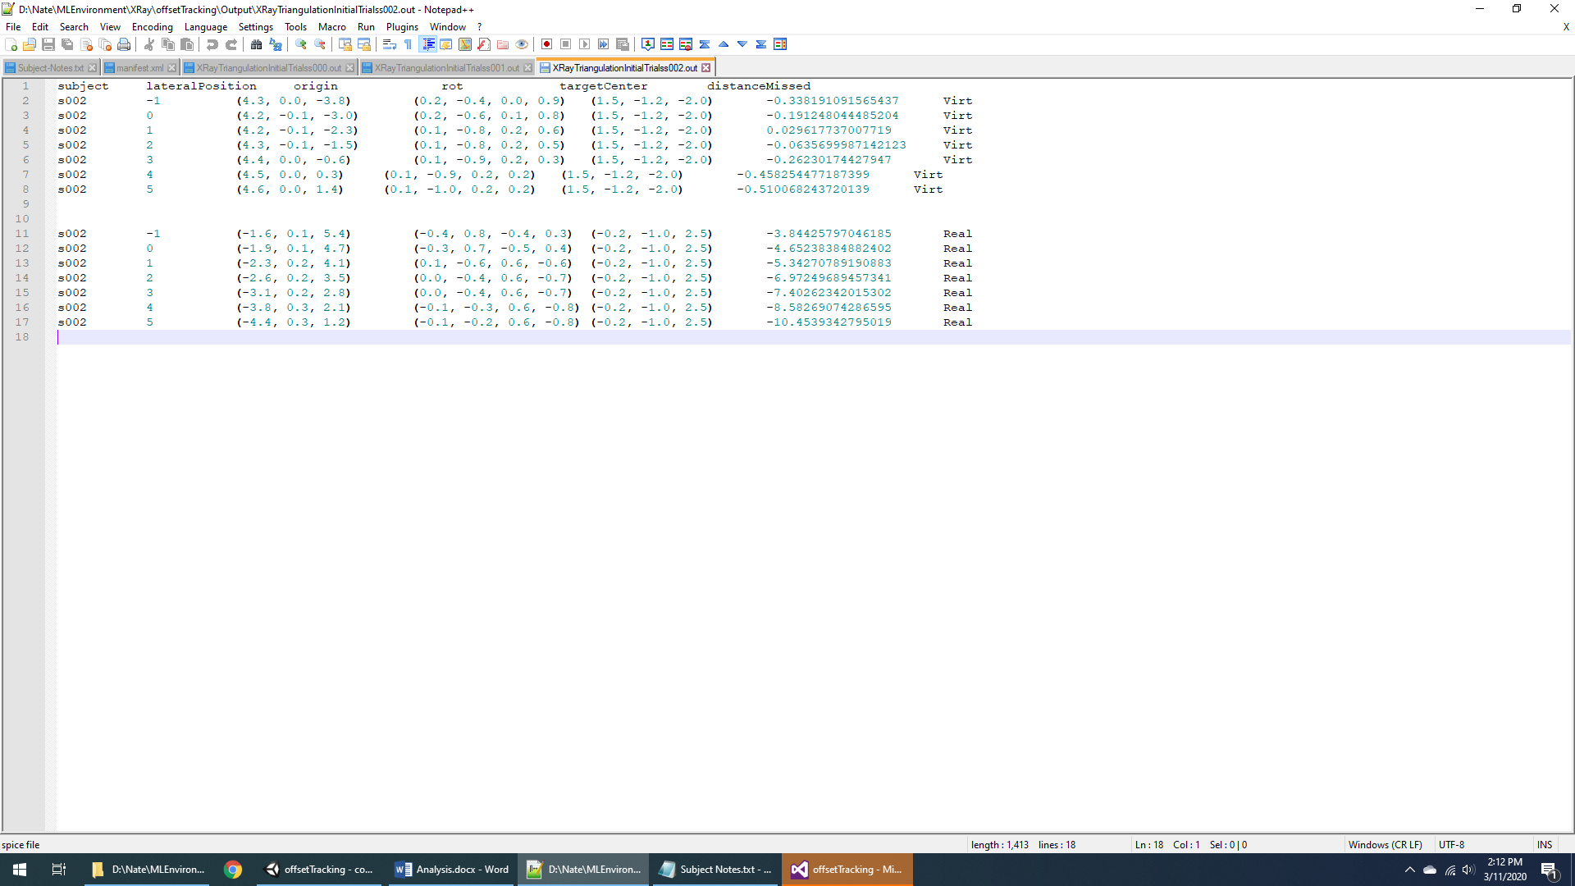

-Results again show stronger accuracy in the virtual condition.

### Analysis and Theories

#### Potential reasons for:

This is a very simple initial test, and a lot of detail remains to be added to the experimental run-through. However, initial results seem to indicate that the virtual condition, surprisingly, yields better results than the real-world condition. This might be due to several different factors:  
-Differences between the real and virtual window:  
--Size of window  
--Amount of environmental features seen through window (something that I would have thought would make the real condition *more* accurate and not less).  
--The ability to move the virtual window. This could have led to more exploration of the environment and a stronger sense of place for the virtual object. This is a feature of the x-ray vision system and so, if it is responsible for increased depth accuracy, that is another argument for our x-ray vision approach.

-Novelty effects. The virtual approach is much more novel and so may have excited more attentional cognition than the real-world condition. It may also have increased focus on the relevant data (thus potentially improving situational awareness).

-Distraction. Removing the cube in the real-world condition involved opening and shutting the door; this may have distracted the user. (There also was some movement in and out of the room in the virtual condition, as well.) In future experimental runs, it may be better to have users close their eyes during transition stages.

-Affordances. The ability to move the screen in the virtual condition may have caused users to experiment more effectively with that affordance and spend more time investigating the object.

Potential interactions that likely don't cause the effect:  
This effect is *not* likely due to:  
-Training. Training would indicate that users would begin performing more effectively at the aiming task.  
-Motion parallax (testing phase). Both tasks had identical motion parallax during the testing phase (moving through the hall a meter at a time).