Midterm
Part A - Architecture Design

Part B - Adversarial Threat Model
Threat | Asset | Attack Vector | Impact | Mitigation | Residual Risk
Brute-Force Attacks | User authentication system (usernames, passwords, and OTP). | Repeated automated login attempts sent over the TCP socket. | Account can be compromised or unauthorized access. | A failed login attempt lockout threshold has been set. | Distributed attacks across multiple sessions.
Credential Sniffing | Plaintext credentials in transit. | An attacker can use a passive packet capture (i.e. Wireshark) on the TCP channel. | Credentials can be stolen and sessions can be hijacked. | Time-based MFA with pyotp limits the token lifespan, reducing the risk of attackers logging in even if they get the credentials. | Passwords and messages can still be read by a third party watching the network traffic.
DDoS Attack | Server socket connection queue, CPU, and memory. | Flooding the server with simultaneous connection requests or malformed loops holding sockets open. | Server crashes or becomes unresponsive to legitimate user connections. | The application currently only has a single connection limit. | The single client architecture lacks high availability flood mitigation.
Unauthorized Port Scanning | Local port scanner module (nmap). | Running scans against an external website or inputting the wrong IP address into the prompt. | Network disruption or triggering IDS/IPS alerts. | Input validation restricting targets to 127.0.0.1 (localhost). | User error during manual IP address input.

Part C - Protocol Design
Specify the TCP application-layer protocol: message structure and command format; authentication and MFA sequence; authorization rules for protected commands; malformed request handling; error responses; session termination; and replay/security limitations. Clearly distinguish protections implemented from those proposed for future deployment.
- Message Structure and Command Format
- The application uses a custom, text-based application-layer protocol running over a standard TCP socket (SOCK_STREAM)
  - Messages use a strict format of “COMMAND|CONTENT” separating the command and content of the message by the pipeline (|) character.
  - Commands that may require multiple parameters, such as AUTH|username|password, split them with additional pipes.
  - Supported commands include AUTH, OTP, MSG, PCAP, and EXIT.

- User Authentication and MFA Sequence
  - Authentication is handled in a multiple step challenge-response flow after the user establishes a connection the server.
    - Password Verification Step: The client is prompted to input their username and password; this is then sent to the server as “AUTH|username|password”. The server then hashes the inputted password with SHA-256 and compares it against the stored hash in the mock user database (users). If the incorrect password is entered the server returns an “ACCESS_DENIED” message and increments the failure counter.
      - If three failed attempts are reached, the server ends the connection with the client and returns a “ACCESS_DENIED|Too many failed attempts. Authentication blocked” message. The socket is then closed.
    - MFA Step: If the password passes the verification step, the server replies with “OTP_REQUIRED”. The client then prompts the user for an OTP code and gets sent back to the server as “OTP|code”.
    - OTP Verification Step: The server validates the inputted OTP code using the pyotp library. If the code is valid, it responds with “ACCESS_GRANTED” which unlocks the security applications menu for the user. If the code is invalid, it returns an “ACCESS_DENIED” message and increments the failure counter.
      - If three failed attempts are reached, the server ends the connection with the client and returns a “ACCESS_DENIED|Too many failed attempts. Authentication blocked” message. The socket is then closed.

- Authorization Rules for Protected Commands
  - The server enforces state-based authorization before the user can complete specific actions. For example, if an unauthenticated client tries to run the PCAP analysis by sending the “PCAP|” command or send a message to the server with the “MSG|” command, the server immediately rejects it with “ERROR|User authentication is required”.

- Malformed Request Handling and Error Responses
  - Format Errors: Every incoming message from the user is checked for the pipe delimiter (|). If the pipe is missing, the server will return an “ERROR|Invalid command format” message to the user.
  - Empty Inputs: If the user sends an empty username, password, OTP, or chat message, the server catches them and will return specific error messages such as “ERROR|Username required” or “ERROR|Message cannot be empty”.
  - Message Length Limit: The server enforces a strict limit of 200 characters for the “MSG” command. If this limit is exceeded the server will return an “ERROR|Message too long” message to the client.

- Session Termination
  - There are currently three ways that a session can be terminated by the server.
    - Normal Exit: The user selects option 5 from the menu, which sends an “EXIT|” command to the server. The server will then reply with an “OK|Goodbye” message, closing the connection on both sides gracefully.
    - Unexpected Disconnection: If a client abruptly closes the window or drops the connection, the server catches the “ConnectionResetError” or empty socket data, prints a disconnection notice, then cleans up the sockets.
    - Exceeding Failed Login Attempt Threshold: If a user exceeds the strict three failed attempt threshold (MAX_FAILED_ATTEMPTS = 3) on the login stage the server will return a “ACCESS_DENIED|Too many failed attempts. Authentication blocked” message and close the socket.

- Replay and Security Limitations (Implemented vs Proposed)
  - What is Currently Implemented:
    - Time-based one-time passwords with pyotp prevent attackers from reusing captured OTP codes outside of their short 30 second validity window
    - SHA-256 password hashing prevents raw passwords from being stored in plaintext on the server backend
  - Proposed for Future Deployment:
    - Since this application runs over plain, unencrypted TCP sockets, all usernames, passwords, OTP codes, and commands travel across the network in plaintext. In the future TLS/SSL using Python’s ssl library should be implemented so that the entire TCP channel is encrypted, preventing packet sniffing.

Part D - Component Design
- TCP Client (client.py)
  - Inputs: Usernames, passwords (via secure prompt), OTP codes, target hostnames, port ranges, chat messages, and menu selections which include the following five options:
    - Run Local TCP Port Scanner
    - Run HTTP Website Security Checker
    - Run Offline PCAP Analysis
    - Run Message Application
    - Exit Application
  - Outputs: Interactive terminal menus, authentication challenge prompts, formatted scan outputs, server responses.
  - Expected Behavior: Establishes a TCP socket connection to 127.0.0.1:12345, runs the interactive authentication loop (sending AUTH and OTP commands). Renders the Security Assessment Tools menu upon successful authentication and verification, translates user choices into framed network commands (PCAP, EXIT, MSG).
  - Failure Conditions: Connection errors or socket drops are caught, prompting clean exit messages if the server goes offline. Invalid menu choices, failed authentication attempts, and empty user inputs trigger respective re-loops or blockages.
  - Security Controls: Passwords are entered securely with getpass to prevent terminal echoing, stateful authentication is tracked.

- TCP Server (server.py) – Also handles the core MFA module
  - Inputs: Inbound client socket connections, raw command strings transmitted over the TCP stream, mock database records (users), and server configuration parameters (MAX_FAILED_ATTEMPTS = 3).
  - Outputs: State progression signals (OTP_REQUIRED, ACCESS_GRANTED, ACCESS_DENIED), command execution results, error strings, and terminal logging notices.
  - Expected Behavior: Binds to 127.0.0.1:12345, listens for a client connection, parses incoming messages using pipe delimiters (COMMAND|CONTENT), maintains sessions state by tracking whether a client is authenticated and counting failed authentication attempts, and routes authorized requests to their respective application modules.
  - Failure Conditions: Unexpected client disconnections raise a ConnectionResetError or empty socket reads, which the server catches to close the socket and reset state cleanly. Malformed strings missing a pipe delimiter return an immediate “ERROR|Invalid command format” response. Client exceeding the preset failed attempt threshold.
  - Security Controls: Delimiter checking, stateful authorization gating, SHA-256 password hashing, pyotp token verification, failure lockout thresholds, and security event logging that captures failed logins, lockouts, and unauthorized command attempts.

- Port Scanner (port_scanner.py)
- Inputs: Target host string (i.e. localhost or 127.0.0.1) and start/end port integers (ranging from 1 to 65535).
- Outputs: Formatted terminal text/tables detailing every port in the tested range alongside its current state (i.e. open or closed) and its mapped service name or “unknown” if applicable.
- Expected Behavior: Resolves the target hostname to an IP address using socket.gethostbyname(), executes a TCP port scan using the python-nmap library, and loops through the full user-defined range to display active services and inactive ports.
- Failure Conditions: Invalid hostnames raise socket.gaierror exceptions caught by retry logic. Out of order port bounds (end port is smaller than start port) or non-integer entries trigger validation re-prompt loops.
- Security Controls: Input validation boundaries ensuring port values stay strictly withing TCP limits (1-65535).

- Message Application Module (send_message.py)
  - Inputs: Chat message strings typed by the user into the active terminal session.
  - Outputs: Formatted protocol messages “MSG|content” sent over the active socket and server acknowledgment responses.
  - Expected Behavior: Operates an active communication loop once the user enters the chat application. Inputted chat messages have the “MSG|” tag attached to them and are then transmitted to the server. Users can type “EXIT” to return to the main menu.
  - Failure Conditions: Blank message strings or messages exceeding the string content length threshold are caught and rejected by local and server-side validation rules
  - Security Controls: Strict 200-character length limit is enforced to protect backend buffer allocations.

- HTTP Security Checker (http_security_checker.py)
  - Inputs: Target base URL (http://127.0.0.1:8765) and an array of specific test path endpoints (/, /health, /redirect, /missing)
  - Outputs: Real-time console logs, vulnerability observation summaries, and two exported CSV report files (http_scan_results.csv and vulnerability_findings.csv).
  - Expected Behavior: Issues HTTP GET requests using the requests library, inspects response headers for missing security controls or version disclosure signatures, exports findings to CSV files and client terminal.
  - Failure Conditions: If the target local test service is offline, requests.RequestException catches connection failures, preventing application crashes and allowing the client to continue running.
  - Security Controls: Uses try-except blocks so the script doesn’t crash if the target website goes offline, and checks findings before writing them to make sure it doesn’t add duplicate rows in the exported CSV files.

- PCAP Analyzer (analyze_pcap.py)
  - Inputs: File path pointing to the target packet capture file (FSCT8561_Operation_Sentinel_Traffic.pcap)
  - Outputs: Terminal summary displaying the total TCP and UDP packet counts, along with a list of flagged suspicious source IPs that exceed traffic thresholds.
  - Expected Behavior: Parses the PCAP file using Scapy’s rdpcap() function, counts the TCP and UDP packets, and flags any IP address that send more than 20 packets within a 5-secocnd window as suspicious.
  - Failure Conditions: Missing packet capture file or incorrect spelling of the path, file exceptions are caught and reported back cleanly.
  - Security Controls: Exception handling around file operations to ensure backend script stability.

- Sensitive Information Exclusion and Justification
  - Plaintext passwords, account password hash strings, and raw TOTP secret keys were excluded from being collected and logged.
  - These were excluded due to their sensitive nature, I wanted to ensure that even if an unauthorized user gains read access to log outputs or captures diagnostic data, they would not be able to recover raw credentials or forge valid MFA tokens.

Part E – Full Integrated Implementation

Part F – Comprehensive Testing
For this stage I have laid out the following tests:
- Successful Authentication
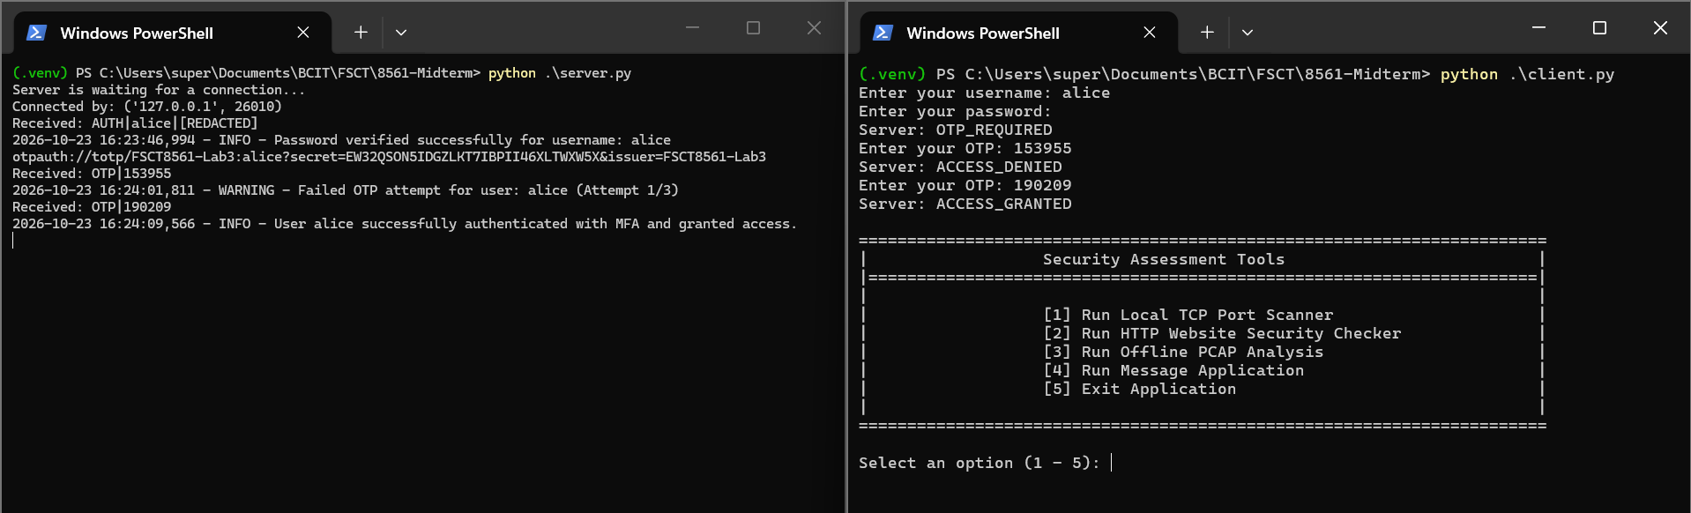
- Authentication Lockout After Exceeding Failed Attempt Threshold
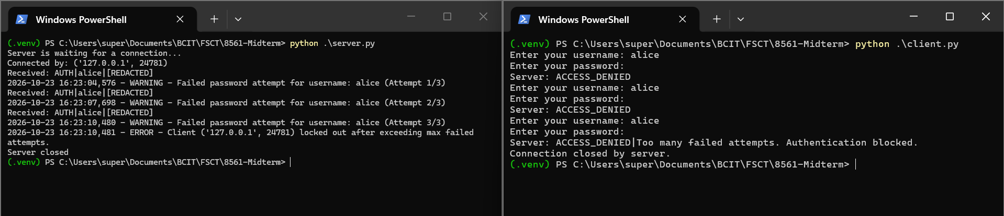
- Sending Expired OTP
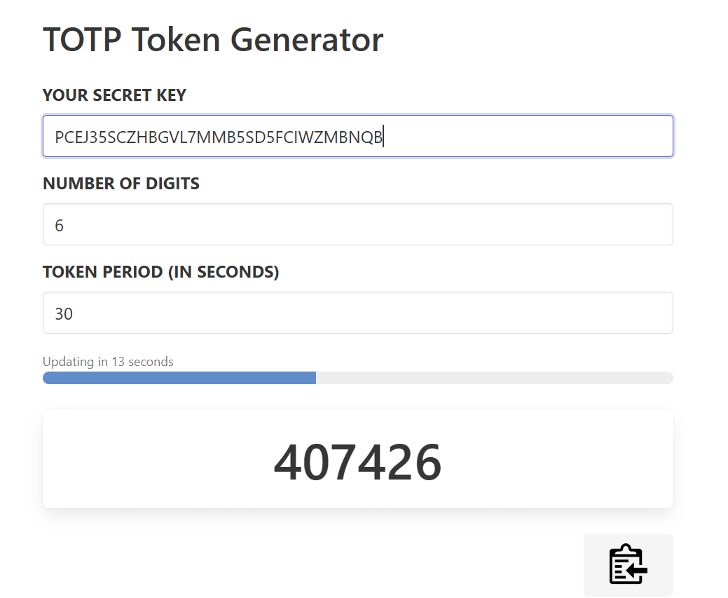
  - Waited for secret to expire
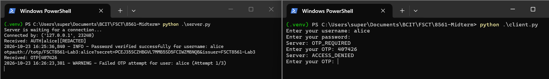
  - Didn’t accept it
- Sending a Command Before Authentication Stage
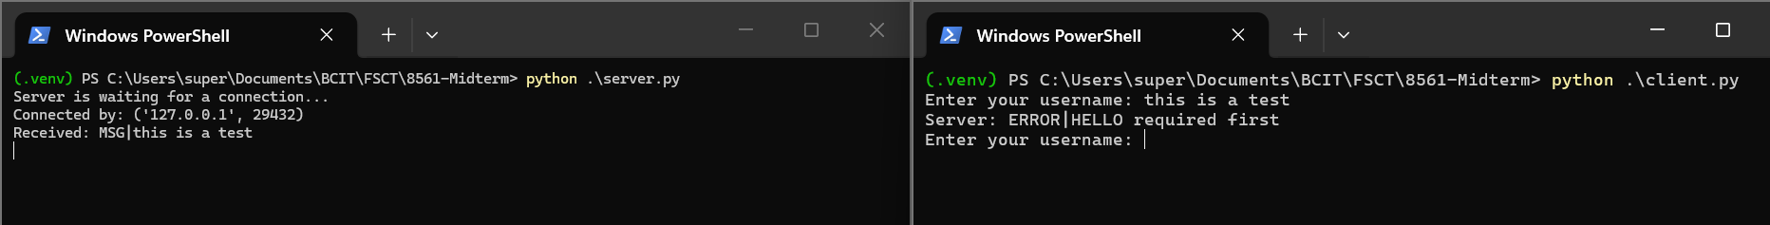
- Input With Incorrect Structure
- Exceeding Input Length
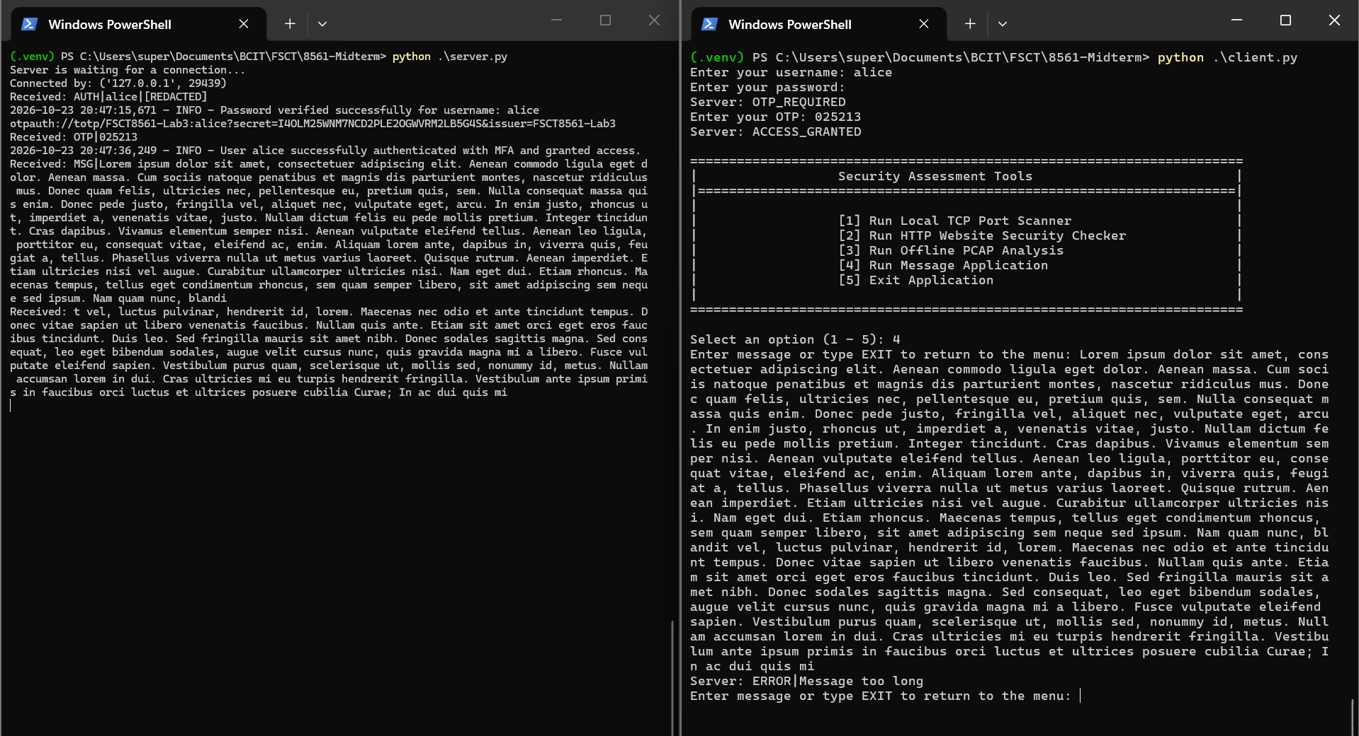
- Running the Port Scanner Module
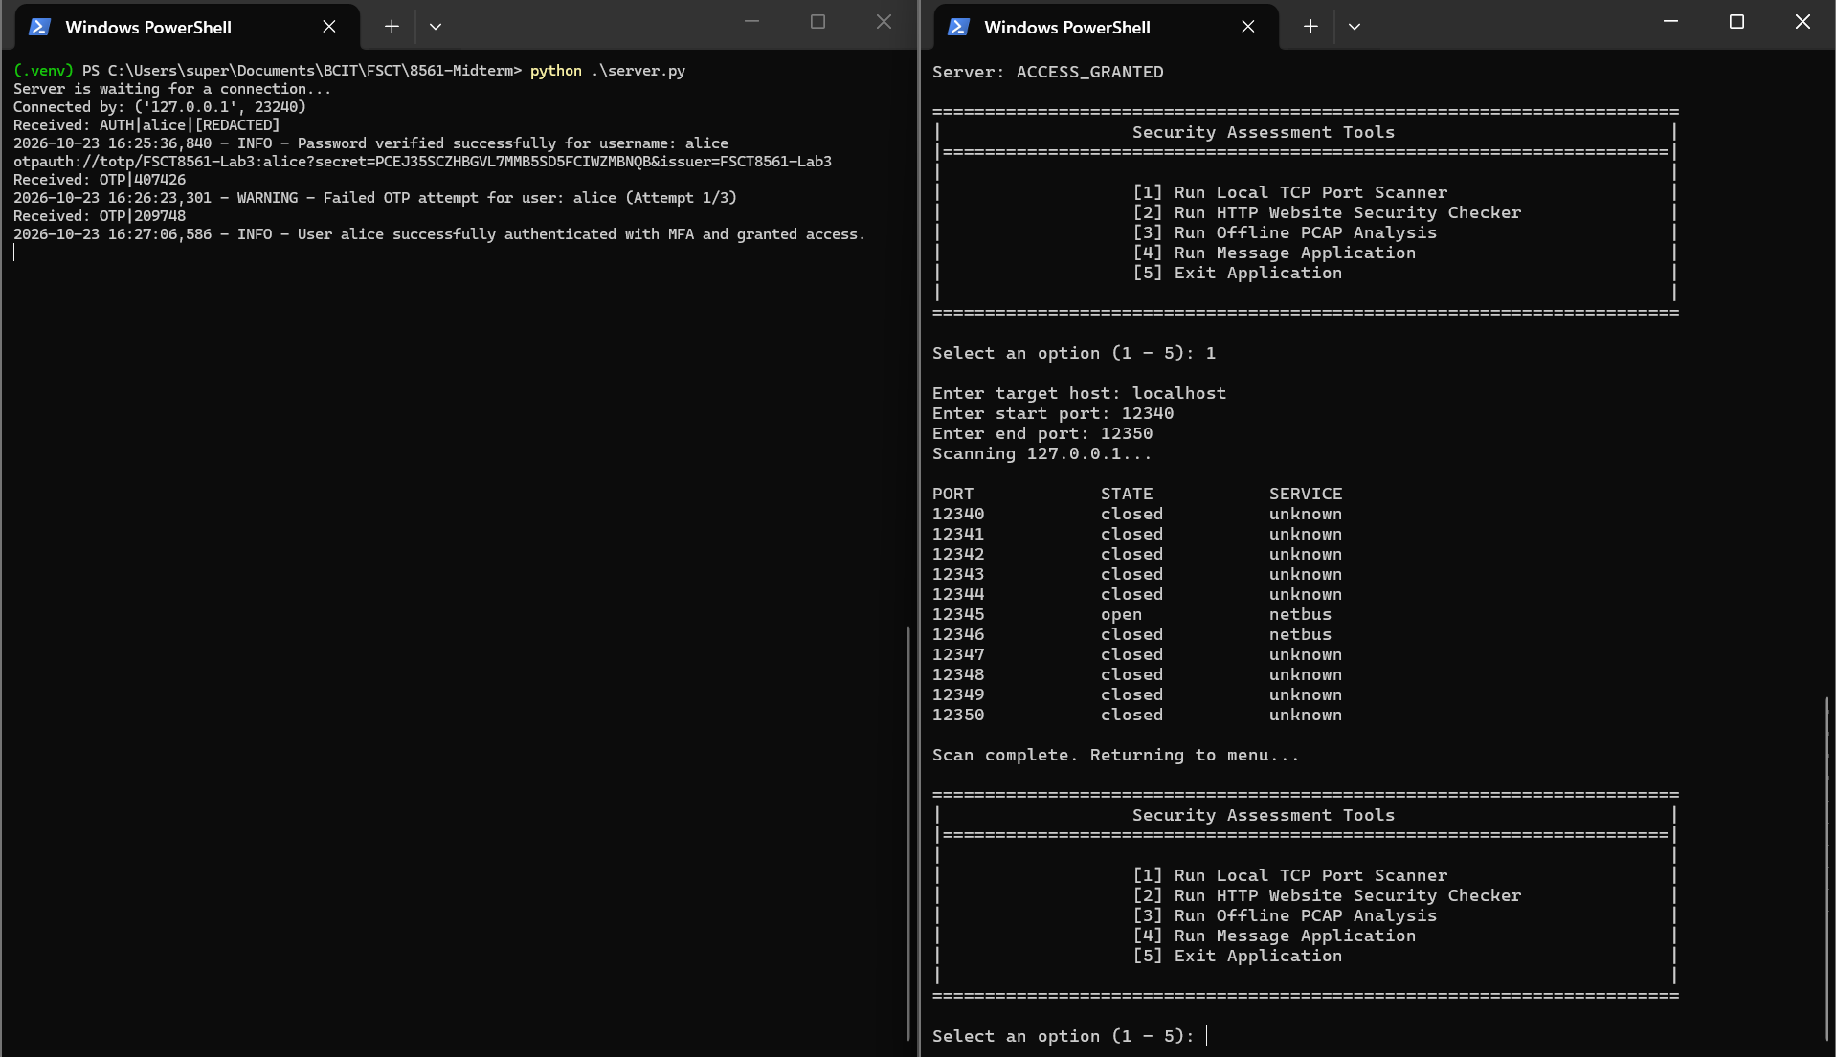
- Inputting an invalid host on the Port Scanner Module
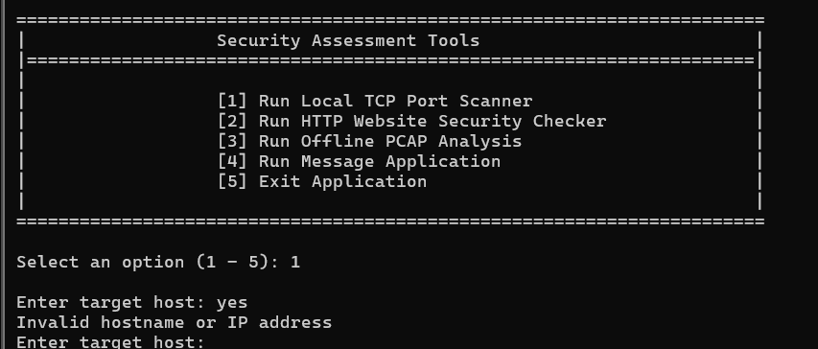
- Running the HTTP Security Checker (success)
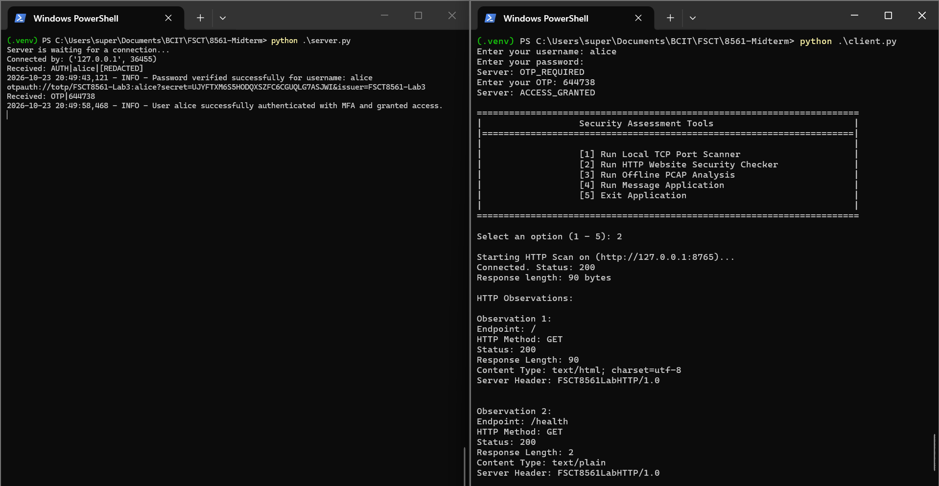
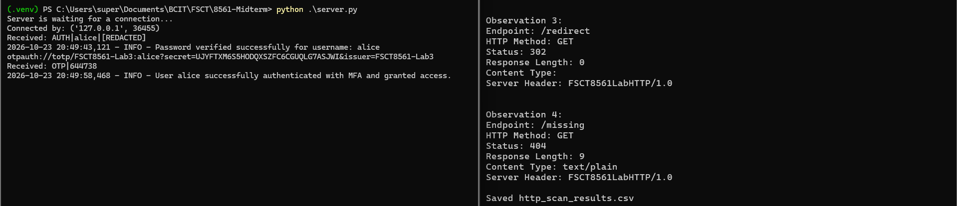
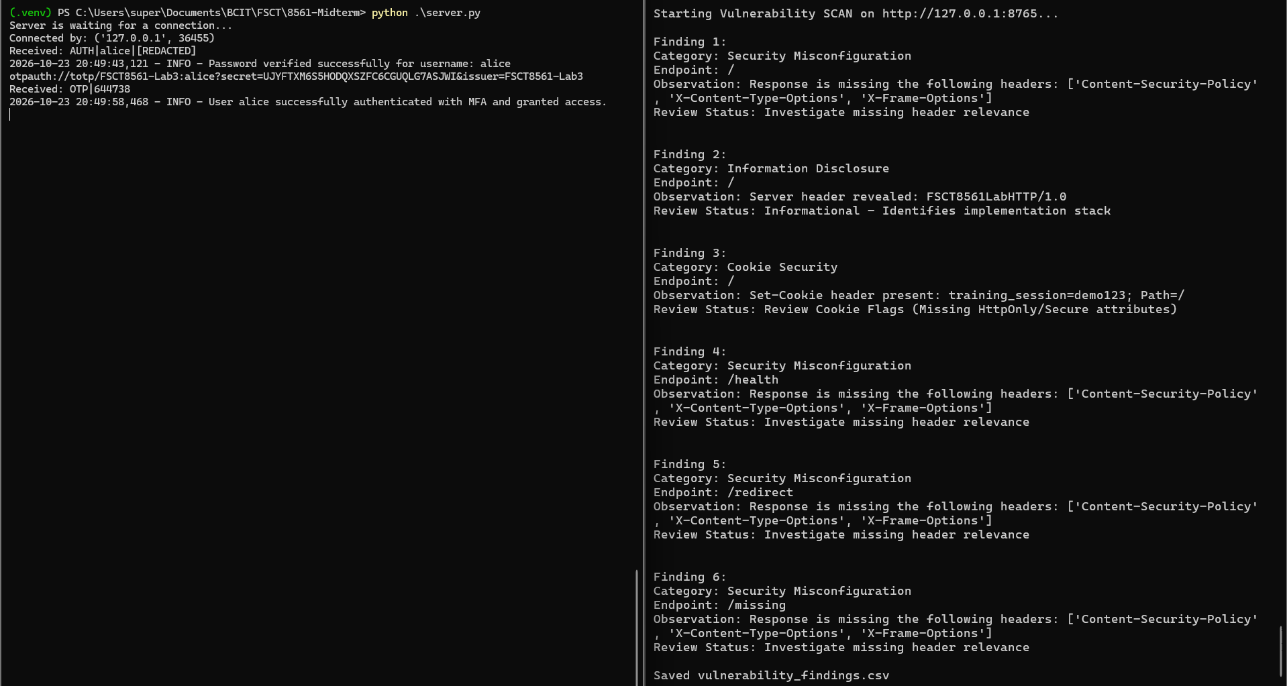
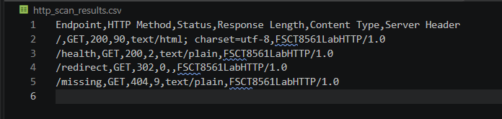
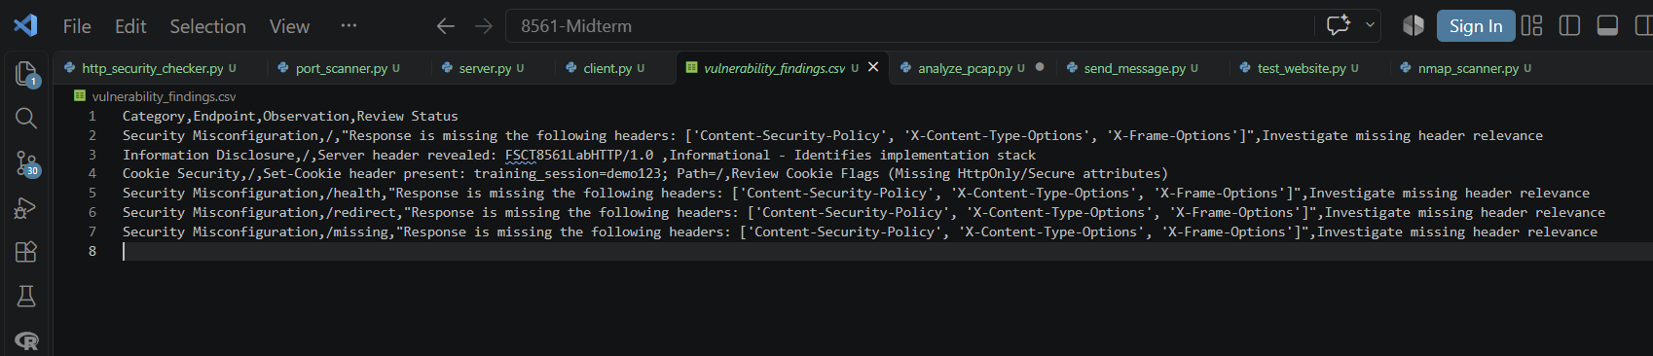
- Running the HTTP Security Checker (failure)
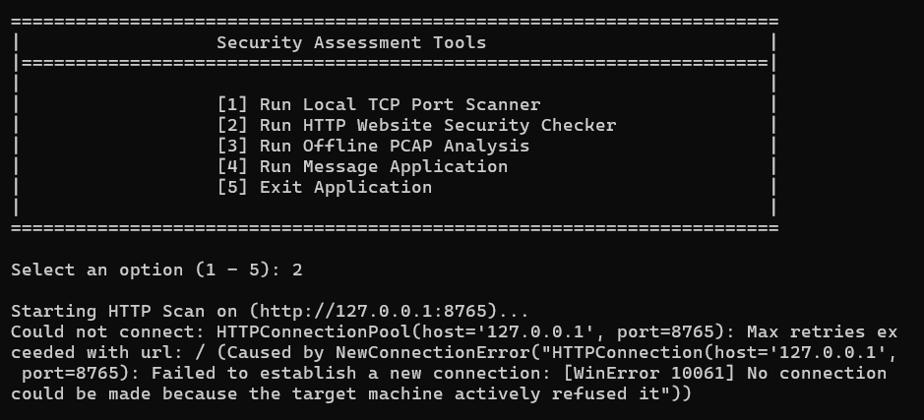
  - Tested with the test site offline
- Running the PCAP Analysis Module (success)
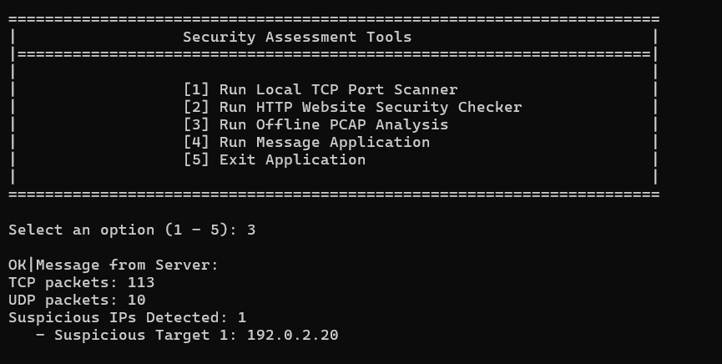
- Running the PCAP Analysis Module (failure)
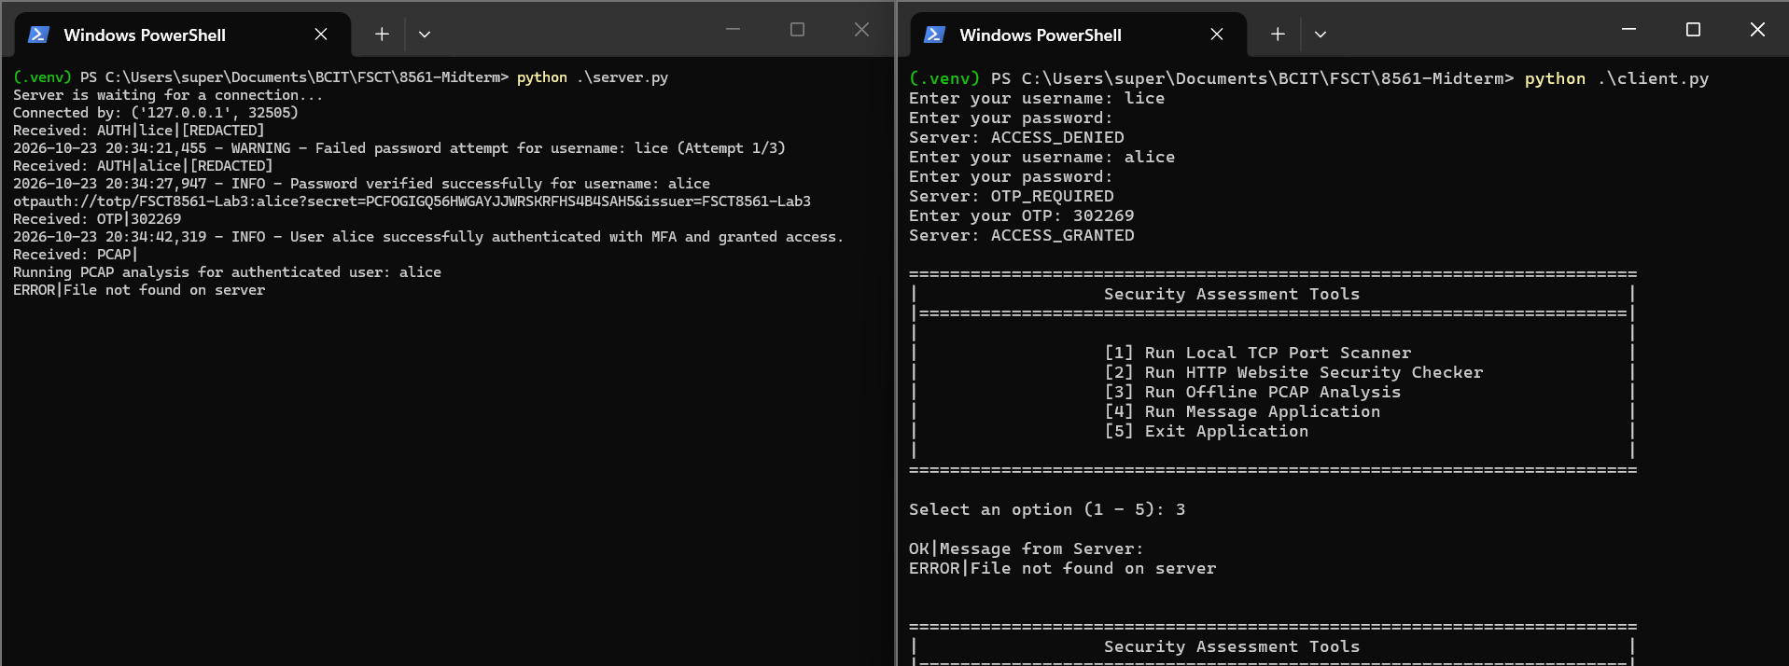
- Security Logging
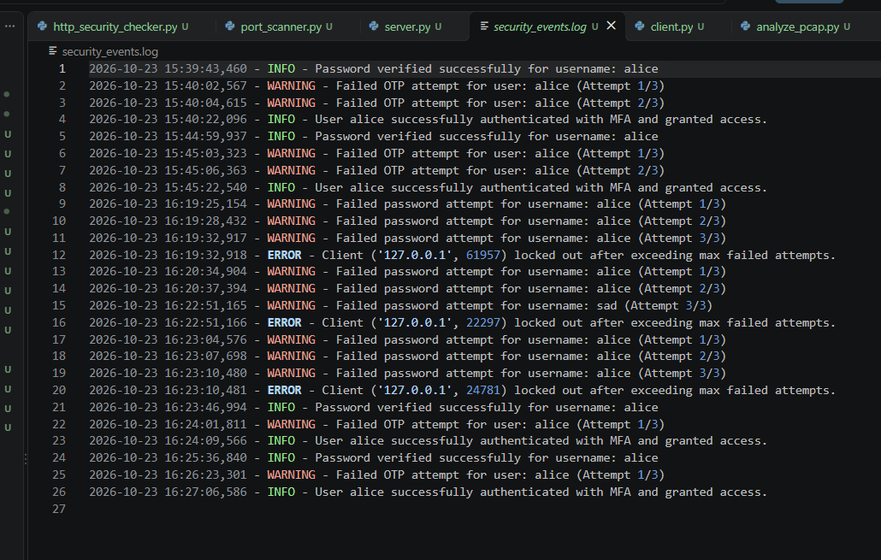
  - Logs are stored in a “security_events.log” file, this was done using the logging python library. Logs are also printed on the server console.

Part G – Security Analysis and Reflection

